Water in my life
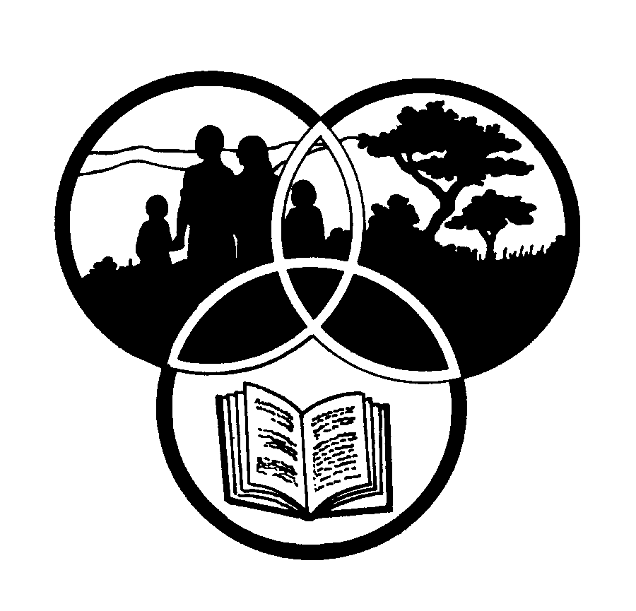
Share-Net

Share-Net is an informal partnership project committed to developing and disseminating materials in support of environmentally focused teaching and learning. Share-Net materials are copyright-free for educational purposes. We encourage you to adapt and use the materials in new, exciting ways but request that you acknowledge Share-Net as an original source. Sensible use of these curriculum activities is entirely the responsibility of the educator. Find similar curriculum materials by visiting www.envirolearn.org.za or contact Share-Net directly at PO Box 394, Howick, 3290, KwaZulu-Natal,
tel: (033) 330 3931, e-mail: sharenet@wessa.co.za
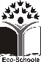
This pack supports an introduction for young learners to an Eco-School’s focus on health and safety

Grade 1

This pack contains:
Activity One: A listening and group work LANGUAGES activity looking at freshwater in our lives. Using a simple demonstration, the teacher is easily able to show learners how limited our freshwater resources are and allow the children to consider ways that water can be conserved.

Activity Two: This LANGUAGES activity introduces the concept of ‘catchments’. It looks at water sources and encourages learners to consider how we can protect and care for them.

Activity Three: This LIFE ORIENTATION lesson looks at basic sanitation and when and why we need to wash our hands.

Activity Four: This TECHNOLOGY activity follows on from the earlier lesson on basic sanitation. Learners use materials gathered from home and around the school to make their own toilet hand washer.

Activity Five: Just for fun!! Making an indoor rainbow.

This pack of lesson plans is part of a series of lesson plans from Grade R to Grade 10 which focus on water and water-related issues. This resource development project has been funded by the Water Research Commission, Private Bag X 03, Gezina, Pretoria, 0031 (Website: www.wrc.org.za).
This pack is available electronically on www.envirolearn.org.za
Activity | Learning Area covered in this activity | Learning Outcomes covered in this activity | Assessment Standards covered in this activity
1. Listening and group work activity looking at freshwater. A simple demonstration by the teacher shows learners how limited our freshwater resources are. A homework worksheet is also included in this activity. | Languages | Learning Outcome 1: Listening: The learner will be able to listen for information and enjoyment, and respond appropriately and critically in a wide range of situations.  Learning Outcome 2: Speaking: The learner will be able to communicate confidently and effectively in spoken language in a wide range of situations. | - Listens attentively to instructions and announcements and responds appropriately.  - Demonstrates appropriate listening behaviour by listening without interrupting, showing respect for the speaker, taking turns to speak and asking questions for clarification.  - Talks about personal experiences, feelings and news.  - Contributes to class and group discussions.
2. Introduction to the idea of a ‘catchment’. This activity looks at water sources and encourages learners to consider how we can protect and care for them. | Languages | Learning Outcome 1: Listening: The learner will be able to listen for information and enjoyment, and respond appropriately and critically in a wide range of situations.  Learning Outcome 2: Speaking: The learner will be able to communicate confidently and effectively in spoken language in a wide range of situations. | - Listens attentively to instructions and announcements and responds appropriately.  - Demonstrates appropriate listening behaviour by listening without interrupting, showing respect for the speaker, taking turns to speak and asking questions for clarification.  - Talks about personal experiences, feelings and news.
3. This activity looks at basic sanitation – when and why does one wash one’s hands? | Life Orientation | Learning Outcome 1: Health Promotion: The learner will be able to make informed decisions regarding personal, community and environmental health.  Learning Outcome 2: Social Development: The learner will be able to demonstrate an understanding of and commitment to constitutional rights and responsibilities, and to show an understanding of diverse cultures and religions. | - Explains steps to ensure personal hygiene and links these steps to environmental health.  - Distinguishes between situations that are safe and those that require precautions against communicable diseases.  - The learner draws up classroom rules.
4. This lesson follows on from the earlier one on sanitation and learners make their own toilet hand washer. | Technology | Learning Outcome 1: Technological Processes and Skills: The learner will be able to apply technological processes and skills ethically and responsibly using appropriate information and communication technologies. | - Designs: Chooses suitable materials or substances to make simple products to satisfy a given need.  - Makes: Makes simple products from different materials.  - Evaluates: Expresses and explains own feeling about the products made.
5. Just for fun – making an indoor rainbow. | - | - | -

