ACTIVITY ONE: WATER IN OUR LIVES

This listening and group work LANGUAGES activity looks at freshwater in our lives. Using a simple demonstration the teacher is easily able to show learners how limited our freshwater resources are and allow the children to consider ways that they can conserve water. The worksheet provided can either be used as a consolidation of the ways we use water in our daily lives, or as a homework activity.

Everyone has a birthday, don’t they? Mine is on the 3 November! I wonder when yours is? Did you know that WATER has a special day as well. It’s 22 March and it’s called World Day for Water¹. It’s not really a birthday, but it’s a day when people all over the world remember how important water is in our lives.

In South Africa, we’re very lucky because our government knows how important freshwater is to all South Africans and they have decided to make the week² that includes 22 March, National Water Week – that’s a whole week dedicated to thinking, talking and doing lots of active things about and for water!

Our country is very rich in gold and diamonds but it is very poor in freshwater. A few parts of South Africa get lots of rainfall but there are many many towns and villages in the western part of the country that receive very little rain throughout the year. Whether we live in towns, cities or on farms where we get lots of rain, or in places where there is very little rain, freshwater is essential to all of us – for our lives and our good health.

Although there are many oceans and seas covering our Earth, we have to remember that all that water is salt water, not freshwater. Only a very small amount of all the water that we find on Earth is freshwater, which we can drink.

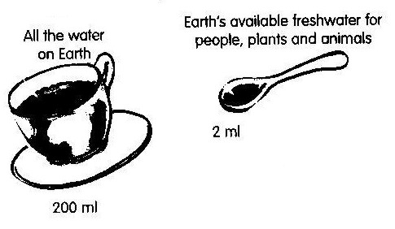
A demonstration for you, the teacher, to show the learners how little freshwater there is on the planet for our daily needs

Fill a teacup with water (200ml) – this represents all the water on Earth. Now take out just less than half a teaspoon (2ml) – these 20 drops of water represent the amount of freshwater available for use by all the people, animals and plants on the Earth! Whew, that’s not very much, is it? Water is precious – so, let’s make sure that none of us waste a drop.
Reproduced from EnviroKids magazine with permission

We use water in many ways - for drinking, for washing our bodies, for cleaning our homes, for preparing and growing food and for our livestock and pets.

ACTIVITY:
● In groups of four or five, think and talk about all the different ways you use water every day. Each person in the group will need to report back to the rest of the class.

One can see from all the report backs that there are so many different ways, each day, that we use water in our lives. Using the worksheet that follows (either during the lesson or as a homework exercise), learners will be able to consolidate and think about other ways that freshwater plays a role in their lives.

Water in our lives
Draw a line from the words on the right to the pictures on the left
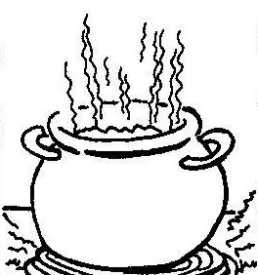

Swimming

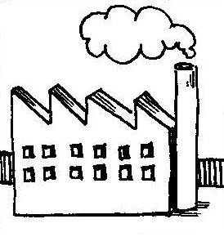

Washing clothes

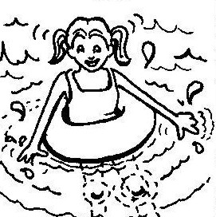

Watering vegetables

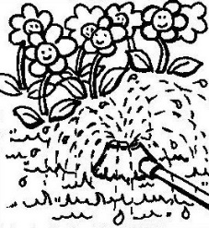

Transport

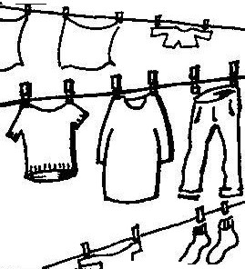

Cooking

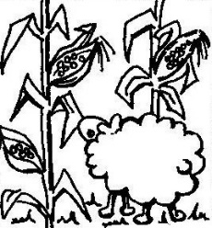
Drinking

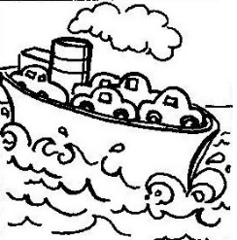

Watering flowers

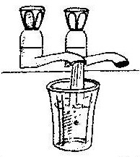

Factories

Reproduced from EnviroKids magazine with permission

ACTIVITY:
- In the same groups, let the children think and discuss ways that they can save water.

Some ideas to get the children thinking ….
○ Don’t leave a tap running
○ Fix leaking taps
○ Put the plug in when washing dishes or vegetables.
○ Greywater (that is, water used for washing dishes, bath water or the washing machine) can
easily be diverted into the garden
○ Plant indigenous trees and bushes – they don’t need as much water as plants that are not
South African
○ Boil just the amount of water you need when making a cup of tea or coffee
○ Turn the tap off when brushing teeth or washing hands
○ Collect rainwater for watering plants
○ Use a bucket to wash the car or one’s bicycle rather than a hosepipe

Once again, each learner in the group will need to clearly report back to the rest of the class what they spoke about within their group. The rest of the class is encouraged to ask each group questions about their water saving ideas.

It may be a good idea to write all the ideas on the chalkboard.

- Finally, from the list that is drawn up on the chalkboard, let the children decide which actions they can take to reduce their water use. Let them chose a simple one (such as making sure that the tap is not running when they wash their hands or brush their teeth) and see, through the week that follows, if they manage to remember this environmental action. You may even chose to conduct this activity during National Water Week, held in March each year.

Criteria to assess learners during this languages lesson

Criteria | Exceeded requirements of the Learning Outcome | Satisfied requirements of the Learning Outcome | Partially satisfied requirements of the Learning Outcome | Not satisfied requirements of the Learning Outcome
The learner listened attentively to the information on water without interrupting the teacher
The learner listened attentively to the instructions and responded appropriately
The learner was able to talk about their personal experiences of using water
The learner was able to report back to the rest of the class
The learner participated confidently and fluently in a group during discussions about water use and water saving

For the teacher’s interest:
- World Day for Water was declared an international day in 1992 by the United Nations General Assembly and was first celebrated in 1993. It was suggested that the day be observed in conformity with the recommendations of the United Nations Conference on Environment and Development (UNCED) contained in Chapter 18 of Agenda 21. The theme for World Day for Water 2007 is ‘Coping with water scarcity’.

- For more information on National Water Week or World Day for Water, contact the Department of Water Affairs and Forestry, Private Bag X313, Pretoria, 0001. Tel: (012) 336 8250. Tollfree number: 0800 200 200. Useful websites are: www.worldwaterday.org; www.dwaf.gov.za and www.unesco.org/water/water_celebrations/
ACTIVITY TWO: WHERE DOES OUR
WATER SUPPLY COME FROM?

This LANGUAGES activity introduces the concept of ‘catchments’ and that every single one of us lives within a catchment. It also looks at water sources and encourages learners to consider how we can protect and care for them.

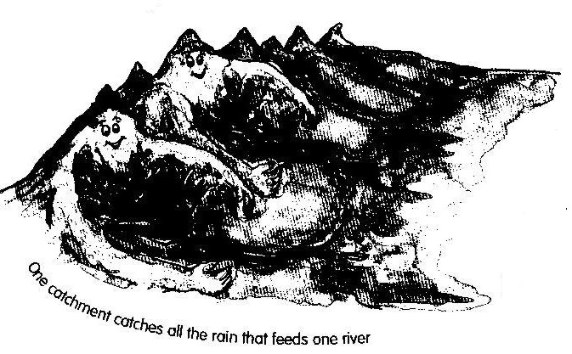
Everyone lives in a catchment. A catchment is the area of land that collects the rain for one main river and all the streams and other rivers that flow into it. Each river has its own catchment and different catchments are separated by mountains or hills.

Water is essential for all of us. We drink it every day, we use it for cooking, washing, cleaning our bodies, watering plants and vegetables, flushing the toilet and many other things. It is essential for our good health and it is very important that we only drink water that is clean.

Where does all the water we use come from?

Ground water. When water falls to the Earth as rain, some of the water is slowed down by plants and grass and slowly sinks into the ground. It is cleaned as it passes through the soil and some of it may end up in an aquifer. An aquifer is a natural rock formation that acts as a sponge to store water underground. Groundwater can collect in huge underground lakes and some water has been in these lakes for many years. When the groundwater comes to the surface, it forms springs, wetlands or lakes. Did you know that most of the world’s freshwater is actually underground!!

Springs. Groundwater sometimes bubbles to the surface as a spring. Springs provide us with clean water so we must make sure that they are protected and carefully looked after. Imagine how muddy and dirty the water would be if we let a herd of cattle trample over a spring!

Wells. If the underground water is close to the surface, it can be reached by digging a hole. This is often done in dry river beds. The water in the well can be brought to the surface using a bucket on a rope. People who collect water from wells must make sure the bucket and rope are clean otherwise they will dirty the rest of the underground water.

Boreholes. Sometimes groundwater is very deep or the ground is very hard and so the water can only be reached by using a machine and drilling a hole into the ground. These deep wells are called boreholes. Water is brought to the surface by a pump.

Rainwater harvesting. Where there is no groundwater, or if it is very dirty and not good to drink, collecting rainwater is another way we can get water. The rainwater can be collected off the roof of a house or school building by using gutters and tanks.

Dams. They store river water which can be used for crops, industries and our own homes.

Reproduced from EnviroKids magazine with permission

After reading the information above to your class, ask the learners the following questions:

- Do you know where the water you drink at home comes from?
- How do people that live near you get their water?
- Do you think the water that you drink is clean?
- How do you know?
- Do any of you live on a farm where you get your water from a river or borehole?
- What does the water taste like?
- How many of you have been swimming or sailing or even fishing on a big dam?
- Did you know that many people will use that water for drinking?
- Have you seen any rivers or streams or ponds that are very dirty?
- What did you see?
- Did you see many plants, animals or insects in the dirty river/stream/pond?
- Have you seen any rivers or streams or ponds that are very clean?
- What did you see?
- Did you see any plants, animals and insects in the clean river/stream/pond?

In the previous lesson, the class explored ways in which water could be saved. It is also very important that the learners consider how to protect and care for the water sources that supply the very water they use each day.

15. What can we do to care for dams, rivers, ponds and streams and even the sea and the beach, when we go fishing, sailing or swimming?

Question 15 should encourage learners to think about how they enjoy many water sources, such as dams and rivers, and how they can make sure that their individual actions do not contribute towards polluting water sources (such as not leaving litter, both near a water source and in the water source, after a picnic or fishing tackle after a fishing expedition with the family).

Depending on your group, the discussion that may arise from Question 15 could lead the class into taking some environmental action such as a river or stream clean-up, or adopting a river and keeping it free of invasive, alien plants. Even if Question 15 does not lead to any class or group environmental action, it should leave the learners knowing that, as individuals, they CAN all make a difference and that their individual actions are very important in keeping our water sources clean.

Criteria to assess learners during this languages lesson

Criteria | Exceeded requirements of the Learning Outcome | Satisfied requirements of the Learning Outcome | Partially satisfied requirements of the Learning Outcome | Not satisfied requirements of the Learning Outcome
The learner listened to the questions and responded appropriately
The learner listened to the exercise on water sources without interrupting the teacher
The learner was able to share his/her personal experiences of water sources
The learner was able to offer solutions and/or comments about their environmental actions when enjoying fun activities near or around a water source (question 15)

ACTIVITY THREE: WATER, SANITATION AND HEALTH

This LIFE ORIENTATION activity looks at basic sanitation – when and why should we wash our hands?

Most of us have different names, we live in different houses, if we were to write our addresses or our telephone numbers, they would all be different; some of us like polony on our bread and some of us don’t; some of us have brothers and sisters and some of us don’t; some of us have pets; some of us live in towns, others live on farms or in small villages. So, it seems like there are quite a few things that make us different from each other BUT there are many many things that make us similar. We all need to eat food or else we’ll get very very hungry and then get sick and we all need to drink fresh clean water. We also ALL need to go to the toilet every day!!

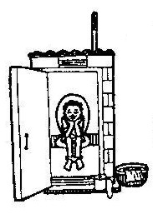
The food and water that we eat and drink makes our bodies strong and our brains clear and bright. If our bodies don’t need all the food and water that we feed them, they need to get rid of it and one of the ways they do that is when we go to the toilet.

CLASS DISCUSSION:
- As a class, let the children discuss different kinds of toilets that they have seen. They may like to draw pictures of the toilets they know – these could include flush toilets, pit latrines (of which there are many different types), ‘eastern toilets’ (also flush toilets but with no seat), commodes and buckets. There may even be mention of people using the bush or a tree as a toilet.

Germs are living things but they are so small, you can’t see them. You have to use a microscope. You get good germs and bad germs and the ones that you can get on your hands after you’ve been to the toilet or helped your mother change the baby’s nappy, are BAD germs. They can make you very sick if they get back into your mouth and then into your tummy.

Photocopy the two comic strip stories on the next page or if you have access to an overhead projector, photocopy the stories onto an overhead transparency.

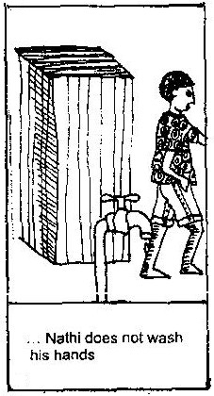
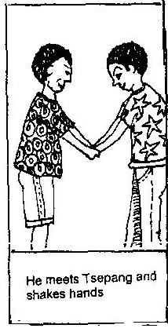
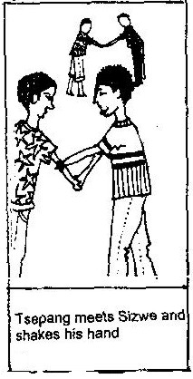
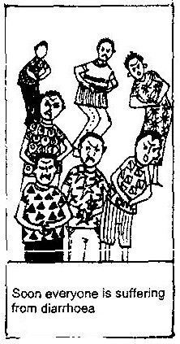
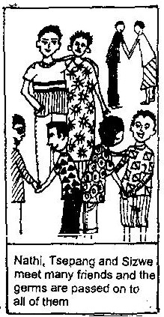
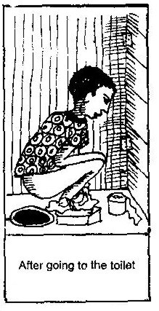
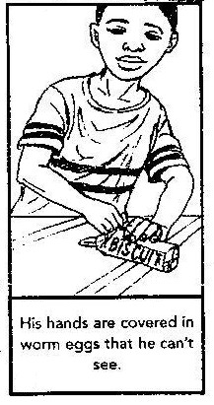
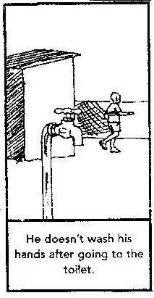
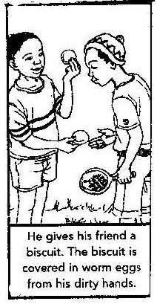
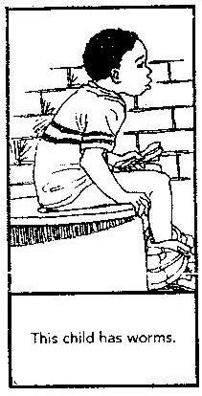
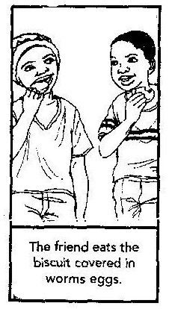
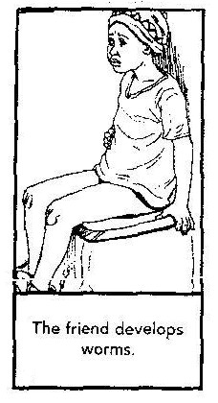

QUESTIONS TO ASK THE CLASS:

- After going through the comic strips, ask the learners, in groups of four or five to discuss the two ‘stories’ amongst themselves. They need to be able to talk through the pictures with words / a story.

- Ask the children how they felt at the end of the story.

- Have any of the children ever had diarrhoea (a runny sore tummy)? Let them know that sometimes a sore runny tummy can also be caused by eating food that is not fresh.

- What should Nathi and the child in the comic strip have done, after going to the toilet?

- When should we wash our hands?

Some answers:
    - After going to the toilet
    - After touching animals
    - After handling old food or taking the garbage outside
    - After changing babies’ nappies
    - After cleaning
    - Before we eat
    - Before we start working with food

- Why should we wash our hands? (remember to link this back to the two comic strips)

- In their groups, let the children think about and discuss rules for when they should wash their hands. Each group needs to come up with as many rules as there are learners in the group – in other words, if there are five children in a group, there will need to be five rules for that group. Each child can then report back to the rest of the class the rule that he/she contributed during the group discussion. These can be written onto the board by the teacher.

Criteria to assess learners during this life orientation lesson

Criteria | Exceeded requirements of the Learning Outcome | Satisfied requirements of the Learning Outcome | Partially satisfied requirements of the Learning Outcome | Not satisfied requirements of the Learning Outcome
The learner was able to describe what happened in the comic strip
The learner was able to answer the question of why hands should be washed in relation to germs/getting sick
The learner was able to contribute at least one rule about when he/she should wash his/her hands

ACTIVITY FOUR: CLEAN HANDS!
MAKING A HAND WASHER

This TECHNOLOGY lesson follows on from the earlier lesson on basic sanitation. Learners use materials gathered from home and around the school to make their own toilet hand washer.

Making a hand washer
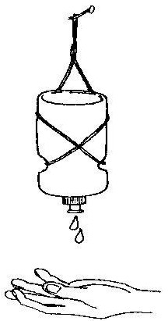
Start collecting different plastic bottles (preferably with ‘clip fast’ nozzles) about a week before you start the activity. Ask the learners to assist with the collection of bottles from home.

The class can either be divided into groups of four or five learners or, if you have enough bottles (and this is the best option!), the learners can make individual bottle hand washers and then take them home.

Some bottles that have been used by many schools are those of the Energade, Powerade variation where the bottles have a ‘clip fast’ nozzle.

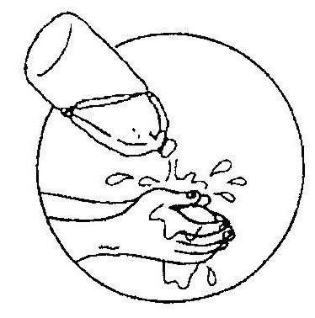
- Add a teaspoon of liquid soap to each bottle and then fill with water.

- Carefully tie string around the bottle so that it hangs in the correct position.

- Hang a hand washer near the toilet for washing hands after using the toilet.

- Hang another hand washer outside the classroom for hand washing before eating.

How to use your hand washer
Depending on the nozzle type of your bottle, it can be clipped and left open and squeezed to release water when needed. Some of the nozzles may need to be clipped shut to prevent losing water.

Soap?
If you don’t have any liquid soap, ‘shavings’ from a bar of soap can be added to the water in the bottle.

Once all the hand washers (in all their different colours, shapes and sizes) have been made, ask each child to hold up his/her hand washer (or if it was a group effort, hold up the group’s hand washer) and ask each child what they feel about their hand washer, could they make it better, does it look good, do they think it will be used, could they make another one on their own at home?

Remember that it is very important to wash your hands often.

Why a towel can be unhygienic?
Most toilets and bathrooms provide a towel near the washbasins on which to dry your hands. This is, however, a very unhygienic practice as germs are wiped onto the towel, which remains damp, providing suitable conditions for the growing of bacteria. Rather have no towel and shake your hands dry.

Criteria to assess learners during this technology lesson

Criteria | Exceeded requirements of the Learning Outcome | Satisfied requirements of the Learning Outcome | Partially satisfied requirements of the Learning Outcome | Not satisfied requirements of the Learning Outcome
The learner was able to choose what he/she needed from all the materials that had been collected by both the teacher and the class
The learner was able to use the available materials (bottle, string, scissors etc) to make a hand washer
The learner was able to discuss his/her hand washer

ACTIVITY FIVE: JUST FOR FUN

Make an indoor rainbow with your learners

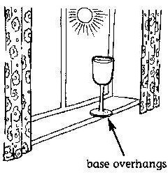
1. Fill a wine glass with water and place it on a sunny windowsill while the sun is still high in the sky. Move the glass so that the base slightly overhangs the edge of the windowsill.

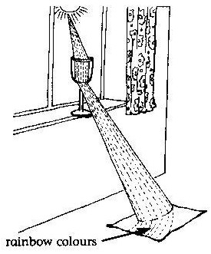

2. Now take an A4 sheet of white paper and hold it up near the base of the glass so that the light shines through the glass and onto the paper. Keeping the light on the paper, move it away and down towards the floor. Once you get far enough away, the white light splits into the seven colours of a rainbow.

How it works: A rainbow is created when light travels through water.
The water bends the light so that it splits into the 7 colours of the
rainbow – red, orange, yellow, green, blue, indigo and violet.

Reproduced from EnviroKids magazine with permission

