|  |
| --- |
| ACTIVITY ONE: FINDING OUT ABOUT THE **WATER SITUATION IN SOUTH AFRICA** |

**How healthy are our rivers? This LANGUAGES research and writing activity**

**looks at water quality in South Africa. Learners research the topic of water quality, using a wide range of sources and methods. They then write up their**

**information in essay format.**

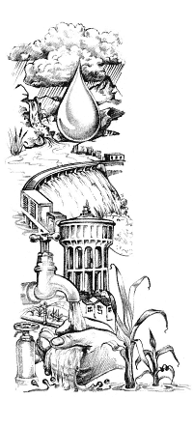

**Hand out the following information on pages 1 and 2 to your learners:**

## Water in South Africa

South Africa is extraordinarily rich in natural resources - except for water. Water is a vital but scarce resource, distributed unevenly in time (frequent droughts alternate with periods of good rainfall) and space (the eastern half of the country is markedly wetter than the western half). Increasing demand for water, and decreasing water quality make careful water management a priority in our country. It has been estimated that by the year 2025 South Africa’s human population will have doubled, and there will be insufficient water for domestic use, agriculture, and industry.

## Rainfall: Our average rainfall is less than 500 mm a year, with the driest part of the country receiving less than 200 mm/year and the wettest receiving more than 2 500 mm/year! Rain does not always fall where it is most needed, and some areas of high demand, such as Gauteng, receive less water than they need. Most rain falls in the narrow belt along the eastern and southern coasts. The rest of the country receives only 27% of South Africa's total rainfall. In addition, hot, dry conditions result in a high evaporation rate.

## Rivers: There are few natural lakes in South Africa. We depend on rivers, dams and underground water for our water supply. Approximately 75% of the water flowing from South Africa into the sea occurs along the eastern and southern seaboards, where many short rivers occur. Flowing from east to west is the largest river in the country, the Orange River, which drains most of the rest of the country. Its water comes from sources in the Drakensberg and Maluti Mountains, and it flows into the Atlantic Ocean on the west coast.

## Dams: About half of South Africa's annual rainfall is stored in dams. We have about 550 government dams in South Africa, with a total capacity of more than 37 000 million m3.

Dams have both positive and negative impacts. They can be beneficial for people in that they regulate the flow of a river, reducing flood damage and contributing to perennial rather than seasonal flow. In addition, sediment is deposited in a dam, and the growth of aquatic plants means that nutrients are removed from the water. Thus water leaving a dam may be cleaner than water entering it. The riverine ecosystem is usually affected negatively by a dam. Alterations in flow regime (quantity of water and timing of periods of high and low flow), temperature and water quality may cause reductions in biodiversity of riverine organisms below dams. Reduction in water flow reduces the river's scouring ability and this can lead to silting of estuaries.

South Africa's landscape is not well suited to dams. There are few deep valleys and gorges, with the result that most dams are shallow with a large surface area. Together with the hot, dry climate, this results in much water evaporating from dams. In addition, the high silt load (a result of an arid climate, steep river gradients and poor farming methods) of our rivers means that the capacity of South Africa's dams is quickly reduced as they become silted. The rivers of the Western Cape carry relatively less silt than those in the rest of the country.

## Water abstraction: A growing problem for South Africa's rivers is a lack of water! Reduction in river flow, owing to abstraction (removal), and damming, has affected many of our rivers, for example those flowing through the Kruger National Park.

## Intercatchment transfer of water: This involves the transfer of water from catchments with good supplies and low demand, to those where demand for water is high and the supply is poor. There are numerous intercatchment transfer schemes already in operation, and more are under construction or proposed. A major scheme is the Orange-Fish River scheme, where water gravitates from the Orange River at the Gariep Dam, and is piped through tunnels and canals to the Sundays and then the Fish Rivers in the Eastern Cape. Transfers of this nature will have far-reaching ecological, political and socio-economic implications. As yet, little research has been carried out to establish the ecological consequences of intercatchment water transfers. However, areas of concern include reducing streamflow and water levels in one system, changes in water temperature and chemistry, and the transfer of invasive species between catchments.

## Water pollution: Industrial and agricultural pollutants common in South Africa include agricultural fertilizers, silt, toxic metals, litter and pesticides. These pollutants affect aquatic ecosystems and human health. Disease-producing bacteria are common in urban waste water, particularly from informal settlements that lack sewage and water purification facilities. For example, typhoid, cholera and gastroenteritis are transmitted by water contaminated with untreated sewage. Gastroenteritis is one of three main causes of death in South African children under the age of five.

### Water Quality

Healthy streams and rivers support a wide variety of water life. Rainwater and cool, tumbling mountain streams contain high levels of oxygen. Low concentrations of nutrient substances which are washed into the system provide both key growth chemicals (such as nitrates) and food (like rotting plants – detritus). Water plants, in turn, photosynthesise to provide more life supporting oxygen and food sources for water organisms. All of these factors interact as a complex web of life both within the river itself and in its surrounding catchment. Much human activity has unfortunately disrupted these ecological processes and degraded water quality.

#### ACTIVITY:

#### How healthy are our rivers?

1. Learners research the water quality situation in South Africa. They need to use at least five different sources (excluding the fact sheet on ‘Water in South Africa’) to gather information. These can include, but are not limited to, books, journals, newspapers, the Internet, interviews, visits to local water suppliers (such as Umgeni Water or Rand Water) or documentaries. Once the research has been completed, learners present their findings in an essay.
2. The following points need to be considered when writing an essay:
   * The **introduction** should be designed to attract the reader's attention and give the person an idea of the essay’s focus. You could begin your introduction with an attention grabber such as startling information (which must be true) or even an anecdote (a story which illustrates a point) – but make sure your anecdote is short, to the point and relevant to your topic.
   * Each main idea will become one of the **body paragraphs**. If you had three or four main ideas, you will have three or four body paragraphs. The topic can now be explained, described, or argued.
   * The **conclusion** sums up your points or provides a final perspective on your topic. All the conclusion needs is three or four strong sentences which do not need to follow any set formula. Simply review the main points (being careful not to restate them exactly) or briefly describe your feelings about the topic. Sometimes, even an anecdote can end your essay in a useful way.

**Remember to:**

* Read and reread your essay.
* Does it make logical sense?
* Leave it for a few hours and then read it again. Does it still make logical sense?
* Do the sentences flow smoothly from one to another?  
  If not, try to add some words and phrases to help connect them. Transition words, such as "therefore" or "however," sometimes help. Also, you might refer in one sentence to a thought in the previous sentence. This is especially useful when you move from one paragraph to another.
* Finally, have you checked your spelling?

### Criteria to assess learners during this languages lesson

|  |  |  |  |  |  |  |
| --- | --- | --- | --- | --- | --- | --- |
| Criteria | **Outstanding** | **Meritorious** | **Satisfactory** | **Adequate** | **Partial** | **Inadequate** |
| The learner used at least five sources when researching ‘how healthy are our rivers’ |  |  |  |  |  |  |
| The learner organised and integrated their information into a concise, well-presented essay |  |  |  |  |  |  |
| The essay had an introduction, paragraphs and conclusion and was in a logical order |  |  |  |  |  |  |
| The final essay was neatly written and presented |  |  |  |  |  |  |

|  |
| --- |
| ACTIVITY TWO: INVESTIGATING THE **HEALTH OF OUR RIVERS** |

This LIFE SCIENCES lesson looks at visible animal life to

**determine the health of our rivers and streams.**

MiniSASS is a simplified form of the South African Scoring System. It is a technique that can be used to measure the health of a river and the general quality of the water in that river. Developed by Umgeni Water and Ezemvelo KZN Wildlife, it uses the composition of invertebrates living in rivers and is based on the sensitivity of the various animals to water quality. It does not, however, measure contamination of the water by bacteria and viruses and thus does not determine if the water is fit to drink without treatment.

The MiniSASS is a miniature version of the more sophisticated SASS method that is used as part of the National River Health Programme. The results produced using MiniSASS have been tested against the more rigorous SASS method and have been found to be sufficiently close to be of real value.

## Are you ready for some environmental action?

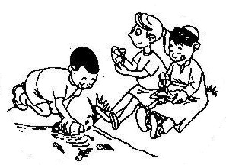

**Method:**

1. The best sites to find insects in a nearby river are where the current is fairly fast moving and where there is some vegetation growing in the water, along the sides of the river.
2. Look for invertebrates in as many of the different habitats (biotopes) you can find at a river site. Insects are collected holding a small net (a kitchen sieve will do) in the current, and then disturbing the stones, vegetation and sand using your feet (with boots on!) or hands just upstream of the net. Be bold in turning the stones over. The insects will be dislodged and will flow into the net. Do this for about 5 minutes while ranging across the river to a number of different habitats. You can also lift stones and pick off the insects with your fingers or you can brush off the underside of the stones with a clean paintbrush.
3. Rinse any mud out of the net then turn the contents into a plastic tray (a 2 litre ice-cream container is ideal). Identify each group using the sheet given on page 6 (keep a tally of the number of each group). If the river is in reasonable condition, you should have several hundred individual insects in the sample.

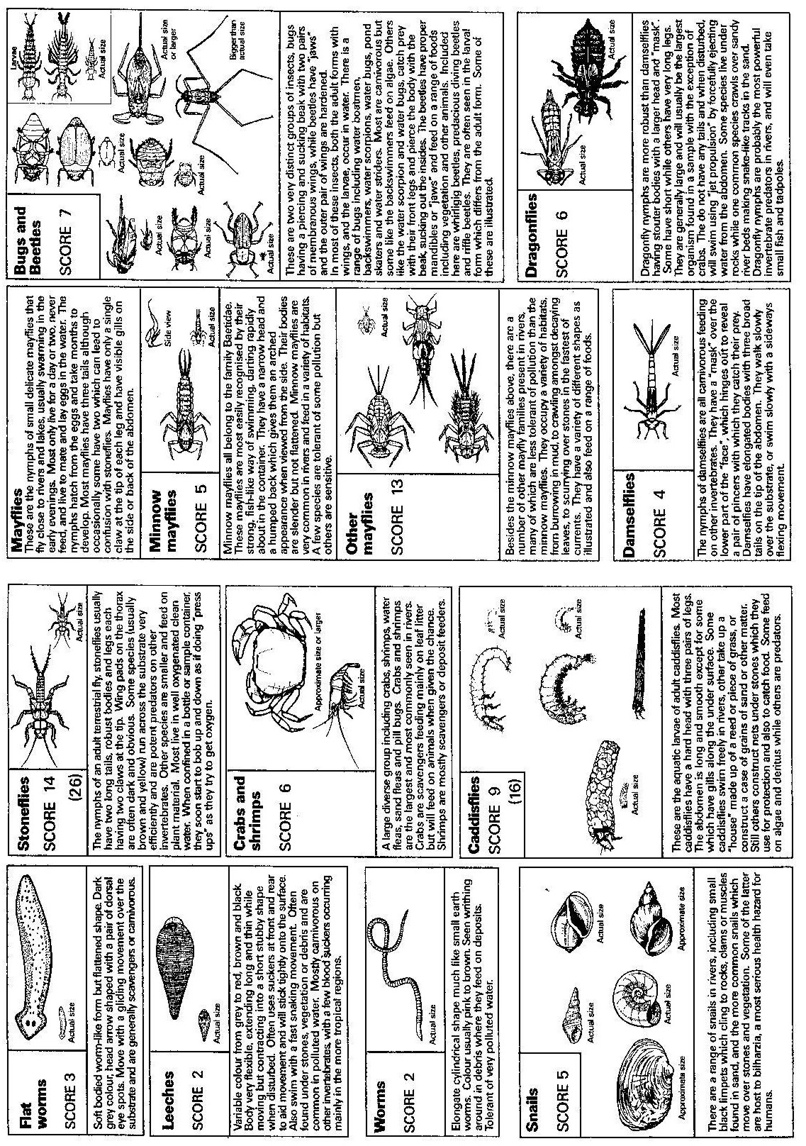

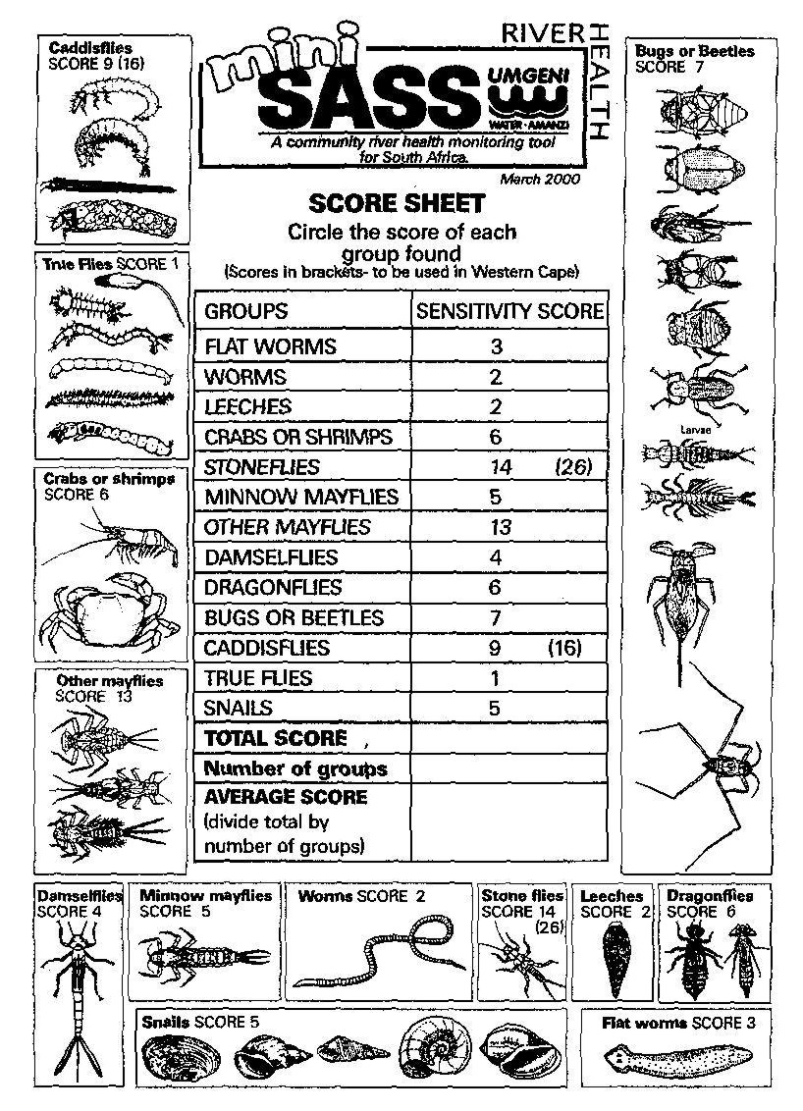

**Calculating your river’s MiniSASS score**

1. For each of the groups found in your sample, circle the score on the table on page 7.
2. Total the scores and divide by the number of groups found. This will give you an average score. MiniSASS produces a single score which is similar and comparable to the average score which is produced by the more complex version of SASS.

**Interpretation**

<4.9 Highly impacted stream (poor condition)

5-5.9 Impacted stream (fair condition)

6-6.9 Slightly impacted stream (good condition)

> 7 Good quality stream (probably approaching natural condition)

On rare occasions, an incorrect result will be obtained when the average score is high but the sample only contained a few (1 to 3) insect groups. When this happens this means that the river is impacted or disturbed but in a way that favours some organisms.

Now that you have calculated and interpreted your river’s MiniSASS score, display a summary of your results in the form of a poster – be creative and add as much details as possible, without making the poster too text heavy.

***Remember to return all the insects back to the river.***

### Criteria to assess learners during this life sciences lesson

|  |  |  |  |  |  |  |
| --- | --- | --- | --- | --- | --- | --- |
| **Criteria** | **Outstanding** | **Meritorious** | **Satisfactory** | **Adequate** | **Partial** | **Inadequate** |
| The learner followed the instructions given by the teacher |  |  |  |  |  |  |
| The learner collected insects and added the data to a table |  |  |  |  |  |  |
| The learner designed a poster to display a summary of their MiniSASS results |  |  |  |  |  |  |

|  |
| --- |
| ACTIVITY THREE: WATER QUALITY IN THE PAST |

**This PHYSICAL SCIENCES lesson looks at water quality, water-borne diseases**

**and some simple ways of purifying water. This is followed by a case study**

**on the water collecting ways of Nguni people.**

READ THE FOLLOWING TO YOUR LEARNERS:

Water from rivers and dams is often not clean and may contain bacteria and dissolved substances, such as salts from the soil and gases from the air. Other contaminants include solid substances and debris, such as mud and refuse. Before we drink any water, we need to ensure that it is safe to drink and that solid substances and any bacteria has been removed.

Water often carries diseases that kill about 25 million people each year. The need to ensure clean adequate water supplies is one of the most urgent problems facing our country.

Some major water-borne diseases include:

* **Cholera** is an acute intestinal infection caused by the bacterium *Vibrio cholerae*. It causes watery diarrhoea and vomiting that can quickly lead to severe dehydration and death if treatment is not promptly given.
* **Typhoid Fever** is an acute illness associated with fever caused by the *Salmonellae Typhi* bacteria. The bacteria is deposited in water or food by a human carrier, and is then spread to other people in the area.

Typhoid Fever is contracted by the ingestion of the bacteria in contaminated food or water. People with acute illness can contaminate the surrounding water supply through the stool, which contains a high concentration of the bacteria. Contamination of the water supply can, in turn, taint the food supply.

* **Bilharzia** is a human disease caused by parasitic worms called *Schistosomes.* Approximately 300 million people in the world are infected. Bilharzia is common in the tropics where ponds, streams and irrigation canals are home to bilharzia-transmitting snails. Parasite larvae develop in snails from which they infect humans, their ultimate host, in which they mature and reproduce.

Within days after becoming infected, you may develop a rash or itchy skin. Fever, chills, coughing, and muscle aches can begin within 1-2 months of infection.

* **Gastroenteritis** is an infection of the guts (intestines). The severity can range from a mild tummy upset for a day or two with some mild diarrhoea, to severe diarrhoea and vomiting for several days or longer. Many viruses, bacteria, and other microbes (germs) can cause gastroenteritis. Food poisoning (infected food) causes some cases of gastroenteritis. Many different types of germs can cause food poisoning. Common examples are bacteria called campylobacter and salmonella. Water contaminated by bacteria or other germs is a common cause of gastroenteritis, particularly in countries with poor sanitation.
* **Dysentery** is an infection usually spread from person to person. It is caused by bacteria called "shigella". It causes inflammation of the bowel, which gives bloody diarrhoea, headaches, fever, nausea and sometimes vomiting and stomach cramps. These symptoms usually only last for a few days, and need no treatment other than rest and plenty to drink. After having dysentry, people may still carry the bacteria for a while, even though they feel better.

In South Africa, tap water is safe to drink as all the bacteria that may have been in it, are killed during the purification process. You should never drink water from rivers or dams without treating it first.

ASK THE LEARNERS:

* Do they know of anyone who has had one of the diseases you have read about?
* Many water-borne diseases can be prevented through being careful about where water for drinking is collected and good hygiene practises. Where do the learners in the class get their drinking water? How can they be sure that it is clean and safe for drinking?
* What personal hygiene practises can your class adopt to prevent the spread of diseases *(such as washing hands before meals, when working with food, after going to the toilet, after changing babies’ nappies).*

**ASK THE LEARNERS:**

Do any of you know of any simple way that you can clean (purify) your drinking water (especially if you are collecting it from a river or spring and are not sure that it is clean)?

* A simple way of purifying water is to add a teaspoon of jik to every 25 litres of water. Jik is very strong and kills all the bacteria, making it safe to drink.
* 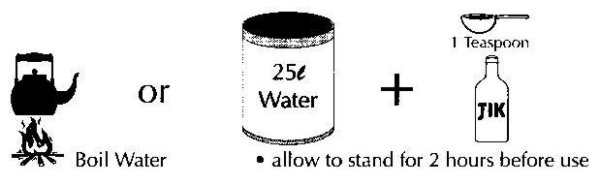You can also boil the water, and that will kill any germs or bacteria that may be living in it. The water can be left to cool. It does not need to be drunk hot.

* What are other good hygiene practises?

**INDIGENOUS KNOWLEDGE AND WATER QUALITY**

**LEARNER ACTIVITY:**

Read the case study below and then answer the questions that follow:

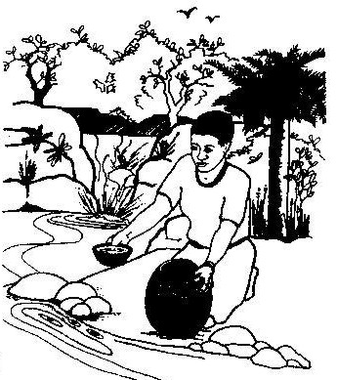

(In the story that follows, comments and scientific observations are in brackets and italised so that the learners can see the practical wisdom behind some water collection myths and techniques of the past).

Before the time of the Zulu King, Shaka, sweet water was called “amanzi amnandi”. Shaka’s mother was called Nandi and it is said that because it was not considered respectful to use the queen mother’s name in this way, Shaka referred to sweet water as “amanzi amtoti”. *(This is how the town of Amanzimtoti, south of Durban, got its name).* Today both terms are used and many people of Nguni origin will sniff, smile and hold up “sweet” water, collected from a river, spring or well for their daily household needs. *(Water quality scientists today still have people smell and taste household water. Human senses give a refined indication of whether water is good and clean and fresh).*

Historically, water was usually collected in areas where people could hear it running over stones or dripping down rocks *(well oxygenated water supports natural biological cleansing processes).* If a spring was for human use, it was protected by a circle of rocks with a small outlet. Cattle drank elsewhere.

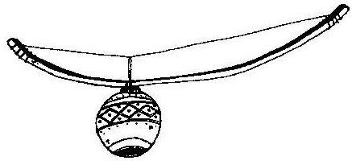An area nearby was cleared and the site soon became a meeting place for young people. Young men would hang around these water collection sites, playing musical instruments and admiring the maidens who came to collect water. The girls would saunter along slowly and gracefully, singing and flirting. Water collecting was rarely seen as a tiring or boring chore because of the prospect of courtship!!

A water source would always be approached with care so as not to frighten crabs and other small water animals. When disturbed, their movement would stir up sediments and the collector would have to wait for the silt to settle. The surface film was brushed aside for “sweet water” to be collected. *(Sediments and surface films have higher bacteria numbers than the middle waters of pools and rivers. Today scientists take water samples below the surface film, taking care not to suck up sediments. In this way, scientists can get consistent and reliable measures of bacterial contamination).*

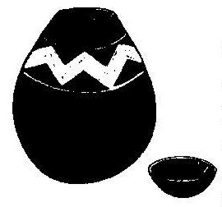Clay pots were filled with water and covered with a collecting bowl, a piece of skin or a mat made from incema (*Juncas kraussii*) grass. The water would thus stay cool and fresh. *(Water evaporating through the sides of a porous clay pot cooled the contents. Most water bacteria cannot reproduce in cool, dark conditions. Some micro-organisms envelop themselves in a calcium secretion in the pores of clay pots. Scientists spoken to were uncertain about the detail of these issues but it is of note that, in earlier times, great care was taken to scour out a calcium-like scale in water pots. Also of note is that when the grass “lids” and head rings for carrying pots became old they were simply thrown away and new ones were woven. Discarded lids did not pollute the river like today’s bottle tops and plastic waste).*

There were many other customs and traditional practices surrounding water. Children were warned that urinating in a river would change them to the opposite sex! *(This myth was probably sufficiently frightening to prevent people urinating in streams and rivers. This would have limited a disease like bilharzia. The bilharzia parasite is passed on from human urine and faeces to small water snails. From these, its life cycle takes the disease back to people through river water).*

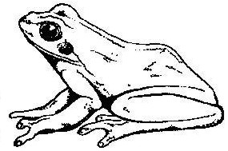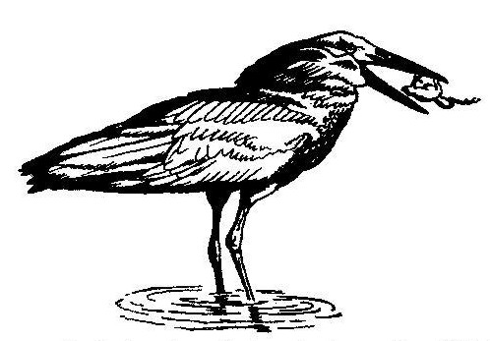Nguni water collectors say that where there are frogs, one does not find sweet water. Frogs are eaten by hammerkops (*uthekwane*, the “lightning bird”) and the prospect of collecting water while being watched by a “witch-bird” must have been terrifying in earlier times when spirits, myths and mystery had a more central place in everyday social life. Children were told that if they killed this bird or stole its eggs, their homes would go up in flames. *(Where there are frogs, one will usually find snakes. Both animals are feared by many people today, not least the children who were told the Nguni myths of witches and lightening to fill their hearts with terror. Today, scientific tests suggest that many frog species need “sweet water” if they are to live and reproduce successfully. There must be some doubt about the Nguni suggestion that frogs are an indication of water that is not fit for human consumption).*

It is also said that it was not advisable to collect water from a river after heavy rain at the start of the annual rainy season. Indigenous commonsense told people to put out pots to collect rain-water. River water would again be collected four days after the rains stopped and the water had cleared. *(Heavy rains wash human and animal wastes into rivers. There is thus a rapid increase in faecal bacteria and disease. In KwaZulu-Natal, health workers have to warn rural people not to collect river water after heavy rains as few remember the earlier Nguni practice of collecting rain-water only four days after the rains have stopped).*

Today human and livestock numbers have increased vastly, catchments have become degraded and rivers are often polluted dumping places. The best indigenous practices for the collection of “sweetwater” may not prevent people getting serious diseases from river water. Learning about historical water collection and storage practices can, however, develop a respect for early people and might also help our understanding of water quality issues.

# QUESTIONS:

1. Have you collected water from a nearby river? What was the water used for? (If for drinking, how were you certain that it was safe to drink?)
2. What do you think ‘well oxygenated water’ means?
3. Why do scientists take water samples below the surface of the water?
4. Why did the Nguni scour their clay pots regularly?
5. Name the methods that the Nguni people used to reduce the contamination of their drinking water?
6. Do you think that these practices of collecting water are still relevant today?

### Criteria to assess learners during this physical sciences lesson

|  |  |  |  |  |  |  |
| --- | --- | --- | --- | --- | --- | --- |
| **Criteria** | **Outstanding** | **Meritorious** | **Satisfactory** | **Adequate** | **Partial** | **Inadequate** |
| The learner contributed to discussions about water-borne diseases and personal hygiene practises |  |  |  |  |  |  |
| The learner adequately answered all six questions at the end of the reading (written answers) |  |  |  |  |  |  |

|  |
| --- |
| ACTIVITY FOUR: INVESTIGATING WATER QUALITY **IN CATCHMENTS** |

**Estuaries are silting up, inland wetlands are disappearing, some perennial rivers are drying up, and rivers, lakes and dams are polluted! Water bodies in southern Africa clearly suffer from many problems – all of which are linked to the way in which the catchment area is used. This PHYSICAL SCIENCES lesson looks at water use in a catchment and encourages learners to look at ways of conserving and caring for our water catchments.**

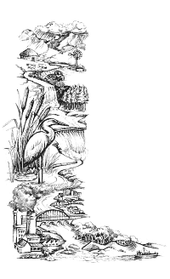**What is the river catchment?**

The river catchment, or drainage basin, is all the land from mountain top to seashore, drained by a single river and its tributaries.

Catchment areas vary greatly in size - a big river may have a catchment area of several thousand square kilometres, whereas a smaller tributary will have a catchment area of only a few hectares.

Catchments are separated from each other by watersheds. The characteristics of any river (physical, chemical, biological) are determined by the nature of the catchment and the activities, both human and natural, that take place in it.

# The importance of plants

In catchments which have not been cultivated or developed, the ground cover or vegetation is still in place. Ground cover is important for the following reasons:

* Plants slow down water as it flows over the land (runoff) allowing much of the rain to soak into the ground and replenish underground waters (aquifers). Water seeps from these aquifers into rivers, which are therefore usually perennial (flow throughout the year).
* Plants prevent soil erosion as their roots hold soil in position, preventing it from being washed away. In addition, plants break the impact of a raindrop before it hits the soil, thus reducing its erosive potential. Rivers running through an undisturbed catchment are clean, erosion is slow and limited to periods of very high rainfall.
* Vegetation in wetlands and on the banks of rivers is of particular importance. The roots of the reeds, sedges, trees, shrubs and grasses growing in wetlands and next to rivers bind the soil of the riverbank and prevent erosion, whilst cleaning the water and regulating its flow.

# Disturbed catchments

Where plant cover in river catchments has been disturbed by farming, industry or settlements, soil erosion increases. In addition, without plants, runoff increases and the supply of water to aquifers is reduced because less water soaks into the ground. Consequently rivers do not have a continuous supply of water from the aquifers and flow only in the rainy season. Much of the deposition of silt into estuaries results from erosion of riverbanks. When riverbank (riparian) vegetation is removed, the banks are at the mercy of the erosive forces of flood waters which scour away the river bank allowing the adjacent slope to collapse.

In many catchments the indigenous vegetation has been replaced by alien plants such as black wattle, pine and eucalyptus. These trees use large amounts of water from the rivers and streams that they thrive next to, thus reducing the amount of water available. In addition, invasive plants tend to smother the natural ground cover and this leads to soil erosion, and of course, a reduction in the biodiversity of that area. Invasive plants tend to be bigger than the indigenous vegetation, and when they burn the fires are very hot - this in turn damages the soil and contributes to more severe erosion.

**ACTIVITY:**

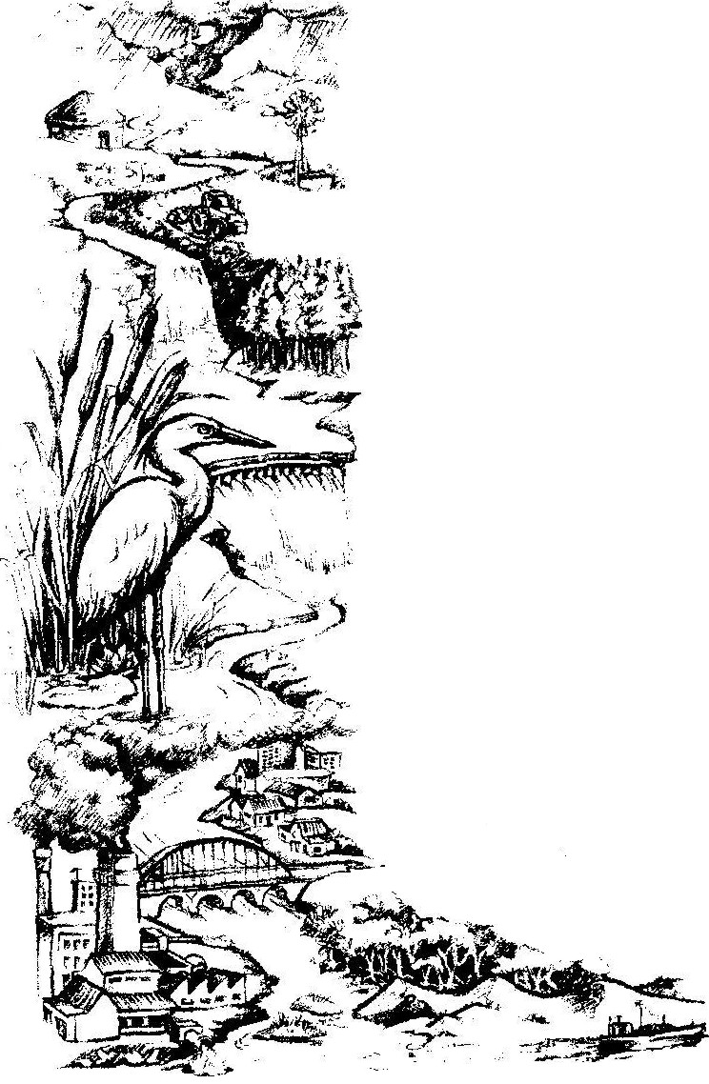

**A**

**C**

**B**

D

Results of tests carried out on samples of water taken from A, B, C and D are shown below:

|  |  |  |  |  |
| --- | --- | --- | --- | --- |
| **Test** | **Sample A** | **Sample B** | **Sample C** | **Sample D** |
| Temperature (ºC) | 11 | 12 | 12 | 16 |
| Dissolved oxygen (ppm) | 16 | 14 | 16 | 4 |
| pH | 7 | 9 | 6.5 | 4.5 |

## Temperature

Temperature is one of the most important and most influential water quality characteristics to life in water. An important physical relationship exists between the amount of dissolved oxygen in water and its temperature. The warmer the water, theless dissolved oxygen, and the colder the water, the more dissolved oxygen.

For this reason, heat or "thermal pollution" may be a problem, especially in shallow slow-moving streams or rivers. Most fish simply cannot tolerate warm water and/or low levels of dissolved oxygen. Thermal pollution may also result when industries release the water used for cooling their machines into waterways. Water temperatures, even kilometres away from the release points, may rise dramatically. The result may be dead fish, fish eggs that won't hatch or a total change in the fish population as warm water varieties replace the original trout or other cold water fish.

## Dissolved oxygen in fresh water

Waters with consistently high dissolved oxygen are usually considered to be healthy, capable of supporting many different kinds of water organisms. Much of the oxygen in water comes from the atmosphere through rainfall, through tumbling water in fast moving streams and from water plants (photosynthesis). In some dams dissolved oxygen may increase owing to photosynthesis during the day but at night it may decrease owing to plant respiration. Large daily fluctuations in dissolved oxygen may be found in rivers and dams choked with invasive water plants. Water temperatures also affect dissolved oxygen levels as oxygen is more easily dissolved and retained in cold water. Effluent and agricultural chemicals enrich water, promoting the growth of algae and other water plants. Sewage effluent promotes large populations of bacteria which consume oxygen as they decompose organic matter. Low oxygen levels are often associated with sewage effluent enrichment.

Ppm stands for parts for million and is a measure of concentration. This is a way of expressing very dilute concentrations of substances. Just as per cent means out of a hundred, so parts per million or ppm means out of a million. It usually describes the concentration of something in water or in soil. One ppm is equivalent to 1 milligram of something per litre of water (mg/l) or 1 milligram of something per kilogram soil (mg/kg).

pH

The "p" stands for "potenz" (this means the potential to be) and the "H" stands for Hydrogen. So you must write pH with a lower case (little) p and an upper case (capital) H.

Water (H20) contains hydrogen ions (H+) and hydroxyl ions (OH-). Pure deionised water contains equal numbers of H+ and OH- ions and is considered neutral (pH 7), neither acid or basic. If the sample measure has more H+ ions it has a pH less than 7 and is considered acid. If it has more OH- ions than H+ ions it is considered basic and has a pH greater than 7.

Rainwater is naturally slightly acidic but the type of rocks and minerals in a catchment usually determines the pH. Atmospheric pollution (nitrogen oxides and sulphur dioxides) from vehicles and thermal power stations usually produce acid rain, a serious threat to aquatic systems. Sewage and industrial effluent discharges can also affect the pH balance of rivers.

ANSWER THE FOLLOWING QUESTIONS:

1. What would you imagine the water to be like at A?
2. What would you imagine the water to be like at D?
3. Suggest why the town’s water supply is taken from the river at C and not D.
4. What is the most likely reason for the high water temperature found D?
5. At B, the river is becoming choked with water plants. Suggest a reason why this is happening.
6. Why do you think the dissolved oxygen has increased at C?
7. Do you think you will find the same species of water creatures at D and A? Explain your answer.
8. What does ppm stand for?
9. If the pH at point D is 4.5, will it be acidic or basic? Will it have more hydrogen ions or more hydroxyl ions?
10. Do you think there is a human impact on this river catchment? Discuss.

### Criteria to assess learners during this physical sciences lesson

|  |  |  |  |  |  |  |
| --- | --- | --- | --- | --- | --- | --- |
| **Criteria** | **Outstanding** | **Meritorious** | **Satisfactory** | **Adequate** | **Partial** | **Inadequate** |
| The learner was able to adequately answer all the questions in the exercise |  |  |  |  |  |  |
| The learner was able to see the impact of human settlements and technology on a river catchment (question 10) |  |  |  |  |  |  |

|  |
| --- |
| **ACTIVITY FIVE: JUST FOR FUN! YOUR ECO FOOTPRINT** |

**We all use water every day for things like drinking, cooking and washing.**

**We could not survive without water! This LIFE SCIENCES activity looks at**

**how small or large our eco footprint is.**

This activity can be done as a class with you, the teacher, reading the questions and learners writing down their answers, or the learners can work out their eco footprint on their own.

The ever-increasing pressures on our environment will have touched all of us in some way and we need to take a careful look at how the choices we make in our everyday lives impact on the Earth. That is, we need to ask “How big is my ecological footprint?” The following questions will encourage learners to think about different ways they impact on the Earth and ultimately stimulate ideas of ways that we can all make improvements to reduce our ecological footprint.

**QUESTIONS TO ASK THE LEARNERS:**

**1. WATER USE**

The amount of water used often depends on whether you have running water in your home, a tap in your yard, or whether you carry water from a river or dam. The way that you use water in your home can sometimes be very wasteful especially when that water is readily available on tap!

**When you wash, do you use:**

a. A bucket?

b. A shower?

c. A bath?

**What points did you get for your answer to question 1?**

a. 0 points b. 5 points c. 20 points

**2. RE-USING WATER**

South Africa is a water-scarce country. It is believed that by the year 2025 we will have insufficient water for use in our homes, for agriculture and for industry.

By using water carefully, you can help to conserve our water sources.

**When you have finished washing at home:**

* + 1. Does your water run straight down the drain?

b. Do you use the water on your plants?

**What points did you get for your answer to question 2?**

a. 20 points b. -10 points

**3. ENERGY USE**

Whether you use electricity, coal or paraffin for energy in your home, you are polluting the air – which causes acid rain, global warming and health problems. You can conserve energy by using energy-saving devices (such as a hot box for cooking), solar-powered energy systems, and energy-saving bulbs.

**In your home do you have at least one energy-saving method?**

1. Yes b. No

**What points did you get for your answer to question 3?**

a. -10 points b. 20 points

**4. INDIGENOUS PLANTS**

By growing indigenous plants in your garden, you can contribute to biodiversity because you will attract indigenous insects, birds and other animals. Indigenous plants have many advantages over alien plants, for example, they require less water.

**Excluding your home-grown fruit and vegetables*, in your garden at home are:**

a. Most of the plants are indigenous?

b. More than half the plants are indigenous?

c. Less than half the plants are indigenous?

1. None of the plants are indigenous?

**What points did you get for your answer to question 4?**

a. -10 points b. 0 points c. 10 points d. 20 points

**5. ANIMAL-BASED PRODUCTS**

Producing animal products (beef, chicken, pork, eggs, fish, dairy etc) puts much more pressure on the environment than producing vegetables. Many people eat more meat than their bodies need. People who eat a lot of meat have more impact on the environment than those who eat less meat or no meat at all.

**How often do you eat animal products?**

a. Never

b. A few times a week

c. Once a day

d. Small amounts at every meal

e. A large part of every meal

**What points did you get for your answer to question 5?**

a. -10 points b. 0 points c. 5 points d. 10 points

e. 20 points

**6. LOCALLY GROWN FOOD**

Much of the energy cost of food production is spent transporting food from harvest to market, and for processing, packaging and storage. Growing food yourself or buying locally grown, in-season, unprocessed food can therefore reduce energy consumption. Buying food from local farmers can greatly reduce your ecological footprint.

**How much of the food that you eat is locally grown, unprocessed and in-season?**

a. Most b. About three quarters c. About half d. About a quarter e. Very little

**What points did you get for your answer to question 6?**

a. -10 points b. 0 points c. 5 points d. 10 points

1. 20 points

**7. LIVING SPACE**

An unnecessarily large home uses more materials from the environment (for building and maintenance) and takes up more space (which could be better used for agriculture and nature reserves).

**In your home, do you have:**

a. More people than bedrooms?

1. The same number of people and bedrooms?
2. More bedrooms than people?

**What points did you get for your answer to question 7?**

a. -10 points b. 5 points c. 20 points

**8. POISONS IN THE HOME GARDEN**

Poisons – more correctly called biocides – are often used to kill rats, insects and weeds. Many of the ingredients in these biocides cause allergies, trigger cancer growth and cause genetic defects.

Frequently we don’t actually need to kill in the first place! The flat spider on the wall won’t hurt you at all. But if we really do need to kill, we need to decide which option of removal is the most environmentally friendly.

**In your home, when you have a problem do you:**

1. Use the strongest insecticide or other poison and use until the problem is solved?
2. Buy specially designed environmentally friendly products?
3. First attempt to solve the problem with a less destructive alternative?

**What points did you get for your answer to question 8?**

a. 20 points b. 0 points c. -10 points

**9. RE-USING**

Re-use of some of your waste helps to reduce the impact on the environment; reduces the amount of waste that goes into landfill sites (rubbish dumps) and reduces the amount of raw materials required.

**At home do you re-use:**

**a. PAPER**

Never Sometimes Often

* + 1. **GLASS**

Never Sometimes Often

**c. TINS**

Never Sometimes Often

**d. PLASTICS**

Never Sometimes Often

**What points did you get for your answers to question 9?**

1. Never – 20 points, Sometimes – 5 points, Often - -10 points
2. Never – 20 points, Sometimes – 5 points, Often - -10 points
3. Never – 20 points, Sometimes – 5 points, Often - -10 points
4. Never – 20 points, Sometimes – 5 points, Often - -10 points

**10. RECYCLING**

Recycling of some of your waste helps to reduce the impact on the environment, reduces the amount of waste that goes into landfill sites (rubbish dumps), and reduces the amount of raw materials required.

**At home do you recycle:**

**a. PAPER**

Never Sometimes Often

* + 1. **GLASS**

Never Sometimes Often

**c. TINS**

Never Sometimes Often

**d. PLASTICS**

Never Sometimes Often

**What points did you get for your answers to question 10?**

1. Never – 20 points, Sometimes – 5 points, Often - -10 points
2. Never – 20 points, Sometimes – 5 points, Often - -10 points
3. Never – 20 points, Sometimes – 5 points, Often - -10 points
4. Never – 20 points, Sometimes – 5 points, Often - -10 points

**11. REDUCING**

You can reduce your eco footprint by shopping carefully. Buy in bulk to reduce packaging; buy refills (e.g. deodorants); chose well-made articles that will last well and those with recycled content; and avoid over-packaged products.

**When you buy products do you:**

1. Always think of the amount you will throw away?
2. Often try – but take into consideration price and brand?
3. Sometimes – depending on the price and brand?
4. Never think of how goods are packaged or how long they will last?

**What points did you get for your answer to question 11?**

a. -10 points b. 0 points c. 5 points d. 20 points

**12. CONSUMER CHOICES**

Some goods available in supermarkets pollute the environment more than others – a roll-on deodorant is better than a spray containing CFCs (which break down the ozone layer); a brightly coloured toilet cleaning liquid is not necessary as that colour doesn’t clean the toilet!

**When you shop do you choose the least polluting product?**

1. Always
2. Often – depending on price, brand or what you have seen on television
3. Sometimes – depending on price, brand or what you have seen on TV
4. Never think about such things

**What points did you get for your answer to question 12?**

a. -10 points b. 0 points c. 5 points d. 20 points

**13. TRAVEL**

Poisonous gases and substances released by cars and other motor vehicles include nitrogen oxides, hydrocarbons and lead which contribute to acid rain, smog, health problems and global warming.

**How do you get to work/school/college?**

a. On foot b. By bicycle c. By taxi d. By car

**What points did you get for your answer to question 13?**

a. -10 points b. 0 points c. 5 points d. 20 points

**Add up all your points!!!**

**Your final ecological footprint**

* Score less than 50: Green Footprint (You have a TINY ecological footprint)
* Score from 51-110: Yellow Footprint (You have a small ecological footprint)
* Score from 111-180: Blue Footprint (You have a medium ecological footprint)
* Score from 181-290: Orange Footprint (You have a large ecological footprint)
* Score from 291-400: Red Footprint (You have a HUGE ecological footprint)

**With your class:**

* Each learner to think of one product that they have, or one thing that they consume. What is its impact on the planet?
* Discuss ways that our school can practically reduce our ecological footprint.
* Discuss ways that our class can reduce our ecological footprint.
* Discuss ways that individual learners can reduce their ecological footprint.

### Criteria to assess learners during this life sciences lesson

|  |  |  |  |  |  |  |
| --- | --- | --- | --- | --- | --- | --- |
| **Criteria** | **Outstanding** | **Meritorious** | **Satisfactory** | **Adequate** | **Partial** | **Inadequate** |
| The learner contributed to the discussion on the impact of products on our environment |  |  |  |  |  |  |