Investigating water quality

in South Africa
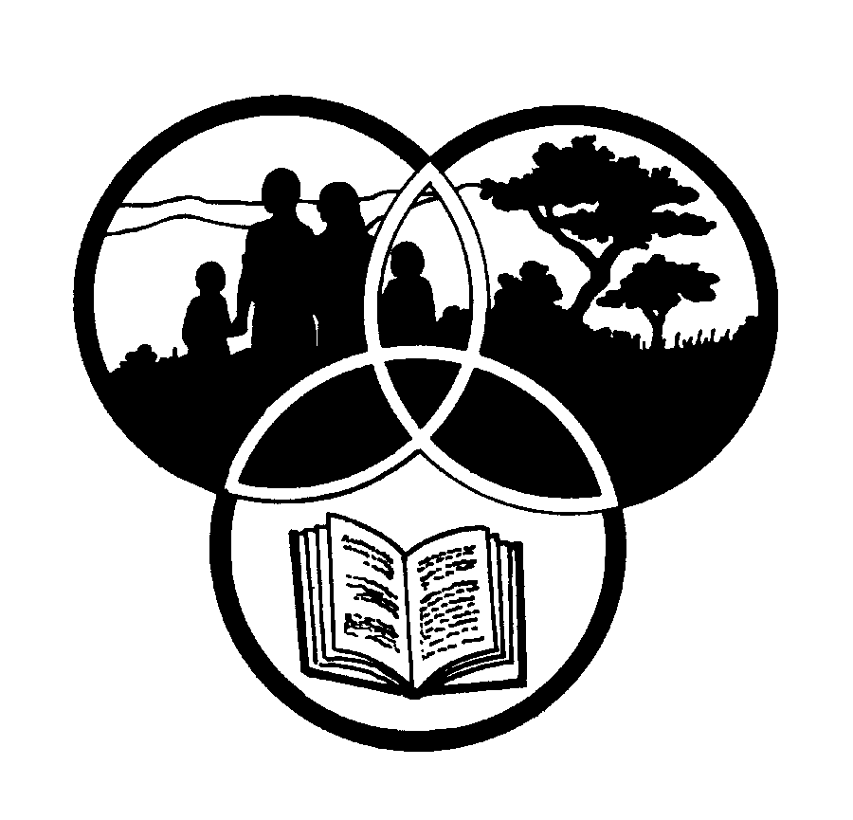
Share-Net

Share-Net is an informal partnership project committed to developing and disseminating materials in support of environmentally focused teaching and learning. Share-Net materials are copyright-free for educational purposes. We encourage you to adapt and use the materials in new, exciting ways but request that you acknowledge Share-Net as an original source. Sensible use of these curriculum activities is entirely the responsibility of the educator. Find similar curriculum materials by visiting www.envirolearn.org.za or contact Share-Net directly at PO Box 394, Howick, 3290, KwaZulu-Natal,
tel: (033) 330 3931, e-mail: sharenet@wessa.co.za
This pack supports an introduction for learners to an Eco-School’s focus on
environmental information and community knowledge

Grade 10

This pack contains:
Activity One: How healthy are our rivers? This LANGUAGES research and writing activity looks at water quality in South Africa. Learners research the topic of water quality, using a wide range of sources and methods. They then write up their information in essay format.

Activity Two: This LIFE SCIENCES lesson looks at visible animal life to determine the health of our rivers and streams.

Activity Three: This PHYSICAL SCIENCES lesson looks at water quality, water-borne diseases and some simple ways of purifying water. This is followed by a case study
on the water collecting ways of Nguni people.

Activity Four: Water bodies in southern Africa suffer from many problems – all of which are linked to the way in which the catchment area is used. This PHYSICAL SCIENCES lesson looks at water use in a catchment and encourages learners to look at ways of conserving and caring for our water catchments.

Activity Five: 5. We all use water every day for things like drinking, cooking and washing. We could not survive without water! This LIFE SCIENCES activity looks at how small or large our eco footprint is.

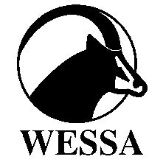
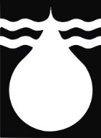
This pack of lesson plans is part of a series of lesson plans from Grade R to Grade 10 which focus on water and water-related issues. This resource development project has been funded by the Water Research Commission, Private Bag X 03, Gezina, Pretoria, 0031 (Website: www.wrc.org.za).
This pack is available electronically on www.envirolearn.org.za
Activity | Learning Area covered in this activity | Learning Outcomes covered in this activity | Assessment Standards covered in this activity
1. How healthy are our rivers? This research and writing activity looks at water quality in South Africa. Learners research the topic of water quality, using a wide range of sources and methods. They then write up their information in essay format. | Languages | Learning Outcome 3: Writing and presenting: The learner is able to write and present for a wide range of purposes and audiences using conventions and formats appropriate to diverse contexts. | Research topics from a variety of sources and records findings.  Locate, access, select, organise and integrate relevant data from a variety of sources.  Apply paragraph conventions to ensure coherence by using topic sentences, introduction and ending, logical progression of paragraphs, cause and effect, comparison and contrast.  Prepare a final draft by proofreading and editing.  Present final draft paying attention to appropriate style such as a neatly presented text.
2. This lesson looks at visible animal life to  determine the health of our rivers and streams. | Life Sciences | Learning Outcome 1: Scientific enquiry and problem-solving skills: The learner is able to confidently explore and investigate phenomena relevant to Life Sciences by using enquiry, problem solving, critical thinking and other skills. | Plans an investigation using instructions.  Systematically and accurately collect data using selected instruments and/or techniques and following instructions.  Displays and summarises the data collected.
3. This lesson looks at water quality, water-borne diseases  and some simple ways of purifying water. This is followed by a case study  on the water collecting ways of Nguni people. | Physical Sciences | Learning Outcome 3: The nature of science and its relationships to technology, society and the environment. | Discusses knowledge claims by indicating the link between indigenous knowledge systems and scientific knowledge.
4. This lesson looks at water use in a catchment and encourages learners to look at ways of conserving and caring for our water catchments. | Physical Sciences | Learning Outcome 3: The nature of science and its relationships to technology, society and the environment. | Describes the interrelationship and impact of science and technology on socio-economic and human development.  - States the impact of human demands on the resources and products in the earth’s system.
5. We all use water every day for things like drinking, cooking and washing. We could not survive without water! This activity looks at how small or large our eco footprint is. | Life Sciences | Learning Outcome 3: Life Sciences, technology, environment and society: The learner is able to demonstrate an understanding of the nature of science, the influence of ethics and biases in Life Sciences, and the interrelationship of science, technology, indigenous knowledge and society. | Describe different ways in which resources are used and applied to the development of products, and report on their impact on the environment and society.

