ACTIVITY ONE: HOW PEOPLE’S EVERYDAY PRACTICES CONTRIBUTED TO THE PREVENTION OF CHOLERA

Learners investigate how people’s everyday activities
in the past contributed towards the prevention of cholera
during this LANGUAGES lesson. This is followed by an
individual self-study on a health issue in the area, related to water.

ACTIVITY:
Photocopy pages 1 and 2 and hand out to your learners.

How People’s Everyday Practices Contributed to the Prevention of Cholera

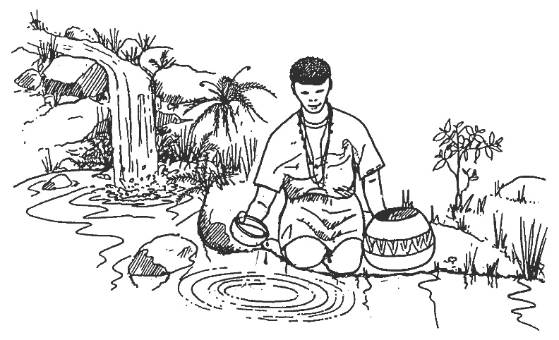

The way people disposed of rubbish was different before sophisticated rubbish such as plastic bags became popular. An area called ‘etaleni’, which lay a short distance from the huts, is where rubbish was dumped. This would be piled up with leaves swept from the cleared sitting space around the huts, ash from old fires, chewed sorghum stalks, pumpkin skins and seeds. The rainy seasons would come and the pumpkin seeds shooted and produced the best pumpkins.

People did not construct pit latrines, and they defaecated in the veld or the forest. They were very discrete in terms of disposing bodily waste. They never defaecated or spat where their faeces and saliva could be discovered for fear that their enemies could use it for witchcraft. This meant grass and forestlands were favoured. Busy places like water collection places were avoided because of their potential as meeting areas for males and females. Males hung around them in anticipation of meeting young ladies who had come to fetch water.

Not defaecating in water contributed to making sure that water, which was drunk by people, was clean and this contributed to preventing cholera.

‘Kuhabula’ (the breathing in of bad air/bad spirits) was guarded against and new mothers took great care that their children were safe from bad air. They never left the house unless the family felt they were strong enough and necessary ceremonies had been performed. Right after the baby had been delivered, they were discouraged from cooking and performing any household chores so that they did not infect other members of the homestead nor pick up infections. Breastfeeding was compulsory except in times of extreme sickness. A mother had to first wash her breasts and squeeze out the first milk before breastfeeding her baby. Children suckled until they were toddlers, which strengthened their immunity systems. Runny tummies were always associated with teething and elders said that it was because children chewed on anything they came across, relieving their itching gums like puppies. Care was taken immediately when a swelling was noted on a child’s gums as an indicator of teething. A mother, who had been away from the house, was forbidden to pick up her baby before washing her hands and her breasts and she had to squeeze out the first milk before breastfeeding. This was most likely done to prevent the spread of disease before they fed their babies.
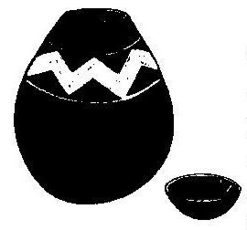
Visitors were always offered something to eat or drink and out of politeness after announcing his/her arrival, he/she would say ‘isisu somhambi asingakanani singange nso yenyoni’ (the stomach of a traveller is not much, it is the size of a bird’s sac). People would shake hands and sit down to chat, which would be followed by a bowl of hot water for washing hands before food was served. People ate with their hands and children usually ate together out of one big bowl. The food was not touched before hands had been washed.

After pouring the local beer into a smaller clay pot, the pot was cleaned with water before the wife would take a sip to display that it was good to drink and at passing it on, she would wipe the spot where she drank with her wet hand. This is a cultural practice to show someone that the beer is safe to drink.

People were sensitive about handshaking. People avoided shaking the hands of their enemies and if they had no choice, they always washed their hands immediately after. This was because an enemy could bewitch you through your hands. When one had been out of the house, people would always wash their hands before returning and doing anything in the house.

There was a popular use of wood ash to purify water. Ash was used when one had hiccups and to cook vegetables such as okra. When faeces were spotted in an area where it should not be, it was covered up with soil or ash. Ash was popularly known to purify things.

Animals were never allowed to drink water from water collection points. This was another way of preventing the spread of disease as animals often defaecate near water, thus contaminating the water and increasing the chances of the spread of disease.

Cholera is an acute intestinal infection caused by ingestion of food or water contaminated with the bacterium Vibrio cholerae. It has a short incubation period and produces an enterotoxin that causes a copious, painless, watery diarrhoea that can quickly lead to severe dehydration and death if treatment is not promptly given. Vomiting also occurs in most patients.

Most persons infected with V. cholerae do not become ill, although the bacterium is present in their faeces for 7-14 days. When illness does occur, about 80-90% of episodes are of mild or moderate severity and are difficult to distinguish clinically from other types of acute diarrhoea. Less than 20% of ill people develop typical cholera with signs of moderate or severe dehydration.

Cholera remains a global threat and is one of the key indicators of social development. While the disease no longer poses a threat to countries with minimum standards of hygiene, it remains a challenge to countries where access to safe drinking water and adequate sanitation cannot be guaranteed. Almost every developing country faces cholera outbreaks or the threat of a cholera epidemic.

Source: World Health Organisation, www.who.int/topics/cholera/about/en/index.html

CLASS ACTIVITY:
With your class, discuss the following two questions:

- In the story it appears that people could not shake hands with their enemies because they were afraid of being bewitched. How has this myth assisted with the prevention of cholera? What are the disadvantages in terms of creating relationships with others?

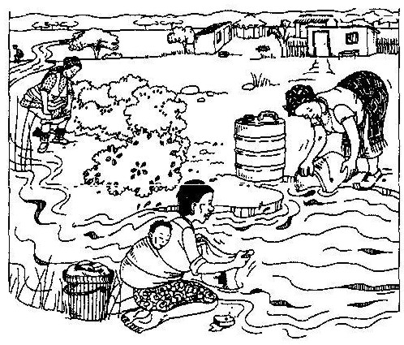

- Study the illustration above. What do you see? If you were living with these people, how would you make sure that you follow health safety practices but at the same time maintain a good relationship with them?

INDIVIDUAL ACTIVITY:
Planning and Research Skills for Oral Presentations

Find out about a health issue related to water in your community (some examples include levels of E-coli bacteria in the water, diarrhoea, cholera or bilharzia - see two news articles, at the end of Activity 1, from The Witness newspaper).

Once you have decided what you are going to research, gather as much information as possible. You need to make use of at least five sources (such as the Internet, personal communications with people or interviews [such as visiting a water board or a river scientist], newspapers, books, magazines, films or documentaries). List these sources carefully as you will have to show them to your teacher. Remember to acknowledge every source you use and keep a record of what you did at each step (ie what made you chose your particular topic – perhaps you know someone personally who has been affected by a river health issue? What sources did you use? Did you have trouble finding information?)

Once you have done all the research, decide how you are going to present your findings to the class. Your presentation must include at least one appropriate visual, audio and audio-visual aid (these could be charts, posters, photographs, slides, music, sound and electronic media).

Your presentation to the rest of the class will be 10 minutes and then there will be five minutes for questions from the class. Remember that to hold the class’s attention, you need to have a dynamic and interesting presentation. Consider different ways to make your introduction and ending effective. Make sure that the content is sound and you have researched your topic thoroughly. Your aids will help with the presentation.

Note to teacher: The learner does not need to be able to answer all the questions asked during the five minute question period. If the answer is not known, he/she may offer the question to the class to see if anyone else knows the answer. The important consideration is that the questions are heard, considered and responded to in some positive way.

Criteria to assess learners during this languages lesson

Criteria | Rating Code 6 (Outstanding) | Rating Code 5 (Meritorious) | Rating Code 4 (Satisfactory) | Rating Code 3 (Adequate) | Rating Code 2 (Partial) | Rating Code 1 (Inadequate)
The learner was able to follow instructions
The learner chose a relevant topic
The learner used five sources for their research
The learner used at least one visual, audio and audio-visual aid
The learner was able to respond to all questions asked of him/her

Duzi toilet time bomb
31 Jan 2008
Stephanie Saville
This is a time bomb.
Stuart Knight, a local pathogenic bacteria control specialist, has spoken to The Witness on the dangers that he said are lurking in the murky depths of the uMsunduzi River.

The E.coli count of 29 000 measured in the river before the start of the Dusi Canoe Marathon was 3 000 higher than the 26 000 that is acceptable in a functioning septic tank.
Knight, who has worked in the field of toilet systems for the past 30 years, said he warned Msunduzi Municipality years ago to sort out the city’s pit latrine toilets and septic tanks to avert a major health disaster.

He said local people are dying from sewage-borne diseases like hepatitis and severe diarrhoea, but "it is always put down to simply natural causes". Cholera is also transmitted via raw sewage.
The extremely unhealthy situation that has developed around the presence of human waste in and around townships and surrounding rivers is having a devastating effect on HIV-positive people and on the elderly and young children, he said.
Knight said he was asked by Msunduzi to do an audit of waste materials flowing into the Duzi in 2005/2006. "I went through town from Vulindlela, the Edendale Valley and to most of the informal settlements looking at pit latrines, pit toilets and septic tanks." What Knight found was a dire lack of knowledge from locals on how such toilet systems should be cared for. "Almost every pit toilet was being used as a rubbish dump with plastics, steel hard wood, carpets, you name it, being chucked into the holes."
He said that as a result, they became over-full and people stopped using them. Many just went to the toilet on the ground. He found that many toilets and septic tanks are built over underground water courses that flow into the Duzi.
Knight was also concerned to find that those with septic tanks were medicating them with solutions like chlorhexidine gluconate and chloroxylenol, (found in Dettol and Savlon), which kill all the enzymes, worms and bacteria needed to break down the solid matter, and destroy the healthy pH system of the septic tank. The result of all this, said Knight, is that when it rains, the toilets and tanks, overflow and the run-off ends up in the Duzi.
Knight said a massive drive is needed to educate people on how to use and care for their toilet systems and that existing ones should be rehabilitated and restored and have the correct bacteria reintroduced into them. "Most of the systems are running at an acidic pH of nought — we need to get these back to six."
Knight said that instead of heeding his advice, the municipality went ahead and built 500 new toilets. "That was two years ago and they are all full now and unusable in many cases. The current situation with the Duzi now is their own fault." Knight said he told the municipality that if there was a cyclone or heavy rain, they would end up with a septic tank in every river.
He said temporary measures like cleaning toilets out with "honey suckers" are pointless as they are full within a month again. "The problem will carry on exacerbating itself again and again, but if we rehabilitate the toilet systems, it would save millions of lives and clean up the Duzi."
Approached for comment, municipal manager Rob Haswell said the problem is not that simple. He said the contamination is caused by a combination of factors, including the age of pipes, the lack of toilets and adequate storm water drainage. Msunduzi Municipality no longer employs a dedicated medical officer of health, but Haswell said they have a "highly qualified person" in the form of Dr Nomasonto Nkosi as an acting process manager in the health department.

Haswell referred The Witness to Phil Mashoko, manager for infrastructure, services and facilities for further comment, but Mashoko was unreachable yesterday.

Source: The Witness

Dusi threat
31 Jan 2008
There are three sporting events in and around this city which have put Pietermaritzburg on the national sporting agenda. The first is the famous Comrades Marathon, run between Durban and the capital city every year. The second is the increasingly popular Midmar Mile, swum on the nearby dam of that name. The third is the annual canoe marathon, contested over three days on the Msunduzi and Umgeni rivers as they flow towards the Indian Ocean. There was special jubilation this year when Michael Mbanjwa was the first black South African canoeist to come in as a winner with his paddling partner, Martin Dreyer.
News has now broken that over half the paddlers who participated in this year’s race have suffered from gastric illnesses, such as diarrhoea, as a result of contaminated river water. “Dusi guts” has been a well-known phenomenon over the years, but not to this extent. The organisers are threatening that if the problem is not adequately resolved, the race could be cancelled next year.
There were acknowledged problems ahead of this year’s race, with unacceptable E. coli levels caused in part by recent heavy rains which washed sewage from the Edendale valley into the river. Efforts were made to rectify the problem and a difficult decision was taken to go ahead with the race. Now it seems that this decision was probably unwise.
It is clearly important that all interested parties, including the municipality and the Department of Water Affairs and Forestry, should get together with a view to resolving this problem before next year’s race. Socio-economic deprivation and an absence of proper sanitation in portions of the city lie at the heart of the problem and this needs to be addressed with vigour. For here is an opportunity for a focusing of the mind in microcosm just as, in macrocosm, the nation as a whole, electricity outages notwithstanding, is seeking to focus its mind around the hosting of the Soccer World Cup in 2010 and all the infrastructural work that this will entail.

Source: The Witness

ACTIVITY TWO: WATER AND SANITATION: SURVEYING OUR SCHOOL ENVIRONMENT

Audits and surveys are systems that allow us to look and examine things the way they are. This enables us to understand something better and improve it if need be. The following LIFE SCIENCES activity allows learners to conduct a pre-designed audit on their school toilets, and then develop a survey around how the current situation can be improved.

INDIVIDUAL ACTIVITY:
Learners complete an audit of their school toilets, using the template below:

Name: ______________________________________

Name of School: ______________________________

Date of Audit: ________________________________

Please complete ALL sections of the following checklist:

Number of learners in the school?

SECTION A: Water and Sanitation | Yes |  | No
1. Is clean drinking water available?
2. Is there enough water available for drinking and washing?
3. Number of toilets available for learners? | Males |  | Females
4. Which of the following toilets are used in your school? | Mark with a
a. Flush toilet – full water-borne sewerage
b. Pit latrine – pit toilet with no vent pipe
c. Ventilated Improved Pit Latrine – pit toilet with vent pipe
d. Bucket system – ½ bucket of water used to wash away sewerage
 | Yes |  | No
5. Are there adequate toilet facilities for learners?
6. Are all of the toilets working?
7. Is there enough privacy when using the toilets?
8. Are there rubbish bins in the toilets?
9. Is there enough toilet paper available?
10. Is there clean water and a basin for hand-washing in or near the toilets?
11. Is soap available for washing hands?
12. Is there a towel available for drying hands?
13. Are the toilets clean and hygienic at all times?
14. Are there many flies around the toilets?
15. Are there staff attending to the maintenance of the toilets?
16. Are the school grounds free from faecal (poo) matter?
17. Is there a place in the school grounds that is used as an
alternative toilet?
18. Boys – Do you know how to use a urinal correctly?
19. Girls – Do you know about menstruation?
- Are there sanitary bins in your toilets?

GROUP AND CLASS ACTIVITY:
- Discuss your findings in groups of 5. Give reasons for why you are satisfied or dissatisfied with your findings? Each learner should then summarise and comment on the findings of the audit in a written paragraph.
- As a class, discuss the findings and comments from each group.
- In the same groups of 5, draw up a survey, with at least 10 questions, to find out how the rest of the school feels about how the school toilets are managed. Have a variety of questions, not only those of the ‘yes’ and ‘no’ type. Remember that this is a survey to see how things can be improved – even if your toilets are in very good condition, there are always little ways that we can make things even better! (A hint: Get positive feedback in terms of how the toilets could be improved; also remember that people responding to a survey may not give accurate answers for a variety of reasons).
- Conduct your survey.
- Discuss the group findings with the rest of the class. Compile all the information into an article and submit it to the editor of your school’s annual / quarterly magazine / newspaper.

Criteria to assess learners during this life sciences lesson

Criteria | Rating Code 6 (Outstanding) | Rating Code 5 (Meritorious) | Rating Code 4 (Satisfactory) | Rating Code 3 (Adequate) | Rating Code 2 (Partial) | Rating Code 1 (Inadequate)
The learner carried out the audit on the school’s toilets
The learner participated in designing a survey for feedback around the school’s toilets
The learner carried out the survey with the rest of his/her group
The learner prepared an article on their findings of the toilet audit and survey
The learner submitted an article of their findings of the toilet audit and survey to the school’s newspaper editor

ACTIVITY THREE: SO MUCH DRAMA IN OUR LIVES!!

This DRAMATIC ARTS lesson encourages learners to look for different solutions and appropriate courses of action around access to water and sanitation.

For the teacher:

An introduction to drama in your lessons:
Drama can offer you various skills and techniques which raise awareness and transform awareness into real-life action. Your role, as teacher, is to stimulate ideas and act as a catalyst. Instead of offering an education package which has pre-prepared solutions, the teacher who uses participatory drama offers a process so that learners can come to terms with many of the issues themselves. Through the drama process, learners are given the chance to ‘rehearse’ solutions to real-life challenges.

These are some of the principles on which participatory drama is based:

- Learning through experiencing: Learners are taken through an experience in which they participate actively. Such experiential learning means that the learner has to engage with issues, to make decisions, to take action, to reflect and to collaborate with others in the group. It also puts the learner in the position of having to draw on his or her real life experience.

- Learner-centred education: The participatory nature of drama challenges the idea that the teacher or facilitator is the ‘all knowing’ authority. Rather, it acknowledges that learners have knowledge and life experience which they can share, build on and use. Drama brings out what learners know, but don’t yet know they know.

- Action and Reflection: For the learning process in drama to be effective, active participation is not enough – what is important is that participants are given the opportunity to reflect. Such reflection could take place in the form of a discussion after the drama, or it could be built into the drama itself. By action, reflection on that action, and then modifying the action based on the reflection, the learner is able to make conscious and informed decisions relating to his or her life.

- The real and fictional worlds: This refers to the ability to keep in mind the real world and the fictional world (the world of the story being told) at the time. So even when playing a role, the learner will draw on his or her real life experience.

- The safety of role: Through role-playing, the learner often feels more free to say or suggest things. This is because it is the character putting him or herself on the spot, rather than the learner personally. It is very important that the teacher creates a ‘safe’ atmosphere in which learners feel comfortable to take on roles and enter into the fiction.

- Process and Product: In participatory drama, the emphasis tends to be on the process that learners go through. Where in conventional theatre, the final play (the product) is the most important, in participatory drama it is the engagement with each other through a process of experience that is important. It is in such process-oriented drama that action and reflection can most effectively take place.

Getting Started

A Space for Drama: Create a physical environment that encourages participation. If you are in a classroom, clear the desks and chairs to the side to create an open space. Or find an open space, outdoors in a clearing, or in a community hall. Whatever space you choose, make it a special place – a space in which there is place for everyone to move, to sit in a circle, and to work in small groups.

Warming Up: It is a good idea to take the group through some warm-up activities at the start of each session. ‘Warming up’ in drama is more that just a physical warm-up – it fulfils a number of functions:
- It builds a group spirit and constructive group dynamic by getting people to work together.
- It stimulates creativity allowing learners to contribute interesting and creative ideas to the drama.
- It gets learners to participate actively using their minds, bodies and emotions imaginatively.
- It helps the group to focus – if they are too active it helps you to calm them down and focus their attention. If they seem lethargic and lazy it helps you to energise them!

Warm-ups can take a number of forms ranging from physical shake-outs of the body to songs and dances that everyone in the group might know, to games and imagination activities.

It is often a good idea to use performance forms that your community or group already knows. Use these as warm-ups, or integrate them into the process in some way.

Here is an example of a warm-up

ACTIVITY:
Walking Around the Space
- Everyone in the group should walk around the space. Learners should not all walk in the same direction, each person can walk in any direction they like and change direction as often as they want to.

- Learners should walk with an attitude …know where they are going … they are walking with a purpose. Every time you clap your hands, learners change direction.
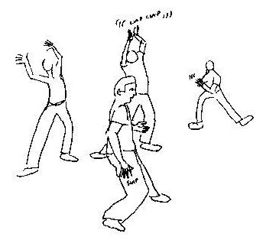
- Call out the following different situations. Learners must change the way they are walking for each situation.
- You are walking on hot coals
- You are taking an energetic dog for a walk
- You are wading through syrup
- You are walking on ice
- You are wading through a river
- You are jumping from puddle to puddle

- Learners must take note of how their walk changes for each situation. Sometimes it becomes faster or slower (the pace changes), or it changes the shape of the body. They start to express themselves physically. They also start to draw on their imagination and memory – for example, the feeling of wading through a river, or what ice feels like.

Start collecting various games and exercises that you can use for your various sessions. In this way you can start to build a ‘basket of activities’ that you can draw from whenever you need to do a warm-up. There will be a number of books in your local library that have details of various games that you can use (see the list at end of Activity Three).

The Teacher-Learner Relationship:
In this kind of work, the teacher becomes part of the learning community rather than an all-knowing figure. This means that you, as the teacher, need to:
- be a good listener – listen carefully to what each learner offers and acknowledge their contribution;
- create an enjoyable atmosphere during your sessions; this does not mean that the work you do is only about ‘fun’, but that you create an atmosphere which allows learners to be creative, to try things out and to take initiative;
- be more of a facilitator than a ‘teacher’, guiding the learners’ activities;
- ask the right questions – instead of telling the learners everything they need to know, see if you can draw out many of the ideas and perspectives from the learners themselves;
- be motivating, flexible, creative and encouraging;
- create a ‘safe environment’ in which learners feel free to participate. This means an atmosphere which is non-judgmental and in which the learners feel they can make a contribution without being laughed at, scolded or ignored. Encourage and nurture the learners.

Read the following to your learners:

What is forum theatre?
Forum theatre is a dramatic game played between actors and the audience. A group of actors will develop a drama around a particular issue. The drama should be structured in a way so that it contains a point of conflict or unresolved tension which does not get resolved by the end of the drama. The conflict must be clearly expressed and carefully rehearsed. This means that the audience must be clear, from the action, what the issue is and what the characters’ mistakes are. Once the drama has been performed for an audience, they are encouraged to participate in re-making the drama by taking the role of certain characters in the drama. The drama can be re-enacted many times with different members of the audience trying out solutions. The aim of the game is to try out different solutions or find appropriate courses of action for the community by trying to find a different ending for the drama that looks towards resolving the conflict.

Aims of Forum Theatre
- To encourage dialogue around issues.
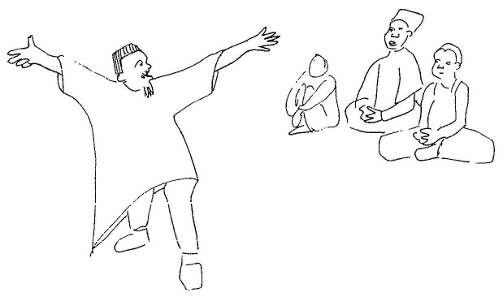
- To practice action for the “real” world.
- To search collectively for solutions to issues.

The Process of Forum Theatre

1. The play is performed for the audience as if it were a conventional play.

2. The audience is asked whether they agree with the way in which the character dealt with the issue. The audience will probably answer no. The audience is then told that the drama will be done a second time. This time it will be in the form of a game between the actors and the audience where the audience have to try and get the drama to end differently so that the conflict is resolved. The actors will, within reason, attempt to get the drama to end in the same way. For example, the actors represent a vision of the world as it is, whereas the audience represent an image of the world as it could be. If the plays ends the same way, the world will stay the same.

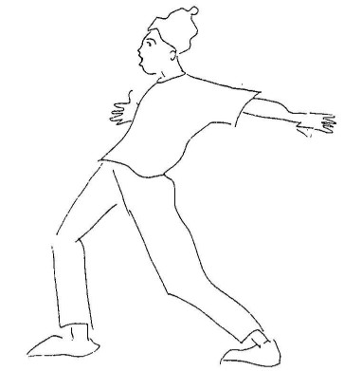
3. The play is restarted. When the audience sees a moment in the play where they could potentially influence a change, a learner cries out “Stop”. The learner will say where he/she wants the play to start from, the actors re-start the play with the learner playing the role of the character. He/she puts forward his/her solution to the problem in the play. The actor who has been replaced stays on the sidelines to encourage and support the learner. The other actors will still remain agents of oppression to get the play to end in the same way. This is to demonstrate to the audience how difficult it is to change reality.

4. Different attempts can be made to change the play. At some point the audience may eventually break the oppression imposed by the actors and the play ends differently. This also may not happen as the audience may not agree on which action brings about the desired ending to the play. This is okay as the forum will still highlight potential ways forward for learners to discuss.

5. One of the actors should take on the role of “joker”. This person will be responsible for facilitating the process by explaining the rules of the game and encouraging everyone to participate.

6. Once the forum is over, it is important to develop a proposed play of action which the audience accepts. The audience play the changed drama from beginning to end.

These techniques are used to start dialogue around particular issues. They are not about producing an amazing piece of theatre. Forum theatre aims at finding potential solutions to problems. If the group comes up with a solution that they all agree on, it is important you and the learners begin looking for ways in which this solution can be enacted in “real life”.

A tip: The joker should explain to the audience that they should try out actions which are “real” and not “magic”. For example, if a person is starving, a magic action would be for him to find a R20 note on the street. This changes his situation briefly but does not address the reason for his position of poverty and thus is an unlikely solution to the problem the character faces.

CLASS ACTIVITY:

1. Put on a play around the theme of sanitation. The class can choose to develop their own play around the issues and challenges of sanitation and healthy living or they can use the scenario given.

The example given explores different peoples’ experience of access to water and how our behaviour, whether informed or uninformed, can influence the health of other people and our relationship with members of our community. It also challenges us to consider how we can best deal with the situation.

The scenario:
An official see a large group of women washing their clothes in a river. He also sees many pit latrines which have been built near the river. He is very angry as he has already told this community that there are people further downstream who use the water for drinking and that washing clothes in the river and building toilets so close to the water, is very bad, not only for themselves but for others. He shouts at the women and says that a bulldozer will be coming in a few days to bulldoze the pit latrines and that if he catches them washing in the river again, he will fine them. Next scene, we see the official at home, in the nearby town which has piped water, preparing a bath for himself and putting his laundry into an automatic washing machine. This is followed by a third scene where we see one of the woman from the nearby community, arguing with her husband as his clothes are not clean for the next day since the washing has not been completed. She has also told him about the visit from the official and the removal of the pit latrines. The play ends with the man shouting that he doesn’t know what to do, shoving his wife aside and leaving the house.

Divide the class into two – one group will enact the play and the other group will be the audience.

2. Once the play has been performed to the learners, explain the rules of the game again and begin the play once more. Remember the key here is to explore different ways in which all the actors can deal with the problem of no access to water and the health risks that are being faced, both by in a realistic and favourable way.

3. At any given point, an audience member can call for the play to stop. He/She should take the place of the person in the drama and try and resolve the situation. Members of the audience can encourage the learner from the sides but it is important to allow him/her to try out his/her idea to its conclusion.

4. Depending on the result of the learner’s actions, other audience members can try out their solutions. Continue replaying the play until you run out of time or until everyone is satisfied with the way the play has ended.

- After the play:
  - ask the learners how the drama relates to their own personal experiences;
  - ask the learners how the drama relates to their community or a community nearby;
  - reflect on what ideas and issues have arisen and together come up with a proposed plan of action for addressing the issue of access to water and better sanitation for all.

Further readings for Warm-Ups and Forum Theatre
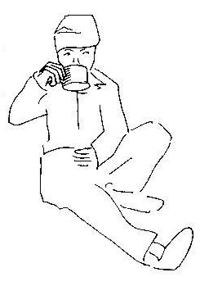
- Boal, A. 1977. Games for Actors and Non-Actors. Routledge: London and New York.
- Brandes, D. and H. Phillips. 1977. Gamesaters’ Handbook: 104 Games for teachers and group leaders. Hutchinson: London and Johannesburg.
- Hayes, S.K. 1984. Drama as a Second Language. National Extension College Trust, Ltd: Cambridge.
- Wessels, C. 1987. Drama (resource books for teachers). Oxford University Press: Oxford.
- Brady, M. and P. Gleason. 1994. Artstarts: Drama, Music, Movement, Puppetry and Storytelling Activities. Teachers Ideas Press: Colorado.

Criteria to assess learners during this dramatic arts lesson

Criteria | Rating Code 6 (Outstanding) | Rating Code 5 (Meritorious) | Rating Code 4 (Satisfactory) | Rating Code 3 (Adequate) | Rating Code 2 (Partial) | Rating Code 1 (Inadequate)
The learner was actively involved in the forum theatre, either as an actor or as an audience member
The learner was able to relate the drama to his/her personal experiences
The learner was able to discuss the drama within the context of his/her community or a nearby community
The learner contributed towards ideas of how access to water and better sanitation for all could be addressed

ACTIVITY FOUR: THE STATE OF OUR

SCHOOL ENVIRONMENT

During this LIFE ORIENTATION lesson, learners find out more about
State of the Environment Reporting. The class then chooses three themes
around water access and sanitation which they would like to investigate either
in their school or community. Learners take their findings further by
developing action plans.

ACTIVITY:
Read and discuss the following information on State of the Environment Reporting with your learners.

Our school should be a healthy environment for us to learn, share together, and enjoy ourselves. Sometimes this is not the case and the best way to make things better is to investigate what needs attention and then take action to make those things better.

What is a State of Environment Report?
Before we can take action to make our world better, we need to understand how the environment around us is coping.

The State of Environment (SoE) Report describes the state of the environment for a city, region or country. These reports then become one of the tools used to assess and monitor changes in the environment and enable us to plan for effective environmental management.

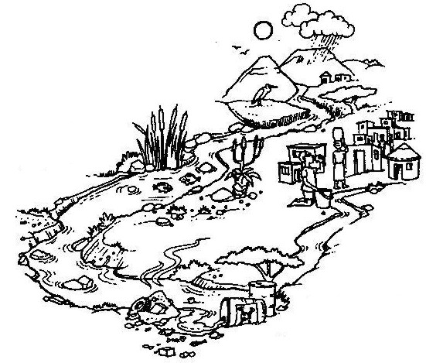

A SoE Report provides action ideas on how to improve our environment through investigation.

Who writes State of Environment Reports?
Anyone can! Different sections of the report are written by those who are the most informed about the topic. Some of the authors include government institutions, universities, specialist consultants, research centres, non-governmental bodies and even YOU can be an author!

State of Environment reporting should be a two-way communication, with the public getting involved in both preparing the State of Environment Report AND finding solutions to environmental problems.

The first SoE Reports in South Africa
The first attempt to produce a National SoE Report was in 1992, when a report was submitted to the United Nations Environment Programme in Rio de Janeiro, describing the South African environment and resource base. The first comprehensive National SoE Report was launched in 1999 by the Department of Environmental Affairs and Tourism (DEAT) and was made available on the Internet together with the city SoE Reports of Johannesburg, Durban, Cape Town, Midrand and Pretoria.

Why is a SoE Report useful?
A State of Environment Report is considered to be one of the most valuable means of informing policy makers, the public and other interested parties on the status of the natural resources and the sustainability of their use. It includes:
- the condition of the environment and information on issues and trends in the quality of the environment;
- the causes of environmental change and how to respond to these changes;
- what is being done to improve environmental conditions, whether these actions are effective and what more could be done.

However, the effectiveness of any State of Environment Report relies on the constant updating of information so that trends in environmental conditions can be monitored as accurately as possible. This helps to ensure that well-informed decisions regarding the environment can be made.

CLASS OR GRADE ACTIVITY:
As a class or grade, learners need to conduct a SoE Report for their school or community. Because the focus of this pack of lessons is on water and sanitation, the learners need to choose at least one of their three focus areas around this issue.

Before you commence this activity, decide whether there will be one SoE Report, conducted by the entire class, working together or whether the class will break into smaller groups. You may even like to work with other teachers and do this across the entire grade! If you decide to do this activity as a grade activity, it would be preferable to assign separate investigations to learners who take specific subjects, to acquire the most accurate insight into that topic. For example, learners who are taking physical and life sciences could focus on water testing and social sciences learners could investigate socially related issues.

Remember that three issues need to be identified for the SoE Report so if the class does break up into smaller groups, make sure there are enough learners in each group to effectively cover each issue.

Hand out the following information to your learners.

How do I go about conducting a SoE Report?
First of all, you need to determine what the purpose of your SoE Report will be:
- What do you want to achieve by writing the report?
- How can it be used? and,
- Who will be able to use it?

It would be very ambitious to report on all environmental and developmental issues in any region. Therefore you need to establish simple key issues to work on.

Are you going to produce a SoE Report with a focus on your:
- school or
- local environment e.g. focusing on the area around your school?

The following questions will help you decide what kind of SoE Report will be most suitable for your school.
- What information do we need to convey? Broad environmental concepts, the reasons for environmental change, how to improve sustainability of resources in our school/local area; how to improve our school or local environment.
- Why do we want to report on this information? To raise awareness in our school or our community; to provide a starting point for collaboration and action.
- Who can benefit from this information? Our school; our community; other schools; the local council.
- How can they use it? To gain a better understanding of their school and / or local environment, so that they can take actions to improve their environment.

Indicators
Indicators are specific measurements or records for monitoring environmental conditions. They are used in SoE Reports to present large amounts of detailed information in a format that is easy to understand.
For example, to see how good water is for drinking, we could measure the amounts of unhealthy substances it contains. If measured over time, we would know whether water quality is improving or getting worse.

Themes and Issues
Every country, society, community or school has its own themes and / or issues, which it may feel are important to report on by means of indicators.

A theme can be described as a key area of concern e.g. atmosphere, waste management or water, whereas an issue represents an item of concern surrounding an environmental problem e.g. air quality, waste reduction or water quality. Indicators are measurable properties of the environment and are derived from environmental data. Data is derived from direct measurements and observations.

When choosing your indicators keep the following guiding points in mind:

Indicators should represent an environmental aspect that is important to your school / community.
- They should help focus information to answer important questions.
- They should be scientifically valid.
- They should provide a picture of environmental conditions.
- They should show patterns or trends over time.

Some examples are:
Theme: Human Well-being
Issue: Population
Indicators:
- Number of children per family
- Access to basic needs like water, education and health

Reporting Framework
Theme: Water
Issue: Water wastage
Indicators:
- Water lost through leaking taps
- Water lost through dripping taps
- Amount of water used per month

Theme: Energy
Issue: Cars
Indicators:
- The number of people who use a car/bus/bicycle/walk to get to school/work
- The number of vehicles per family
- The number of people per vehicle

Theme: Land Use
Issue: Land condition
Indicators:
- Land degradation
- Soil loss
- Soil fertility
- Mineral content

Theme: Water
Issue: Freshwater systems
Indicators:
- Availability of water
- Accessibility of water
- Quality of water
- Evidence of waterborne diseases

Theme: Human Well-being
Issue: Health Care
Indicators:
- Prevalence of illnesses in the community
- Types of illnesses people are suffering from
- Accessibility to medical assistance
- Available of adequate sanitation

The SoE Report for South Africa uses the ‘Driving Forces, Pressure, State of Environment, Impacts of Ecosystems and Responses to Environmental Changes’ (DPSIR) reporting system to describe environmental issues:

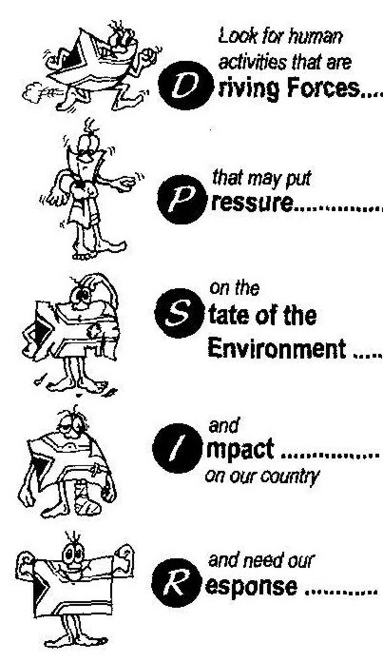

These are underlying social, political and economic activities that lead to environmental change.

These are pressures on the environment that result from the driving forces.

This describes the current state of the environment and recent trends by exploring what makes up an ecosystem.

These are the consequences or results of the pressures on the environment in terms of capacity for human development.

This describes human responses to environmental change, including policies and plans to reduce environmental damage, and encourage sustainable development.
This is an example of using water as a theme within the DPSIR reporting system
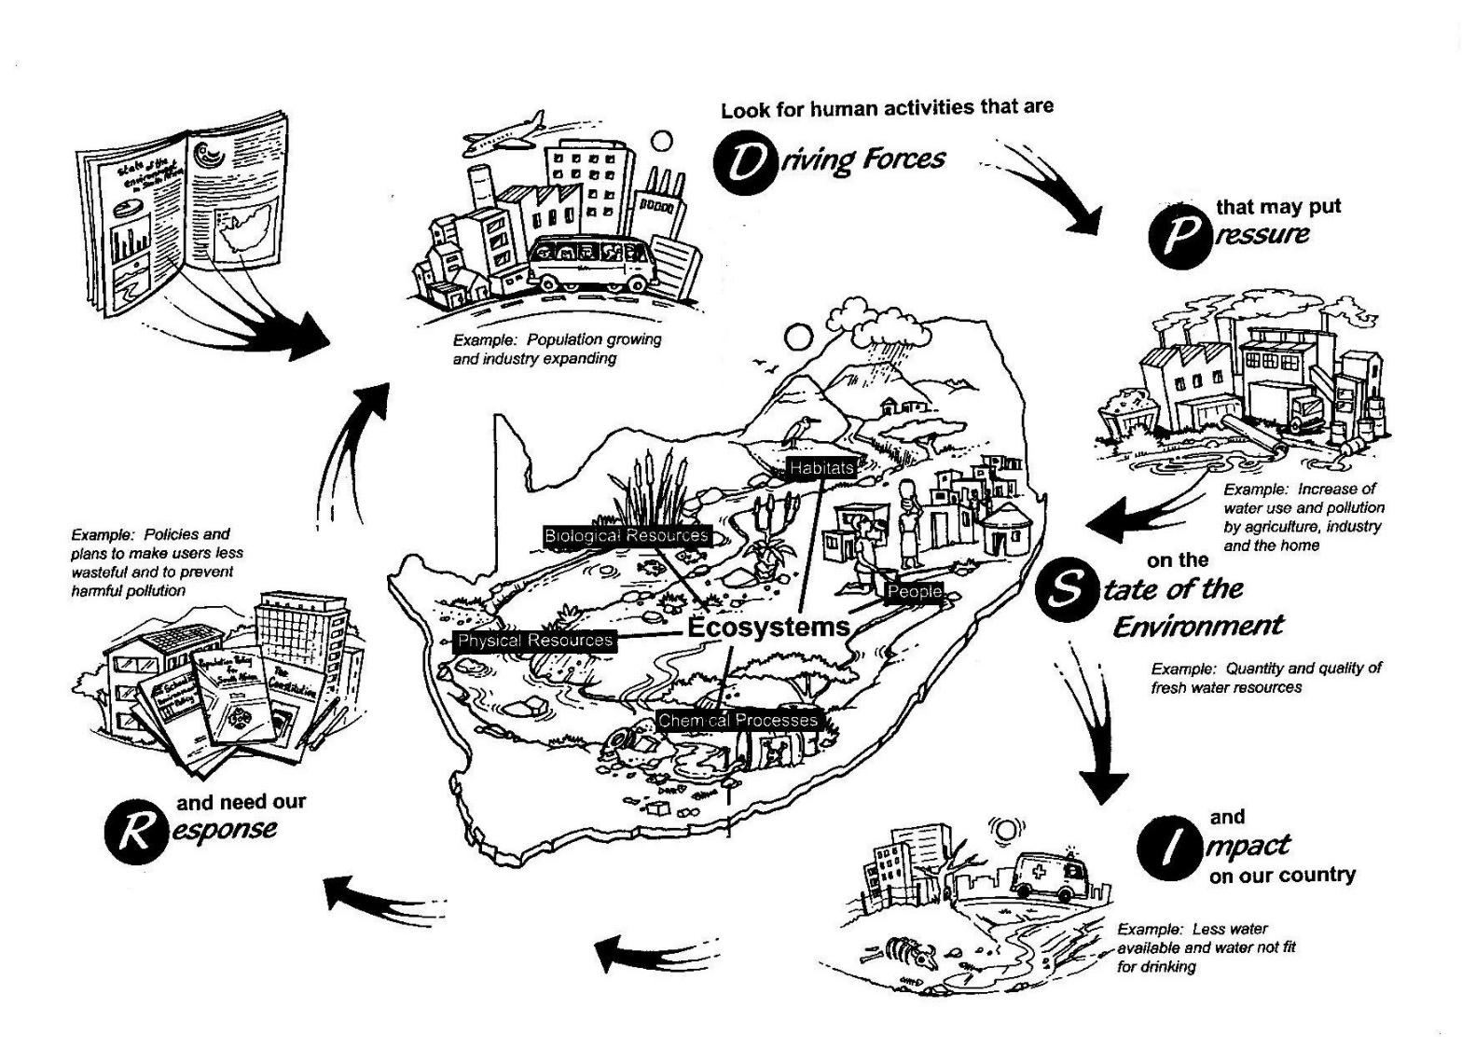

Drafting the report

The next step is to collect, interpret and present the information. There are 4 main steps in this process:

Step 1:
Conducting the investigation, e.g. doing a sanitation audit, looking at water consumption. This will depend on which issues/themes/topics you have selected to investigate.

Step 2:
Integration of the material, i.e. linking your findings to one another as demonstrated in the DPSIR reporting system (on pages 18 and 19).

Step 3:
Editing and reviewing your report.

Step 4:
Presentation.

Conducting the Investigation
A State of the Environment Report should reflect the views of all people, those affected by environmental change, as well as those causing it, and those attempting to manage environmental change.
Integration of the material
Once the individual ‘specialist’ studies have been completed they will need to be integrated to ensure consistency in data, highlighting links, reduction of repetition and flow of writing styles. For example, impact of dripping taps or leaking toilets in the school could be covered under a section on ecology or resource management – these need to be worked out.

Do not be surprised if you find that the different work groups have come up with the same issues. For example, a group may have been investigating water quality and found it to be of poor quality as a result of inadequate sanitation in the area. Similarly a group investigating social issues may find that illness in the community is caused by poor water quality. These overlaps will help you to clarify the issues.

Editing and review
Your group should review the final draft report, to confirm that all perspectives have been included. Obviously it will not be possible to consult every member of your school or local community, but you should try to create opportunities for representatives of different grades at your school or sectors in your local community to give input.

Presentation
The presentation of the information in your SoE Report is almost as important as the information itself. The purpose of the report is to effectively communicate information, in order to support the informed management of resources. Therefore the report should be presented in a way that is meaningful to users. It should be presented as a document, which is clear, simple and relevant. Consistency in format is very important, so if you choose to type it on a computer, make sure that each group is using the same font and style. If your group is writing it up by hand, use the same colour ink and choose either cursive or print, keeping it neat and tidy.

Try to use as many illustrations, photographs, maps and graphs as possible. This always helps in emphasising or demonstrating an issue and makes the report more appealing.

Use the following format as a guideline to the layout of your report:

Title – Give a short and concise title to your report.

Introduction – Give a brief introduction about your report so that those reading it will gain insight into the report. Also describe the objectives and aims of your study.

Study Area – Describe your school grounds and the surrounding area.

Methods – Describe the methods you used to identify and carry out the audits and obtain your results.

Results and Discussion – These may be reported on together as they are interlinked. Provide data, in the form of graphs, tables, charts, maps etc. and then discuss your findings. Be critical, offer possible solutions and state whether your objectives have been met.

Conclusion – A summary of your findings. Include here at least three practical and do-able action plans to improve the way things currently are.

Acknowledgements- Acknowledge any person who may have contributed to your report ie. technical assistance, financial support, valuable comments or information.

References – Make sure all the learning support materials you have referred to in the text are noted under references.

Summary: The Structure, Investigation and Planning of your SoE Report

→ What kind of SoE Report are we going to investigate: our local surroundings, our school?

→ Who is the report for: our school management, our local council, our municipality, our community?

→ Organise our reporting team, according to classes, learning areas etc?

→ What do we report on?
▪ Identify issues
▪ Identify indicators
▪ Understand our reporting systems

→ Where do we find other information? Libraries, Internet, environmental education resource centres, government departments

→ Drafting the report
▪ Conduct our investigation: collect data
▪ Integrate our findings and researched information
▪ Edit and review

Once complete, present your final SoE Report to your headmaster and school, school governing body, parents, local council, municipality or Department of Environmental Affairs and Tourism.

Criteria to assess learners during this life orientation lesson

Criteria | Rating Code 6 (Outstanding) | Rating Code 5 (Meritorious) | Rating Code 4 (Satisfactory) | Rating Code 3 (Adequate) | Rating Code 2 (Partial) | Rating Code 1 (Inadequate)
The learner and his/her group identified three environmental issues within the school/community
The learner participated and contributed to the group’s SoE Report
The SoE Report followed the format given
The SoE Report was well planned and well presented
The SoE Report had at least three practical and do-able action plans to improve the school/community

ACTIVITY FIVE: JUST FOR FUN! MAKING SOAP

Just for fun! Making soap - this PHYSICAL SCIENCES lesson gives
instructions on how to make ‘Settlers Soap’.

Did you know that Andrew Pears started making Pears Soap in 1789 and we still find it in our supermarkets today. He developed the soap using pure ingredients – glycerine, natural oils, rosemary, cedar and thyme.

Soaps have been made for many many years but not much was known about the chemistry at the molecular level.

A fat or vegetable oil provides the long non-polar ‘tail’. This reacts with an alkali, such as potassium hydroxide (KOH) for softer soaps, or with sodium hydroxide (NaOH) for harder soaps.

Animal fats and vegetable oils are esters and therefore the reaction with NaOH is as follows:

O O
װ װ
R-C-O-R¹ + Na⁺OH⁻ → R-C-O-Na⁺ + R¹OH
fat sodium hydroxide soap glycerine

ester + alkali → sodium salt + alcohol

R and R¹ are hydrocarbon chains.

Making Settlers Soap:
This is a fun class activity. The ingredients for the soap can be obtained from your local chemist and supermarket.

This recipe makes 10 bars of soap
- 425g vegetable fat (Holsum)
- 285g sweet almond oil
- 198g olive oil
- 57g white beeswax, coconut oil or castor oil
- 283g distilled water or spring water
- 142g caustic soda (caustic soda is sodium hydroxide (NaOH) – a very strong base so be careful when you are handling it).
- 30g honey

What to do?
  - Place vegetable fat, oils and beeswax in a glass container and heat in the microwave to 55-60°C. Alternatively heat over a warm bath.
  - Add caustic soda to spring water and stir till dissolved.
  - Both the caustic solution and oils must be approximately 60°C. Pour caustic solution into the oils and stir with a wooden spoon for about 20 minutes until the spoon leaves a trail behind it.
  - Add honey and stir well.
  - Pour into moulds and cover with a blanket for 24 hours to set. Then cut the soap into pieces and wash quickly under running water.
  - Cure for a further four weeks before using.

Source: Unilever. Adapted from the Unilever soap making course

