Water and Sanitation

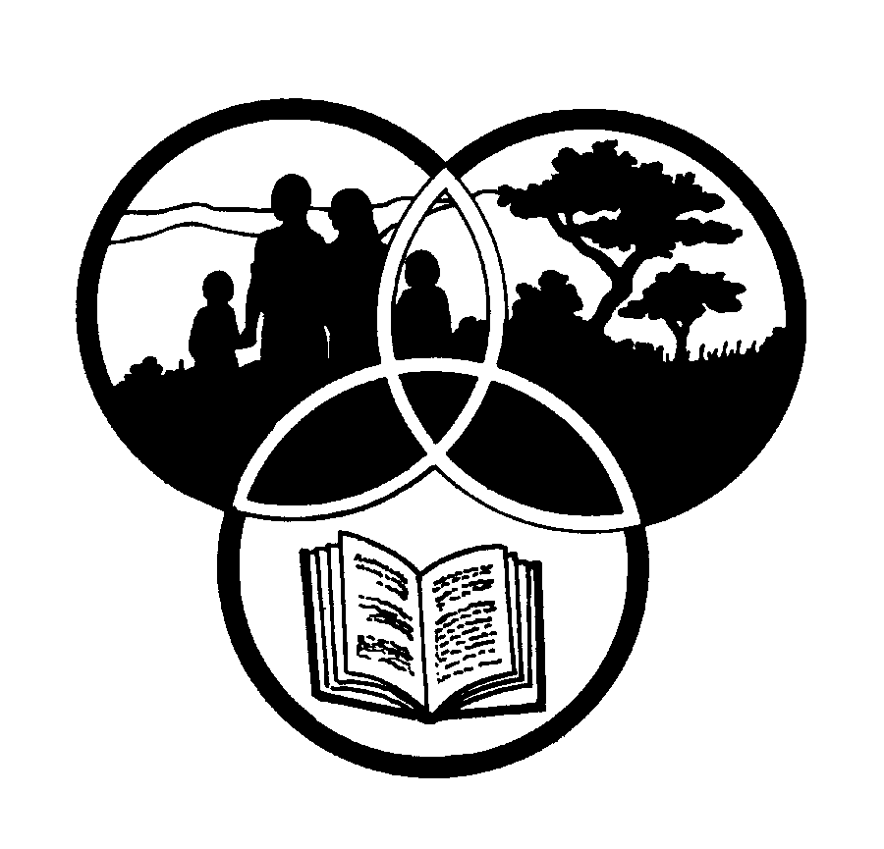
Share-Net

Share-Net is an informal partnership project committed to developing and disseminating materials in support of environmentally focused teaching and learning. Share-Net materials are copyright-free for educational purposes. We encourage you to adapt and use the materials in new, exciting ways but request that you acknowledge Share-Net as an original source. Sensible use of these curriculum activities is entirely the responsibility of the educator. Find similar curriculum materials by visiting www.envirolearn.org.za or contact Share-Net directly at PO Box 394, Howick, 3290, KwaZulu-Natal,
tel: (033) 330 3931, e-mail: sharenet@wessa.co.za
This pack supports an introduction for learners to an Eco-School’s focus on Healthy Living

Grade 11

This pack contains:
Activity One: During this LANGUAGES lesson, learners investigate how people’s everyday activities in the past contributed towards the prevention of cholera. This is followed by an individual self-study on a health issue in the area, related to water.

Activity Two: Audits and surveys are systems that allow us to look and examine things the way they are. This enables us to understand something better and improve it if need be. This LIFE SCIENCES activity allows learners to conduct a pre-designed audit on their school toilets, and then develop a survey around how the current situation can be improved.

Activity Three: This DRAMATIC ARTS lesson encourages learners to look for different solutions and appropriate courses of action around access to water and sanitation, through forum theatre.

Activity Four: During this LIFE ORIENTATION lesson, learners find out more about
State of the Environment Reporting. The class then chooses three themes, one of them
around water access and sanitation which they would like to investigate either
in their school or community. Learners take their findings further by
developing action plans.

Activity Five: Just for fun! Making soap - this PHYSICAL SCIENCES lesson gives instructions on how to make ‘Settlers Soap’.

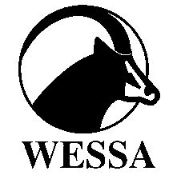
This pack of lesson plans is part of a series of lesson plans from Grade R to Grade 12 which focus on water and water-related issues. This resource development project has been funded by the Water Research Commission, Private Bag X 03, Gezina, Pretoria, 0031 (Website: www.wrc.org.za).
This pack is available electronically on www.wrc.org.za
Activity | Learning Area covered in this activity | Learning Outcomes covered in this activity | Assessment Standards covered in this activity
1. Learners investigate how people’s everyday activities in the past  contributed towards the prevention of cholera. This is followed by an individual self-study on a health issue in the area,  related to water. | Languages | Learning Outcome 1: Listening and Speaking. The learner is able to listen and speak for a variety of purposes, audiences and contexts. | The learner is able to demonstrate planning and research skills for oral presentations:  - Research a topic by referring to a range of sources;  - Organise material coherently by choosing main ideas and relevant and accurate details or examples for support;  - Prepare effective introductions and endings;  - Incorporate appropriate visual, audio and audio-visual aids such as charts, posters, photographs, slides, images, music, sound and electronic media.
2. This activity allows learners to conduct a pre-designed audit on their school toilets, and then develop a survey around how the current situation can be improved. | Life Sciences | Learning Outcome 1: Scientific inquiry and problem-solving skills. The learner is able to confidently explore and investigate phenomena relevant to Life Sciences by using inquiry, problem solving, critical thinking and other skills. | The learner is able to systematically and accurately collect data using selected instruments and / or techniques.  - As a member of a team (class) carries out a survey in selected areas;  - Recognises that people responding to the survey may not give accurate answers for a variety of reasons.  Analysing, synthesising, evaluating data and communicating findings.  - The learner prepares and submits an article for the school newspaper or newsletter describing the research and findings.
3. Learners look for different solutions and appropriate courses of action around access to water and sanitation, using forum theatre | Dramatic Arts | Learning Outcome 4: Reflect and Evaluate. The learner is able to reflect on and evaluate own and others’ dramatic processes, practices and products. | The learner is able to analyse how a drama relates to:  - own personal experience;  - human commonality and diversity.
4. Learners find out more about  State of the Environment Reporting. The class chooses three themes, one of them  around water access and sanitation, which they would like to investigate either  in their school or community. | Life Orientation | Learning Outcome 2: Citizenship Education: The learner is able to demonstrate an understanding and appreciation of the values and rights that underpin the Constitution in order to practice responsible citizenship, and to enhance social justice and environmentally sustainable living. | The learner is able to participate in a community service that addresses a contemporary social or environmental issue, indicating how it can harm certain sectors of the society more than others.
5. Just for fun! Making soap - how to make ‘Settlers Soap’. | Physical Sciences | - | -

