Water and our Health

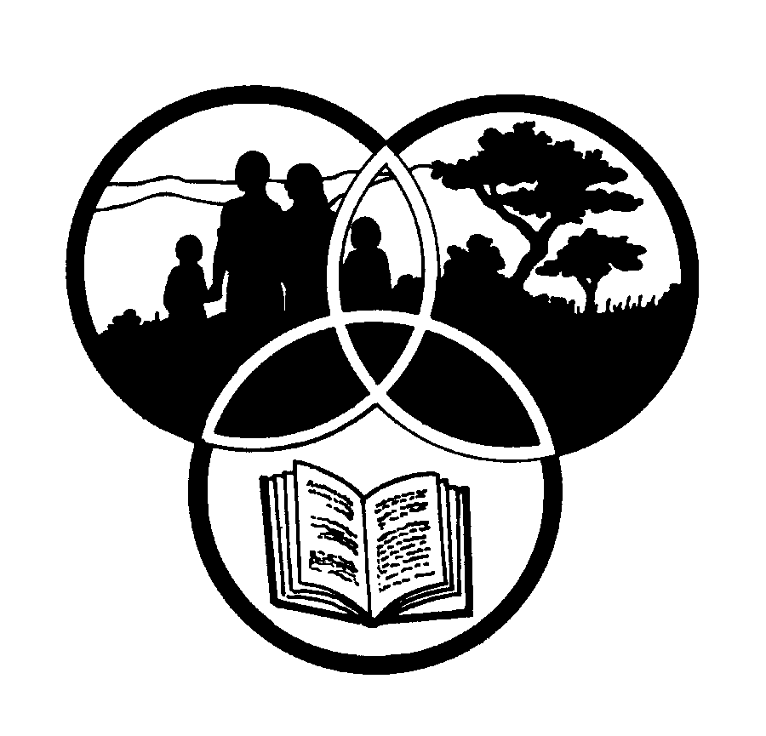
Share-Net

Share-Net is an informal partnership project committed to developing and disseminating materials in support of environmentally focused teaching and learning. Share-Net materials are copyright-free for educational purposes. We encourage you to adapt and use the materials in new, exciting ways but request that you acknowledge Share-Net as an original source. Sensible use of these curriculum activities is entirely the responsibility of the educator. Find similar curriculum materials by visiting www.envirolearn.org.za or contact Share-Net directly at PO Box 394, Howick, 3290, KwaZulu-Natal,
tel: (033) 330 3931, e-mail: sharenet@wessa.co.za
This pack supports an introduction for learners to an Eco-School’s focus on Healthy Living

Grade 12

This pack contains:
Activity One: During this LIFE ORIENTATION lesson, learners consider safe and healthy living in our communities.

Activity Two: This LIFE SCIENCES lesson looks at the effects of biodegradable waste on dissolved oxygen. Learners conduct an experiment and then graph and write a report on their investigation which they present to the rest of the class.

Activity Three: This LANGUAGES lesson focuses on the art of speech making. Learners choose three water and water-related topics from a given list and then write and deliver introductions for each chosen topic.

Activity Four: During this LANGUAGES lesson, learners debate whether or not intercatchment transfers will solve South Africa’s water problems.

Activity Five: Just for fun! This LIFE SCIENCES lesson encourages learners to explore a nearby water source and assess the water quality by looking at visible animal life.

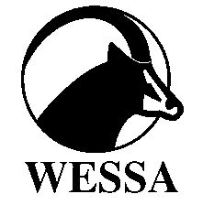
This pack of lesson plans is part of a series of lesson plans from Grade R to Grade 12 which focus on water and water-related issues. This resource development project has been funded by the Water Research Commission, Private Bag X 03, Gezina, Pretoria, 0031 (Website: www.wrc.org.za).
This pack is available electronically on www.wrc.org.za
Activity | Learning Area covered in this activity | Learning Outcomes covered in this activity | Assessment Standards covered in this activity
1. This lesson encourages learners to consider safe and healthy living in our communities. | Life Orientation | Learning Outcome 1: Personal Well-being: The learner is able to achieve and maintain personal well-being.  Learning Outcome 2: Citizenship Education: The learner is able to demonstrate an understanding and appreciation of the values and rights that underpin the Constitution in order to practice responsible citizenship, and to enhance social justice and sustainable living. | Investigate the human and environmental factors that cause ill health, accidents, crises and disasters, and explore appropriate ways to deal with them.  Evaluate services offered by a community project on a contemporary social or environmental issue, and evaluate own contribution to the project.
2. This lesson looks at the effects of biodegradable waste on dissolved oxygen. Learners conduct an experiment and then graph and write a report on their investigation which they present to the rest of the class. | Life Sciences | Learning Outcome 1: Scientific inquiry and problem-solving skills. The learner is able to confidently explore and investigate phenomena relevant to Life Sciences by using inquiry, problem solving, critical thinking and other skills. | Analysing, synthesising, evaluating data and communicating findings:  - Critically analyse, reflect on and evaluate the findings;  - Suggest specific changes that would improve the techniques used;  - Presents a report to the class in which they communicate their findings.
3. This lesson focuses on the art of speech making. Learners choose a few water and water-related topics from a given list and then write and deliver introductions for each chosen topic. | Languages | Learning Outcome 1: Listening and speaking. The learner is able to listen and speak for a variety of purposes, audiences and contexts. | Demonstrate planning and research skills for oral presentations:  - Research a topic by referring to a wide range of sources;  - Organise material coherently by choosing main ideas and relevant and accurate details or examples for support;  - Prepare effective introductions;  - Use tone, voice projection, pace, eye contact, posture and gestures correctly and respond appropriately.
4. During this lesson, learners debate whether or not intercatchment transfers will solve South Africa’s water problems. | Languages | Learning Outcome 1: Listening and speaking. The learner is able to listen and speak for a variety of purposes, audiences and contexts. | - The learner is able to participate in panel discussions, debates, forums and formal meetings, following correct procedures.  The learner demonstrates planning and research skills for oral presentations:  - Researches a topic by referring to a wide range of sources;  - Organises material coherently by choosing main ideas and relevant and accurate details or examples for support;  - Prepares effective introductions and endings.
5. Learners explore a nearby water source and assess the water quality by looking at visible animal life. | Life Sciences | - | -

