ACTIVITY ONE: WHERE DOES RAIN COMES FROM?

This listening and writing LANGUAGES activity looks at the
water cycle. It follows the adventures of Drip the Drop who starts
his journey in the sea, goes on an amazing adventure,
and eventually returns back to the ocean, only to start
his adventure again!

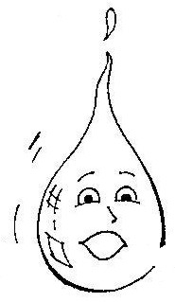
READ THE FOLLOWING STORY TO YOUR CLASS:

From Sea to Sky

Far out at sea, Drip the Waterdrop floated with his friends. Drip rolled over slowly in the sunlit ocean. The warmer he got, the harder it was for him to stay still. “I feel jumpy”, he said.

Suddenly he was gone! Drip’s friends vanished too, they burst from the water’s surface and disappeared. They had evaporated. (Do the children know what you mean when you say ‘evaporated’? Have any of them walked or driven through mist? It’s like walking through floating teeny tiny raindrops – that is what has happened to Drip). Drip was now a misty, invisible vapour (teeny tiny, “too small to see”, water droplet) floating up to the sky. “I’m finally rid of that itchy salt” he said. “Who wants to be seawater anyway?”

No one answered Drip. His friends were rising too quickly. Winds carried Drip and his friends over the huge ocean towards the land. As he floated through the air, Drip gasped “What a view! But we are so high up in the sky! Those birds way down there look like tiny dots”.

As Drip floated over the land, more drops evaporated and joined him. “Hey, where did all of you come from?” Drip shouted. “I came from the salty sea”. “We came from the damp forests, lakes and rivers down below”, they all shouted back.

From Cloud to Rain

Soon the air got cooler and the droplets crowded closer together. They gathered so close that they formed a thick cloud. “Boy, it’s getting dark in here!” whispered Drip, a bit afraid. The air got even cooler. “I feel wet”, Drip murmured. He and his friends were condensing, or changing from mist into raindrops.

Kaboom! With a flash and a crash, lightning ripped through the clouds. The raindrops began falling. “Ummpff” groaned Drip as he splashed onto a rock and rolled onto the ground. “Now where are we going?” he asked some friends who had splashed down next to him. Nobody answered him because nobody knew.

From Stream to River

The water drops joined together and sped along as part of a tiny stream. They played games as the stream flowed through the grasses and rocks. “I’ve got you!! You’re on!” Drip shouted as he caught another drop. Instead of being on, though, the drop disappeared!! “Wait!” yelled Drip. “That’s not fair. Where did you go?”

But the drop couldn’t answer. It had soaked into the ground and was on its way to join millions of other drops in an underground lake. A short time later, Drip’s tiny stream joined another tiny stream to form a bigger one. This steam joined others until they all grew so big that they became one great, wide river.

The force of the flowing water amazed Drip. He and his friend held fast to each other as they bounced off the rocks, whipped around the bends, and splashed all over the place.

A Dirty Journey

After a long while, the river began to slow down. Drip drifted along, silent for once. Until …. “Oomph! What was that?” Drip cried as a floating object bumped into him. Looking about, he spied crushed cartons, bobbing cans and cups, and globs of tar all around him. “How did I get into this disgusting mess?” he wondered.

Drip edged away trying to find a cleaner place. Then all at once, everything went dark. “Oh no”, he moaned. Gushing from some pipes on the river’s edge was dirty water from a nearby town. And running into the river from the farms was a flood of mud! Drip and his friends moved blindly through this mess.

“If waterdrops had to breathe, we’d choke to death on all this rubbish and dirty water”, he complained to his friends. “Why do people allow this to happen? Don’t they care?”

As the river widened, more water flowed with Drip and his friends. More drops helped carry the dirty load downstream. Drip just missed being swallowed by an open bottle that was slowly sinking. In making his escape, he ran right into a large clump of water grass. Further along, more grass, reeds and other water plants spread out in a huge wetland. All the drops had to drift through it. When they got to the end of the wetland, they were much cleaner!

“Where did that disgusting junk go?” Drip asked. Then he realised that the leaves, stems and roots of the plants had trapped much of the rubbish, dirt and chemicals.

Back at Sea

Drip and his friends passed out of the wetland and into a large bay. Just as he looked to the horizon, he noticed a funny taste. It seemed familiar. Then he remembered and understood. “Well! What do you know! We’re back where we started”, Drip exclaimed as he and his friends rode the top of the big wave. “So, where do you think the sun and the wind will send us next time?” No one knew but wherever they were sent the next time round, it was sure to be a great adventure again!!

Writing Activities:
- After reading the ‘water cycle’ story to your learners, get the children, either individually or in groups to discuss and write down an appropriate title for the story they have just heard. Each child then needs to share his or her title or group’s title with the rest of the class.

- Each child can now write a few lines on their own personal experience within the water cycle. They may like to write about what it felt like to be caught in the rain, or when they went swimming in a river/dam, or an outing to the beach/sea.

- For homework or in class, let the children colour in the water cycle worksheet provided on the next page.

Criteria to assess learners during this languages lesson

Criteria | Exceeded requirements of the Learning Outcome | Satisfied requirements of the Learning Outcome | Partially satisfied requirements of the Learning Outcome | Not satisfied requirements of the Learning Outcome
The learner listened to the story, without being distracted or distracting
The learner was able to share ideas in the group or with the teacher about a possible title for the ‘Drip the Drop’ story
The learner was able to write a simple, short story about a personal experience
The learner formed the letters of his/her story clearly and easily
The learner used basic punctuation (capital letters and full stops)

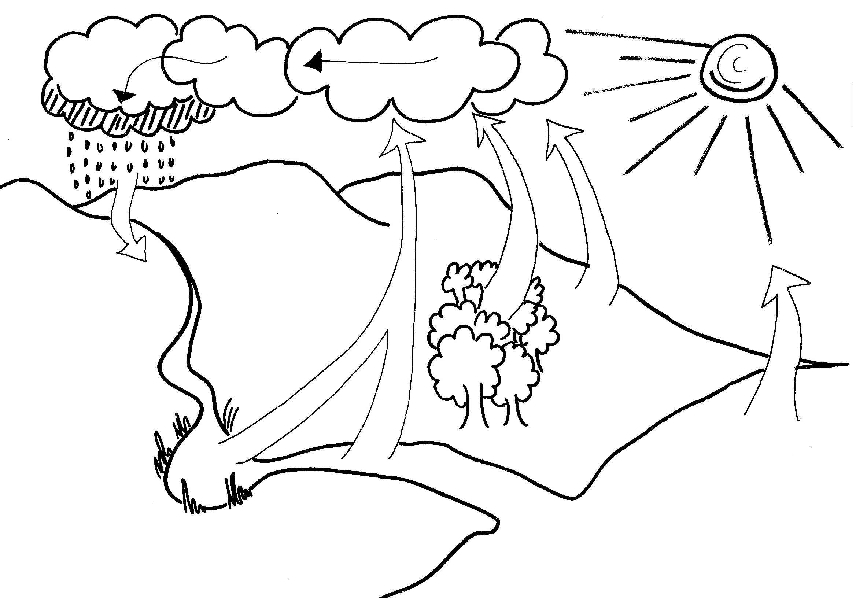

ACTIVITY TWO: MOVING AND SHAKING!

This ARTS AND CULTURE activity follows on from the story of
the water cycle in Activity One with learners having fun
expressing the story in different physical ways.

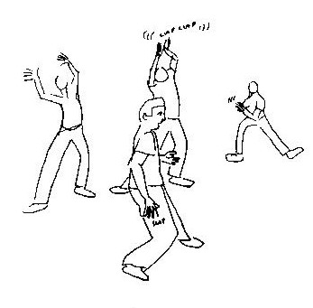
Getting Started – a space for drama
Create a physical space that encourages participation. If you are in a classroom, clear the desks and chairs to the side to create an open space. Make sure there is place for everyone to move or sit in a circle.

Warming Up
It is a good idea to take the class through some warm-up activities. Warming up in drama is more than just a physical warm-up, it also helps to build a group spirit and encourages the learners to focus (if they are too active it helps calm them down; if they seem lethargic and lazy, it will help you to energize them!!)

Warming Up 1: Walking around the space
- Everyone in the class should walk around the space that you have created. Each child can walk in any direction they like and change direction as often as they want to. However, they must be careful not to bump into other learners.
- Each time you clap your hands, the learners must change direction.
- Everyone to:
- Walk
- Run
- Skip
- Hop
- Leap
- Jump
- Gallop (like a horse)
- Slide
- Move sideways
- Move backwards
- Move diagonally
- Turn around
- Call out different situations to your learners and they must change the way they are walking for each situation. (They must also change their facial expressions!)
  - You are walking on hot coals
  - You are taking a puppy for a walk
  - You are swimming through syrup
  - You are walking on ice
  - You are jumping from puddle to puddle

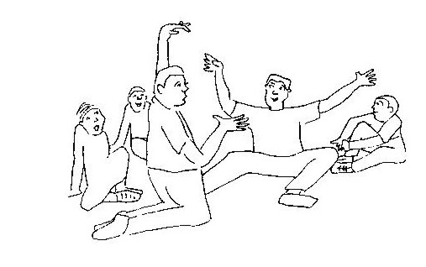
Warming Up 2: Making body shapes
- While the children are walking around the room, call out a number. The children need to quickly get into a group of that number and keep walking. For example, if you call out “two”, the children must pair up with someone, link arms, and keep walking. They must not stop walking or worry about who they have paired up with – they must pair up with the closest person. If you call out “four”, the four closest children must pair up with each other.
- After this has been done a few times with different numbers, get the children into groups of five or six. Call out different shapes, and each group should make that shape with their bodies, for example “square” …. “rectangle”… “triangle” …. “circle”. The children can make the shape standing up, sitting or lying down but everyone in the group must be part of the shape.
- Since our theme in this series of lesson plans is WATER, get the children to form the letters W A T E R.

Using a shortened version of the story in Activity One, the children need to act out the water cycle story as you read it to them. They need to use their bodies and change their facial expressions as you read the story but not utter a word!! Remind them to be careful not to bump into others as they pretend to be a little water droplet on an exciting adventure!

Are the children ready? Let’s start reading ….

Far out to sea, Drip the Waterdrop floated with his friends. Drip rolled over slowly in the sunlit ocean. The warmer he got, the harder it was for him to stay still. “I feel jumpy”, he said.

Suddenly he was gone! Drip’s friends vanished too, they burst from the water’s surface and disappeared. They had evaporated. Drip was now a misty, invisible vapour floating up to the sky.

Winds carried Drip and his friends over the huge ocean towards the land. As he floated through the air, Drip gasped “What a view! But we are so high up in the sky! Those birds way down there look like tiny dots”.

Soon the air got cooler and droplets crowded closer together. They gathered so close that they formed a thick cloud. “Boy, it’s getting dark in here!” whispered Drip, a bit afraid. The air got even cooler. “I feel wet”, Drip murmured.

Kaboom! With a flash and a crash, lightning ripped through the clouds. The raindrops began falling. “Ummpff” groaned Drip as he splashed onto a rock and rolled onto the ground.

The water drops joined together and sped along as part of a tiny stream. They played games as the stream flowed through the grasses and rocks. “I’ve got you!! You’re on!” Drip shouted as he caught another drop.

A short time later, Drip’s tiny stream joined another tiny stream to form a bigger one. This steam joined others until they all grew so big that they became one great, wide river.

The force of the flowing water amazed Drip. He and his friend held fast to each other as they bounced off the rocks, whipped around the bends, and splashed all over the place.

After a long while, the river began to slow down. Drip drifted along, silent for once. Until …. “Oomph! What was that?” Drip cried as a floating object bumped into him. Looking about, he spied crushed cartons, bobbing cans and cups, and globs of tar all around him. “How did I get into this disgusting mess?” he wondered.

As the river widened, more water flowed with Drip and his friends. More drops helped carry the filthy load downstream. Drip just missed being swallowed by an open bottle that was slowly sinking. In making his escape, he ran right into a large clump of water grass. Further along, more grass, reeds and other water plants spread out in a huge wetland. All the drops had to drift through it. When they got to the end of the wetland, they were much cleaner!

Drip and his friends passed out of the wetland and into a large bay. Just as he looked to the horizon, he noticed a funny taste. It seemed familiar. Then he remembered and understood. “Well! What do you know! We’re back where we started”, Drip exclaimed as he and his friends rode the top of a big wave. “So, where do you think the sun and the wind will send us next time?” No one knew but wherever they were sent the next time round, it was sure to be a great adventure again!!

Once the story and the acting is over, let the children sit down. Ask them:

- What was that like?
- Was it fun?
- Was it easy to do without saying a word?
- How did you feel?

- Were there parts of the story that I was reading that you didn’t know what face to pull or how to make your body move? (If there are many children who felt unsure of what to do, you can show them how one would feel to ‘float through the air’ as Drip did, or a facial expression of disgust as Drip saw all the dirty water around him. You may also like to go through the story again, acting it out with the children so that those who are unsure, can follow your lead.

Remind the children constantly that this is a fun activity and other than being careful and thoughtful of walking or bumping into someone else (no one must get hurt during these drama activities), they are free to be as expressive and creative as they like. No-one will laugh or scold them and they are all encouraged to participate and contribute their movements and facial expressions.

Criteria to assess learners during this arts and culture lesson

Criteria | Exceeded requirements of the Learning Outcome | Satisfied requirements of the Learning Outcome | Partially satisfied requirements of the Learning Outcome | Not satisfied requirements of the Learning Outcome
The learner was able to role play Drip the Drop during the story told by the teacher
The learner was able to express his/her feeling in their facial and body movements during the story of Drip the Drop
The learner was able to demonstrate the eight basic locomotor movements (walk, run, skip, hop, leap, jump, gallop and slide)

ACTIVITY THREE: CREATE YOUR OWN WATER CYCLE

This NATURAL SCIENCES activity is a fun way
of looking at part of Drip the Drop’s journey!

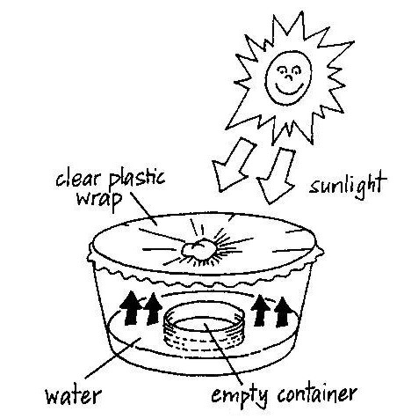
You may like to read the story of Drip the Drop (Activity One) again, before you start this natural sciences activity.

Creating our own water cycle!
Individually if you have enough bowls, containers and clingwrap,
or in groups if these materials are in short supply, let the learners:
- Mix some salt in a glass of water. Make sure
it dissolves.
- Place a small container in the centre of a
larger bowl.
- Pour the salty water around it into the large
bowl, NOT into the small container. Make sure
that no water splashes into the small container.
- Cover the top of the larger bowl with clear plastic wrap, making sure that it seals firmly. (It must be airtight).
- Put a small stone in the centre of the plastic wrap, directly above the centre of the smaller container.
- Place the bowl in direct sunlight.

(If the children are working in small groups, each child needs to contribute to the experiment in some way and so the group needs to decide who will do what).

What happens?
The water will evaporate as a result of the heat of the sun and will condense on the plastic wrap and drip into the smaller container like rain.

Questions to ask the children:
- Why do you think we added salt?
- What has happened to the salty water in the larger bowl?
- Is there any water in the smaller container? Taste it! What does it taste like? Remind the children of the story of Drip the Drop and how he lost his saltiness when he evaporated out of the ocean and into the sky.
- What do you think would have happened to the water if we had left the clingwrap off?
- What task did each child do? How did the group decide who would do what?

Remember that in the natural water cycle, the water that falls to Earth as rain, would eventually reach the ocean again and the cycle would continue. In our experiment above, we are not completing the full cycle as the evaporated water is not returning to the salty ‘seawater’.

Criteria to assess learners during this natural sciences lesson

Criteria | Exceeded requirements of the Learning Outcome | Satisfied requirements of the Learning Outcome | Partially satisfied requirements of the Learning Outcome | Not satisfied requirements of the Learning Outcome
The learner discussed with the teacher (if done individually) or in the group who was going to do what during the construction of the water cycle system
The learner played a role in carrying out instructions given by the teacher
The learner could explain what he/she did during the construction of the water cycle system
The learner was curious about what might happen if the clingwrap was left off the larger bowl

ACTIVITY FOUR: DRIP THE DROP’S JOURNEY
TO OUR TAP

This LIFE ORIENTATION lesson makes use of a fun comic story to encourage learners to discuss sources of clean and unclean water and simple water purification methods.
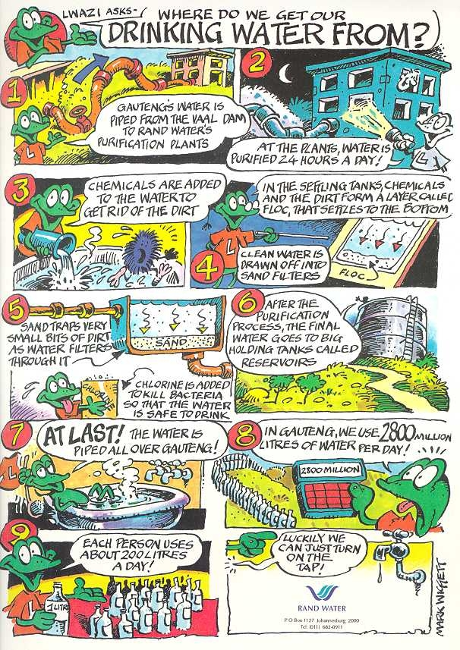
Read the comic story of ‘Where do we get our drinking water from?’ to your class. If you are able to photocopy the story onto an overhead transparency, please do. Even better, print out the story so that each child gets their own copy.

ACTIVITY:
- Have a jug of water and plastic/paper cups in the classroom. Let each learner drink some water.
  - What does the water taste like?
  - Does it taste the same as the water they drink at home?

Teacher, find out: How does the school get its water?
How do you know that it is clean?

QUESTIONS TO ASK THE LEARNERS:
- How do we know that the piped water that Rand Water takes to the people in Gauteng, is clean? (You may need to go through the comic story again and explain the processes of adding chemicals, filtering and finally adding chlorine to kill the bacteria).

- Where would we find clean water, good for us to drink?

- Where would we find dirty water, not good for us to drink?

- Do any of you live in areas where you are not sure if the water is clean or not?

- Do any of you know of any simple way that you can clean (purify) your drinking water (especially if you are collecting it from a river or spring and are not sure that it is clean). (Show the learners the two simple methods of water purification that follow and then make sure that each child is able to describe what you did).

- A simple way of purifying water is to add a teaspoon of jik to every 25 litres of water. Jik is very strong and kills all the bacteria, making the water safe to drink.

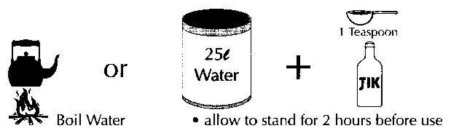
- You can also boil the water, and that will kill any germs or bacteria that may be living in it. The water can then be left to cool (it does not need to be drunk hot).

Criteria to assess learners during this life orientation lesson

Criteria | Exceeded requirements of the Learning Outcome | Satisfied requirements of the Learning Outcome | Partially satisfied requirements of the Learning Outcome | Not satisfied requirements of the Learning Outcome
The learner was able to describe sources of clean and unclean water
The learner was able to describe the two simple water purification methods, shown to them by the teacher

ACTIVITY FIVE: JUST FOR FUN!

Have fun with your learners constructing a mobile which will
represent the different plants and animals found in
the different levels in a pond or stream.
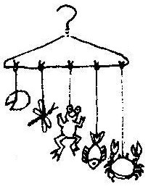
Each learner will need:

- an old wire coat hanger
- string
- cardboard
- crayons
- scissors

Level 1: Water plants or those found in wetland areas such as bulrushes and reeds

Level 2: Just above the water surface (animals like
dragonflies)

Level 3: Water surface (such as water striders or a frog on a lily pad)

Level 4: Just below the surface (fish and tadpoles)

Level 5: Base of the river or pond (animals like crabs)

