ACTIVITY ONE: HOW MUCH WATER DO I USE?

This week-long MATHEMATICS activity encourages young learners to take careful note of the water they use by keeping a water diary of their daily water use.

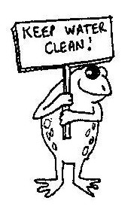
Water is very important to us as we cannot live without it. Did you know that 75% of our body is made up of water and the longest we can go without drinking water is 3 to 4 days! With more and more people needing clean water there is a greater demand for water in our country.

Sadly, water pollution is very common in South Africa. One of the most common pollutants comes from wastewater from towns, especially where people do not have sewage and water cleansing facilities. Water pollution can cause health problems so we need to make sure that we do not pollute the water supplies that we have. We also need to make sure that we use water carefully and wisely and not wastefully.

In order to be more careful about the water we use, we need to look at how much water we each use every day. We can do this by keeping a daily water diary.

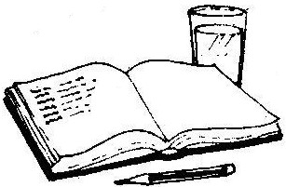
ACTIVITY:
- Hand out the ‘My Water Diary’ provided on page 3. Let the children keep a water diary of all the activities where they use water, during the school day. You can make it a day diary, that is, for one day they record every time they use water. Or, you could be more ambitious and get the learners to keep the diary for a week.

The following amounts are rough estimates of water use, which may help the learners when calculating their water usage.

- Cup of water/juice – 250ml
- Flushing toilet - 13 litres
- Having a short shower (10 minutes) – 30 litres
- Having a long shower – (30–40 minutes) – 120 litres
- Washing hands (with water running ) – 5 litres
- Washing hands (without the tap running) – 1 litre

- At the end of the day / week, get the learners to draw a bar graph of their water use at school.

  - Discuss with your class where most of the water is being used.
  - Is it possible for the learners to save water during their daily activities? How?

You may want to take this activity further and get the children to extend their water diary to include after-school activities (such as having a bath/shower at home, helping to wash a car or their bicycle or watering the home vegetable garden or flower beds).

More estimates for the learners to use if you extend this activity to after-school activities:

- Brushing teeth (with water running) – 2 litres
- Having a bath – 90 litres
- Washing a sinkful of dishes – 18 litres
- Washing the car (with a hosepipe) - 50 litres
- Watering the garden (15 minutes) - 50 litres
- Washing clothes in an automatic washing machine – 250 litres
- Washing clothes in a twin tub machine – 40 litres
- Topping up the pool - 4 000 litres

Remember, if the children recycle their bath water at home and use it for watering flowers or vegetables, they will still need to record this, 90 litres, for a bath but there will be ‘0 litres’ in the amount of “how much water did I use” column for watering the garden – see example below.

Day | Time | What did I do? | How much water did I use?
Monday | 6pm | Had a bath | 90 litres
Monday | 6.30pm | Watered the vegetable garden with the bath water | 0 litres

Criteria to assess learners during this mathematics lesson

Criteria | Exceeded requirements of the Learning Outcome | Satisfied requirements of the Learning Outcome | Partially satisfied requirements of the Learning Outcome | Not satisfied requirements of the Learning Outcome
The learner was able to fill in the time on the ‘My Water Diary’ worksheet
The learner was able to collect information (data) during the time they spent at school and correctly write it down in their water diary
The learner was able to draw a bar graph of the data from their water diary

My Water Diary Name:_______________________

Day | Time | What did I do? | How much water did I use?
e.g. Monday | 7.30am | Flush toilet | 13 litres

ACTIVITY TWO: A WALK ALONG TWO RIVERS

This LANGUAGES exercise encourages learners to discuss and write
about their experience of walking along two rivers, one clean and beautiful
and one dirty and polluted.

ACTIVITY:
- Hand out the River A worksheet. As a class, let the children discuss what they see – what creatures and plants can they see, have any of them ever been to a beautiful river or stream (when, with who, how did they get there, can they remember where it was?); how do they feel when they see a river like this?

- Hand out the River B worksheet. As a class, let the children discuss what they see – ask them what creatures and plants can they see (if any), have any of them ever been to a river or stream that looks like this (when, with who, how did they get there, can they remember where it was?); how do they feel when they see a river like this?
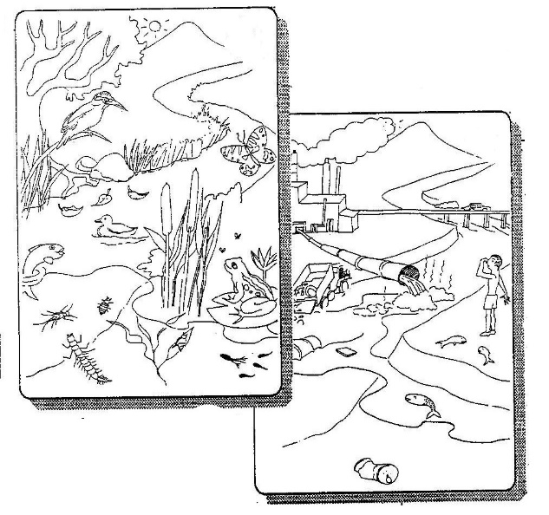

River A

River B

Ask the children:

- Which river would you like to swim in or drink from?

- Why has River B become polluted? (Possible answer: The plant and animal life has been destroyed. There are horrible smells and toxic human pollutants emptying into the water which have killed the river animals and plants. This means that the river is ‘dying’. The river can no longer cleanse itself and it is a health hazard and unpleasant to be near).

- How can we get River B to look like River A? (Some ideas: Cleanse our waste before it leaves the factories and towns. Stop human pollution going into the river. Plant indigenous trees along the banks – this will reduce the noise and disturbance, make the river a beautiful place to be, create homes for birds and animals. Can the children think of some laws (they can make up their own) to protect our rivers, streams and fresh water?)

- Why should we try to keep all our rivers in South Africa like River A? (Possible answers: To make sure that we always have clean water for drinking and other human uses; to make sure that animals and plants have places to live; to make sure that we look after and conserve our beautiful places).

Having brainstormed ideas and emotions within the class, about the two rivers, the children can now write one or two paragraphs on which river they would rather swim and drink from and why.

They will also need to write a title for their piece of writing.

- For the keen artists in the class, let the children take the two river worksheets home and colour them in. Or better still, draw their own rivers and colour them in! An additional “An African River” colour-in worksheet is also available at the end of this activity.

- If your school is fortunate enough to live close to a river or stream, why not consider taking the children for a walk along the river. It may be useful to divide the class into groups of 4 or 5 children, each with pen and paper so that they can make notes of what they see – plants, animals, litter, anything and everything! Your class and you may even decide to ‘adopt’ your nearby local river and ensure that it is kept clear of alien invasive plants and litter!

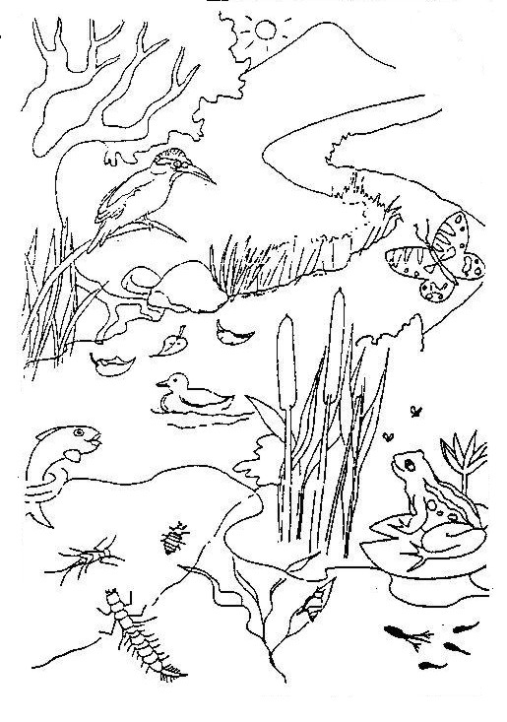
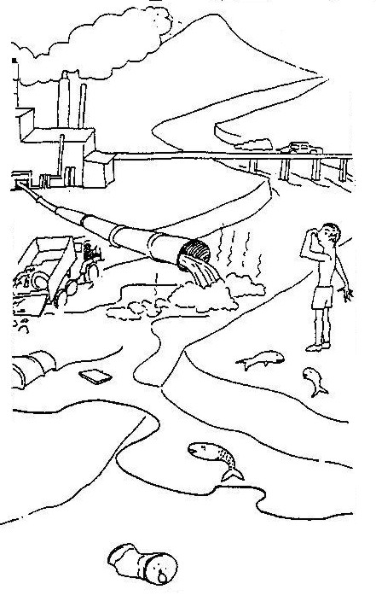
RIVER A WORKSHEET
RIVER B WORKSHEET

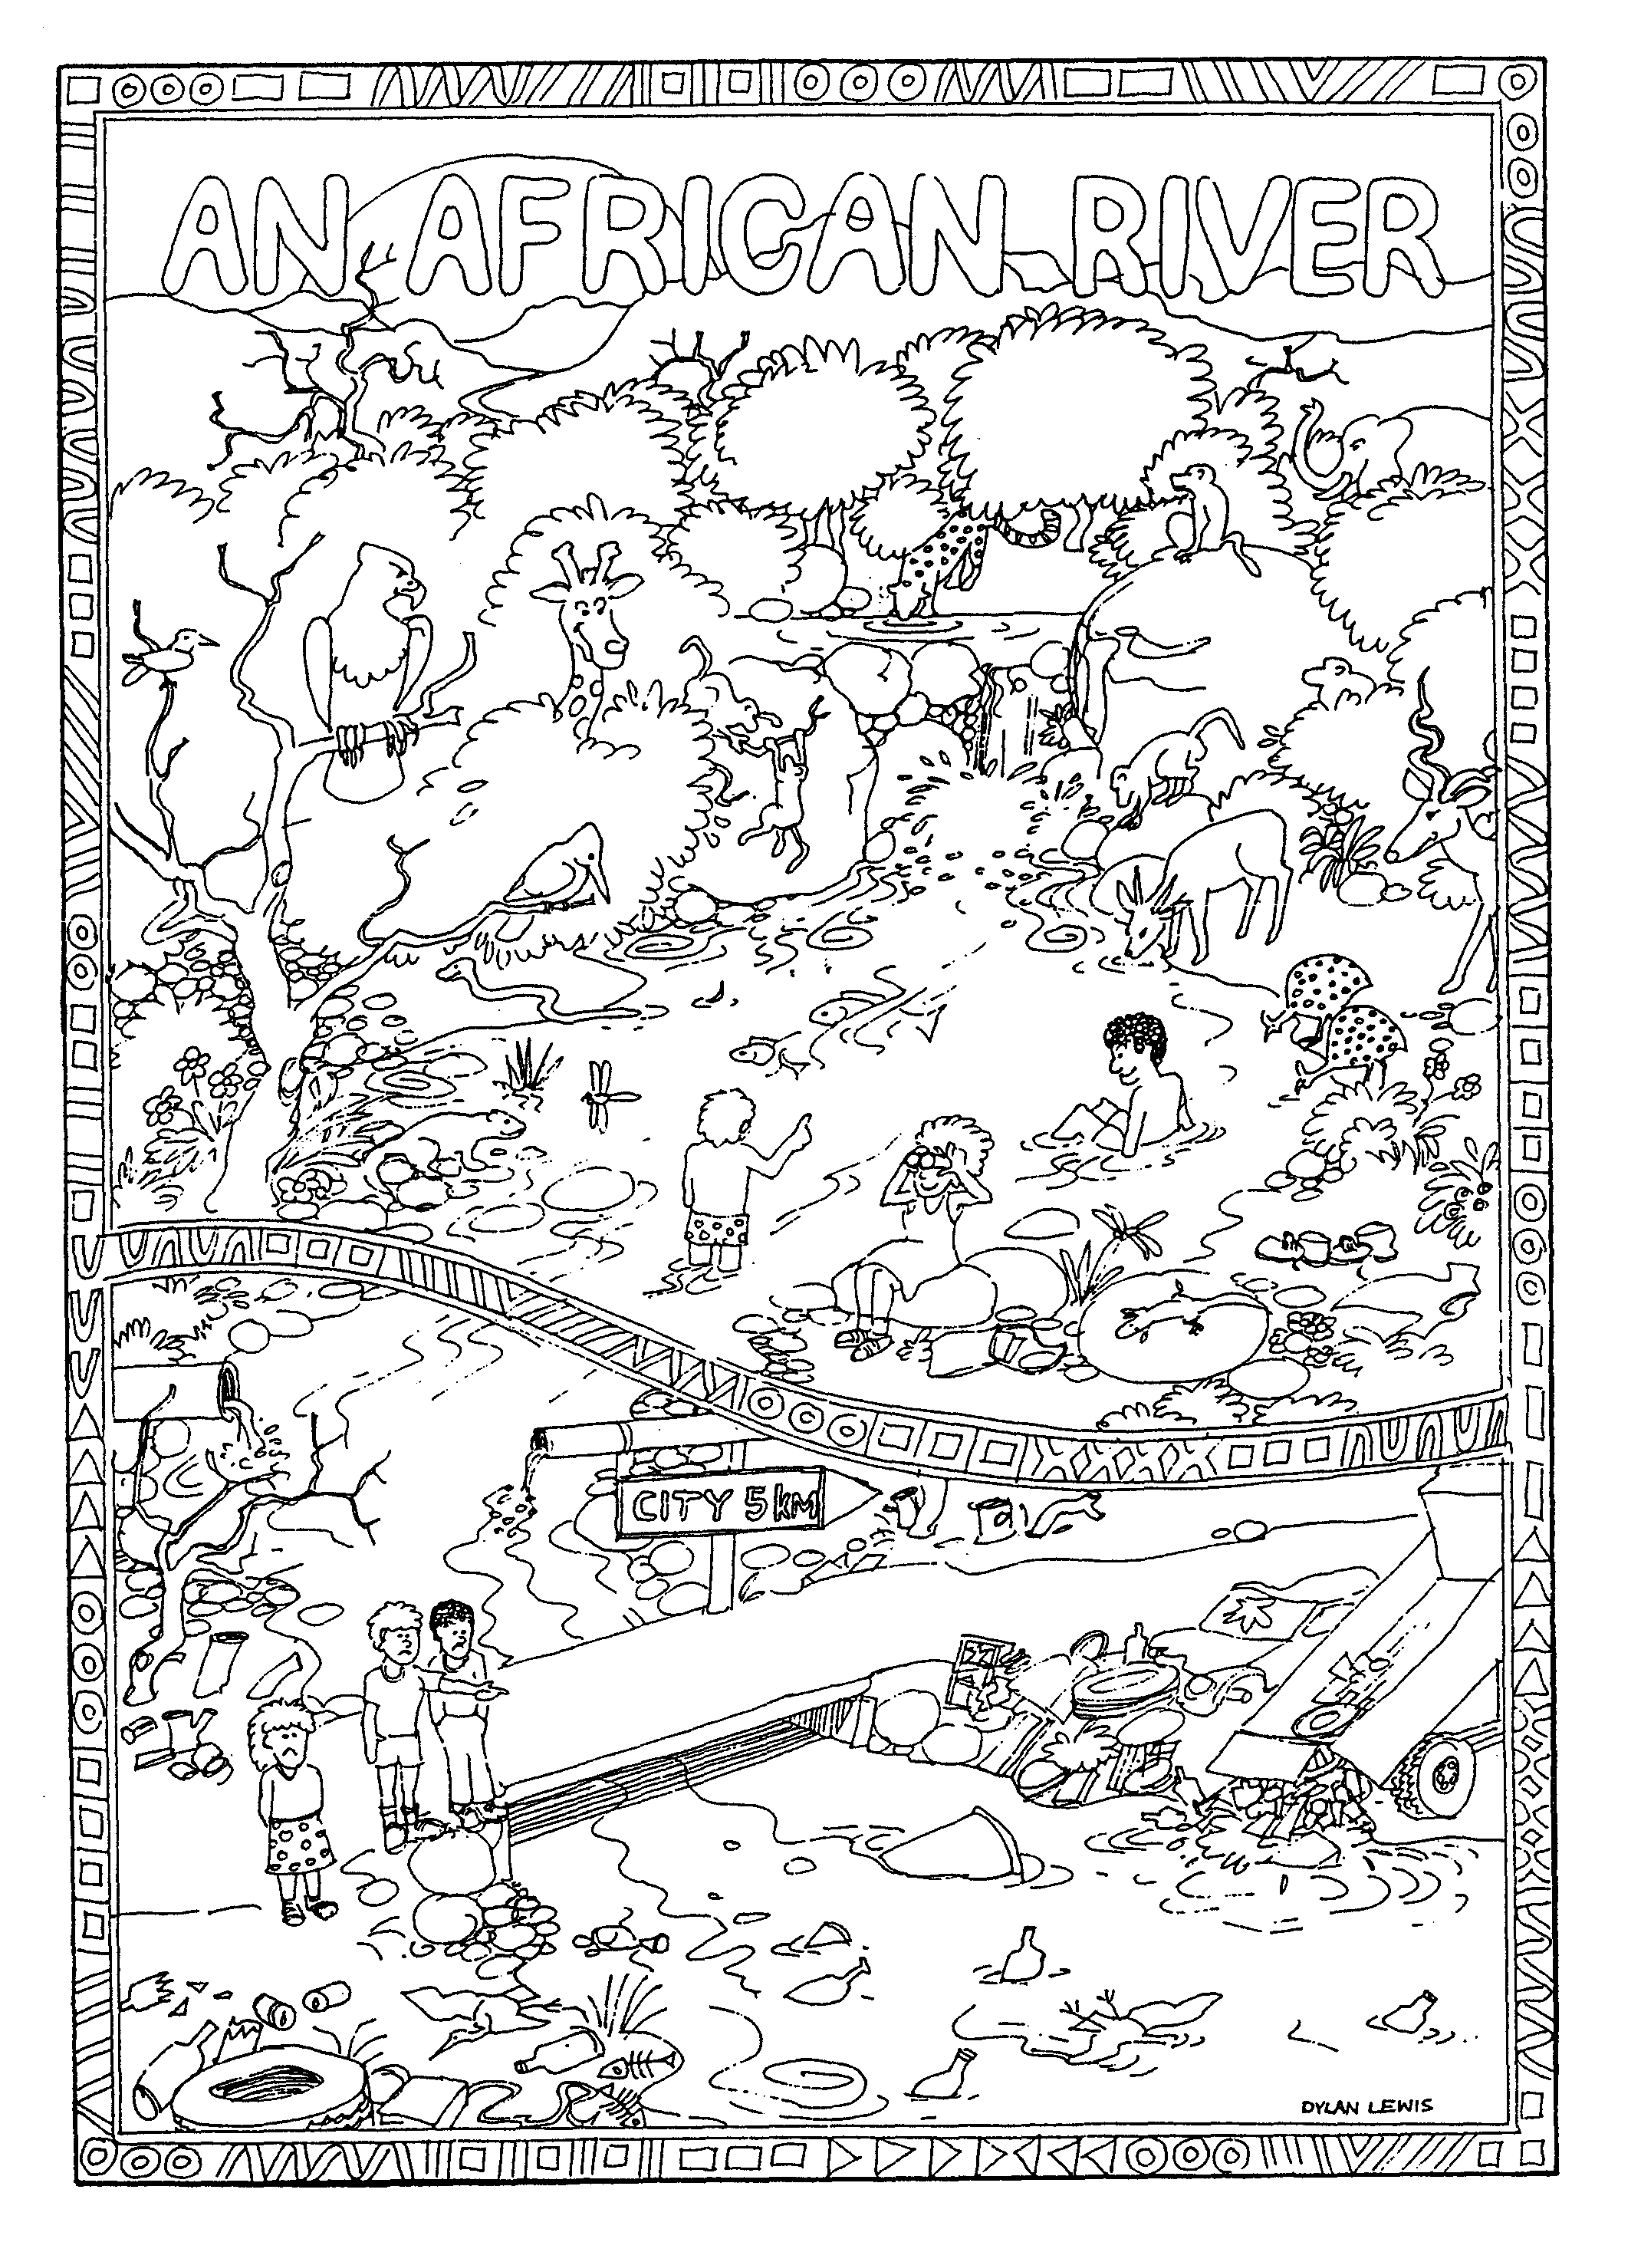
Criteria to assess learners during this languages lesson

Criteria | Exceeded requirements of the Learning Outcome | Satisfied requirements of the Learning Outcome | Partially satisfied requirements of the Learning Outcome | Not satisfied requirements of the Learning Outcome
The learner contributed answers and suggestions to questions asked about Rivers A and B
The learner spoke of a personal experience when visiting a river and/or expressed their own feelings when speaking about Rivers A and B
The learner wrote a one or two paragraph story on which of the two rivers they would rather drink from and swim in

ACTIVITY THREE: THE IMPORTANCE OF WATER, AT HOME, AT SCHOOL AND IN MY COMMUNITY

This NATURAL SCIENCES activity focuses on the importance of water in our lives and the problems of pollution. Learners summarise their ‘saving water’ and ‘how to stop water pollution’ group discussions with colourful posters.

Without water, no life could survive on our planet. It is precious and important and too many of us are wasting it! If we all learn to value and conserve our freshwater, there will be enough for everyone, now and in the future. Not only will there be enough for all people on the Earth, but there will be enough for all the animals and plants as well.

ACTIVITY:
- As a class, and using the questions below, the children can discuss the importance of water. Encourage them to think about who or what else needs water (not only people but animals and plants as well). Encourage the children to share their ideas on what causes water pollution and what are ways of reducing pollution.

The following questions can be used to prompt the class discussions.

- Why is water important to us?
- How would life be different with very little water?
- Is water only important to humans?
- How can we use water more wisely and carefully?
- How is water being polluted?
- How does polluted water affect us, our family and our friends?
- What can people do to reduce pollution in water?
- What can I do to reduce water pollution?
- What can people do to save or recycle water?
- What can I do to save or recycle water?

Divide your class in small groups of four or five learners. Half the groups can then draw up a list on “How to save water”, the other half on “How to stop water pollution”. Once the lists have been drawn up, the groups can each design a colourful, bright and eye-catching poster (with some of their ideas on it) and then display them in the classroom or around the school. An example of a list is given below:

“How to save water”
1. Switch taps off properly after you have used them.
2 Wash dishes in a shallow sink of water rather than washing them under a running tap.
3 Take shorter showers (5 minutes or less) or shallow baths. Showers generally save up to one third of water used.
4 Turn off the tap when brushing your teeth and washing your hair.
- Use stale drinking water to water plants rather than throwing it away.
- Reduce the amount of water used with each toilet flush by putting a cool drink bottle filled with stones into the toilet tank.
- Use rain barrels to collect water for gardening.
- In summer, water your garden early in the day (before 9:00am) or late (after 4pm) to minimise water loss through evaporation.

Did you know? You can save up to 4 400 litres of water a year by not letting
the water run while you brush your teeth!! Whew, that’s a lot of water – enough
to fill up a swimming pool!!

Criteria to assess learners during this natural sciences lesson

Criteria | Exceeded requirements of the Learning Outcome | Satisfied requirements of the Learning Outcome | Partially satisfied requirements of the Learning Outcome | Not satisfied requirements of the Learning Outcome
The learner was able to identify that water pollution was a problem (an environmental issue)
The learner was able to contribute towards the class discussions on what causes water pollution
The learner was able to contribute ideas on how to prevent water pollution
The learner was able to contribute ideas on how they could reduce water pollution
The learner was able to contribute ideas on how they could save water

ACTIVITY FOUR: WHERE IS THAT WORD HIDING?

This LANGUAGES activity encourages learners to use a dictionary before
they find the hidden words in the word search.

In an exercise book, let the children write down the words below and using dictionaries, let them look up the meaning of each word and write it down as well. If they have not already got a personal dictionary, they need to start one now. If they already have a personal dictionary, let them add any of the words below that are ‘new words’ to it.

Next, they need to find ALL the hidden words in the letter maze below. They need to remember that some of the words go up and down, some go back and forwards and others go diagonally.

1. water 4. river 7. health 10. factory
2. pollution 5. sewage 8. recycle
3. shortage 6. taps 9. clean

W | T | S | H | O | R | T | A | G | E
H | A | A | F | K | A | H | V | M | E
I | P | T | H | A | G | F | X | K | G
G | S | O | E | K | C | K | K | T | A
J | U | C | A | R | L | T | S | I | W
P | O | L | L | U | T | I | O | N | E
S | E | E | T | R | E | V | I | R | S
U | D | A | H | U | T | T | E | D | Y
F | J | N | E | T | L | D | O | D | H
T | U | E | L | C | Y | C | E | R | I

For the more adventurous learners, see how many words from the list can be used to make one complete (and sensible!) sentence.

Criteria to assess learners during this languages lesson

Criteria | Exceeded requirements of the Learning Outcome | Satisfied requirements of the Learning Outcome | Partially satisfied requirements of the Learning Outcome | Not satisfied requirements of the Learning Outcome
The learner was able to listen to and follow all the instructions regarding the word puzzle – using a dictionary to find out what the word means, writing the word and meaning down in their personal dictionary and then finding the word hidden in the maze
The learner used a dictionary
The learner added new words to their personal dictionary
The learner understood the meanings of any new words

ACTIVITY FIVE: JUST FOR FUN!

An interesting activity to try with your learners as they learn about water!

How do carrots drink?

Carrots are taproots – big roots that grow straight down into the ground. Roots hold the plant in place, keep soil around it, absorb nutrients, and move water from the soil to the leaves.
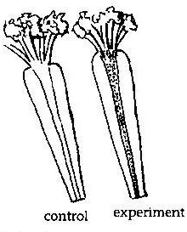
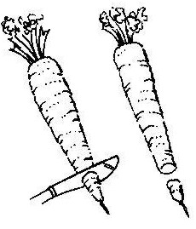
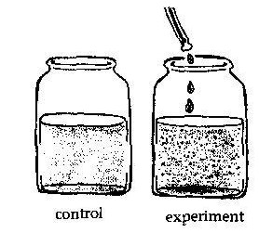
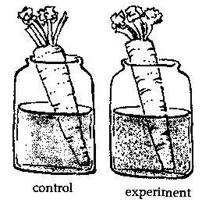

- Half fill two glass jars with water. To one jar add 10 drops of red (or blue or green) food colouring – this is the experiment. The plain water jar is the control.
- Choose two young fresh carrots that still have some leaves at the top. Cut the tips off both carrots and place one in each jar.
- Put the glass jars on a sunny windowsill and leave for three days so that the carrots can absorb water.
- Take the carrots out of the jars and slice in half lengthwise. (Don’t let the learners do this on their own – it is dangerous!) Compare the insides of the experiment and control carrots.

What is happening?
The coloured water has been pulled up through tiny channels in the centre of the carrot and has stained the carrot red. This is the water transport system that takes water and nutrients up to the leaves. Plants also have a sap transport system that flows both up and down the plant and transports food made in the leaves to the rest of the plant.

Reproduced from EnviroKids magazine with permission

