Water Creepy Crawlys
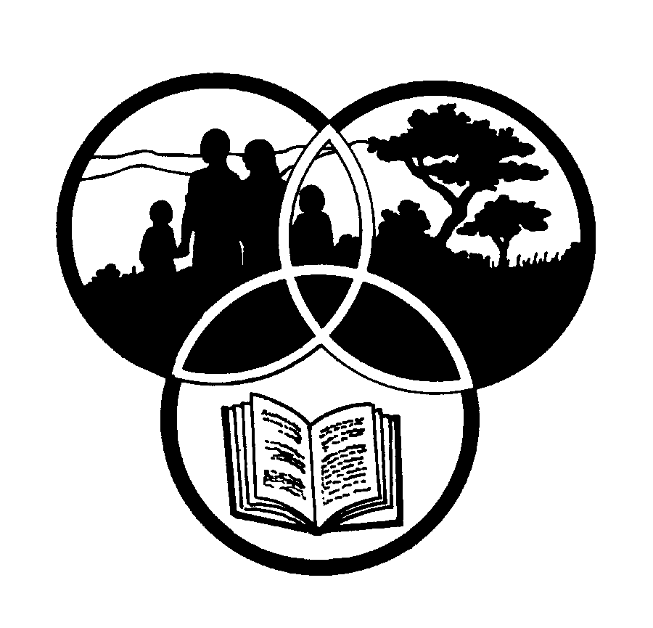
Share-Net

Share-Net is an informal partnership project committed to developing and disseminating materials in support of environmentally focused teaching and learning. Share-Net materials are copyright-free for educational purposes. We encourage you to adapt and use the materials in new, exciting ways but request that you acknowledge Share-Net as an original source. Sensible use of these curriculum activities is entirely the responsibility of the educator. Find similar curriculum materials by visiting www.envirolearn.org.za or contact Share-Net directly at PO Box 394, Howick, 3290, KwaZulu-Natal,
tel: (033) 330 3931, e-mail: sharenet@wessa.co.za
This pack supports an introduction for learners to an Eco-School’s focus on health and safety

Grade 4

This pack contains:
Activity One: Learners look for different water creatures during an explorative water investigation. This NATURAL SCIENCES activity should take place at a river, stream, dam, nearby wetland or pond.

Activity Two: Following Activity One, learners use MATHEMATICS to count and illustrate the numbers and types of creatures they found. As many water creatures are sensitive to water pollution, learners can also determine the overall health of the water they explored.

Activity Three: Certain water insects are known as ‘indicator species’. This means their presence in a river, stream or pond indicates polluted or unpolluted water. Within this LIFE ORIENTATION lesson learners look at the relationship between water insects and water quality and water insects and our health.

Activity Four: This TECHNOLOGY lesson encourages learners to think about the health of water and how to make water safe to drink. It also looks at how indigenous people collected clean and healthy water in the past.

Activity Five: This LANGUAGES writing exercise allows learners to imagine what
it would be like to be one of the water creepy crawlies that was caught
during their water study in Activity One!

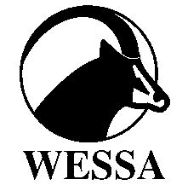
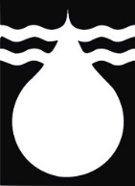
This pack of lesson plans is part of a series of lesson plans from Grade R to Grade 10, which focus on water and water-related issues. This resource development project has been funded by the Water Research Commission, Private Bag X 03, Gezina, Pretoria, 0031 (Website: www.wrc.org.za).
This pack is available electronically on www.envirolearn.org.za
Activity | Learning Area covered in this activity | Learning Outcomes covered in this activity | Assessment Standards covered in this activity
1. An explorative water investigation. | Natural Sciences | Learning Outcome 2: Constructing Science Knowledge: The learner will know and be able to interpret and apply scientific, technological and environmental knowledge. | - Recalls meaningful information: At the minimum uses own most fluent language to name and describe objects, materials and organisms.  - Categories information: Sorts objects and organisms by a visible property.
2.Learners measure, count and illustrate the numbers and types of creatures they found. As many water creatures are sensitive to water pollution, learners can also determine the overall health of the water they explored. | Mathematics | Learning Outcome 4:  Measurement: The learner will be able to use appropriate measuring units, instruments and formulae in a variety of contexts.  Learning Outcome 5: Data Handling: The learner will be able to collect, summarise, display and critically analyse data in order to draw conclusions and make predictions and to interpret and determine chance variation. | - Estimates, measures, records, compares and orders two-dimensional shapes and three-dimensional objects using S.I. units with appropriate precision for: mass using grams (g) and kilograms (kg).  - Uses appropriate measuring instruments to appropriate levels of precision including: bathroom scales, kitchen scales and balances to measure mass.  - Organises and records data using tallies and tables.  - Draws a variety of graphs to display and interpret data (ungrouped) including: bar graphs.
3. Certain water insects are known as ‘indicator species’. This means their presence in a river, stream or pond indicates polluted or unpolluted water. Learners look at the relationship between water insects and water quality and water insects and health. | Life Orientation | Learning Outcome 1: Health Promotion: The learner will be able to make informed decisions regarding personal, community and environmental health. | - Explores and reports on links between a healthy environment and personal health.
4. Learners think about the health of water and how to make water safe to drink. They also look at how indigenous people collected clean and healthy water in the past. | Technology | Learning Outcome 3:  Technology, Society and the Environment: The learner will be able to demonstrate an understanding of the interrelationships between science, technology, society and the environment. | Impact of Technology  - Expresses opinions about how technology products make people’s lives easier.  Bias in Technology  - Expresses reasons why certain groups of people might be disadvantaged when using technological products.
5. A writing exercise which allows learners to imagine what it would be like to be one of the water creepy crawlies that was caught during their water study. | Languages | Learning Outcome 1:  Listening: The learner will be able to listen for information and enjoyment, and respond appropriately and critically in a wide range of situations.  Learning Outcome 2: Speaking: The learner will be able to communicate confidently and effectively in spoken language in a wide range of situations.  Learning Outcome 4:  Writing: The learner will be able to write different kinds of factual and imaginative texts for a wide range of purposes. | - Enjoys listening to different kinds of oral texts and responds appropriately.  - Uses language with ease for interpersonal communication in everyday conversation.  - Shares ideas and offers opinions  - Writes for personal, exploratory, playful, imaginative and creative purposes.

