ACTIVITY ONE: THERE’S A CREEPY CRAWLY

IN THIS STREAM!!

Learners look for different water creatures during an explorative water investigation. This NATURAL SCIENCES activity should take place at a river, stream, dam, nearby wetland or pond. If this is not possible, the teacher will need to photocopy and cut out some of the creatures on the identification sheet on page 4 and set up an imaginary stream or pond in the classroom!!

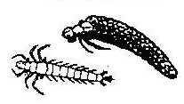
What is a Water Creepy Crawly?
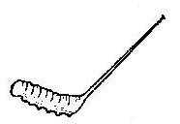
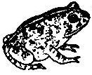
A Water Creepy Crawly is an animal that is able to breathe and live in or on water. Some of them are beautiful, some are rather ugly, some of them are tiny, others are quite big and all of them have special things about them which make it possible for them to live, breathe, feed, grow and reproduce in or on water.

It’s time to see what creepy crawlies we have

in our stream!
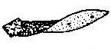
What you will need:
- Containers (ice-cream containers or 2 litre plastic bottles cut in half)
- Small plastic cups
- Pencils (to record findings)
- Plasticine
- Photocopies of the ‘Water Creatures Identification Sheet’ and the ‘More information on each of the water creatures’ sheets
- Coloured pencils or crayons

What to do with the learners:
- Divide the class into groups of four.

- Give each group one container, a small plastic cup, a pencil, coloured crayons and a photocopy of the ‘Water Creatures Identification Sheet’.

- Each group needs to decide on a name for themselves. They can use the ‘Water Creatures Identification Sheet’ (and call themselves, for example, ‘the mayflies’ or ‘the water shrimps’) or the groups can make up their own names.

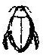
- Each group must collect a full container of river or stream water and then carefully lift up rocks and rotting branches that are in the water and inspect them. Any animal that is found should be gently removed with the end of a pencil or stick and carefully placed into the water container.

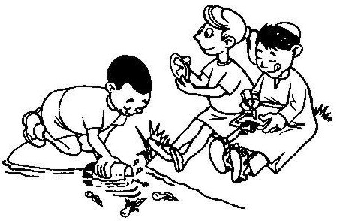
- Learners can explore the stream and collect as many creepy crawlies as they can for 20 to 30 minutes (they may see larger creatures, such as fish, which they are not able to catch – they must make a note of this on their ‘Water Creatures Identification Sheet’).

Make sure that the children do not harm ANY of the creatures that
they find in the stream. They must be VERY VERY careful
when handling these small delicate animals.

You, the teacher, need to:

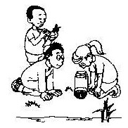
- Hand out a photocopy of the characteristics of each animal (pages 5 and 6)and some plasticine to each group.

- The groups need to colour in, on their identification sheet, the creatures they are able to identify. They must also keep a ‘tally’ on their identification sheet of how many of each creature they find (see example below).

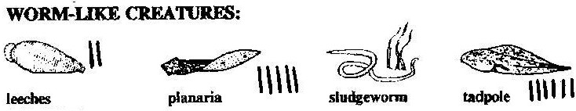

- The groups then need to read the information about the creatures they have caught and discuss within their group what makes each creature unique and successful in living in water and not on land.

- Lastly, using the plasticine, the groups each have to make a water creepy crawly that can live in water (it can be an imaginary, non-existent animal, never before seen by humans BUT it must be able to breathe in water, be strong enough not to be swept away by strong water currents and it must be able to eat in water).

Bring all the groups together, with their containers full of creepy crawlies, and ask the class the following questions:

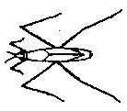
- What animals did each group find?

- Why do you think these animals are better able to live in the water than on land?
- How do the animals make sure that they are not swept away in the strong water currents?

- If you were to sort these water creepy crawlies into different groups, using only one physical thing that you can see on the animals, what would you choose? (some of the learners may use legs to sort the insects, ie. those with none, two, four, or more than four, others may use the presence or absence of wings).

- If you lived in water, what would you need to make sure you lived safely and happily?

- Each group can now share their plasticine creepy crawly with the rest of the class. They need to explain what makes their creature so special and why it is able to survive in water.

Teacher, make sure that all the groups have coloured in all the creatures they found during the water study and have a ‘tally’ next to
each coloured-in animal.

Immediately after this activity, return ALL the creatures back to the stream. This needs to be done gently and carefully. Make sure that none of the animals are left in the plastic containers.
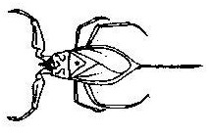

Otter

Criteria to assess learners during this natural sciences lesson

Criteria | Exceeded requirements of the Learning Outcome | Satisfied requirements of the Learning Outcome | Partially satisfied requirements of the Learning Outcome | Not satisfied requirements of the Learning Outcome
The learner took an active part in the water investigation and collected water creatures to add to the group’s collection
The learner was able to identity the water creatures that were found by the group
The learner contributed to the discussions of describing his/her group’s plasticine animal

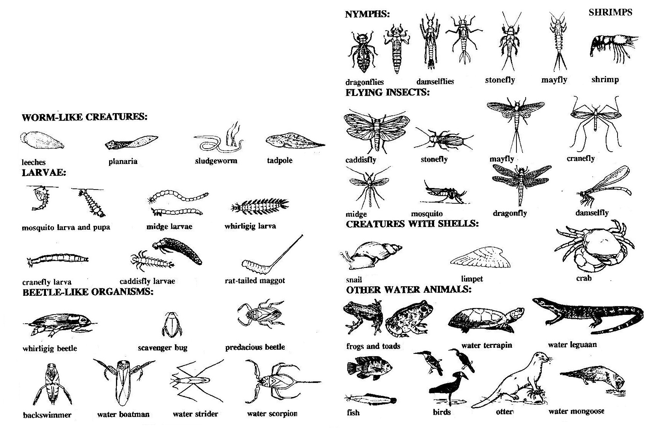
Water Creatures
Identification Sheet
More information on each of the water creatures on your identification sheet

Leech: Leeches are small worm-like creatures that have suckers to suck the blood or body fluids from other animals. They like nutrient-rich water that is low in oxygen. They are mostly parasitic, which means they prey on other living animals, including people. If leeches stay on your body for too long they can cause your blood pressure to drop and make you feel ill. The suckers of a leech release a chemical, which stops blood from clotting so that they can feed properly.

Planaria: They are dark brown with flat bodies. Planarias live in clean, unpolluted water. They can regenerate themselves if cut in pieces, with each piece growing into a new individual.

Sludge Worm: Their tails are used as gills to absorb oxygen. They are dark red due to the high oxygen levels in their bodies. Sludge worms like to eat mud, and they are able to live in polluted waters.

Water snail and limpet: Water snails have a soft body protected by a coiled shell. They have a muscular foot that sticks out of the shell and is used to move. Limpets have a flattish shell covering their body. This shell has a foot that sucks on to the smooth surface of rocks and plants. Snails eat water plants. Limpets eat algae on rocks and on water plants. Snails can live in slightly polluted water. Snails can carry very small (microscopic) animals, like bilharzia, inside their bodies, that can make people sick. Snails that carry bilharzia like slow moving waters and stay near reeds to keep from being washed away. People who have bilharzia often feel very tired and may have kidney damage.

Damselfly: Adult damselflies are smaller and thinner than dragonflies. Nymphs are usually brown or green and have three large, flat gills at the end of the abdomen. They swim and run among stones at the bottom of streams.

Back swimmer: They swim and rest on their backs. The hind legs are used for movement. They breathe at the surface and an extra supply of air is trapped amongst the hairs on the upper side of the body.

Water scorpion: This insect does not have a poisonous sting. It is usually brown and often looks like a dead leaf! It creeps around amongst water reeds or in the mud at the bottom of shallow pools. The water scorpion breathes through its tail – this is used like a snorkel.

Water strider: The water strider has long middle and back legs for resting and skating on the surface of the water. Water striders eat insects which have fallen into the water. To find their prey, water striders have sensory areas in their feet. With these they can feel the vibrations of the insects that have fallen into the water.

Midge: Adult midges or gnats are tiny insects that are usually seen flying in swarms above the water. Midge larva are often called ‘bloodworms’ because many have red or brown body fluids. The larvae are often found in mud in slow-flowing or still water. The red midge larvae are usually found in polluted water. The adult midge never eats anything! Its stomach remains an empty air sac. Generally midges are found in water that is slightly polluted.

Cranefly: Cranefly larvae are found in water, in moist ground or in mud or under leaves. The larvae eat roots, dead plants and some small water animals like worms. The cranefly is often called a daddy-long-legs!

Rat-tailed maggot: Rat-tailed maggots are usually grey with a fat wrinkled body and a long breathing tube. They can live in mud and polluted water.

Caddisfly: The larvae have 6 long legs close to the head. Caddisflies like clean, unpolluted water.

Mosquito larvae: Mosquito larvae live in stagnant (still) pools of water just below the surface. They feed on tiny plants and animals. Male mosquitos suck plant juices when they are adults but adult female mosquitos suck blood from humans and other animals. If they are infected, the female mosquito will then pass on malaria to people, which can be deadly! Mosquito larvae are often found in poorly oxygenated ponds of water.

Whirlygig beetle: The larvae look like small centipedes. Adult whirligig beetles are smooth and streamlined and are usually a shiny grey colour. Adults and larvae both feed on dead or dying insects that have fallen into the water.

Water beetles and bugs: All the water beetles and bugs have flat, smooth bodies. They are usually found in clean streams and rivers.

Dragonfly: The adults fly very fast. The nymphs of dragonflies are aggressive feeders who eat other insects. They can live in fairly polluted water. When it is ready to become a dragonfly it sheds its skin emerging as an adult dragonfly.

Water boatman: They swim mostly on the surface of the water and dive down deeper to feed on algae. They catch bubbles of air in their body hairs that they use to breathe from when they dive down deeper – similar to a scuba diver! This air bubble is what gives the Boatman a silvery colour in the water.

Mayfly: The nymphs (baby mayfly) have three long thin tails and have gills on the sides of their bodies. Mayflies need unpolluted water with plenty of oxygen to live in. They eat vegetable matter. The adult mayflies only live for one day once they hatch, and in this time they must find a mate and reproduce before they die. This is why mayflies often all hatch at the same time. This gives them the greatest chance of success.

Stonefly: The nymphs have two thin ‘tails’. They live under stones in running streams. They can only live in clean, unpolluted water. Nymphs eat small water insects and algae. If one finds stoneflies in a stream, it usually indicates good water quality as they are affected by small amounts of pollution.

Crab: Crabs have a hard exoskeleton. They have flat bodies and 5 pairs of legs. Crabs eat mostly dead or dying animals but also catch some live prey, such as tadpoles.

Freshwater fish: Fish have streamlined bodies that are covered with slimy scales. Fins are used to move. Breathing is through their gills.

Frogs and toads: Tadpoles have gills and live under water. Adult frogs and toads have lungs. Frogs spend their whole lives in very moist areas or near water. Toads are stout, have short limbs and live in open country. Platanna (clawed toads) are neither true frogs or toads. They spend their whole lives in water.

Terrapin and leguaan: Water terrapin are usually a muddy brown colour. They have a scaly skin and scales modified to form a leathery shell. Water leguaan are very large lizards with a patterned scaly skin.

Water birds: A wide variety of water birds are found in and around water systems. They have beak and feet adaptations for feeding in streams, rivers, ponds and wetlands.

Otter and water mongoose: Otters and water mongoose are shy animals and are seldom seen. You may see their droppings, which contain large quantities of crab shells.

Freshwater shrimp: They feed on small animals and plants and are usually transparent, green or brown.

ACTIVITY TWO: EVEN CREEPY CRAWLIES

LIKE CLEAN WATER!

Following on from Activity One, learners use MATHEMATICS to count and illustrate the numbers and types of creatures they found. As many water creatures are sensitive to water pollution, learners can also determine the overall health of the water they explored.

ACTIVITY:
1. Get each group to count up the tallies of each different type of water creature that they found, in Activity One, and write them down in a table (photocopy the table provided on page 9).

2. Using the individual tables from each group, the teacher can draw a large table on the chalkboard.

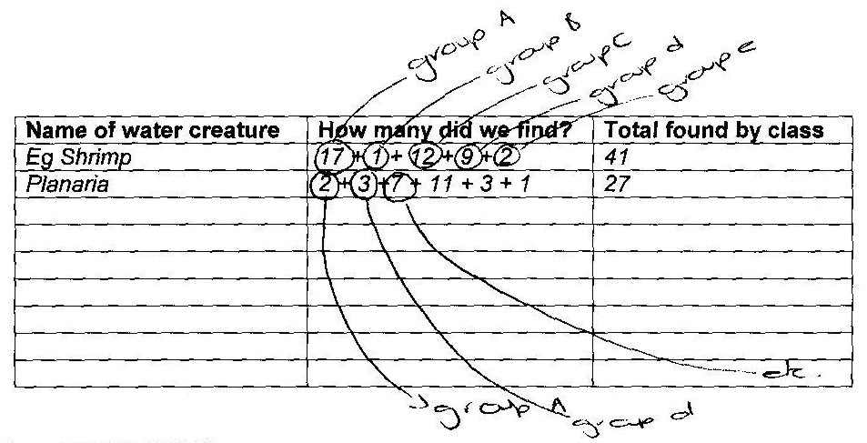
3. Let the learners add up all the numbers of creatures that were found as a class (see table below)

ASK THE LEARNERS:

- How do we measure water? (Choose the correct answer/s)
milligrams kilograms millilitres ounces tons litres

(Answer: millilitres and litres).

- Hand back the water containers that the groups used during the previous activity. Estimate the mass of your group’s container in grams. Write down your estimate.

- Fill your container with tap water. Now estimate the mass of the water in your group’s container. Write down your estimate.

- Using a kitchen scale find out the mass of your container, filled with water. Each group must write down the answer.
- Now, empty the water out of the containers (preferably onto a flower bed or vegetable garden outside so as not to waste water) and this time, find out the mass of the empty container. Each group must write down this answer.

- What is the mass of the water in grams? (subtract the total mass measured on the scale from the mass of the empty container to give the mass in kilograms or grams for the water).

- How accurate were your estimates?

- Draw a bar chart of the types and numbers of animals found in your group (see example below).

- How many water creatures prefer only clean water? (The learners may need to use the notes from Activity One).

- How many of the creatures you found can live in slightly polluted water? (Learners may need to read the information sheets again).

- How healthy do you think the river/stream is that we explored in Activity One (remember that water creatures are very good indicators of water quality – certain creatures like mayfly nymphs and stonefly nymphs are only found in clean, unpolluted water).

Criteria to assess learners during this mathematics lesson

Criteria | Exceeded requirements of the Learning Outcome | Satisfied requirements of the Learning Outcome | Partially satisfied requirements of the Learning Outcome | Not satisfied requirements of the Learning Outcome
The learner was able to estimate the mass of the water and the mass of the container
The learner was able to use the scale to measure the mass of the container & the mass of the water
The learner was able to tally up the information on the identification sheet and transfer it onto the table
The learner was able to draw a bar graph of the water creatures found during the water study
Name of Group: ___________________________________

Name of water creature | How many did we find?
e.g. Shrimp | 17

ACTIVITY THREE: DID YOU KNOW THAT CREEPY CRAWLIES CAN TELL US HOW HEALTHY A STREAM IS?

Certain water creatures are known as ‘indicator species’. This means their presence in a river, stream or pond indicates polluted or unpolluted water. Within this LIFE ORIENTATION lesson learners look at the relationship between water creatures and water quality and water creatures and our health.

Teacher, write the names of the water creepy crawlies below on the chalkboard:

Mayfly Mosquito Leech Planaria Sludge Worm

Dragonfly Water boatman Water Snail

With your class and using the ‘More information on each of the water creatures’ pages from Activity One, write down any words that link to the animals above
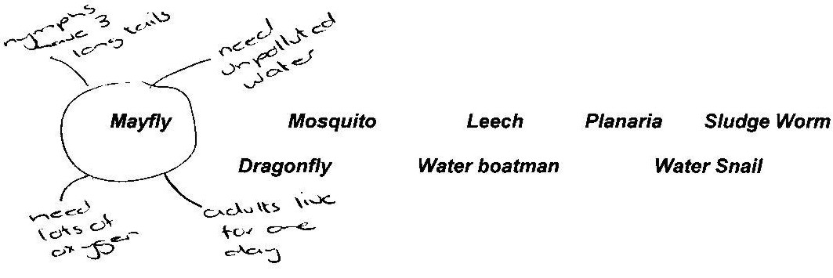

E.g.

AS A CLASS, DISCUSS THE FOLLOWING QUESTIONS:

- Which water creepy crawlies can cause ill health or disease in people?
- Leech, Mosquito, Water Snail

- What illnesses can you get from each of these?
- Low blood pressure, Malaria, Bilharzia

- If you find a sludge worm in the water, what is it telling you about the health of the water?
  - That the water is most likely polluted.

- Which water creatures tell us the water is unpolluted and clean?
- planaria, mayfly

- What type of water can a dragonfly larvae live in?

- Give 3 different ways that water can be polluted?

- If you found two ponds of water and the one was filled with leeches, sludge worms, and mosquitos and the other had a few planaria and water boatman living in it, which one would you choose for your drinking water?
- Planaria pond

- Why is it important to ensure that the water we drink is safe to drink, wash in and use for cooking?

- How can we help to make sure our streams and rivers are not polluted?
- Some examples are: We can clean up our local wetlands, rivers and streams; we can make sure we throw our waste away properly; we can write to our local councillors and municipality; we can report people and businesses who we see are polluting our rivers and streams; we can decide never to use rivers or streams as a toilet.

- What can you do to make sure you do not get any diseases from water?
- Do not use water from dirty pools of water where cattle and human faeces (poo) can be found; boil all water first when collecting from natural healthy water sources; make sure that the water is collected from clean, fast flowing waters; do not swim and play in rivers or streams that are very close to where people live (like a town or city) and have lots of litter and rubbish lying in and around them.

Criteria to assess learners during this life orientation lesson

Criteria | Exceeded requirements of the Learning Outcome | Satisfied requirements of the Learning Outcome | Partially satisfied requirements of the Learning Outcome | Not satisfied requirements of the Learning Outcome
The learner was able to match certain water insects with water quality (ie. the leeches and sludge worms indicated poor water quality but the planaria and water boatman indicated good/better water quality)
The learner was able to explain what he/she was doing

ACTIVITY FOUR: HOW DO WE MAKE WATER

SAFE TO DRINK?

This TECHNOLOGY lesson encourages learners to think about the health of water and how to make water safe to drink. It also looks at how
indigenous people collected water in the past.
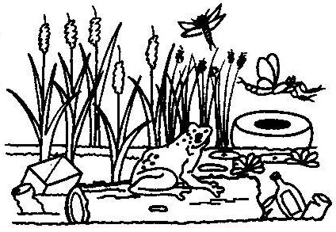
If possible, organise a trip to your local water sanitation plant. You will need to find out if your local water board offers guided tours of their water processing plant. If they do, ask them to focus on sanitation and how and why water is cleaned before it reaches our taps. This will help learners understand how and why water is treated before we can use it in our homes and at school. If you are unable to visit the water works, share the comic story of ‘How is Tap Water Cleaned’ (on page 14) with your class.

READ THE FOLLOWING TO YOUR CLASS:

Did you know?
About 6 000 children die every day because of dirty, unhealthy water. Water that goes through a chemical and filtration process to remove the germs and dirt is the best way to treat water. In cities, water boards look after the treatment of water for people. However, in many parts of the country, away from cities, people have to collect their own water from nearby rivers and streams. Sometimes these streams and rivers are clean and unpolluted but sometimes they are dirty with lots of rubbish and disease in them.

As a class, discuss and brainstorm where and how you should collect water for your family, if you lived in a rural area with no access to piped treated water. Write down all the learners’ ideas on the chalkboard

Some ideas to get the discussions going ….

We would collect water that
- is unpolluted by livestock (cattle, goats, sheep)
- is unpolluted by human waste (faeces, washing of clothes or people)
- is not close to pit toilets
- has no dead fish or other dead animals in it
- has no litter and rubbish
- is not close to factories that might pump waste into the river / water source
- is not close to where you can see pipes going into the river or stream
- is from fast flowing water sources
- is not known to have caused any ill health in the past (community knowledge)

Once the water has been collected, how would you store it?
  - Collect and store the water in clean, hygienic containers at all times.;
  - Keep water containers for collecting and using water only not for other liquids such as paraffin or petrol;
  - Keep water that is collected for home use in a cool, dry place.

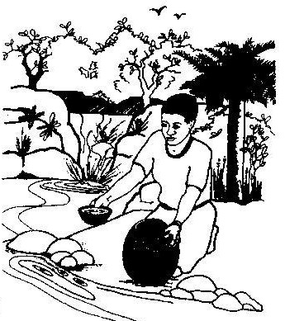
READ THE FOLLOWING TO YOUR CLASS:
Long ago, the Nguni people collected water where they could hear it running over stones or dripping down rocks. If a spring was for human use, it was protected by a circle of rocks with a small outlet. Cattle drank elsewhere.

A water source would always be approached with care so as not to frighten crabs and other small water animals. If these small animals were disturbed, their movement would stir up sand and the person collecting the water would have to wait for the river sand to settle. The surface of the water was ‘swept’ with the hand and water was collected well below the surface. (Did you know that there are higher numbers of bacteria living on the surface water of streams and ponds then there are just below the surface).

ASK THE CHILDREN:
- Have you heard or do you know of any other ways that people collected water long ago?

- Do any of you know of any simple way that you can clean (purify) your drinking water (especially if you are collecting it from a river or spring and are not sure that it is clean). (Demonstrate to the learners the two simple ways of purifying water that follow below).

- A simple way of purifying water is to add a teaspoon of jik to every 25 litres of water. Jik is very strong and kills all the bacteria, making the water safe to drink.

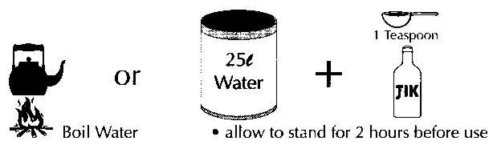
- You can also boil the water, and that will kill any germs or bacteria that may be living in it. The water can then be left to cool. It does not need to be drunk hot.

ASK THE CHILDREN:

- To describe what you, the teacher, did during the two demonstrations.
- Why is the water safe to drink if it is boiled or has jik in it?
- Do they know of any other ways of purifying water?
- Do they think a purification water works would make life easier for people? Why?

Criteria to assess learners during this technology lesson

Criteria | Exceeded requirements of the Learning Outcome | Satisfied requirements of the Learning Outcome | Partially satisfied requirements of the Learning Outcome | Not satisfied requirements of the Learning Outcome
The learner gave an opinion (yes/no) on whether a water purification works would make life easier for people
The learner could give a valid reason as to why life was (or was not) easier for people who had to collect and purify their own water

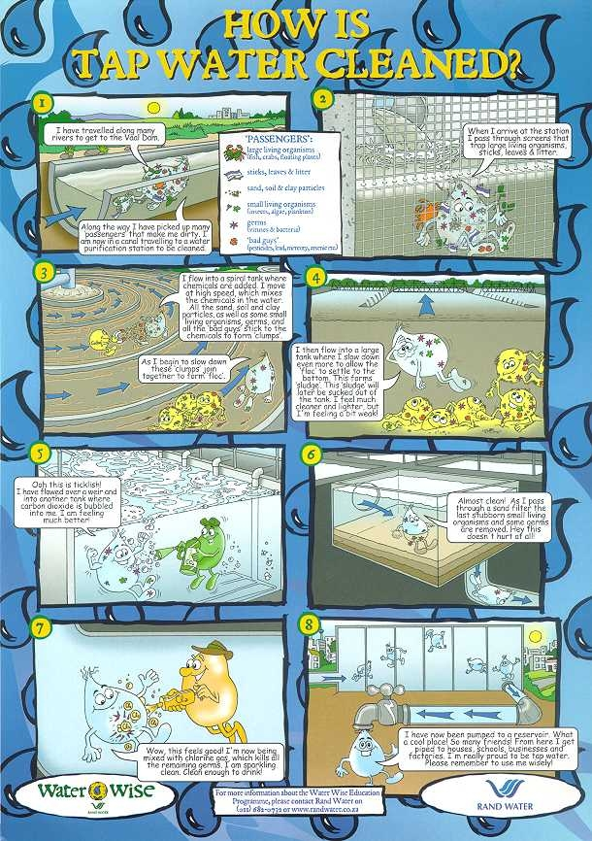

ACTIVITY FIVE: IF I WAS A TADPOLE AND CAPTURED BY A GRADE 4 LEARNER ON A HOT MONDAY AFTERNOON ….

This LANGUAGES writing exercise allows learners to imagine what
it would be like to be one of the water creepy crawlies that was caught
during their water study in an earlier lesson!

Before starting this writing exercise with your class, discuss and brainstorm the following questions:

- If you were a tiny tadpole or a water strider or any water creature (even the imaginary one that the groups created), what do you think you would do during the day?

- What would you do at night?

- What would you eat?

- What would you smell?

- What do you think you would see when you woke up each morning?

- Would you have any friends? If yes, what would your friends be like (like you or different). If no, why not?

- How would you feel if a Grade 4 learner scooped you out of the water and put you in a two-litre ice-cream container? (Perhaps scared, perhaps excited?)

- What would you be thinking would happen to you?

- How would you feel seeing all the eyes of the Grade 4 learners looking at you?

- What would you say to the other water creatures, also in the container with you?

- How would you feel when you were put back into the river or stream?

(During this brainstorming/questioning activity, you may wish to write down words on the chalkboard to help the learners when they write their own stories later on).

WRITING
Learners should now write a simple story of how they would feel if they were a water creature that was caught by a Grade 4 learner and then later on, released back into the water.

Criteria to assess learners during this languages lesson

Criteria | Exceeded requirements of the Learning Outcome | Satisfied requirements of the Learning Outcome | Partially satisfied requirements of the Learning Outcome | Not satisfied requirements of the Learning Outcome
The learner enjoyed listening to the story of how water was collected long ago as well as the other information on water
The learner contributed to all the discussions during this activity
The learner contributed to brainstorming and discussing what it would feel like to be a water creepy crawly
The learner was able to write a creative (imaginary) piece of writing about being a water creature caught by a Grade 4 learner

