ACTIVITY ONE: IT’S RAINING TODAY!

During this Social Sciences: Geography activity, learners look at the geographical distribution of rainfall across South Africa. This is linked to vegetation and farming practices as well as the spread
of water-borne diseases, such as cholera.

Read the following to your class:

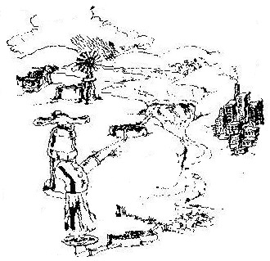
Did you know that 75% of your body is made up of water and the longest we can go without drinking is 3 to 4 days! Water probably is the most precious resource we have on Earth. We live on a beautiful blue planet with most of the surface covered by seawater, but it is all salty and we cannot drink it. Only 2.5% of the world’s water is fresh and, of that, 99% is frozen in icebergs or hidden deep in underground lakes. All South Africans, including you and me, are part of the 6.5 billion people living on the planet and we all have a responsibility to make sure that everyone gets enough fresh clean water for their needs. So, everyone needs to help keep the freshwater we have clean, and use it wisely.

South Africa is a dry country with two-thirds of it receiving less than 500 millimetres (mm) of rain per year. The world average rainfall is 857mm. For this reason we need to appreciate and conserve our mountain catchments, rivers, lakes, and other wetland areas. They all play a vital role in providing fresh clean water for agriculture, wildlife and the people of our county.

Everyone lives in a river catchment. In the days when there were fewer people, our catchments were clean and healthy and full of life. But today, with over 6 billion people on our planet, we are quickly using up our freshwater supplies. We also pollute our water by dumping waste and pollution into our rivers and the sea.

Did you know that it takes 22 litres to make one glass of concentrated orange juice from a carton. This is because of the water used to grow the orange trees, manufacture the cartons, make the concentrated juice and then re-hydrate (add water) it. That is a LOT of water!!

WHAT TO DO:

- Hand out a copy of Worksheet 1 to each learner.

- Let them mark, with a cross, where they live in South Africa (it does not need to be exact, just a rough idea).

You will need to explain to the learners the rainfall pattern across the country, using the worksheet and the key – lots of rain in the extreme east,
very little rain in the west.

- Learners can now colour in the worksheet showing rainfall distribution – (colour in the area which gets the most rain, a dark blue, getting lighter and lighter blue as less rain falls, eventually using yellow or brown pencil crayons in areas with very low rainfall [in the west]).

QUESTIONS TO ASK THE CLASS:

- What part of the country (the wetter part or the drier part) do we live in? Do you have any friends or relatives who live in other parts of the country? Looking at your coloured in worksheet, do your friends and family live in an area that gets more or less rainfall than you?

- If you were a mealie farmer, where would you want to live to grow your mealies successfully and why?

- What types of plants do you think you would find in the western part of South Africa? (Plants that don’t need much water – perhaps aloes, cactuses).

- What kind of plants do you think you would find in the eastern part of the country? (Plants that need lots of water).

For questions 2, 3 and 4, it may be useful to have available a collection of library books on agriculture, farming and gardening in South Africa.

Read the following to your class:

The rain that falls across South Africa feeds our streams and rivers. Many people in our country use this water for different reasons – the mealie farmer pumps water from the nearby river to irrigate his crops, children swim and have fun in the water, women wash their clothes in the water, some people collect water to take it home for drinking and cooking, water boards build dams to collect the water and then use it to supply tapped water to people who live in towns and cities. Can you think of any other ways that the rain water falling into our rivers and stream is used?

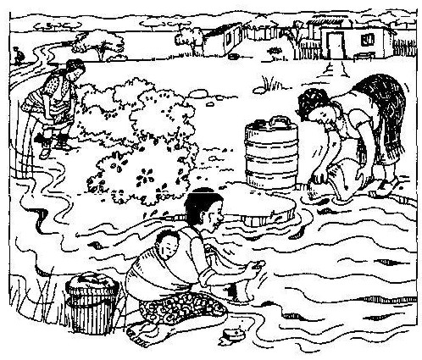
Look at the picture below:

________________

ASK YOUR CLASS:
- What do you see?

- If you wanted to go for a swim in this river, where would you go to swim (upstream or downstream). Why?

Many germs that make people very sick can be found in the faeces (poo) of infected people, who have diseases like cholera and dysentry. These germs multiply quickly in water. Rain will wash the faeces of the woman who is going to the toilet near the river, into the water. If she has a disease like cholera (which gives people a runny tummy and makes them feel very sick and weak), it will get into the river, the germs will multiply and other people using the river, downstream, may get the disease as well! Many people wash their clothes in the river. If they are also washing nappies of babies who have diseases, the germs will get into the river.

Glossary of terms:
- Dysentry - a severe diarrhoea (loose or watery poo) illness often associated with blood in the faeces (poo). It is caused by eating food which contains bacteria
- Cholera – a disease of the stomach which gives people a runny tummy and makes them feel very sick and weak and want to vomit

Multiply – increase

Infect – pass on a disease

Diseases – illness, infection, bad health

Germs – micro organisms (too small to see) that will make you sick

QUESTIONS TO ASK THE CLASS:

- What do you think the people in the picture could do so that their actions don’t make other people sick?
  - wash clothes away from the river, in other words, carry buckets of water away from the river to use for washing, not wash directly in the water;
  - build toilet far away from water sources;
  - do not go to the toilet close to or in a river or stream.

- What can we do to make sure that our daily actions do not contribute towards making other people sick or polluting our rivers and streams?

Criteria to assess learners during this social sciences: geography lesson

Criteria | Exceeded requirements of the Learning Outcome | Satisfied requirements of the Learning Outcome | Partially satisfied requirements of the Learning Outcome | Not satisfied requirements of the Learning Outcome
With the help of the teacher, the learner was able to draw a cross on the map, roughly in the region where they lived
The learner was able to answer the question as to where a farmer would choose to grow crops
The learner saw the problems of sanitation issues
The learner was able to contribute solutions as to what the women in the picture could do to prevent spreading diseases to other people

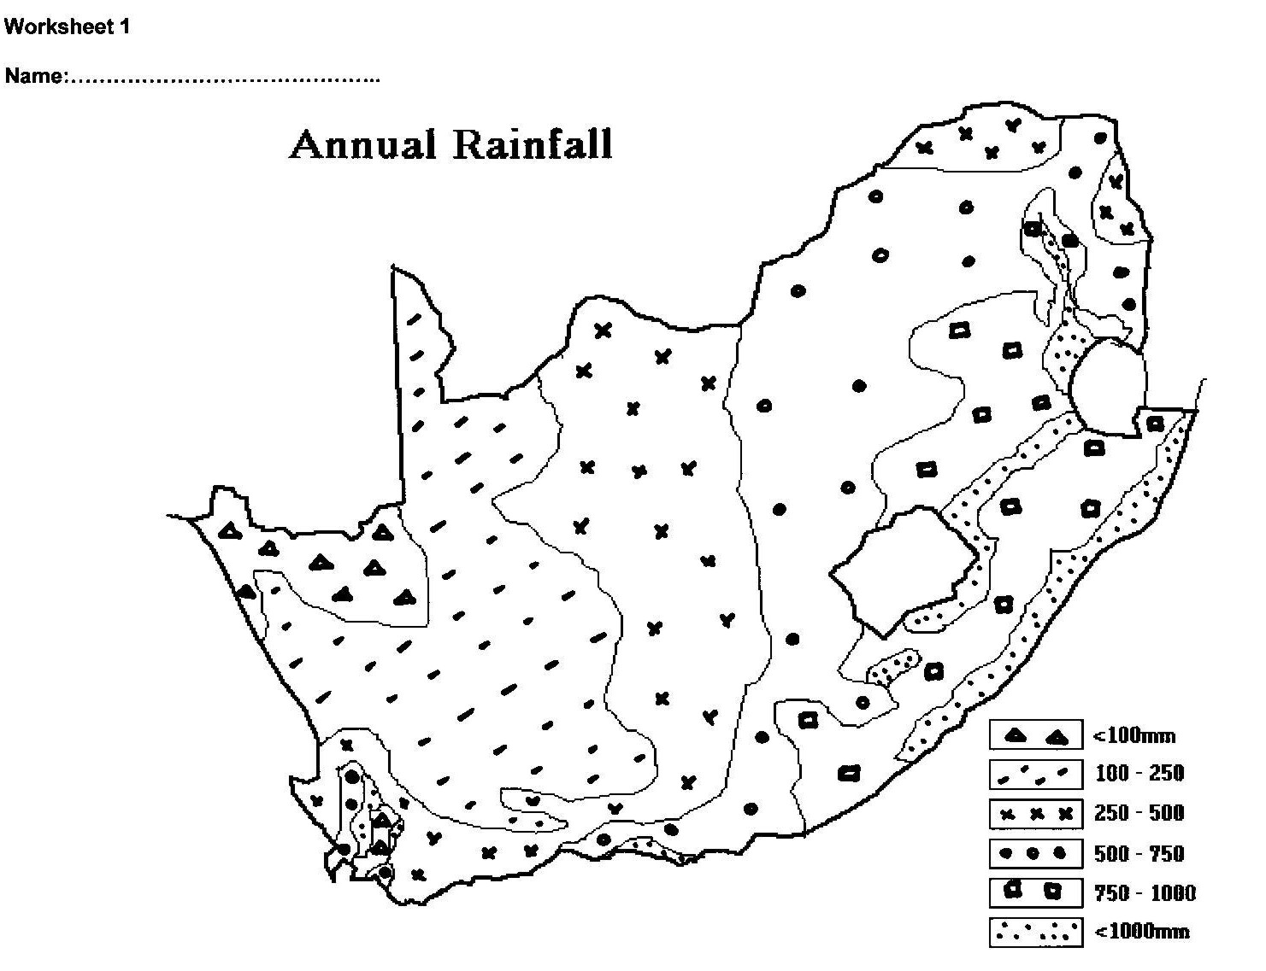

ACTIVITY TWO: LET’S MAKE A RAIN GAUGE

During this TECHNOLOGY lesson, learners make an easy but accurate
rain gauge, to measure the rainfall at school.

One of the ways we can measure how much rain falls in our area is by using a rain gauge and recording the rainfall daily. Learners need to work neatly, safely and carefully, ensuring minimum wastage of materials.

Let’s make our own tin can rain gauge

Each learner will need:
- Tin can
- Breakfast cereal packet
- Glue
- Scissors
- Ruler
- Pencil

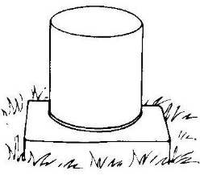
WHAT TO DO:
  - Put an empty tin on a flat surface out in the school grounds, well away from overhanging trees, shrubs and sprinklers.

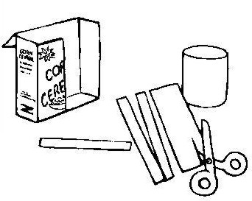

  - Make some rain dipsticks by cutting long 1cm-wide strips from the breakfast cereal box. The sticks must be longer than the height of the can.

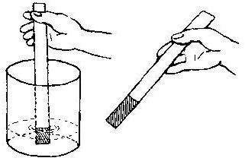
  - With your class, at the same time each day, measure the rainfall by dipping the dipstick into each can so that they touch the bottom. See how the rain leaves a wet mark on the cardboard.

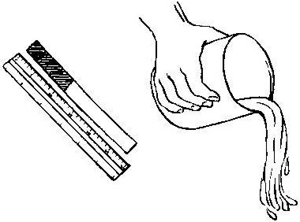
  - Use a ruler to measure the length of the wet part of the cardboard in millimetres – this is how much it has rained. Empty the cans.

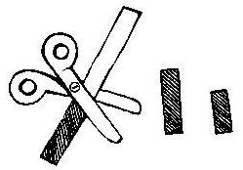

  - Cut the wet piece off the dipstick and let it dry. Keep it flat and write the date and rainfall in millimetres on it.

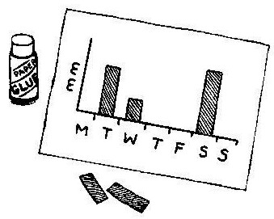
  - When the piece of dipstick is dry, make a chart of the rainfall for a week. Glue each piece to paper to form a record of rainfall at your school.

Reproduced from EnviroKids magazine with permission

You may decide to place the tin can rain gauges in different places around the school to see if there is any difference in rainfall within the school grounds.

Note: if possible ensure that the learners choose tin cans deep enough to hold
an average day’s rainfall for your area. The can must not have a rim that
makes the mouth narrower than the base.

ASK THE CLASS:
- Do you think our rain gauges worked well?

- Could they have worked better? How?

- Were our results accurate? (you, the teacher, can find out the correct rainfall figures for your area for that particular week, by contacting the local Weather Bureau).

If some of your learners live a distance from the school, why not get them all to make a rain gauge for their gardens at home and record the rainfall during the holidays or over a long weekend. You and your class can then plot and compare the different rainfall amounts on a map of your area.

Criteria to assess learners during this technology lesson

Criteria | Exceeded requirements of the Learning Outcome | Satisfied requirements of the Learning Outcome | Partially satisfied requirements of the Learning Outcome | Not satisfied requirements of the Learning Outcome
The learner worked neatly and safely when making his/her rain gauge
The learner cut out 1cm-wide strips for rain dipsticks
The learner discussed (evaluated) how they had made their rain gauge
The learner made a chart to show rainfall at school over a one-week period

ACTIVITY THREE: A WATER STUDY

AROUND OUR SCHOOL

This NATURAL SCIENCES lesson looks at water in your school. Learners
map out where water enters and leaves the school and areas, within
the school grounds, where it is used.

Teacher, before you start this activity, find out where your school’s water meter is located. Try to get plans of where the water pipes are in the school and the latest water account. These will be useful to show the learners during this lesson.

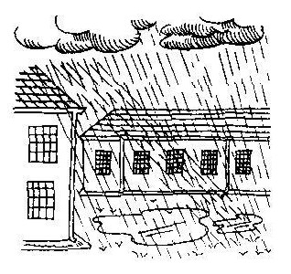
GET THE LEARNERS TO:

- Sketch a plan of the school and show where:

  - the water supply enters the school (if there is no piped water, show the water tanks or where water for school use is stored);

  - the water is used (such as toilets, swimming pool, playing fields, gardens, outside and inside taps).

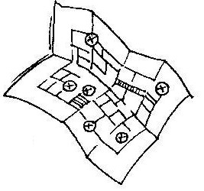
- Sketch on your plan where the water goes to, after being used (include waste water, rain water, hose water run-off).

- Look along the street to see where the gutters go. Where are the stormwater drains? What happens to the water when it rains? Does water lie around the playgrounds or playing fields?
- Find out how much water the school uses in a month. Find out how much this water costs.

LEARNERS, WORK OUT:

- If 12 litres of water is used every time a toilet is flushed, how much water would be used if every learner in the school went to the toilet once a day?

- Make a list of ten ways you use water at school. Now imagine that there is a shortage of water and cut out five of the ways you use water. Which would you cut? How might this affect the school?

TEACHER, WITH YOUR CLASS:

  - Discuss all the ways the learners use water at school. List them on the chalkboard.

  - Discuss practical and possible ways that you think your school could reduce the amount of water that is being used and so save water. List these on the board.

  - Discuss practical and possible ways in which you, the teacher, and the learners can reduce the amount of water you use. List them on the chalkboard. Let everyone choose one and see what happens over the following week. (Some ways we can all reduce the amount of water we use is to have shorter showers or make sure we don’t fill the bath too much; turn off taps when brushing our teeth; washing our cars and bicycles using a bucket, not with a running hosepipe; watering our flower and vegetable gardens during the early morning or late evening; asking our parents to fix leaking taps in and around our homes).

Criteria to assess learners during this natural sciences lesson

Criteria |  | Exceeded requirements of the Learning Outcome | Satisfied requirements of the Learning Outcome | Partially satisfied requirements of the Learning Outcome | Not satisfied requirements of the Learning Outcome
The learner was able to follow instructions and draw a map of the school
The learner was able to mark the places on their map where water is used
The learner was able to contribute to discussions of what would happen if there was a water shortage
 | ACTIVITY FOUR: ARE WE WASTING OUR WATER AT SCHOOL, HOME AND IN OUR COMMUNITY?

This MATHEMATICS lesson looks at water use at school, home and the local community. Learners complete a quick checklist before designing their own simple data collection sheet for dripping taps around the school.

ACTIVITY FOR THE LEARNERS:
- Give each learner the checklist on the following page to do a quick check of
local patterns of water use at school, in and around their home and in their local community. They need to tick bad and good practices. This activity can be done as a homework exercise.
- Discuss the ‘good’ and ‘bad’ practices that they observed in their own homes and in their community and make a tally on the chalkboard of all the actions (e.g. long showers with big nozzle – 16; big cistern with slow leak – 7; low-flow shower with stop switch – 8; bottle or bag in cistern or dual flush – 4).

ACTIVITY:
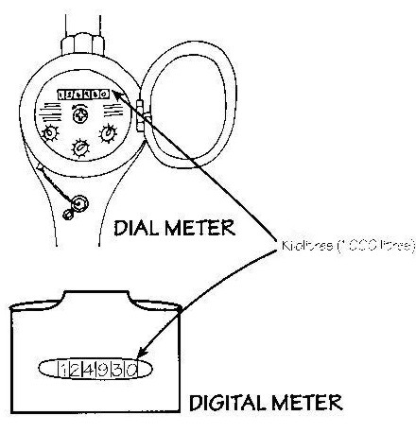
1. Take your class for a walk around the school. Does your school have a water meter? Show the learners where the municipal workers read the meter each month. Let them see the water account from the municipality. If your school does not have piped water, where do you get your water? Perhaps at a community stand-pipe or pump or maybe your school collects rainwater? Show the children where the rainwater tanks are.

2. Next, walk around the school grounds. Can the children see any signs of wasteful water use? Continue around the school grounds – can the learners see any leaking taps? Send someone into the toilets – did they see any leaking taps or overflowing toilets?

TIME TO HEAD BACK TO THE CLASSROOM:
- Get each learner to design a simple sheet which will be a record of any water wastage in the school. (An example is given on the next page – this is NOT for the children to use but to give you, the teacher, an idea of what the record sheet should look like. The children may put in more or less detail if they wish).

Day | Date | Time | What I saw
e.g. Monday | 31 January | 7.45am | A dripping tap near the boys toilets
Monday | 31 January | 10.15am | A teacher washing his car at break using a hosepipe with lots of water being wasted.
Monday | 31 January | 13.50pm | My friend let the water run when she was washing her hands. Lots of water was wasted.
Monday | 31 January | 14.00pm | I saw a leaking tap near the sport field

Let the learners keep a record for an entire school day, starting from when they arrive at school, before lessons start, until the end of the day, after sport in the afternoon. They must remember not to record the same leaking tap twice!!

AS A CLASS DISCUSS:
- What were the results? Discuss these and list them on the chalkboard.
- Let each learner draw a bar graph showing where water is wasted in the school (see example below).

- What could the school do to stop water being wasted?
- What can we do to stop water being wasted?

Criteria to assess learners during this mathematics lesson

Criteria |  | Exceeded requirements of the Learning Outcome | Satisfied requirements of the Learning Outcome | Partially satisfied requirements of the Learning Outcome | Not satisfied requirements of the Learning Outcome
The learner made a simple record sheet to gather information about water wastage at school
The learner used their record sheet to collect data of water wastage
The learner drew a bar graph showing water wastage in the school
 | ACTIVITY FIVE: JUST FOR FUN!! FOR ADULTS ONLY!

The Water Challenge Quiz challenges you, the learner, to find adults and test how much they really know about one of the most important things in life – water! This test is given to adults (like your parents, aunts and uncles and adult family friends) by you. Test as many adults as you can, add up the scores and give the adults a report card.

Take the challenge!
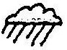
Make copies of this quiz and test as many adults as you can!
Correct each adult’s quiz using the answers given after the quiz.

QUESTIONS

1. The largest river in South Africa is the
a) Orange b) Vaal c) Limpopo

2. South Africa’s average annual rainfall is less than _____ per year.
a) 200 mm b) 300mm c) 500mm?

3. Global warming will cause sea levels to rise because water expands when it is heated?
a) True b) False

4. The water and other fluids we pour down our drains end up in
a) drinking water b) rivers c) oceans d) all of these?

5. The Orange River flows from the Drakensberg into
a) Alexander Bay b) Vaal River c) Namibia

6. Each time we flush the toilet we use ________ litres of water?
a) 12 b) 24 c) 30

7. The ______________ river has the largest watershed in the world?
a) Nile b) Amazon c) Mississippi

8. The Orange River’s name is derived from the colour of the river?
a) True b) False

9. The majority of the Earth’s freshwater is stored in ___________ form?
a) solid b) liquid c) gas

10. ______% of the Earth is covered with water?
a) 50% b) 70% c) 90%

Sink or swim?
Over 8 correct ….. Swimming!
Over 5 correct ….. Bobbing!
Under 5 correct … Sunk!!!!

Answers to the quiz
1. a 2. c 3. a 4. d 5. a 6. b 7. b 8. b – it is believed to be named after the Duke of Orange 9. a 10.b

