|  |
| --- |
| ACTIVITY ONE: THE WATER CYCLE IN NATUREAND THE WATER CYCLE IN ME |

**During this LANGUAGES lesson, learners find out some amazing facts about water, and practise their reading, listening and speaking skills.**

# ACTIVITY:

1. Divide the class into groups of 4 or 5 learners. Each learner will need a photocopy of ‘Two Water Cycles’, which can be found on page 3.
2. Learners need to read the ‘Two Water Cycles’ silently, to themselves.
3. Next, each learner must take a turn to read aloud to the rest of their group. *Remind the learners to vary their tone and tempo of voice for emphasis to make the listening for the other learners more enjoyable. Learners must also take note of question marks and exclamations in the text and vary their voices accordingly. They also need to read in full, any abbreviations such as ‘ybw’ which stands for ‘your body weight’. You, the teacher, will need to move between groups, checking that the children are following these instructions.*
4. Using the information given in the reading, learners now need to make a pie chart showing where water is stored in our body *(see pie chart below).*
5. How else can the information given in the reading about how water is stored in our body, be displayed in a creative way? Learners need to creatively design a book cover with text and graphics (the book is called “Water in the human body”), using the factual information given in the ‘Storing Water’ paragraph on page 3.
6. Using the bar chart given below, learners must interpret the information given and write a short paragraph *(in other words they need to transfer the information they are given in the bar chart to another form, in this case, written text).*

# TWO WATER CYCLES

There are many different cycles in nature, but the most important one is probably the water cycle, as this gives life to our planet. Find out more about “the water cycle in nature” and “the water cycle in you”.

# The water cycle in nature

# Energy to go

The warmth of the sun’s rays drives Nature’s water cycle. Here’s how:

1. The heat from the sun evaporates water, mainly from the sea, to form water vapour.
2. The vapour cools as it rises into the sky, and forms tiny water droplets that group to form clouds.
3. As they get colder the droplets join to make larger drops that fall as rain.

Fact: It has been calculated that all the Earth’s water may have been through the water cycle over one million times since the oceans first formed.

# Drinking water

Most of the Earth’s water is either salty or frozen in the polar ice caps. Less than 1% is available as fresh drinking water for all the plants, animals and people on the planet!

# Transporting water

Rivers and groundwater transport rainwater back to the sea. The water carries dissolved nutrients, air, soil particles and debris downstream, and finally into the sea.

# Storing water

Mountain wetlands seep stored rainwater and release it slowly to rivers. Lakes and reedbeds lower in the catchment, also slow down and store rainwater run-off, reducing soil erosion and flooding. Rain that sinks into the ground is stored in aquifers – water-filled spaces in rocks and sand underground.

# Cleaning water

The soils, plants and micro-organisms in wetlands absorb nutrients, debris and pollutants and release cleaned water to our rivers.

###### The freshwater discharge centre

###### Rivers carry rainwater run-off to estuaries and the sea. Groundwater discharges into rivers or directly into the sea.

###### The water users

People, plants and animals all rely on Nature’s water cycle to provide fresh, clean water.

# Are there water leaks?

None – it all stays on our planet.

Reproduced from *EnviroKids* magazine with permission

# THE WATER CYCLE IN YOU

###### Energy to go

Food fuels your body and its water cycle. If you eat nourishing foods then your body cells can work efficiently and keep you healthy.

###### Drinking water

Our drinking water comes from rivers or rain stored in tanks, dams or underground aquifers. It is then purified and piped to taps in our homes. However, more than one third of South African homes still don’t have taps.

*Fact: South Africa has nearly 48 million people, all of whom need to consume about 2 litres of clean water each day to stay healthy.*

###### Transporting water

Our blood vessels are like rivers that carry watery plasma, blood cells, nutrients and oxygen to all our body cells which are the tiny factories that keep us going.

###### Storing water

Your body stores water in the blood (5% of your body weight (ybw)), in your cells (40% ybw) and between the cells (15% ybw). Your body needs this amount of water to function properly.

*Fact: Your body is two-thirds water – if you weigh 30kg you are carrying 20 litres (80 cups!) of water inside you!*

###### Cleaning water

The blood carries body waste products to the kidneys. They clean your water system and expel waste in your urine.

*Fact: The kidneys of an adult filter 180 litres of liquid each day. Most is reabsorbed, so you wee only about one litre.*

###### The freshwater discharge centre

The bladder stores waste water until you offload it into the toilet.

###### The water users

All body cells use water for their chemical reactions. Our lungs and noses use water to make mucus, and our digestive systems make, and then reabsorb, about 7 litres of mucus and enzymes while digesting food each day.

###### Are there any water leaks?

Yes – we have very leaky bodies. We lose about 1.6 litres of water each day through urine (1.2 litres), breath and sweat (0.2 litres) and poo (0.2 litres).

*Fact: You will lose more water if you are doing hard exercise or living in a very hot climate. Remember to drink more water when it is hot.*

# Criteria to assess learners during this languages lesson

|  |  |  |  |  |
| --- | --- | --- | --- | --- |
| **Criteria** | **Exceeded requirements of the Learning Outcome** | **Satisfied requirements of the Learning Outcome** | **Partially satisfied requirements of the Learning Outcome** | **Not satisfied requirements of the Learning Outcome** |
| The learner faced the group when he/she was reading |  |  |  |  |
| The learner varied his/her tone and tempo of voice when reading to the group |  |  |  |  |
| The learner was able to draw a pie chart from the information given in the text (question 4) |  |  |  |  |
| The learner was able to design a book cover, with text and graphics, using the information given in the ‘Storing Water’ paragraph |  |  |  |  |
| The learner was able to write a paragraph using the information given in the bar graph (question 6) |  |  |  |  |

|  |
| --- |
| ACTIVITY TWO: WATERY WORD SUMS,  NUMBER SENTENCES AND FRACTIONS |

Read the facts, then do the sums!! This MATHEMATICS lesson focuses on word sums, number sentences, fractions, time and measurement – all with a watery wet focus!

# Water fact file

**Water disguises**

* 70% of the Earth’s surface is covered in water. The water comes in 3 forms: liquid water droplets, a gas called water vapour, and solid ice crystals. It changes form by melting, freezing, evaporating or condensing.

# Underwater cities?

* If all the Earth’s ice sheets and glaciers melted, the sea would rise by 60 to70 metres and flood our coastal cities.

# Water power

* Running water wears away soil and rocks. The Niagara River between Canada and the United States of America plunges over a waterfall nearly 55m high, and is cutting into the soft rock at a rate of one metre a year! The falls have moved 11km upstream over the last 10 000 years! In many countries waterpower is used to generate electricity.

# Alien water wasters

* Alien trees like wattles and pines growing in our river catchments absorb and use as much as 61% of the rain that falls on them. Indigenous fynbos plants use only 6% and the rest is left to seep into our rivers. So … grow indigenous!

# Dams make us wobble!

* The dams and canals built over the last 100 years have altered the distribution of freshwater on our planet. This has led to a small change in the wobble of the Earth as it spins!

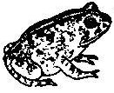

# Amazing animals

* A frog that lives in the Central Australian Desert hibernates underground and only comes out every 5 to 6 years when it rains. Then it drinks half its weight in water so that it looks like a small balloon!

# Making cars, and even eggs, uses water

Making goods and growing food uses lots of water:

* 450 000 litres to make one small car
* 1 000 litres for one Sunday paper
* 9 500 litres to grow half a kilogram of beef
* 1 000 litres for a kilogram of maize
* 150 litres for an egg!

Reproduced from *EnviroKids* magazine with permission

**ACTIVITY: Solve the number sentences**

Example: 2×−4=16 Answer: 10

|  |
| --- |
| **Remember:** Brackets, multiplication and division are always done **BEFORE** addition and subtraction. |

**A** 1) 7÷−1=0

1. 18×2−6+=31

3) 8÷4÷=1

4) 17x2÷1x3=

5) 1×+999=999

6) 54÷÷9=3

7) 110−+25=128

8) 1000−+3=10

9) 67×+5629=6299

10) 536÷−65=2

11) (17×2)−18+(6÷2)+9=

12) 4×8×1÷2÷8×=2

1. (15×3)+22−(29×1)−(8÷)=34
2. +50−(50÷50)−49+(50×2)=200
3. +9-7x22-11=0

**B** The area below represents a river catchment. You read earlier that nearly two thirds of the rain that falls where alien plants have grown, is used up by these alien plants. Using a coloured pencil or highlighter, shade in the amount of water left over to seep into our rivers and streams.

|  |  |  |  |  |  |
| --- | --- | --- | --- | --- | --- |
|  |  |  |  |  |  |
|  |  |  |  |  |  |
|  |  |  |  |  |  |
|  |  |  |  |  |  |

**C** The following activity focuses on word sums and their corresponding number sentences. Two examples of word sums and their number sentences are given below.

**Example 1 Word sum:** An adult needs 2 litres of water each day. How many litres of water will she need in a week?

**Number sentence:** 2 × 7 = 14

**Example 2 Word sum:** A woman walks to a river to collect water for washing her family’s clothes, for drinking and for cooking. On the first day she walks 21/8km. On the second day, she sees a crocodile at the same place so walks another 53/8km to collect water from a safer spot. On day 3, the water tanker arrives in her village so she does not need to fetch water. On day four she decides to walk in the opposite direction to see if there is a water source closer to her. If the total distance she walked in the four days was 12km, how far did she walk on the fourth day and was this water source closer?

**Number sentence:** 21/8 + 21/8 + 53/8 + 0 + 23/8 =12km and no, the water source was not closer, the first water source was.

|  |
| --- |
| **Did you know?** 4/8 can be written as 1/2. |

**It is now your turn to write 5 word sums and 5 number sentences about water. Use the information provided at the beginning of this Activity to make up some exciting and interesting word sums!**

# D Time to tell the time!!

## **Show your answer on the two clock faces below:**

For example, a Midmar Mile swimmer takes 45 minutes and 30 seconds to get across Midmar Dam during the annual water race. **If she started the race at quarter past eight in the morning, what time would she get to the other side of the dam and finish the race?**

09:0030

8

7

6

5

4

2

12

3

1

10

9

11

12

|  |
| --- |
| ***Note:*** *The hour hand is always shorter than the minute hand* |

1. It takes five hours, 20 minutes and 10 seconds to walk to the bottom of the Karkloof Waterfalls. If two friends start walking at half past two in the afternoon, what time will they get to the bottom of the falls?

8

7

6

5

4

2

12

3

1

10

9

11

2. A factory owner pumps pollutants into a nearby river at a quarter past

one in the morning. Three hours, 15 minutes and 22 seconds later he is caught by the police. At what time is the factory owner caught?

8

7

6

5

4

2

12

3

1

10

9

11

3. A group of adults go on river cruise at 8:35pm. The cruise finishes 9 hours, 12 minutes and 16 seconds later. What time will they get off the boat?

8

7

6

5

4

2

12

3

1

10

9

11

## **Bonus Question!!!!!**

The cube above has a length, breadth and height of 5cm

a. Calculate the volume of the cube

b. Calculate the surface area of the cube

**TRY THIS AT HOME!! Fun homework activities using measuring instruments:**

* **A Bathroom Scale:** Use your scale at home to measure
  + (1) Your weight
  + (2) Your brother’s / sister’s weight and
  + (3) Your dog’s / cat’s weight.
  + Write down your answers in kilograms and next to each write your answer in grams.

# ANSWERS TO MATHEMATICS QUESTIONS IN ACTIVITY TWO

# A

1) 7 2) 1 3) 2 4) 102

5) 0 6) 2 7) 7 8) 993

9) 10 10) 8 11) 28 12) 1

13) 2 14) 100 15) 156

**B**

|  |  |  |  |  |  |
| --- | --- | --- | --- | --- | --- |
|  |  |  |  |  |  |
|  |  |  |  |  |  |
|  |  |  |  |  |  |
|  |  |  |  |  |  |

##### **D**

1)

8

7

6

5

4

2

12

3

1

10

9

11

19:5010

2)

8

7

6

5

4

2

12

3

1

10

9

11

04:3022

3)

8

7

6

5

4

2

12

3

1

10

9

11

05:4716

**Bonus question**:

(a) 125cm³ (b) 150cm²

# Criteria to assess learners during this mathematics lesson

|  |  |  |  |  |  |
| --- | --- | --- | --- | --- | --- |
| **Criteria** | **Exceeded requirements of the Learning Outcome** | **Satisfied requirements of the Learning Outcome** | **Partially satisfied requirements of the Learning Outcome** | **Not satisfied requirements of the Learning Outcome** | |
| The learner solved the number sentences |  |  |  |  | |
| The learner developed five word sums |  |  |  |  | |
| The learner developed five number sentences |  |  |  |  | |
| The learner wrote analogue, digital and 24-hour times on the clocks provided |  |  |  |  | |
| ACTIVITY THREE: FROM CAPE TO CAIRO | | | | |

This SOCIAL SCIENCES : GEOGRAPHY lesson takes learners through the waterways of Africa, starting in the Cape and heading north to Cairo!! As they navigate their journey, they will work out longitude and latitude co-ordinates.

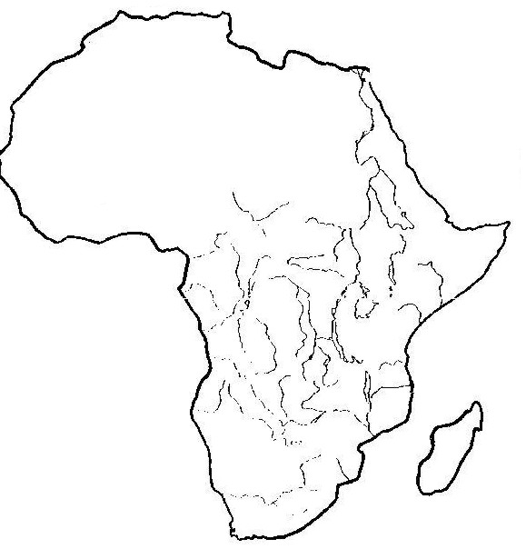**Equipment needed for each learner or group:**

* An atlas
* Pens, pencils and paper
* An A4 map of Africa showing the major rivers (use map on page 13)
* Cotton for measuring distances

**What to do:**

This activity requires that groups (or individuals) travel from Cape Town to Cairo along all the waterways of Africa. The idea is that participants plan a route through Africa which will be carried out using a Landrover and a small boat. The learners must plan their journey to incorporate as many of the waterways as possible. This can include the sea but learners should be encouraged to avoid using the sea in favour of the land routes. *(Do not worry about mountain ranges and deep valleys – measure the route as if the route from the Cape to Cairo was flat).*

Once the learners have mapped out their route which will mean using both the atlas and the A4 map, they must calculate the distances they have travelled over:

Land : number of kilometres travelled in the landrover

Sea : number of kilometres travelled on the sea

Water : number of kilometres travelled (rivers and lakes and dams)

The “winner” will be the learner or group who has travelled the shortest distance over land, in other words, who has used the rivers and lakes of Africa for travel.

Remember that when learners are using an atlas to calculate the distances, they need always to take note of the scale of the map.

# QUESTIONS FOR EACH LEARNER / GROUP: WRITE THE ANSWERS DOWN

1. List all the countries through which you travel.
2. List all the capital cities of the countries through which you travel.
3. Give the longitude and latitude (degrees and minutes) for these cities.
4. Name 10 of the rivers you travelled.
5. Using the atlas, which was the area/country of highest rainfall?
6. Using the atlas, which was the area/country of lowest rainfall?
7. What did you notice about the vegetation as you travelled north?
8. What was the most dangerous thing that happened during your journey? (be as creative and imaginative as you can!!)
9. What the kindest thing you or your group did during your Cape to Cairo journey?

*You, the teacher, may wish to discuss all the answers to the questions in class after the groups have written down their answers. You could also take this work in, mark it, and add it to the learners’ portfolios.*

# Criteria to assess learners during this social sciences : geography lesson

|  |  |  |  |  |
| --- | --- | --- | --- | --- |
| **Criteria** | **Exceeded requirements of the Learning Outcome** | **Satisfied requirements of the Learning Outcome** | **Partially satisfied requirements of the Learning Outcome** | **Not satisfied requirements of the Learning Outcome** |
| The learner gave the longitude and latitude for each capital city of each African country they travelled through |  |  |  |  |

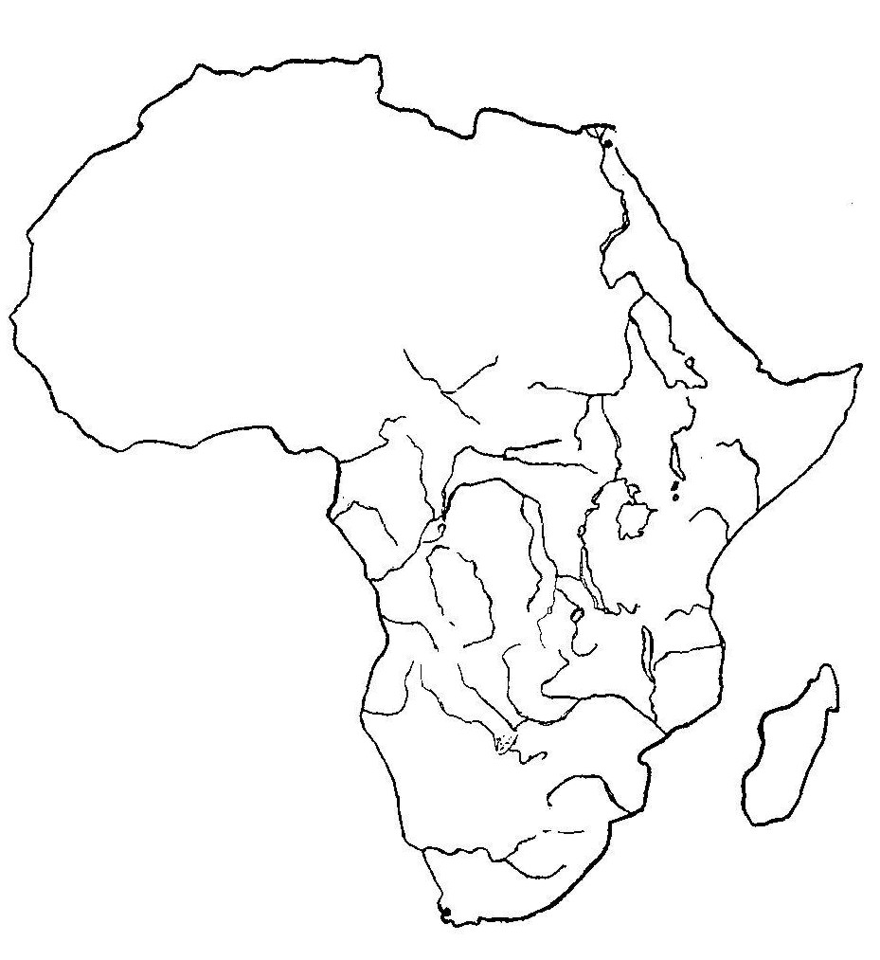

a) Land - number of kilometres travelled in the Landrover =

b) Sea - number of kilometres travelled on the sea =

c) Water - number of kilometres travelled (rivers, lakes and dams) =

|  |
| --- |
| ACTIVITY FOUR: WHERE DOES OUR DRINKING WATER  COME FROM? |

This NATURAL SCIENCES lesson looks at a water catchment. Learners consider some positive environmental action taking to help our precious water catchments and then trace the path of water, starting from their taps (or water tanks) at school or home, back to the source.

# RIVER CATCHMENTS

The river catchment, or drainage basin, is all the land from mountain top to seashore, drained by a single river and its tributaries.

Catchment areas vary greatly in size – a big river may have a catchment area of several thousand square kilometres, whereas a smaller tributary will have a catchment area of only a few hectares. Catchments are separated from one another by watersheds.

Waterbodies in southern Africa suffer from many problems – all of which are linked to the way in which the catchment area of each is used. Catchment conservation should include the protection of wetlands and sound conservation practices on agricultural and forestry lands (such as all ploughing and planting should be on the contours, river-bank vegetation should not be disturbed, and there should be the prevention of water pollution from industry, agriculture or informal settlements).

# ACTIVITY:

People are realising that we must protect our precious rivers and streams and many folk across South Africa have started ‘adopt a river’ projects. As a class or in groups discuss the positive action plans that you can see in the river catchment below:

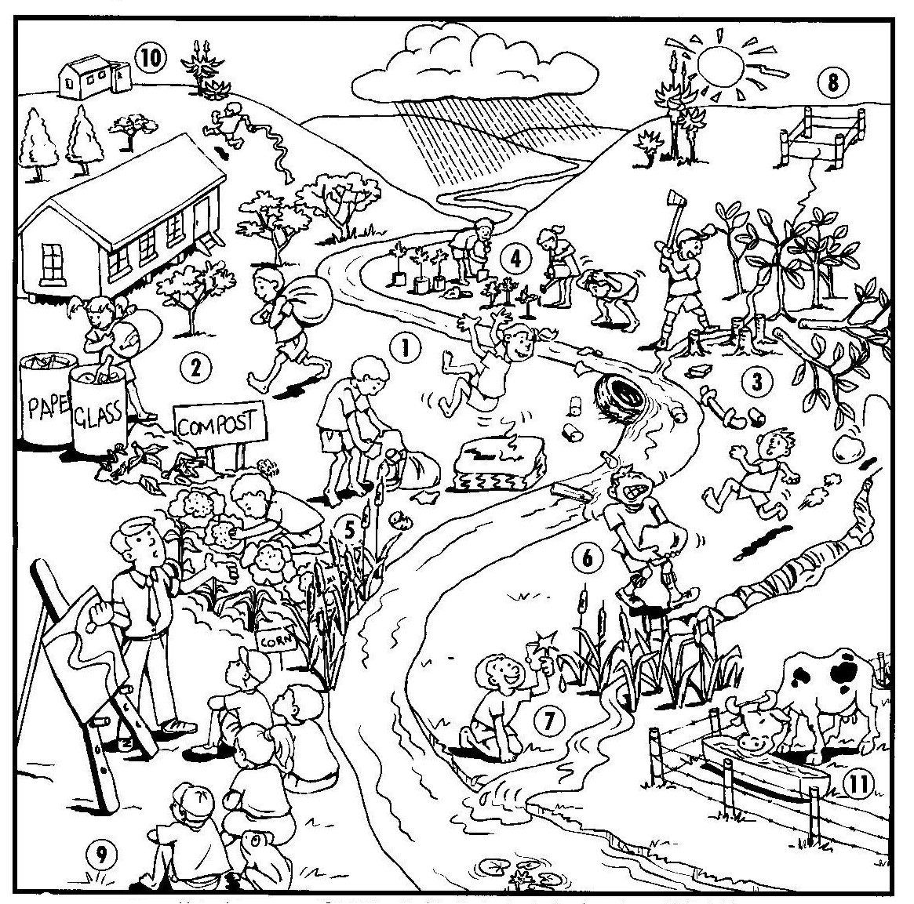

|  |
| --- |
| **For the teacher: Some of the positive action projects in the water catchment are:**   1. Organising litter clean-ups 2. Recycling waste 3. Removing alien invasive plants 4. Replanting river banks 5. Keeping strips of wetland between the river and the gardens 6. Fixing dongas 7. Repairing damaged wetlands 8. Fencing and protecting springs 9. Building houses and toilets well away from river banks 10. Keeping farm animals away from river banks |

**ACTIVITY (GROUPWORK OR INDIVIDUALLY):**

1. Using your own personal observations, the picture on the previous page and the comic strips at the end of this activity, trace the water we drink everyday from our taps or water tanks, back to the source.
2. Your information must be in the form of a flow-chart.
3. Make notes, on your flow-chart, of where possible contamination of the water takes place.

**AS A CLASS:**

1. Discuss the journey of water from our taps, back to the source. Teacher, use all the information from the different groups to draw a comprehensive flow-chart on the chalk board.
2. Where did learners feel contamination could take place? Discuss this, putting all the possible contamination points on the flow-chart.
3. What environmental action could be taken to address these issues?

# Criteria to assess learners during this natural sciences lesson

|  |  |  |  |  |
| --- | --- | --- | --- | --- |
| **Criteria** | **Exceeded requirements of the Learning Outcome** | **Satisfied requirements of the Learning Outcome** | **Partially satisfied requirements of the Learning Outcome** | **Not satisfied requirements of the Learning Outcome** |
| The learner took part in the discussion around the positive environmental actions they could see happening in the catchment |  |  |  |  |
| The learner used a flow-chart and traced the journey of water from where it is drunk to its source |  |  |  |  |
| The learner contributed to discussions on how water could be contaminated between where it is drunk and the source |  |  |  |  |
| The learner contributed ideas of what one could do to address the contamination of water |  |  |  |  |

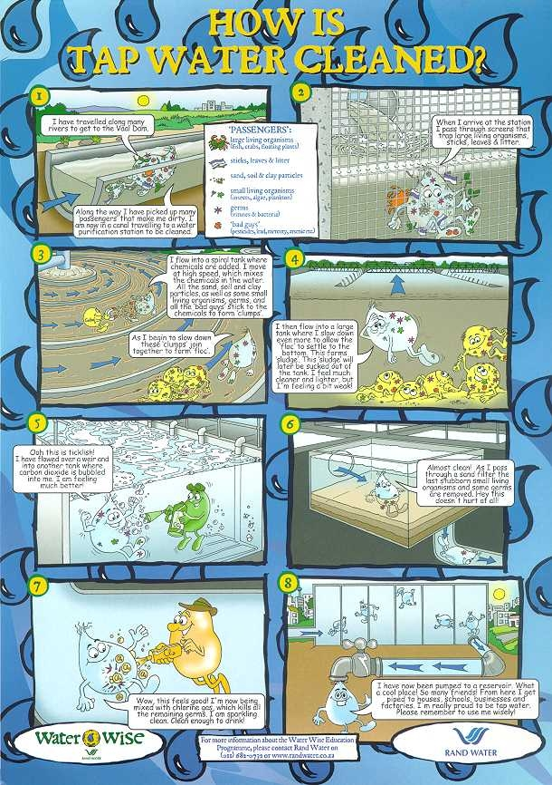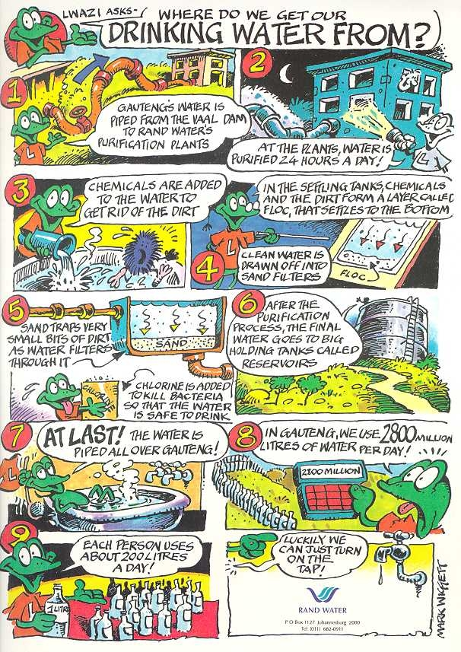

|  |
| --- |
| ACTIVITY FIVE: JUST FOR FUN: MAKING A  **BOTTLE RAIN GAUGE** |

This fun TECHNOLOGY activity can be done in the classroom or at home. For learners who may struggle with this, there are instructions for an easier ‘tin can rain gauge’ in Activity 2 of the Grade 5 pack.

# Measuring rainfall

Rain is measured in millimetres. The narrow base of a cone-shaped rain gauge makes it easier to measure small amounts of rain. The cone has to be specially calibrated (to check, adjust, or determine by comparison with a standard) by doing some magic with maths. To save you the effort, we have given you a rain scale that is calibrated for a 2-litre Fanta cold-drink bottle on the following page *(note: the scale is only accurate on this shaped bottle).*

**You will need:**

* Two empty 2-litre Fanta bottles
* Craft knife or scissors to cut the bottles
* A photocopy of the rain scale at 100%
* Prestik
* A strong stick
* String
* Fine permanent marker

Reproduced from *EnviroKids* magazine with permission 