Wetlands are wonderful!
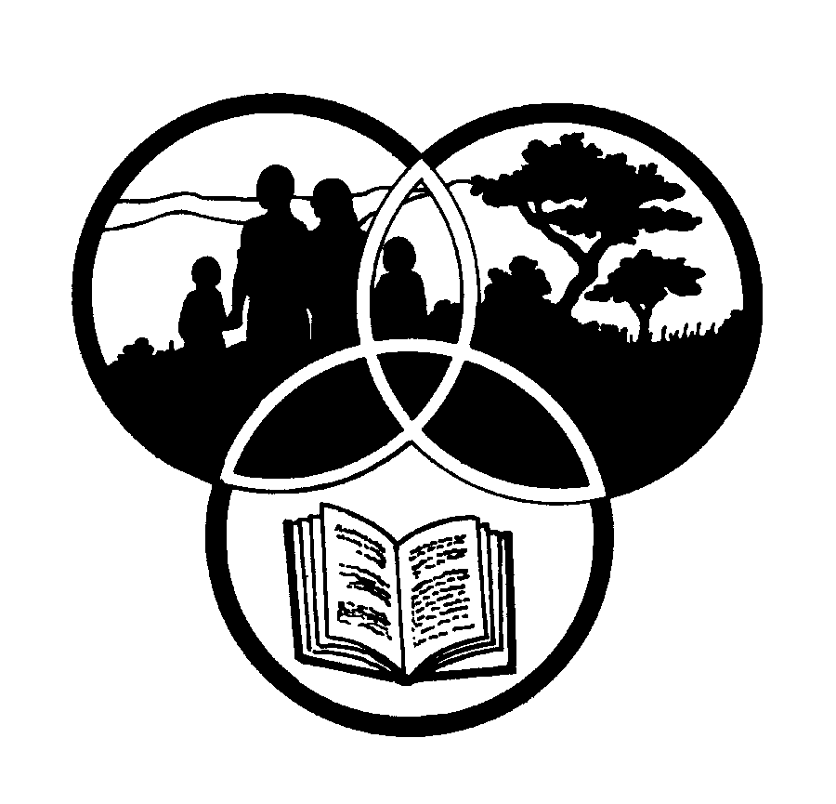
Share-Net

Share-Net is an informal partnership project committed to developing and disseminating materials in support of environmentally focused teaching and learning. Share-Net materials are copyright-free for educational purposes. We encourage you to adapt and use the materials in new, exciting ways but request that you acknowledge Share-Net as an original source. Sensible use of these curriculum activities is entirely the responsibility of the educator. Find similar curriculum materials by visiting www.envirolearn.org.za or contact Share-Net directly at PO Box 394, Howick, 3290, KwaZulu-Natal,
tel: (033) 330 3931, e-mail: sharenet@wessa.co.za
This pack supports an introduction for learners to an Eco-School’s focus on environmental information

Grade 7

This pack contains:

Activity One: These LANGUAGES activities introduce learners to the importance of wetlands. There is a reading activity, followed by a word search, a comprehension and a fun way of writing poetry.

Activity Two: During this TECHNOLOGY exercise, learners investigate, design, make and evaluate a water filtration system, similar to that of a wetland.

Activity Three: Following on from Activity Two, learners test out and evaluate their water filters during this NATURAL SCIENCES lesson.

Activity Four: This SOCIAL SCIENCES: GEOGRAPHY lesson takes learners on a walk through a wetland and a river, looking for good and bad land management practices.

Activity Five: During this ARTS AND CULTURE lesson, learners design and create a “Save our Wetlands” poster. They are encouraged to use mixed media such as paint, pastels, wax crayons, chalk and pastels.

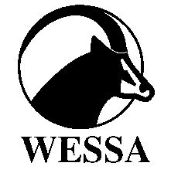
This pack of lesson plans is part of a series of lesson plans from Grade R to Grade 10, which focus on water and water-related issues. This resource development project has been funded by the Water Research Commission, Private Bag X 03, Gezina, Pretoria, 0031 (Website: www.wrc.org.za).
This pack is available electronically on www.envirolearn.org.za
Activity | Learning Area covered in this activity | Learning Outcomes covered in this activity | Assessment Standards covered in this activity
1. Learners are introduced to the importance of wetlands. There is a reading activity, followed by a word search, a comprehension and a fun way of writing poetry. | Languages | Learning Outcome 3: Reading and viewing: The learner will be able to read and view for information and enjoyment, and respond critically to the aesthetic, cultural and emotional values in texts. | - Shows understanding of information texts.  - Identifies and discusses the social, cultural, environmental and ethical issues contained in texts.
2. Learners investigate, design, make and evaluate  a water filtration system, similar to that of a wetland. | Technology | Learning Outcome 1: Technological processes and skills: The learner will be able to apply technological processes and skills ethically and responsibly using appropriate information and communication technology. | Investigates:  - Investigates the background context, the nature of the need, the environmental situation, and the people concerned.  Designs:  - Writes or communicates a short and clear statement or a design brief for the development of a product or system related to a given problem, need or opportunity.  - Lists product and design specifications and constraints for a solution to a given problem, need or opportunity based on the some of the design key words.  Makes:  - Develops a plan for making that details all of the following: resources needed; dimensions.  - Chooses and uses appropriate tools and materials to make products by measuring, marking, cutting or separating, shaping or forming, joining or combining and finishing different materials with some accuracy.
3. Learners test out and evaluate their water filters. | Natural Sciences | Learning Outcome 1: Scientific investigations: The learner will be able to act confidently on curiosity about natural phenomena, and to investigate relationships and solve problems in scientific, technological and environmental contexts. | - Conducts investigations and collects data: Organises and uses equipment or sources to gather and record information.
4. Learners take an imaginary walk through a wetland and a river, looking for good and bad land management practices. | Social Sciences: Geography | Learning Outcome 1: Geographical enquiry: The learner will be able to use enquiry skills to investigate geographical and environmental concepts and processes. | - Identifies a variety of geographical and environmental sources relevant to an enquiry.  - Organises and interprets information relevant to the enquiry from simple map.  - Uses information to suggest answers, propose alternatives and possible solutions.
5. Learners design and create a “Save our Wetlands” poster. They are encouraged to use mixed media such as paint, pastels, wax crayons, chalk and pastels. | Arts and Culture | Learning Outcome 2: Reflecting: The learner will be able to reflect critically and creatively on artistic and cultural processes, products and styles in past and present contexts. | - Explains the need for conservation of a country’s indigenous knowledge systems, heritage artefacts in museums, galleries, theatres, cultural sites and natural heritage sites.

