|  |
| --- |
| ACTIVITY ONE: WETLANDS ARE WONDERFUL! |

## During these LANGUAGES activities, learners find out more about wetlands. A reading activity introduces the importance of wetlands, followed by a word search, a comprehension and

## a fun way of writing poetry.

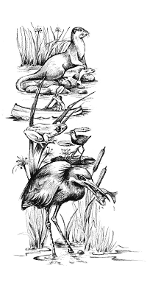

Wetlands are often thought of only in terms of their hydrological importance, but they also hold great cultural significance. Many cultures have developed traditional practices and belief systems for regulating the use of wetlands and to protect these valuable ecosystems.

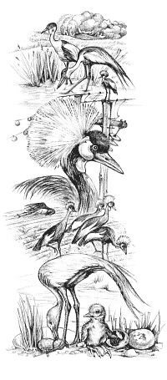Wetlands are also known as *vleis, bogs, swamps, marshes or sponges*. They are regarded as some of the most productive ecosystems in the world because they serve as sponges that regulate river flow, they provide habitats for a variety of plant and animal species and they help to absorb silt and cleanse water of pollutants.

Wetlands are at risk all around the world due to practices of draining the land for alternative use. Construction of dams, removal of plants, waste water pumped into the area by industries, seepage of agricultural fertilisers and mining are all threats to these sensitive ecosystems.

Each year, government departments, non-governmental organisations, schools and groups of individuals undertake actions to raise awareness of the values and benefits of wetlands as well as the important role they play in sustainable freshwater use.

2 February is the anniversary of the signing of the Ramsar Convention in 1971. The Convention took place in the Iranian city of Ramsar and is an inter-governmental treaty to promote national action and international co-operation for the conservation and wise use of wetlands and their resources. There are presently 153 Contracting Parties to the Convention with 1 629 wetlands sites, totalling 145.6 million hectares.

## ACTIVITY: UNDERSTANDING THE VOCABULARY:

* All the words in the crossword on the next page can be found in the text above. Use the clues given (across and down) to fill in the spaces.

## Name:…………………………………

|  |  |  |  |  |  |  |  |  |  |  |  |  |  |  |  |  |  |  |  |  |  |  |  |  |
| --- | --- | --- | --- | --- | --- | --- | --- | --- | --- | --- | --- | --- | --- | --- | --- | --- | --- | --- | --- | --- | --- | --- | --- | --- |
|  |  | **1** |  |  | **2** |  |  |  |  |  | **3** |  |  |  |  |  |  |  |  |  |  |  |  |  |
|  |  |  |  |  |  |  |  |  |  |  |  |  |  | **5** |  |  |  |  |  |  |  |  |  |  |
| **4** |  |  |  |  |  |  |  |  |  |  |  |  |  |  |  |  |  |  |  |  |  |  |  |  |
|  |  |  |  |  |  |  |  |  |  |  |  |  |  |  |  |  |  |  |  |  |  |  |  |  |
|  |  |  |  |  |  |  | **6** |  |  |  |  |  |  |  |  |  |  | **7** |  |  |  |  |  |  |
|  |  |  |  |  |  |  |  |  |  |  |  |  |  |  |  |  |  |  |  |  |  |  |  |  |
|  |  |  |  |  |  |  |  |  |  |  |  |  |  |  |  |  |  |  |  |  |  |  |  |  |
|  |  |  |  |  |  |  |  |  | **8** |  |  |  |  |  |  |  |  |  |  |  |  |  |  |  |
|  |  |  |  |  |  |  |  |  |  |  |  |  |  |  |  |  |  |  |  |  |  |  |  |  |
|  |  |  |  |  |  |  |  |  |  |  |  |  |  |  |  | **9** |  |  |  |  |  |  |  |  |
|  |  |  |  |  |  |  |  |  |  |  |  |  |  |  |  |  |  |  |  |  |  |  |  |  |
|  |  |  |  |  |  |  |  |  |  |  |  |  |  |  |  |  |  |  |  |  |  |  |  |  |
|  |  |  |  |  |  |  |  |  |  |  |  |  |  |  |  |  |  |  |  |  |  |  |  |  |
|  |  |  |  |  |  |  |  |  |  |  |  |  |  |  |  |  |  |  |  |  |  |  |  |  |

## Across Down

## 1. This word describes the laws and properties of water. 2. Adjusting, controlling or keeping order.

4. Matter that has soaked or oozed through a filter. 3. Of different traditional beliefs and practices.

6. Making or creating. 4. Something that is ongoing, that will continue and not be used up.

8. Impurities, dirt and toxins in water. 5. Specific areas in which plants and animals live.

## 9. Things that we are able to use. 7. Specific habitats and the relationship between all living and non-living parts within it.

**COMPREHENSION:**

After reading the article on wetlands, answer the following questions in full sentences.

1. Wetlands are important for their storage and filtering of freshwater. In what other ways are they important?
2. What are other names given to wetlands?
3. Name two threats that endanger our wetlands?
4. If wetlands clean pollutants out of the water, why would waste water from industries be a threat to the wetlands?
5. What is a non-governmental organisation?
6. Do you think raising awareness of the problems in wetlands is enough? Give a reason for your answer.
7. For how many years has the Ramsar Convention been in existence?
8. What is a treaty?
9. By looking at the statistics given here, do you think this treaty has been effective?
10. Do you know of any wetlands in your area that require better management? Describe.

## ACTIVITY: THERE’S A POET IN ALL OF US!!!

A cinquain is a special kind of poem with 5 lines that’s fun, easy and quick to write.

Here is the basic structure of one:

1 word – subject

2 words – descriptive words about the subject

3 words – also descriptive words about the subject

4 words – a phrase

1 word – the subject again

An example would be:

*Waterlilies*

*Delicate, beautiful*

*Round, green, floating*

*Found in all wetlands*

*Waterlilies*

Learners can write two or three cinquains on wetlands. If your school produces a yearly magazine, pass the best ones on to the editor!

# Criteria to assess learners during this languages lesson

|  |  |  |  |  |
| --- | --- | --- | --- | --- |
| **Criteria** | **Exceeded requirements of the Learning Outcome** | **Satisfied requirements of the Learning Outcome** | **Partially satisfied requirements of the Learning Outcome** | **Not satisfied requirements of the Learning Outcome** |
| The learner filled the correct words into the crossword puzzle |  |  |  |  |
| The learner answered all the questions in the comprehension correctly, with thorough comprehension |  |  |  |  |
| The learner followed the structure of the cinquain |  |  |  |  |
| The learner was able to describe a wetland in their cinquain |  |  |  |  |

|  |
| --- |
| **ACTIVITY TWO: DIRTY WATER, CLEAN WATER,**  **LET’S DESIGN AND BUILD A WATER FILTER** |

#### During this TECHNOLOGY exercise, learners investigate, design, make and

#### evaluate a water filtration system, similar to that of a wetland.

Wetlands are one of the most threatened habitats in the world. Many have been destroyed because people did not realise their importance. We used them as dumping grounds, for farmland or built houses on them. Now we know better and are working towards conserving our wetlands.

One of the important things that wetlands do is act as filters.

* **Living filters:** Wetland plants absorb nutrients in the water, using them for growth. Plant roots can also trap polluting heavy metals in the soil, especially in clay soil.
* **Spongy soil:** Wetland soils are often made up of clay and contain lots of organic material. Water passes very slowly through these soils before running into streams. This means that the wetlands stay wet for longer, and keep the streams running for longer too.
* **Silt cleaners:** Floodwaters are often muddy, carrying silt from soil erosion. Plants in the wetlands slow down the flow, and the silt settles out. Water running out of a wetland is often much clearer and cleaner than that flowing in. This can be important to people who drink the water downstream.

Aren’t wetlands wonderful! They improve water quality as they are such good natural filters and the water leaving the wetland is cleaner than the water entering it!

**It’s time for the learners to investigate, design, make and evaluate their own water filters.**

**What the learners need to do:**

**1. Investigate whether wetlands clean visible pollutants out of water**

* Give each learner copies of the enviro fact sheets on wetlands and pollution (at the end of this activity); a copy of the ‘A waterworks that works sheet’ (they may only use these sheets for ideas and to get them thinking about their own designs, they may not copy these designs).

The investigation phase is the research phase. Learners need to look at pictures of wetlands, look at books, the enviro fact sheets provided and any other material that they can find on wetlands. They can also discuss their ideas with friends, in small groups and with you, the teacher. Let the learners write a paragraph on their “research” (what sources of information they used, what they found out, what they think they would like to design).

**2. Design**

* Each learner will need paper and pencils so that they are able to write and draw their design ideas. The design must be on paper and learners should make rough drawings first. When they are happy with their designs, they need to make a neat drawing with a heading and labels or a colour key. The dimensions of the design must be written down and the materials that will be used must be listed. Any constraints / restrictions that the learner can see / anticipate in the future must also be noted.
* It is very important that you, the teacher, guide the learners through this design phase. Some of the learners designs may be wonderfully creative but very impractical, so you need to be on hand to make sure that their designs will work.

**3. Make**

* The learners need to gather together the materials they will need to construct their design. Encourage them to use recycled objects if possible. When they have all they need, the designs need to be constructed!

## 4. Evaluate

* Test the designs during the next activity, a NATURAL SCIENCES lesson!!

#### Good luck with your water filters!!

**Enviro Fact : Pollution**

Pollution is an unwelcome concentration of substances that are beyond the environment's capacity to handle. These substances are detrimental to people and other living things. In an undisturbed ecosystem, all substances are processed through an intricate network of biogeochemical cycles, such as the nitrogen and carbon cycles. During these cycles, substances are taken up by plants, move through the food chain to larger and more complex organisms, and when the latter die, are decomposed (broken down) into simpler forms to be used again when they are taken up by plants. Biodegradable substances are those that can be broken down by the environment's biological systems. Pollution occurs when the environment becomes overloaded beyond the capacity of these normal processing systems.

Examples include:

* An excess of normally helpful substances, such as the nutrients nitrogen and phosphorus.
* An excess of substances that are harmless, and perhaps even necessary in tiny amounts, but toxic in concentration. Copper, for example, is necessary in small amounts for healthy plant growth, but becomes a pollutant if it occurs in greater quantities.
* Synthetic (human-made) compounds that are poisonous in the environment, often even in trace amounts, such as DDT, dioxin, PCBs and organochlorines.
* Substances that, in any amount, are not biodegradable, such as plastics and highly persistent chemicals like DDT and other organochlorines.
* Some pollutants kill living organisms outright, other sub-lethal pollutants do not kill, but may cause long-term biological damage, interfere with organisms' reproductive cycle, or make them more vulnerable to disease.

###### Types of pollution. Pollutants can be grouped according to the main ecosystem which they affect. One pollutant often affects more than one ecosystem.

|  |  |
| --- | --- |
| POLLUTANTS AND MAIN SOURCE | HEALTH AND ENVIRONMENTAL EFFECTS |
| AIR | |
| Sulphur dioxide – burning of coal | Acid rain and respiratory problems |
| Nitrogen oxides - vehicle emissions Volatile hydrocarbons - vehicle emissions | Combine to form photochemical smog; causes respiratory problems |
| Carbon monoxide - vehicle emissions | Restricts oxygen uptake, causes drowsiness, headaches, death |
| Carbon dioxide - burning of coal | Global warming |
| CFCs - aerosol, refrigeration, air-conditioning and foam-blowing industries | Destroy ozone layer |
| Methane - feedlots, rubbish dumps | Global warming |
| Noise - industry, traffic | Affects hearing, stressful |
| Asbestos dust - construction, mining, industry | Asbestosis, mesothelioma |
| FRESHWATER | |
| Sewage – inadequate sanitation | Pathogens cause typhoid, cholera, gastroenteritis; nutrients cause eutrophication |
| Fertilizers – agriculture | Eutrophication |
| Silt - agriculture, construction, mining | Smothers aquatic organisms; affects light penetration |
| Pesticides - agriculture, and health services | Toxic; interfere with breeding of mammals and birds |
| Toxic metals – industry | Health and life threatening |
| Salinisation – industry, agriculture, landfill | Reduced crop yields; scale and corrosion in domestic and industrial water systems |
| MARINE | |
| Sewage – inadequate sanitation | Pathogens cause typhoid, cholera, gastroenteritis; nutrients cause eutrophication |
| Fertilizers – agriculture | Eutrophication |
| Oil spills | Smother marine plants and animals |
| Plastics | Death of marine animals |
| Pesticides - agriculture, and health services | Toxic; interfere with breeding of mammals and birds |
| LAND |  |
| Solid waste is classified as hazardous (radioactive, pesticides, medical, poisons), or non-hazardous (domestic, urban, mining, industrial, scrap metal) | Hazardous waste is health- and life-threatening; non-hazardous is unsightly and disposal takes up much space |

###### Dealing with pollution

In the past, most approaches to handling pollution could be summed up by the phrase `dilution is the solution to pollution'. However, pollution levels have increased so much in amount and toxicity that this approach is no longer acceptable. An alternative approach is source reduction, i.e. a reduction in the amount of pollution where produced.

* Point source pollution: pollutants are produced from a stationary location, e.g. industrial plants, mines, and municipal sewage works.
* Non-point source pollution: this pollution cannot be traced to a specific spot, and is far more difficult to monitor and control. Common examples are veldt fires, motor vehicle emissions, fertilizer runoff, sediment from construction and erosion, plastic packaging, and gases from aerosol cans. Some non-point sources can be addressed by laws, such as banning CFCs (chlorofluorocarbons), or requiring car manufactures to install emission controls.

###### Polluter-must-pay principle

This means that a polluter should bear the costs of avoiding pollution, or remedying its effects. This principle is difficult to apply when the source of pollution cannot be identified, as is often the case with atmospheric pollution. The principle can be usefully applied following a pollution disaster, such as an oil spill from a tanker. However, the consumer often pays for such pollution costs. For example, Eskom estimates that the fitting of scrubbers on the chimneys of their power stations will increase the cost of electricity by 30%.

###### Movement of pollution

Pollution does not stay in one place but is moved around the world by air and water, as well as by living organisms. Even in Antarctica, birds and marine mammals show traces of pollutants such as DDT and PCBs. Some pollution is deliberately moved abroad. Companies restricted by pollution control regulations at home, sometimes move their plants to other less restrictive countries, as was the case with the plant involved in the Bhopal chemical disaster. Or while remaining at home, they may sell products abroad, that are classed in their own countries as too dangerous for sale, such as banned pesticides. In some cases hazardous waste may also be shipped abroad, generally from industrialised countries to developing countries willing to accept such waste for a fee, despite the hazards. When such pollutants turn up again in the originating country, as when food is imported that contains banned pesticides, the process is said to be completing the `circle of poison'.

###### What can you do

* *Avoid the creation of waste.*
* *Find out all you can about pollution and protest loudly when you see it happening.*
* *Report air pollution to the Chief Air Pollution Control Officer (CAPCO), Department of Health.*
* *Report freshwater and land pollution to the Department of Water Affairs and Forestry.*
* *Report marine pollution to the Department of Environment Affairs and Tourism, Marine Pollution Division.*

Enviro Fact : Wetlands

Wetlands are difficult to define because of their great variation in size and location. The most important features of wetlands are: waterlogged soils or soils covered with a shallow layer of water (permanently or seasonally), unique types of soil, and distinctive plants adapted to water-saturated soils. Marshes, bogs, swamps, vleis and sponges are examples of wetlands.

**Why are wetlands important?**

Wetlands associated with streams and rivers slow floodwaters by acting as giant, shallow bowls. Water flowing into these bowls loses speed and spreads out. Wetland plants, particularly reeds and sedges, play an important role in holding back the water. The wetland acts as a sponge as much of the flood water is then stored in the wetland and is slowly released to downstream areas, instead of it all rushing to the sea within a few days. This greatly reduces flood damage, particularly erosion, and ensures a more steady supply of water throughout the year.

**Filters:** Wetlands improve water quality as they are very good natural filters, trapping sediments, nutrients (e.g. nitrogen and phosphorus), and even pathogenic (disease-causing) bacteria. In addition, pollutants such as heavy metals (e.g. mercury, lead) and pesticides, may be trapped by chemical and biological processes. In other words, the water leaving the wetland is cleaner than the water entering it.

**Wetlands and wildlife:** Wetlands are filters where sediments and nutrients accumulate, so many plants, such as bulrushes, grasses, reeds, waterlilies, sedges and certain trees grow there. The plants, in turn, provide food and a place for attachment and shelter for many creatures. There is more life, hectare for hectare, in a healthy wetland than in almost any other type of habitat. These productive places support huge numbers of insects, fish, birds and other animals. Some animals are completely dependent on wetlands, whilst others use wetlands only for part of their lives. The wattled crane, for example, is dependant on wetlands for breeding. The rich diversity of waterbirds in southern Africa (totalling 130 species) is possible because of the many wetlands spread across the sub-continent. The wetlands of southern Africa are of international importance as they are the southern destination for many migratory water birds.

**People and wetlands:** Wetlands have been used for centuries as grazing for domestic stock, and as a source of reeds used for thatching, hut construction and basket weaving. They provide fishing and hunting, and the opportunity to observe wildlife, especially birds. Wetlands are appreciated for their beauty as open spaces and also for their educational value.

Wetlands in trouble: To many people the thought of a marsh, swamp, bog or vlei is associated with dampness, disease, difficulty and danger. Because of this wetlands are often seen as wastelands that should be converted to cropland, dams, commercial timber plantations of alien trees, waste disposal sites and pastures. Many wet- lands have been "reclaimed" for industry and the construction of airports, harbours and sewage treatment plants. Historically wetlands have been drained in attempts to control malaria.

All wetlands in southern Africa are threatened. Botswana's magnificent Okavango Delta is threatened by the possible canalisation of the Boro River to supply South Africa with water for both domestic and industrial use. Throughout the region, smaller seasonal wetlands in urban areas have virtually disappeared, while riverine wetlands are constantly under threat of being turned into agricultural land.

What you can do:

* *Get to know the wetlands in your area and list the plants and animals living there. Draw a map of the wetland's position, size and use. Take photographs of the wetlands from fixed vantage points, and at different seasons of the year, to compare the changes between seasons and from year to year.*

*Report the abuse of wetlands to your local nature conservation officer, agricultural extension officer or the Department of Environmental Affairs and Tourism. Always make your report in writing to ensure that the officer concerned has to investigate.*

**Criteria to assess learners during this technology lesson**

|  |  |  |  |  |
| --- | --- | --- | --- | --- |
| **Criteria** | **Exceeded requirements of the Learning Outcome** | **Satisfied requirements of the Learning Outcome** | **Partially satisfied requirements of the Learning Outcome** | **Not satisfied requirements of the Learning Outcome** |
| The learner wrote a paragraph outlining what he/she did during the research phase |  |  |  |  |
| The learner drew rough and neat designs of his/her water filter. He/she had a heading, labels, or a key and had a list of all the materials needed and their measurements |  |  |  |  |
| The learner built his/her design |  |  |  |  |

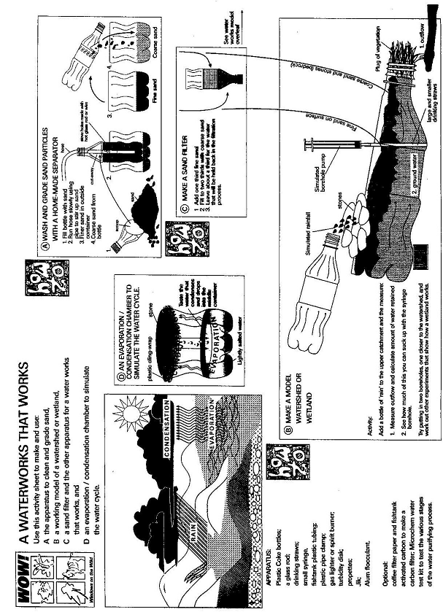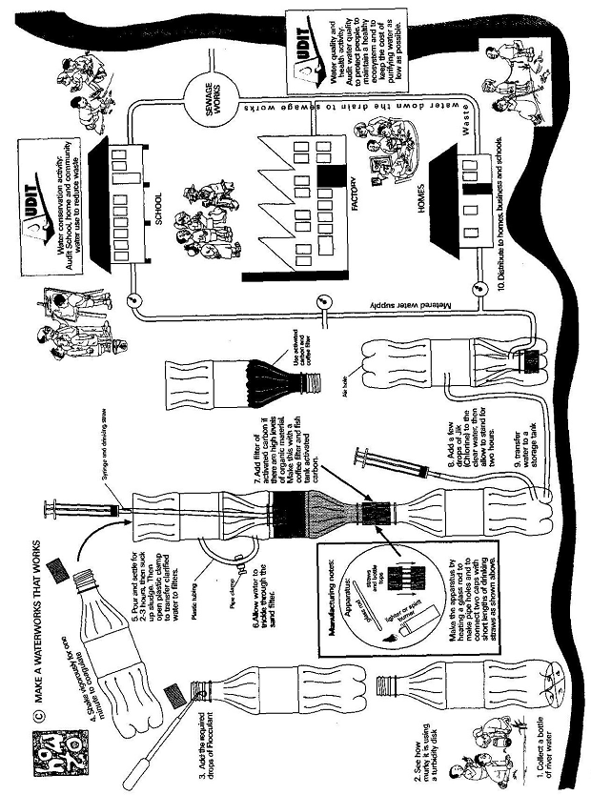

|  |
| --- |
| ACTIVITY THREE: HOW WELL DO OUR WATER FILTERS WORK? |

#### Following Activity Two, learners test out and evaluate their water filters

**during this NATURAL SCIENCES lesson.**

## ACTIVITY

1. Divide the class into groups. Each group must have the equipment listed below.
2. The groups will have as many filters in each group as there are number of learners (in other words if there are five learners in each group, there will be five filters as each learner will have designed and made his/her own filter during Activity Two).
3. Set up the equipment.
4. Each group must test the turbidity of their glass of water before and after filtering.
5. Record the results.

**Each group will need the following equipment:**

* The water filters constructed during Activity Two, the technology lesson
* Pens and paper
* A glass of dirty water (either collected from a local river or made dirty by adding sand)
* A container to collect the filtered water
* A turbidity disk (to be found on page 12)
* Water clarity (turbidity) information (on page 13)
* Groundwater recharge and discharge (on page 14)
* Enviro fact sheets on “Wetlands”, “Pollution” (use the enviro fact sheets at end of Activity Two) and “Water” (found at end of this activity)

At the end of this activity, groups need to report back on their findings.

Each learner must write up the experiment, the results and their conclusion. *(This could be included into the learner’s portfolio).*

**TURBIDITY DISK – to cut out:**

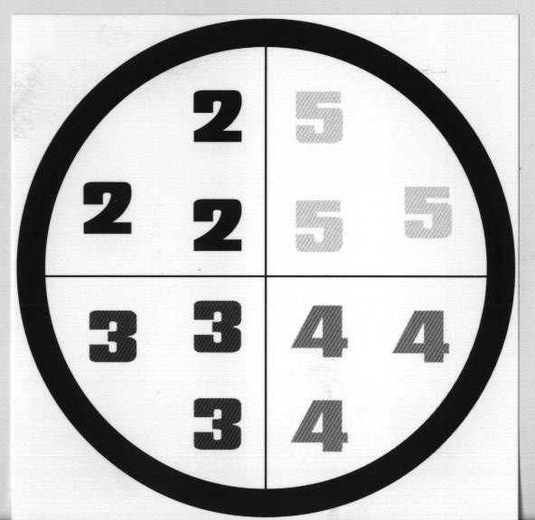

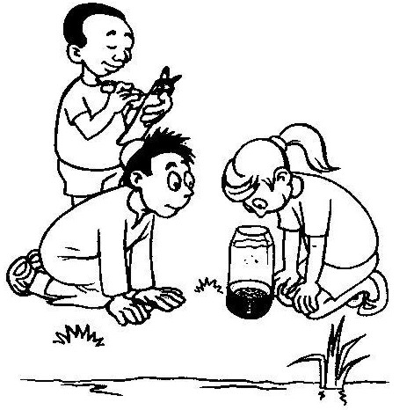**WATER CLARITY (TURBIDITY)**

Turbidity refers to the relative clarity of water. Murky water stops light penetration and inhibits water life with a consequent loss of plant and animal diversity. Plants need light to grow and both large and small animals may suffer growth retardation or death because they cannot see to hunt and breed, or their gills may become clogged with particles of silt and organic matter. Suspended solid pollution can be caused by silt from soil erosion, by sewage and industrial waste or by excess microscopic life in the water.

*Note: Some rivers are naturally turbid and many organisms can only live in turbid conditions. The key is knowing natural levels in your area especially in Cape and forest ‘black water’ streams and rivers.*

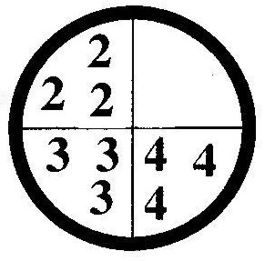

**How the test works:**

The turbidity sighting disk is based on an early technique of lowering a black washer into a long glass tube of water and noting the depth at which it is no longer visible. The turbidity disk has a circular washer (outer ring scored as 1) and numbers of differing density (scored 2-5). A measure of clear or murky water (turbidity) can be obtained by noting the image density visible in a 20 centimetre column of water.

**Testing water clarity / turbidity:**

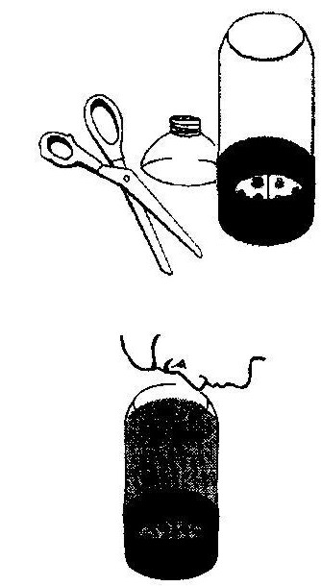

1. Cut down a 1.5 or 2 litre plastic cool drink bottle.
2. Fix the disk to the inside bottom of the bottle.
3. Fill the bottle to 20cm with a debris-free sample of water.
4. Look into the bottle and pick out the water clarity number that is visible (outer ring [1], 2, 3, 4 or 5).
5. Repeat to get a reliable result.

The water clarity is: Disk not visible Score 1-3 All visible

|  |  |  |
| --- | --- | --- |
| **BAD** | **NOT SO GOOD** | OK |

**Information Sheet on Groundwater recharge and discharge**

Wetlands may have an important influence on the recharge or discharge of groundwater. Groundwater recharge refers to the movement of surface water down through the soil into the zone in which permeable rocks and overlying soil are saturated. Groundwater discharge, in contrast, refers to the movement of groundwater out onto the soil surface. Although poorly understood, it appears that most wetlands are groundwater discharge or throughflow areas. Wetland areas where groundwater is discharging are often referred to as seepage wetlands because they are places where the water seeps slowly out onto the soil surface.

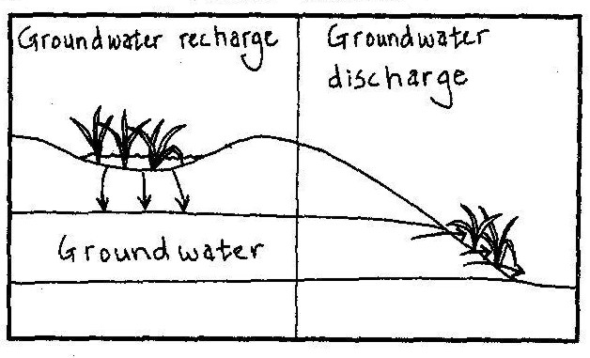

## Water purification

Wetlands are natural filters, helping to purify water by trapping pollutants (such as sediments, excess nutrients [most importantly nitrogen and phosphorus] heavy metals, disease-causing bacteria and viruses and synthesized organic pollutants such as pesticides). Thus, the water leaving a wetland is often purer than the water which enters the wetland. Wetlands are able to purify water effectively because:

* they slow down the flow of water causing sediment carried in the water to be deposited in the wetland. This also results in the trapping of other pollutants (e.g. phosphorus) which are attached to soil particles;
* surface water is spread out over a wide area, making it easier for exchanges between soil and water;
* 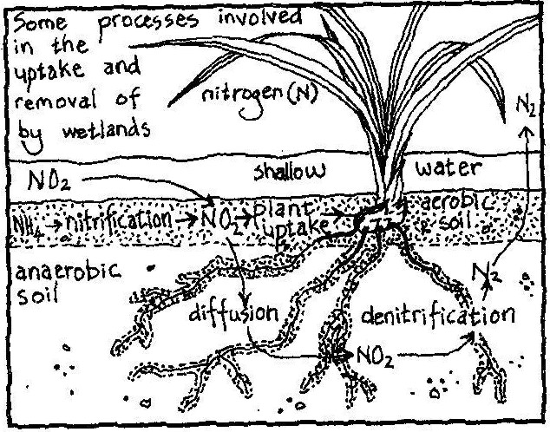there are many different chemical processes taking place in wetlands that remove pollutants from the water. For example, wetlands provide a suitable place for denitrification because anaerobic and aerobic soil zones are found close together. Denitrification is important because it converts nitrates, which could potentially pollute the water, to atmostpheric nitrogen which is not a pollution hazard;
* some pollutants such as nitrates are taken up by the rapidly growing wetland plants;
* the abundant organic matter in wetland soils provides suitable surfaces for trapping certain pollutants such as heavy metals; and
* wetland micro-organisms help decompose human organic pollutants such as pesticides.

**Enviro Fact : Water**

Water. South Africa is extraordinarily rich in natural resources - except for water. Water is a vital but scarce resource, distributed unevenly in time (frequent droughts alternate with periods of good rainfall) and space (the eastern half of the country is markedly wetter than the western half). Increasing demand for water, and decreasing water quality, make careful water management a priority in our country. It has been estimated that by the year 2025 South Africa’s human population will have doubled, and that there will be insufficient water for domestic use, agriculture, and industry.

Rainfall. Our average rainfall is less than 500 mm a year, with the driest part of the country receiving less than 200 mm/year and the wettest receiving more than 2 500 mm/year! Rain does not always fall where it is most needed, and some areas of high demand, such as Gauteng, receive less water than they need. Most rain falls in the narrow belt along the eastern and southern coasts. The rest of the country receives only 27% of South Africa's total rainfall. In addition, hot, dry conditions result in a high evaporation rate.

Water is thus a very scarce resource in South Africa. Large-scale engineering has been used to store water behind dam walls, and to distribute water from regions of plenty to regions of need.

Rivers. There are few natural lakes in South Africa. We depend on rivers, dams and underground water for our water supply. Approximately 75% of the water flowing from South Africa into the sea occurs along the eastern and southern seaboards, where many short rivers occur. Flowing from east to west is the largest river in the country, the Orange River, which drains most of the rest of the country. Its water comes from sources in the Drakensberg and Maluti Mountains, and it flows into the Atlantic Ocean on the west coast.

Dams. About half of South Africa's annual rainfall is stored in dams. We have about 550 government dams in South Africa, with a total capacity of more than 37 000 million m3. Dams have both positive and negative impacts. They can be beneficial for people in that they regulate the flow of a river, reducing flood damage and contributing to perennial rather than seasonal flow. In addition, sediment is deposited in a dam, and the growth of aquatic plants means that nutrients are removed from the water. Thus water leaving a dam may be cleaner than water entering it. The riverine ecosystem is usually affected negatively by a dam. Alterations in flow regime (quantity of water and timing of periods of high and low flow), temperature and water quality may cause reductions in biodiversity of riverine organisms below dams. Reduction in water flow reduces the river's scouring ability and this can lead to silting of estuaries.

South Africa's landscape is not well suited to dams. There are few deep valleys and gorges, with the result that most dams are shallow with a large surface area. Together with the hot, dry, climate, this results in much water evaporating from dams. In addition, the high silt load (a result of an arid climate, steep river gradients and poor farming methods) of our rivers means that the capacity of South Africa's dams is quickly reduced as they become silted. The rivers of the western Cape carry relatively less silt than those in the rest of the country.

Water abstraction. A growing problem for South Africa's rivers is a lack of water! Reduction in river flow, owing to abstraction (removal), and damming, has affected many of our rivers, for example those flowing through the Kruger National Park.

Intercatchment transfer of water. This involves the transfer of water from catchments with good supplies and low demand, to those where demand for water is high and the supply is poor. There are numerous intercatchment transfer schemes already in operation, and more are under construction or proposed. A major scheme is the Orange-Fish River scheme, where water gravitates from the Orange River at the Gariep Dam, and is piped through tunnels and canals to the Sundays and then the Fish Rivers in the Eastern Cape.

Transfers of this nature will have far-reaching ecological, political and socio-economic implications. As yet, little research has been carried out to establish the ecological consequences of intercatchment water transfers. However, areas of concern include reducing streamflow and water levels in one system, changes in water temperature and chemistry, and the transfer of invasive species between catchments.

Water pollution. Industrial and agricultural pollutants common in South Africa include: agricultural fertilizers, silt, toxic metals, litter, hot water and pesticides. These pollutants affect aquatic ecosystems and human health. Disease-producing bacteria are common in urban waste water, particularly from informal settlements that lack sewage and water purification facilities. For example, typhoid, cholera and gastroenteritis are transmitted by water contaminated with untreated sewage. Gastroenteritis is one of three main causes of death in South African children under the age of five.

# Criteria to assess learners during this natural sciences lesson

|  |  |  |  |  |
| --- | --- | --- | --- | --- |
| **Criteria** | **Exceeded requirements of the Learning Outcome** | **Satisfied requirements of the Learning Outcome** | **Partially satisfied requirements of the Learning Outcome** | **Not satisfied requirements of the Learning Outcome** |
| The learner was able to test the filters in his/her group |  |  |  |  |
| The learner was able to record the results of the filter tests (ie what happened) |  |  |  |  |
| The learner was able to write up the experiment, the results and make a conclusion |  |  |  |  |

|  |
| --- |
| ACTIVITY FOUR: WALKING IN A WETLAND WITH DAVID |

This SOCIAL SCIENCES: GEOGRAPHY lesson takes learners on walk through a wetland

and a river, looking for good and bad land management practices.

Historically, wetlands have been regarded as unproductive and even unhealthy wastelands. Although an understanding of the value of wetlands and wetland conservation has grown in recent years, some people continue to convert natural wetlands to intensive agricultural land or fill them with soil and rubble to provide space for industrial, urban and tourist expansion.

**Each group will need the following equipment:**

* A copy of ‘David’s Wetland Walkabout’ (see end of this pack)
* 2 different coloured highlighter pens per group
* Articles on flood reduction and streamflow regulation (see end of this activity)
* Enviro fact sheet on Wetlands (at the end of Activity Two)

## WHAT TO DO?

* 1. Divide the class into groups of 5 or 6 learners.
  2. Give each group the equipment listed above.
  3. The groups are to follow these instructions:

Using the highlighter pens, mark the following:

* + - Areas where good management of the land around the river will help prevent flooding *(teacher, there is a wetland checklist for you to use if necessary at the end of this activity).*
    - Areas where bad land management could lead to flooding *(teacher there is a wetland checklist for you to use if necessary at the end of this activity)*.
    - Using the information gathered, each learner is to write a letter to the Mayor of Bokkiesburg, warning him/her of the potential flooding hazard in the town. Include some suggestions for good land management. *This letter could be included in the learner’s portfolio.*

## Flood reduction and streamflow regulation

Wetlands spread out and slow down water moving through the catchment because:

1. The characteristically gentle slopes of the wetlands and,
2. The resistance offered by the dense wetland vegetation.

Also many wetlands do not have well-defined channels that would otherwise speed up the movement of water.

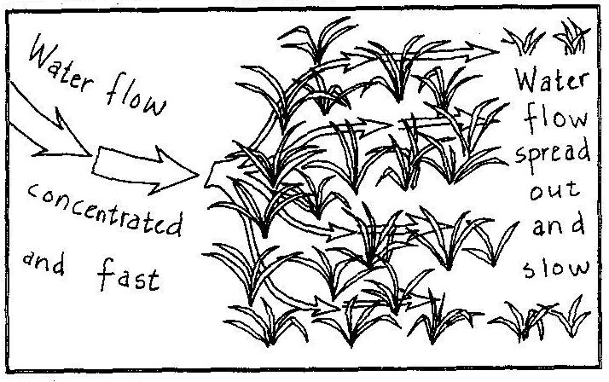

By slowing down the movement of water and detaining it for a while, wetlands act as sponges which reduce floods and also prolong streamflow during low flow periods. Loss of water to the atmosphere through evaporation and transpiration does, however, reduce the amount of water available to prolong low flows. When wetland vegetation is growing, water is lost from the leaves through transpiration. However, the water lost into the atmosphere from a vegetated wetland is usually less than would be lost from the surface of an open water area such as a dam. This is because the cover provided by wetland vegetation reduces evaporation from saturated or flooded soil by sheltering it against the sun and wind. When the vegetation dies back, there is no loss of water through transpiration and the dead leaves remain, continuing to shelter the soil. During such times, water Ioss is most effectively regulated.

**WETLAND CHECKLIST**

|  |  |
| --- | --- |
| **Harmful actions / Poor land management** | **Good actions / Good land management** |
| Toilets, rubbish, cattle and erosion polluting a water supply. | A water source protected by a fence, and water being piped to a storage dam for community use. |
| Alien trees planted in a mountain valley catchment. | A permaculture farm (growing several crops) which has natural vegetation between the fields and the river |
| Farmer draining and ploughing a wetland. | A restored catchment (start of a river) where rocks and plants prevent soil erosion, and people can picnic and enjoy nature. |
| Four places where housing and farming practices have removed natural plants from the river’s edge and caused erosion. |  |
| Farmer John who uses too much fertiliser. Water run-off from his land causes algal bloom in the dam. |  |
| Farmer Brown spraying pesticide too close to the river. This kills water animals. |  |
| A dry river bed because of a dam. All the river animals and plants have died. |  |
| A wetland being filled with rubble for housing development. |  |
| Bokkiesburg factories, and litter polluting the river. |  |
| A narrow bridge causing erosion of the river banks. |  |
| A mangrove swamp that has been drained, and houses built too close to the river mouth. |  |

# Criteria to assess learners during this social sciences: geography lesson

|  |  |  |  |  |
| --- | --- | --- | --- | --- |
| **Criteria** | **Exceeded requirements of the Learning Outcome** | **Satisfied requirements of the Learning Outcome** | **Partially satisfied requirements of the Learning Outcome** | **Not satisfied requirements of the Learning Outcome** |
| The learner was able to identify good land management practices from ‘David’s Wetland Walkabout’ |  |  |  |  |
| The learner was able to identify bad land management practices from ‘David’s Wetland Walkabout’ |  |  |  |  |
| The learner wrote a letter, warning of the flood potential to the town and was able to offer suggestions of good/better land management practices |  |  |  |  |

|  |
| --- |
| ACTIVITY FIVE: “SAVE OUR WETLANDS” POSTER |

During this ARTS AND CULTURE lesson, learners design and create a “Save our Wetlands” poster. They are encouraged to use mixed media such as paint, pastels,

**wax crayons, chalk and pastels.**

**You will need:**

* Paper – white or coloured
* Paint
* Pastels
* Kokis
* Chalk
* Wax crayons

**What the learners need to do:**

1. In groups of 4 or 5 learners, discuss why we need to conserve our natural areas, like wetlands.
2. What are ways that an awareness can be raised? *(examples could be through radio, television, posters, newspaper articles, demonstrations, debates)*
3. Individually, and using a mixture of media (paint, pastels, kokis, chalk, wax crayons), create a bright and colourful “SAVE OUR WETLANDS” poster.

Learners may want to add very brief notes on their poster as to

the threats of wetlands, why they are so special but

they must remember not to add too much text.

1. Put the posters up around the school to create awareness of the threat to wetlands.

# Criteria to assess learners during this arts and culture lesson

|  |  |  |  |  |
| --- | --- | --- | --- | --- |
| **Criteria** | **Exceeded requirements of the Learning Outcome** | **Satisfied requirements of the Learning Outcome** | **Partially satisfied requirements of the Learning Outcome** | **Not satisfied requirements of the Learning Outcome** |
| The learner was able to explain, within his/her group, why there is a need for the conservation of wetlands |  |  |  |  |
| The learner used a variety of media to draw an informative, bright and colourful poster |  |  |  |  |

