|  |
| --- |
| ACTIVITY ONE: SWEET WATER AND  EARLY NGUNI PEOPLE |

This SOCIAL SCIENCES : HISTORY reading and questioning activity looks at early Nguni people of southern Africa and their commonsense ways of collecting and storing “sweet” water.

*(In the story that follows, comments and scientific observations are*

*in brackets and italised so that the learners can see the*

*practical wisdom behind some water collection myths*

*and techniques of the past).*

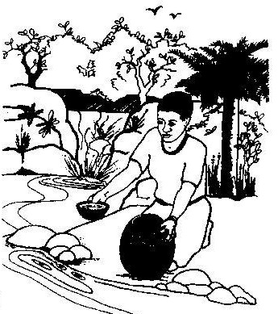Before the time of the Zulu King, Shaka, sweet water was called “amanzi amnandi”. Shaka’s mother was called Nandi and it is said that because it was not considered respectful to use the queen mother’s name in this way, Shaka referred to sweet water as “amanzi amtoti”. *(This is how the town of Amanzimtoti, south of Durban, got its name).* Today both terms are used and many people of Nguni origin will sniff, smile and hold up “sweet” water, collected from a river, spring or well for their daily household needs. *(Water quality scientists today still have people smell and taste household water. Human senses give a refined indication of whether water is good and clean and fresh).*

Historically, water was usually collected in areas where people could hear it running over stones or dripping down rocks *(well oxygenated water supports natural biological cleansing processes).* If a spring was for human use, it was protected by a circle of rocks with a small outlet. Cattle drank elsewhere.

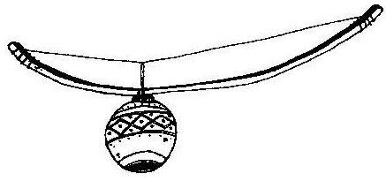An area nearby was cleared and the site soon became a meeting place for young people. Young men would hang around these water collection sites, playing musical instruments and admiring the maidens who came to collect water. The girls would saunter along slowly and gracefully, singing and flirting. Water collecting was rarely seen as a tiring or boring chore because of the prospect of courtship!!

A water source would always be approached with care so as not to frighten crabs and other small water animals. When disturbed, their movement would stir up sediments and the collector would have to wait for the silt to settle. The surface film was brushed aside for “sweet water” to be collected. *(Sediments and surface films have higher bacteria numbers than the middle waters of pools and rivers. Today scientists take water samples below the surface film, taking care not to suck up sediments. In this way, scientists can get consistent and reliable measures of bacterial contamination).*

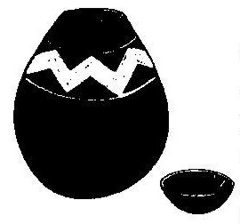Clay pots were filled with water and covered with a collecting bowl, a piece of skin or a mat made from incema (*Juncas kraussii*) grass. The water would thus stay cool and fresh. *(Water evaporating through the sides of a porous clay pot cooled the contents. Most water bacteria cannot reproduce in cool, dark conditions. Some micro-organisms envelop themselves in a calcium secretion in the pores of clay pots. Scientists spoken to were uncertain about the detail of these issues but it is of note that, in earlier times, great care was taken to scour out a calcium-like scale in water pots. Also of note is that when the grass “lids” and head rings for carrying pots became old they were simply thrown away and new ones were woven. Discarded lids did not pollute the river like today’s bottle tops and plastic waste).*

There were many other customs and traditional practices surrounding water. Children were warned that urinating in a river would change them to the opposite sex! *(This myth was probably sufficiently frightening to prevent people urinating in streams and rivers. This would have limited a disease like bilharzia. The bilharzia parasite is passed on from human urine and faeces to small water snails. From these, its life cycle takes the disease back to people through river water).*

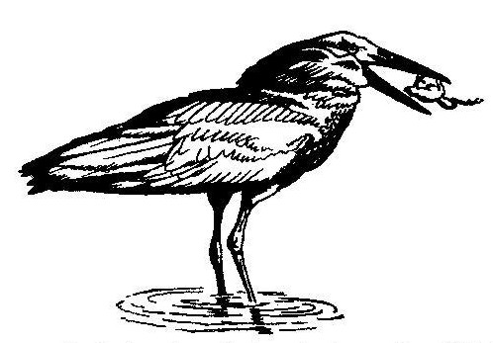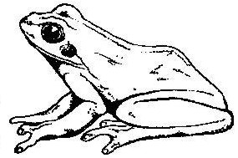Nguni water collectors say that where there are frogs, one does not find sweet water. Frogs are eaten by hammerkops (*uthekwane*, the “lightning bird”) and the prospect of collecting water while being watched by a “witch-bird” must have been terrifying in earlier times when spirits, myths and mystery had a more central place in everyday social life. Children were told that if they killed this bird or stole its eggs, their homes would go up in flames. *(Where there are frogs, one will usually find snakes. Both animals are feared by many people today, not least the children who were told the Nguni myths of witches and lightening to fill their hearts with terror. Today, scientific tests suggest that many frog species need “sweet water” if they are to live and reproduce successfully. There must be some doubt about the Nguni suggestion that frogs are an indication of water that is not fit for human consumption).*

It is also said that it was not advisable to collect water from a river after heavy rain at the start of the annual rainy season. Indigenous commonsense told people to put out pots to collect rain-water. River water would again be collected four days after the rains stopped and the water had cleared. *(Heavy rains wash human and animal wastes into rivers. There is thus a rapid increase in faecal bacteria and disease. In KwaZulu-Natal, health workers have to warn rural people not to collect river water after heavy rains as few remember the earlier Nguni practice of collecting rain-water only four days after the rains have stopped).*

Today human and livestock numbers have increased vastly, catchments have become degraded and rivers are often polluted dumping places. The best indigenous practices for the collection of “sweetwater” may not prevent people getting serious diseases from river water. Learning about historical water collection and storage practices can, however, develop a respect for early people and might also help our understanding of water quality issues.

# Read the story of ‘Sweet Water and Early Nguni People’ to the class or make photocopies and allow the learners to read it on their own.

# As a class, discuss the following questions:

1. How many of you have collected water from a nearby river? What was the water used for? (If for drinking, how were you certain that it was safe to drink?)
2. How many of you have heard the story that has just been read? Who told you this story?
3. Do any of you have stories of other ways of collecting water long ago?
4. Many stories from long ago, are passed down orally from one generation to another. One does not find them written down in books and one has to ask the older people in a community who may remember how things were done long ago. How reliable is this information? What is the danger of not writing down stories from different cultures?
5. Why do you think it is important to look after our rivers and streams?
6. Does the class think that rivers and streams throughout South Africa have changed over the last 100 years? In what way? Why? Have any of you seen changes taking place in a river in your life-time? *(Keen young fishermen in the class may have noticed a decrease or increase in fish species and a change in the water quality or path of the stream/river).*
7. How can we find out what the rivers, streams and other water sources were like in our own community 50 years ago so that we can compare them with what we see today?

# Criteria to assess learners during this social sciences: history lesson

|  |  |  |  |  |
| --- | --- | --- | --- | --- |
| **Criteria** | **Exceeded requirements of the Learning Outcome** | **Satisfied requirements of the Learning Outcome** | **Partially satisfied requirements of the Learning Outcome** | **Not satisfied requirements of the Learning Outcome** |
| The learner was able to discuss how reliable and useful stories told by older members in the community were (question 4) |  |  |  |  |
| The learner was able to give reasons why we should conserve and look after our rivers and streams  (question 5) |  |  |  |  |
| The learner was able to discuss possible or real changes that have taken place in rivers or streams (question 6) |  |  |  |  |

|  |
| --- |
| ACTIVITY TWO: LOCAL INTERVIEWS, INDIGENOUS STORIES AND CATCHMENT HISTORY |

In this ARTS AND CULTURE activity, learners conduct interviews in their local community and then share their findings to the rest of the class in small group role-plays.

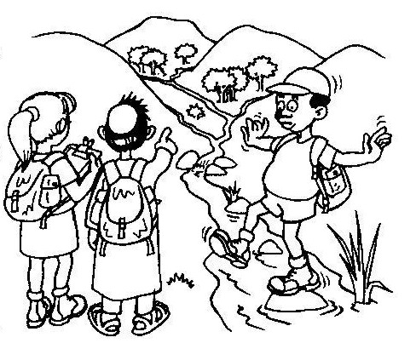A watershed and its catchment is the land from which rainwater flows into wetlands, streams or rivers.

Many of the river catchments of southern Africa have been changed by historical land use practices, settlements and industrial growth to cater for a rapidly expanding population. In many cases, wetlands have been destroyed and riverine vegetation removed, decreasing natural flood control so that the amount and quality of water released by our river catchments is decreasing.

Interviewing local people and collecting stories can develop a sense of how things have changed. Local information and stories are essential for our understanding of local water quality issues.

# ACTIVITY

* In small groups of 4 or 5, the learners must work out a set of questions to ask local people, particularly older folk, who have lived in the area for many years.

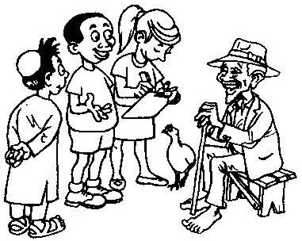Some ideas for questions for older people could be:

1. How long have you lived here?
2. Have you noticed any changes, since you were young?
3. What are these changes?
4. How did you collect water long ago?
5. Have you noticed any change in the water? Quality? Amount of water?
6. Have you noticed any changes in the amount of rain that falls?
7. Do you know any local stories about water? (Or animals linked to water?)

Learners also need to work out another set of questions about the present conditions of their catchment and possible problems. These questions can be asked to their friends, parents and other members of the community.

1. How long have you lived here?
2. Where do you get your water?
3. Have you noticed any problems with the quality of water here, in this community? What are these problems?
4. Are the streams and rivers clean in this area? Can one drink from them?
5. Is the community involved in any river clean-up / alien plant eradication projects that you know of?

**NB: Only use the questions above if learners are struggling to work out their own sets of questions**

Time needs to be set aside, either during or after school, to conduct these interviews, using the questions prepared during the lesson. These local interviews will give the learners information on water and the water quality situation both in the past and today.

**And now … it’s time for some drama in our lives!!**

# What is role-play?

We use role-play to explore different situations and ideas. This is done by acting out a usually authentic situation, without a script.

Now that the water quality and catchment interviews have been completed, each group will role-play their experiences of:

* Deciding what questions the group was going to ask the interviewees;
* Deciding who they were going to interview;
* The interviews themselves;
* Some of the funny/sad/interesting/unusual things that may have happened during the interviews;
* Their interactions with one another during this activity – any conflicts that arose, any differing of opinions (how they were sorted out, or not!), any laughs and good times.

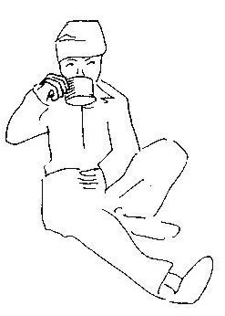One of the first tasks of the role-play is for each group to decide who are the different characters involved. It is a good idea to use simple props for each character (such as a hat, wig, jacket or jewellery to help characters get into their ‘role’).

Role-play is a fun way of exploring environmental issues and concerns. At the end of the role-plays, a list of all the main points that emerged from the interviews can be drawn up and shared with the whole class, thus giving a broader and fuller overview of the water and water quality situation in your local catchment.

# Criteria to assess learners during this arts and culture lesson

|  |  |  |  |  |  |
| --- | --- | --- | --- | --- | --- |
| **Criteria** | **Exceeded requirements of the Learning Outcome** | **Satisfied requirements of the Learning Outcome** | **Partially satisfied requirements of the Learning Outcome** | **Not satisfied requirements of the Learning Outcome** | |
| The learner was able to research the issue of water quality by conducting interviews within their local community |  |  |  |  | |
| The learner was able to work in a group and play a part in the role-play of water and water quality |  |  |  |  | |
| **ACTIVITY THREE: AUDITING OUR WATER CONSUMPTION** | | | | |

Auditing our individual family’s water consumption is a good start to investigating how we can all reduce water waste and together, as a community, develop a water-wise management plan. This NATURAL SCIENCES activity allows learners to prepare for a water audit, collect data in and around their home, school and community and then develop a school water-wise management plan.

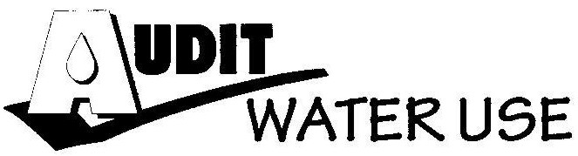

To prepare for an audit of the school, home or community water-supplies, current patterns of use must be calculated and averaged. This makes an audit a simple matter of recording the number of times each activity happens. Preparation activities also point to wasteful practises that can be changed.

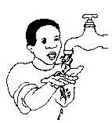

For example: People with piped water often clean their teeth or take a drink with the tap running. In this way, fresh water is wasted when it would have been more sensible to use a cup.

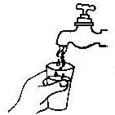

**Let the learners try this activity:**

Calculate the water used when brushing teeth or taking a drink from a running tap. Use a plastic bag to collect the wasted water and measure the amount wasted using the measuring equipment *(see box on the next page)*

**Calculate the difference:**

Water used with the tap left running ………*l*

Water used with a cup ………*l*

Difference ………*I*

(not wasted when cup used)

|  |
| --- |
| BAG MEASURE For fast leaks and running taps, use a supermarket plastic bag. Pour the water collected into a container and use a measuring jug to measure. A cheaper alternative is to make your own measuring equipment. Making your own measures  * Cut the bottles as shown in the picture. This will give you 50ml; 200ml;   1 000ml; measuring apparatus.   * Accurate apparatus is important so check by filling the larger from the smaller:   * The 2.5ml is pre-calibrated  * 50ml is 20 x 2.5ml  * 250ml is 5 x 50ml  * 1 000ml is 4 x 250ml  Although not as accurate as a measuring jug, this equipment is more than adequate for auditing water use.  To measure a bag of water, simply fill the 1 000ml, counting each time until a part-filled container remains. Pour this into the 250ml until a part-filled container remains and do the same right down to a part-filled 50ml measure which is determined by the propette. Written like this, it seems a little complex but with practise a bailing and counting method is both quick and accurate. |

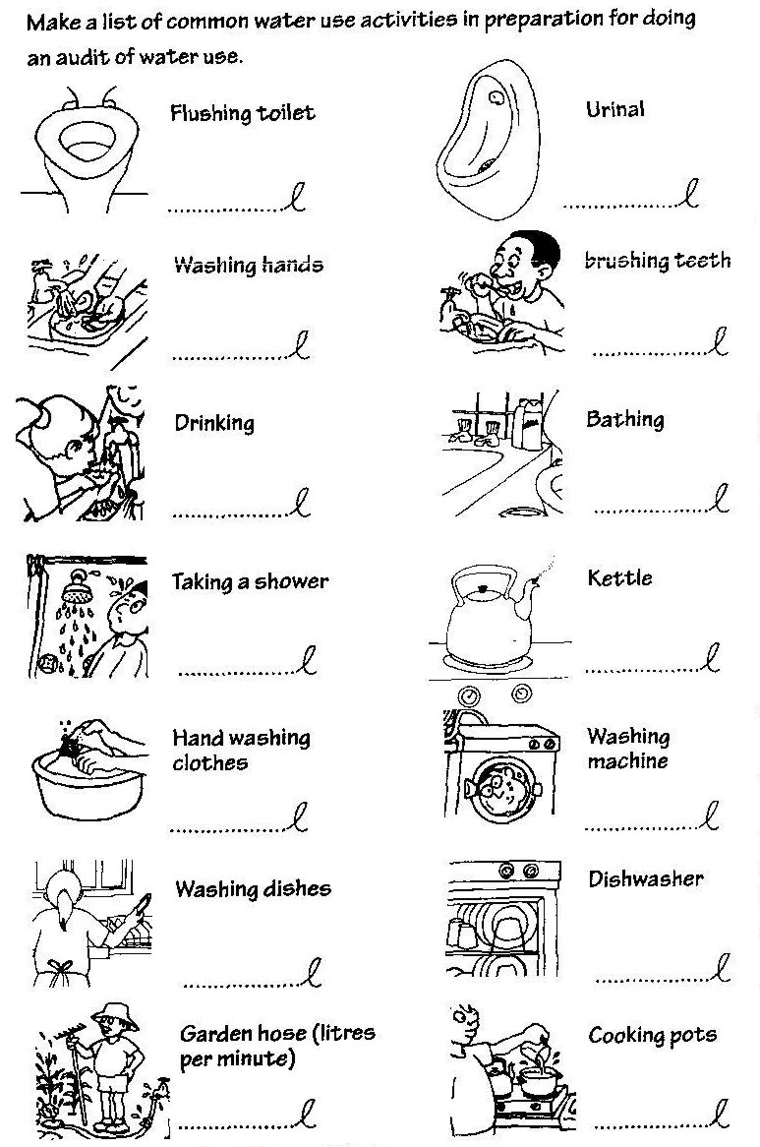

# REMIND THE LEARNERS THAT …

Despite sound preparation and knowing how much water is used for each activity, a water audit is never an easy matter. You will only be successful if, from the beginning, you keep it simple and have ways of checking your work for accuracy.

**For example:**

If a check of results against the meter reading shows that more water is used that the audit records then:

1. 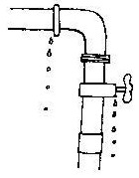There may be a leak in the pipes (check this by switching all the taps off and seeing if the meter keeps ticking)
2. You may have missed measuring an important water activity, or
3. 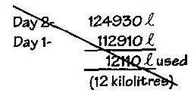Your calculations may be wrong!

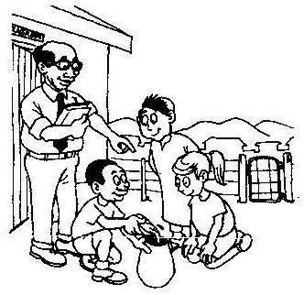In this way, an audit of water use will always present challenges and problems to be solved. Here are some ideas to help the learners plan an audit of the school, home and community water use.

**SCHOOL:** Start with each person in the class doing an audit of the water they use in a day. This can then be combined into an audit of the water used by the whole class. During National Water Week, try an audit of water use in the school and check the accuracy of your records using the water meter if there is one.

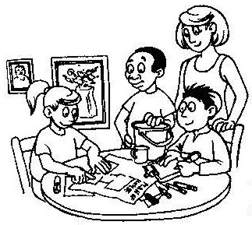

**HOME:** Get the learners to plan an audit with their family, using simple record sheets at each site of water use. Totals for the day should be matched with the meter reading or monthly water bill.

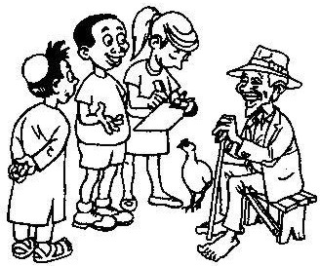**COMMUNITY:** Patterns of use at home and at school can give the learners an idea of domestic water use in the community. Offices, industries and agriculture often use vast amounts of water when compared with domestic consumption. There are also many people in our communities who do not use piped water.

Remember that we need clean water for our health. Water conservation is not about people drinking or using less water but a challenge of working out ways to reduce unnecessary waste so there is more clean water to go around.

Let the learners adapt this table or develop their own to calculate school, home and community water use. Results should be compared with metered use. This is a good check of how accurate the audit has been:

|  |  |  |  |  |  |  |  |  |  |  |  |  |  |  |  |  |
| --- | --- | --- | --- | --- | --- | --- | --- | --- | --- | --- | --- | --- | --- | --- | --- | --- |
|  | **Name of person** | Washing hands | Drinking | Kitchen use | Washing machine | Toilet | Urinals | Hand basin | Shower | Garden hose | Washing carpets | Leaks detected | Other | Total Meter Reading  *kl l* | | |
| 1 |  |  |  |  |  |  |  |  |  |  |  |  |  |  |  |  |
| 2 |  |  |  |  |  |  |  |  |  |  |  |  |  |  |  |  |
| 3 |  |  |  |  |  |  |  |  |  |  |  |  |  |  |  |  |
| 4 |  |  |  |  |  |  |  |  |  |  |  |  |  |  |  |  |
| 5 |  |  |  |  |  |  |  |  |  |  |  |  |  |  |  |  |
| 6 |  |  |  |  |  |  |  |  |  |  |  |  |  |  |  |  |
| 7 |  |  |  |  |  |  |  |  |  |  |  |  |  |  |  |  |
| 8 |  |  |  |  |  |  |  |  |  |  |  |  |  |  |  |  |
| 9 |  |  |  |  |  |  |  |  |  |  |  |  |  |  |  |  |
| 10 |  |  |  |  |  |  |  |  |  |  |  |  |  |  |  |  |
| 11 |  |  |  |  |  |  |  |  |  |  |  |  |  |  |  |  |
| 12 |  |  |  |  |  |  |  |  |  |  |  |  |  |  |  |  |
| 13 |  |  |  |  |  |  |  |  |  |  |  |  |  |  |  |  |
| 14 |  |  |  |  |  |  |  |  |  |  |  |  |  |  |  |  |
| 15 |  |  |  |  |  |  |  |  |  |  |  |  |  |  |  |  |
| Total: | |  |  |  |  |  |  |  |  |  |  |  |  |  |  |  |

Once the audits have been conducted – at school and home, discuss the results with the class.

Water audit actions can help us to reduce water wastage and thus save money. Many schools are now developing water wise management plans to make changes in their water consumption.

# Has your school got a water wise management plan?

* If not, get the class to develop a plan for the entire school? Divide the class into small working groups and let them come up with five to ten ways of reducing water consumption in the school. As a class, go through the list and write down the most useful ones. Pass this plan to the head and management team of the school.

# Criteria to assess learners during this natural sciences lesson

|  |  |  |  |  |
| --- | --- | --- | --- | --- |
| **Criteria** | **Exceeded requirements of the Learning Outcome** | **Satisfied requirements of the Learning Outcome** | **Partially satisfied requirements of the Learning Outcome** | **Not satisfied requirements of the Learning Outcome** |
| The learner adapted the water audit record sheet, where necessary, and added in more headings |  |  |  |  |
| The learner was able to carry out a water audit around the school |  |  |  |  |
| The learner contributed ideas in his/her group and during class to developing a school water wise management plan |  |  |  |  |

|  |
| --- |
| ACTIVITY FOUR: THE WATER CONFLICT GAME |

Development in a sensitive wetland area! Is it a yes, is it a no? Can the environment, the culture, the people who live there and the economic future be considered, in a sustainable way, without one aspect compromising the other? This LANGUAGES lesson encourages learners to investigate an environmental situation and debate,

discuss and communicate their ideas.

Read the following story to your class:

The Strong River system rises in the majestic 7 000m peaks of the Molombi mountain range. After cascading down the mountain slopes it winds down into the Strong River valley where the river channel widens to form a large wetland area. From here, the river continues to flow into the river estuary and the ocean.

There are five groups of people involved in the area. They are:

* The nomadic indigenous Bongo tribe which has migrated between the floodplain and the mountains for over two thousand years. They are dependent on water and the land for their existence. Nomadic pastoralism, fishing and crop cultivation are some of their livelihood activities.
* The Wildlife and Environment Society of South Africa (WESSA) who are dedicated to maintaining the social and ecological biodiversity of the wetland system. They want to install research facilities in the area to obtain a better understanding of the dynamics of the wetland system.
* The Goodgrip Tyre Company want to build a tyre factory in the area. Vast quantities of water will be consumed and the waste from the factory will need to be disposed. No environmental impact assessment (EIA) has been conducted in the area where they want to build the factory. Three hundred job opportunities will be created.
* The Fitness Fanatics Group is planning to develop a huge sports centre which will provide accommodation, canoeing, golfing, yachting, hiking and fishing.
* The Provident Engineering Firm wants to build a dam to provide water and electricity to the tyre factory and the sports centre.

ACTIVITY:

* Divide the learners into groups to represent each of the five groups involved in the area.
* Each group will need:
* a map (Worksheet 1),
* a set of the enviro fact sheets (Enviro Fact 1 to 9)
* a marker (you can use stones, leaves, bark, a small piece of rubber etc).

Each group spends time planning where they would like to complete their development – this is then marked on their worksheet. They must consider the advantages and disadvantages of their choices. *(The groups need to consider all the other groups – they are more likely to make a better decision if they focus on a sustainable and long-term view rather than a quick, unthoughtful decision which is based only on the money that will be made over a short period of time).*

1. The groups then gather around a larger copy of the map (you can enlarge the A4 sheet to A3 size), and place their markers where they plan to develop.
2. Two or more groups can use the same space (if they have both decided on that during their earlier discussions).
3. Each group is then given the opportunity to state the reasons for their choice. Through the guidance of the teacher, the groups argue their cases. It is important, that, despite conflicts that may arrive, the groups find a solution.

Worksheet 1

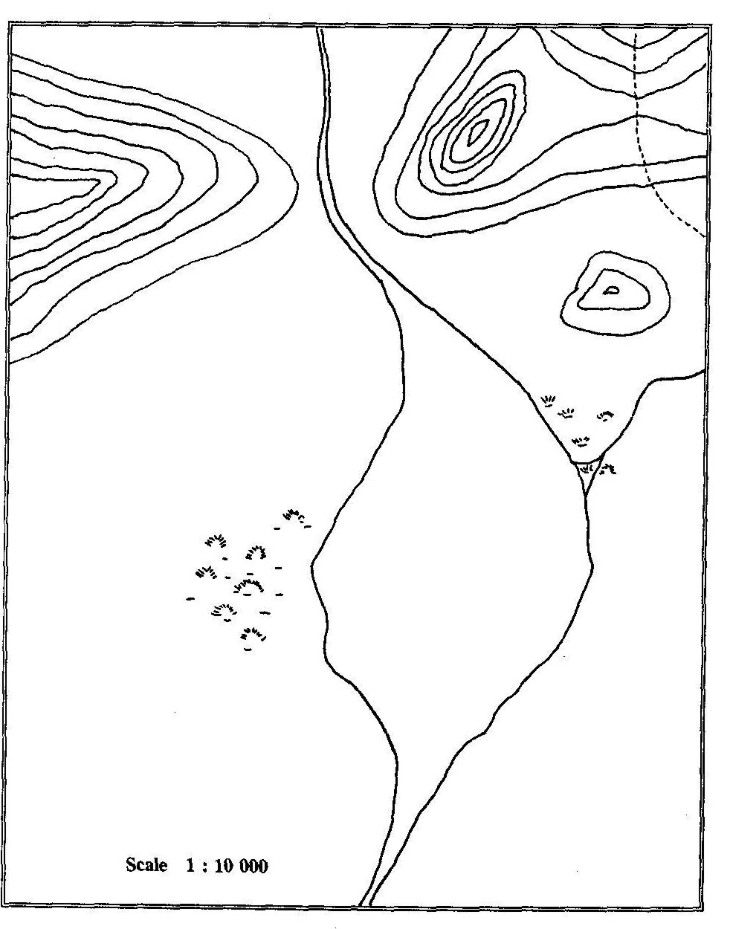**Enviro Fact 1: Sustainable Development**

Historically, development and conservation have been in conflict, because conservation has been understood as the protection of resources. Recognising the need for both, the United Nations appointed, in 1987, a commission on environment and development to advise on development and conservation. In the commission' s report called "The Bruntland Report" or "Our Common Future", the concept of sustainable development was emphasised. The report's definition of sustainable development as "… development which meets the needs of the present without compromising the ability of future generations to meet their own needs", is one of many definitions of sustainable development, and is the most commonly used. There are many definitions, principles and criteria for sustainable development, however, the concept is seldom explained or deeply understood, and is thus difficult to put into practice.

**Historical perspective.** During the Industrial Revolution, development was associated with economic growth through industries such as mining, manufacturing and large-scale farming. Industrialisation began in Britain and spread to mainland Europe, North America and Japan, all of which became known as the First World. Characteristics of First World countries are high economic growth, many and varied job opportunities, and high incomes. The Soviet Union and its satellite states, governed under the economic system of communism, became known as the Second World. Third World countries, such as those in Africa, South America and parts of Asia, have slow, if any, economic growth, with a high level of unemployment and very low incomes, but often substantial natural resources. In fact, the wealth of many First World countries is founded in part on the exploitation of resources (natural and human) from Third World countries.

**Environmental problems.** The environmental problems of the First World are associated with economic wealth, high resource consumption and industrialization. These have contributed to, for example, ozone depletion and global warming. Environmental problems of the Third World, however, can be associated with poverty, high population growth rates, lack of food, shelter and water, and a lack of technical capacity.

**Development as a solution?** The solution to the devastating poverty, environmental problems of Third World countries is often seen as 'development'. For example, the development of Third World countries towards the First World ideas of economic growth through Industrialisation and high consumption patterns. However, many people have began to seriously question the wisdom of this approach. Thabo Mbeki, South Africa' present president, believes Africa must use African resources, especially human, in order to achieve a strong, well-developed and competitive continent - he has called this process the 'African Renaissance'.

**Limited resources.** It is argued that the Earth's finite resources would not be able to support all the world' s people if everyone had the high consumption patterns of those living in First World countries. Mahatma Gandhi, when asked if, after independence, India would attain British standards of living, commented that "… it took Britain half the resources of the planet to achieve its prosperity, how many planets will a country like India require?”

**A different type of development?** Development is conventionally seen as economic growth, dependant upon 'throughput growth', i.e. growth which depends on ever increasing consumption of energy and natural resources. This type of development is unsustainable. One alternative being suggested is qualitative development, with minimum inputs and outputs, maximum reuse, recycling and repair, and little or no growth in throughput. Organisations would thus try to deliver the same high standards of service, but use fewer material resources such as fossil fuels, minerals and water. Development programmes in Third World countries probably need both quantitative growth (to address poverty), and qualitative development. The First World also needs to minimise its throughput growth, and replace it with qualitative growth. For example, an industry-oriented economy (high throughput) might be characterized by coal mining and steel manufacture, whereas a service-oriented economy might focus on information technology including the use of fibre optics and electronics (low throughput).

**Who benefits?** Third World development programmes that focus on economic growth as a solution to widespread poverty, assume a 'trickle down' effect, i.e. the benefits of economic growth will trickle down to all members of society. However, economic growth does not always benefit the poor in a country. Many development programmes now give special attention to human needs, improved participation in programmes, and the distribution of development benefits, rather than focusing all efforts on economic development. A more people-oriented development should empower people to take greater control over all aspects of their lives: social, political, economic and ecological.

**Indicators of economic performance.** If we are to move towards sustainable development, we will need tools with which to measure our performance. At present the performance of an economy is measured in term of its gross domestic product (GDP). The GDP is the total value of all the money transactions that take place, and is a poor measure of the effect of economic policies and practices on people and the environment. The GDP does not differentiate between different kinds of economic activity. For example, if a new prison is built, this amount is added to the GDP - the more prisons built the better the GDP!

However, there are no simple answers to how sustainable development can be assessed. Many attempts endeavour to value, or put a price to, the depletion and degradation of natural resources as a way of ensuring that this is taken into account when assessing economic performance. Other approaches argue that valuing the environment is often impossible or undesirable, and maintain that environmental quality should be measured in purely physical terms, which should then be published alongside the GDP as an environmental account. As situations and conditions change, so will our understanding of sustainable development change. Sustainable development is not a model to be imposed, but can be seen as a process of learning how to live on the Earth. Ultimately the focus of sustainable living and sustainable development is to find a balance between the social, economic and ecological aspects of our existence.

|  |
| --- |
| **Agenda 21** Agenda 21 is a global action plan for socially, economically and environmentally sustainable development. It was adopted at the United Nations Conference on the Environment and Development held in Rio de Janeiro in June 1992 (Earth Summit). The conference proposed that Agenda 21 be implemented at the local authority level, and this came to be known as Local Agenda 21. The principles guiding Local Agenda 21 in South Africa are: people-centred development, meeting basic needs, integrated planning and development. Several South African cities and provinces have developed Local Agenda 21 programmes. |

**Enviro Fact 2: Pollution**

Pollution is an unwelcome concentration of substances that are beyond the environment's capacity to handle. These substances are detrimental to people and other living things. In an undisturbed ecosystem, all substances are processed through an intricate network of biogeochemical cycles, such as the nitrogen and carbon cycles. During these cycles, substances are taken up by plants, move through the food chain to larger and more complex organisms, and when the latter die, are decomposed (broken down) into simpler forms to be used again when they are taken up by plants. Biodegradable substances are those that can be broken down by the environment's biological systems. Pollution occurs when the environment becomes overloaded beyond the capacity of these normal processing systems.

Examples include:

* An excess of normally helpful substances, such as the nutrients, nitrogen and phosphorus.
* An excess of substances that are harmless, and perhaps even necessary in tiny amounts, but toxic in concentration. Copper, for example, is necessary in small amounts for healthy plant growth, but becomes a pollutant if it occurs in greater quantities.
* Synthetic (human-made) compounds that are poisonous in the environment, often even in trace amounts, such as DDT, dioxin, PCBs and organochlorines.
* Substances that, in any amount, are not biodegradable, such as plastics and highly persistent chemicals like DDT and other organochlorines.
* Some pollutants kill living organisms outright, other sub-lethal pollutants do not kill, but may cause long-term biological damage, interfere with organisms' reproductive cycle, or make them more vulnerable to disease.

###### Types of pollution. Pollutants can be grouped according to the main ecosystem which they affect. One pollutant often affects more than one ecosystem.

|  |  |
| --- | --- |
| POLLUTANTS AND MAIN SOURCE | HEALTH AND ENVIRONMENTAL EFFECTS |
| AIR | |
| Sulphur dioxide - burning of coal | Acid rain and respiratory problems |
| Nitrogen oxides - vehicle emissions Volatile hydrocarbons - vehicle emissions | Combine to form photochemical smog; causes respiratory problems |
| Carbon monoxide – vehicle emissions | Restricts oxygen uptake, causes drowsiness, headaches, death |
| Carbon dioxide - burning of coal | Global warming |
| CFCs - aerosol, refrigeration, air-conditioning and foam-blowing industries | Destroy ozone layer |
| Methane - feedlots, rubbish dumps | Global warming |
| Noise - industry, traffic | Affects hearing, stressful |
| Asbestos dust - construction, mining, industry | Asbestosis, mesothelioma |
| FRESH WATER | |
| Sewage - inadequate sanitation | Pathogens cause typhoid, cholera, gastroenteritis; nutrients cause eutrophication |
| Fertilizers – agriculture | Eutrophication |
| Silt - agriculture, construction, mining | Smothers aquatic organisms; affects light penetration |
| Pesticides - agriculture, and health services | Toxic; interfere with breeding of mammals and birds |
| Toxic metals – industry | Health and life threatening |
| Salinisation - industry, agriculture, landfill | Reduced crop yields; scale and corrosion in domestic and industrial water systems |
| MARINE | |
| Sewage - inadequate sanitation | Pathogens cause typhoid, cholera, gastroenteritis; nutrients cause eutrophication |
| Fertilizers – agriculture | Eutrophication |
| Oil spills | Smother marine plants and animals |
| Plastics | Death of marine animals |
| Pesticides - agriculture, and health services | Toxic; interfere with breeding of mammals and birds |
| LAND |  |
| Solid waste is classified as hazardous (radioactive, pesticides, medical, poisons), or non-hazardous (domestic, urban, mining, industrial, scrap metal) | Hazardous waste is health- and life-threatening; non-hazardous is unsightly and disposal takes up much space |

###### Dealing with pollution

In the past, most approaches to handling pollution could be summed up by the phrase `dilution is the solution to pollution'. However, pollution levels have increased so much in amount and toxicity that this approach is no longer acceptable. An alternative approach is source reduction, i.e. a reduction in the amount of pollution where produced.

* Point source pollution: pollutants are produced from a stationary location, e.g. industrial plants, mines, and municipal sewage works.
* Non-point source pollution: this pollution cannot be traced to a specific spot, and is far more difficult to monitor and control. Common examples are veldt fires, motor vehicle emissions, fertilizer runoff, sediment from construction and erosion, plastic packaging, and gases from aerosol cans. Some non-point sources can be addressed by laws, such as banning CFCs (chlorofluorocarbons), or requiring car manufactures to install emission controls.

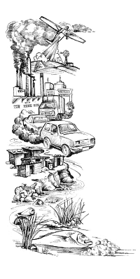

###### Polluter-must-pay principle

This means that a polluter should bear the costs of avoiding pollution, or remedying its effects. This principle is difficult to apply when the source of pollution cannot be identified, as is often the case with atmospheric pollution. The principle can be usefully applied following a pollution disaster, such as an oil spill from a tanker. However, the consumer often pays for such pollution costs. For example, Eskom estimates that the fitting of scrubbers on the chimneys of their power stations will increase the cost of electricity by 30%.

###### Movement of pollution

Pollution does not stay in one place but is moved around the world by air and water, as well as by living organisms. Even in Antarctica, birds and marine mammals show traces of pollutants such as DDT and PCBs. Some pollution is deliberately moved abroad. Companies restricted by pollution control regulations at home, sometimes move their plants to other less restrictive countries, as was the case with the plant involved in the Bhopal chemical disaster. Or while remaining at home, they may sell products abroad, that are classed in their own countries as too dangerous for sale, such as banned pesticides. In some cases hazardous waste may also be shipped abroad, generally from industrialised countries to developing countries willing to accept such waste for a fee, despite the hazards. When such pollutants turn up again in the originating country, as when food is imported that contains banned pesticides, the process is said to be completing the `circle of poison'.

###### What can you do

* *Avoid the creation of waste.*
* *Find out all you can about pollution and protest loudly when you see it happening.*
* *Report air pollution to the Chief Air Pollution Control Officer (CAPCO), Department of Health.*
* *Report freshwater and land pollution to the Department of Water Affairs and Forestry.*
* *Report marine pollution to the Department of Environment Affairs and Tourism, Marine Pollution Division.*

**Enviro Fact 3: Energy and Environment**

Some of South Africa's most serious environmental problems are associated with our use of energy. Coal-fired and nuclear power stations for electricity generation, coal combustion in the townships, SASOL coal-to-oil processes, petrol and diesel use in vehicles for bulk transport, and over exploitation of fuelwood resources, all result in serious, long-term environmental damage.

#### Pollution from burning coal

More than three-quarters of South Africa's energy comes from coal, approximately half of which is used to generate electricity, a quarter to produce synthetic liquid fuels and another quarter directly by industry and in homes. Air pollution problems from coal combustion are serious. Medical studies are revealing increased rates of respiratory disease in residents in polluted areas.

#### Acid rain

Most of South Africa's power stations are concentrated within a 100 km radius in Mpumalanga and this leads to pollution problems. While all of Eskom's coal-fired power stations are designed to remove dust and other particles from waste gases produced during coal combustion, none are fitted with flue-gas scrubbers (cleaning equipment) to remove oxides of sulphur and nitrogen. Tall chimney stacks in power stations assist in releasing oxides of sulphur and nitrogen into the upper atmosphere where atmospheric conditions are more favourable for their dispersal and dilution. Although this reduces ground level concentrations of these pollutants, they may combine with moist air and rain at higher levels and cause acid rain in areas far from the source of pollution.

Whilst South Africa's coal has a relatively low sulphur content there is considerable concern about the potential environmental and economic impact of acid rain. Half of South Africa's agriculturally productive land, half of its commercial forests and a quarter of its surface water run-off are in Mpumalanga.

#### Pollution from vehicles

Motor vehicle fumes make air pollution problems worse and are the main cause of photochemical smog in cities. Unleaded fuel has recently been introduced to South Africa and this may reduce the amount of lead in exhaust fumes. Catalytic converters fitted to exhausts would result in a significant reduction in the release of carbon dioxide, hydrocarbons, and nitrogen oxides. However, South Africa lags far behind other countries (e.g. Japan, Germany) in legislation to control vehicle emissions. Solutions to transport pollution and vehicle congestion require long-term planning to introduce efficient public transport systems in our cities.

#### Deforestation

Another environmental concern associated with energy use is the reliance by a significant number of South Africans on fuelwood, once a renewable resource, but now being used at a rate much greater than that at which it is naturally regenerated. Fuelwood is an inefficient source of energy for cooking and heating and its use can cause increased respiratory illnesses. It has been estimated that if current consumption trends continue, all natural woodland in the former "homelands" will be denuded by 2020. In addition to the environmental consequences of deforestation, diminishing supplies of wood require rural people (particularly women) to travel further and further from home to gather wood, placing a great burden on them.

#### Global warming

South Africa uses a great deal of energy, very much more per unit of gross domestic product (GDP) than most other countries. The combustion of coal, oil and wood results in increased carbon dioxide production. This gas acts likes a greenhouse - it lets short-wave, natural light through but traps out going long-wave (infra-red or heat) radiation. The potentially devastating consequence is that the earth is slowly getting warmer, causing the climate to change and sea levels to rise. Although South Africa produces only a small percentage (1,6%) of the total, global carbon dioxide emissions, it plays a disproportionately large role per person in contributing towards the greenhouse effect and global warming. As a country needing rapid economic growth in the medium-term to satisfy the country's developmental needs, South Africa's potential contribution to global warming is an area of concern.

#### Nuclear energy

South Africa currently has one commercial nuclear power station at Koeberg near Cape Town. It provides 1 800 MW of Eskom's installed electricity generation capacity of 37600 MW, less than 5% of the total. There is intensive debate among energy planners as to whether nuclear energy should play a role in South Africa. In addition to being a costly option, nuclear fission produces dangerous radioactive by-products. There is considerable concern about their safe containment in the case of accidents at nuclear power stations, the closing down (decommissioning) of old power stations, and the storage of highly toxic wastes. At present, low-level radioactive wastes are stored in sealed containers which are buried underground at disposal sites. No long-term solution has been agreed on for the safe storage of high-level radioactive wastes, some of which remain harmful for thousands of years. At present there is no national policy to deal with radioactive waste.

**Enviro Fact 4: Energy Options**

Coal supplies most of South Africa’s electrical energy. It is a finite, non-renewable resource. Burning coal to produce electricity causes serious environmental problems. Pollution from power stations contributes to global warming and acid rain. In addition to the environmental challenges associated with energy supply, South Africa faces significant social challenges. Although we produce half of the electricity on the African continent, 40 % of South Africans do not have access to electricity and rely instead on fuelwood and other inconvenient fuels such as coal, paraffin, gas, or candles. It is important that South Africa addresses both the environmental problems associated with energy supply, and the inequalities in access to adequate and affordable energy.

**How can we provide adequate and affordable energy for all, while promoting environmental sustainability?**

Many of South Africa's medium- and long-term energy needs could be addressed through regional cooperation. This could include the establishment of a regional electricity transmission grid and a SADC power pool, and regional energy planning. Such coordination would create opportunities for SADC countries to provide their people with clean and sustainable energy into the next century. Regional cooperation does however require political and economic stability. There are also several technologies that could improve the sustainability of the regional electricity industry.

In addition to reducing pollution from coal-fired power stations, hydroelectric and solar power, natural gas, wind, tide and wave power may all help the region address its energy needs with minimum impact on the environment.

#### Reducing pollution from coal-fired power stations. This pollution can be reduced by using equipment which removes oxides of sulphur and nitrogen from the gases released when coal is burnt. This could result in electricity being more expensive, but this should be weighed against the benefits to the environment.

#### Hydro-power. Coal stocks are finite and sooner or later we shall have to rely on another source of energy. A possible medium-term alternative is to harness the huge hydro-electric potential of the sub-Saharan Africa region, estimated to be more than twice Eskom's current generating capacity. For example, the Zaire River alone is capable of providing in excess of 70 000 MW (megawatts) of hydroelectricity. There are many other rivers in Zambia, Zimbabwe, Angola and Mozambique suitable for hydroelectricity.

Hydroelectricity is renewable and does not pollute. However, it is expensive, and requires the construction of large dams which have significant social and environmental costs. In addition, this option requires regional co-operation and political stability.

#### Solar energy. Solar energy can be used to produce heat. In Israel more than two-thirds of houses are fitted with solar water heaters. South Africa experiences more sunshine than most places and there is much potential for widespread use of solar water heaters, particularly in mass, low-income housing projects. However, the initial outlay for solar panels is expensive as large areas of panels are needed to collect useful amounts of energy. Solar energy could be particularly useful in remote areas far from the electricity grid, such as farms, rural clinics, and water pumping stations.

#### Nuclear energy. There is much debate among energy planners in South Africa as to whether nuclear energy should play a role in this country's future. Using current technology it is a costly option, with unresolved environmental problems such as the disposal and storage of waste products.

#### Natural gas. Although natural gas is a non-renewable energy resource, it has great potential as a future energy source for South Africa. South Africa has a limited amount of natural gas reserves, but strong regional ties would allow us to import gas from Namibia and Mozambique. Natural gas produces less pollution that other fossil fuels. In fact, latest natural-gas-burning turbines can produce electricity 50% more efficiently than those burning coal. Natural gas can also be burned cleanly in co-generation (see below). Because of its advantages over coal and oil, some analysts see natural gas as the best fuel for the transition to energy efficiency and renewable energy.

#### Wind power. As global energy resources become more and more scarce, wind power is becoming increasingly attractive. Wind energy is freely available and poses less of a threat to the environment than fossil and nuclear energy sources. Wind energy can provide electricity for communities not linked to the electricity grid. Telecommunications companies currently use small wind turbines to support cellular networks in the region. In addition, wind energy can be exploited on a large grid-tied scale through the development of wind farms. However, wind is not a reliable source of energy, and its use is limited to areas with steady winds. These areas are often found near coastal regions and in some arid and semi-arid areas.

#### Energy efficiency. South Africa uses more energy per unit of economic output (GDP or gross domestic product) than many other countries. There is much potential for energy saving. European countries and Japan have shown in recent years that industrial production can be increased while using less energy through energy-efficient manufacturing processes. Passive solar design principles and more efficient lighting and insulation contribute to energy savings in buildings. Industry is able to save energy through cogeneration, advanced heat recovery systems and better control of energy usage. (Cogeneration is a process which produces both electricity and heat at the same time, while advanced heat recovery systems economize on, and use the heat generated in industrial and chemical processes). Recycling waste materials can also save energy, for example aluminium produced from scrap uses 95% less energy than when it is manufactured from ore. New motor vehicles are also becoming more fuel efficient.

Planning in towns and cities should encourage the use of efficient public transport systems rather than private motor vehicles. In the long term we shall also have to find alternative fuels for transport. Hydrogen offers a clean alternative and as one of the elements in water it is plentiful. But it still requires energy to separate hydrogen from oxygen in water. Nuclear fusion (the combination of hydrogen atoms to form helium, i.e. the reaction which powers the sun) may also be a future option, but scientists do not foresee major progress in this area for many years to come.

**Enviro Fact 5: Soil Erosion**Soil erosion is a natural process. It becomes a problem when human activity causes it to occur much faster than under natural conditions, and it impacts on the lives of people and their environment.

Wind and water are the main agents of soil erosion. The amount of soil they can carry away is influenced by a number of related factors: rainfall intensity, speed of flowing water and blowing wind, slope steepness, soil erodibility and soil cover.

**The importance of plants**

Plants provide protective cover on the land and prevent soil erosion for the following reasons:

* Plants break the impact of raindrops before they hit the soil, improving rainfall infiltration into the soil, reducing the amount and rate of runoff and therefore its ability to erode.
* Plants slow down water as it flows over the land (runoff) and this allows much of the rain to soak into the ground.
* Plant roots hold the soil in position and prevent it from being washed or blown away.
* Plants in wetlands and on the banks of rivers are of particular importance as they slow down the flow of the water and their roots bind the soil, thus reducing erosion.

The loss of protective vegetation through deforestation, over-grazing, under-grazing, ploughing, and fire, makes soil vulnerable to being swept away by wind and water. In addition, over-cultivation and compaction cause the soil to lose its structure and cohesion and it becomes more easily eroded.  
  
Erosion will remove the top-soil first. Once this nutrient-rich layer of soil is gone, few plants will grow in the soil again. Without soil and plants the land becomes desert-like and unable to support life - this process is called   
desertification. It is very difficult, very expensive, and often impossible to restore desertified land.

**Politics, economics and soil erosion**  
To understand soil erosion we must be aware of the political and economic factors affecting land users.  
  
In South Africa apartheid policies ensured that 42 % of the people lived on 13 % of the land (the 'homelands'). This overcrowding has resulted in severe erosion. As the land became increasingly degraded and thus less productive, subsistence farmers were forced to further overuse the land. The intensive agriculture and overgrazing that followed caused greater degradation. A reduced ability to produce, invest one's profit and increase productivity, contributes to increasing poverty, and can lead to desertification, drought, floods, and famine.  
  
On commercial farmlands, overstocking, over-resting (plants become moribund and unproductive), injudicious burning, mono-cropping, and the ploughing of marginal lands unsuitable for cultivation, have led to soil erosion and desertification. Frequently these practices have been unwittingly encouraged by the state offering subsidies which made it profitable to exploit the land in the short-term. Economic pressure (caused, for example, by falling commodity prices and rising input costs) can also drive some farmers to over-exploit their land.

**Preventing soil erosion**  
Preventing soil erosion requires political, economic and technical changes. Political and economic changes need to address the distribution of land in South Africa as well as incentives to encourage farmers to manage their land in a sustainable manner. Technical changes include:

* the practice of conservation tillage on cultivated land;
* the use of contour tillage, the construction of contour banks for runoff control, and the use of wind breaks;
* avoiding excessive cultivation that will deplete soil organic matter;
* ensuring that there are always plants growing on the soil, and that the soil is rich in humus (decaying plant and animal remains) - this is the glue that binds soil particles together and is significant in preventing erosion;
* the use of cover crops and crop rotations;
* withdrawal of low potential land from annual cultivation by establishing a suitable perennial crop;
* allowing indigenous plants to grow along the river banks instead of ploughing and planting crops right up to the water's edge;
* encouraging biological diversity by planting several different types of plants together;
* conservation of wetlands.

**Did you know?**

* An estimated 25 tonnes/ha of soil are lost from annually cultivated fields in KwaZulu-Natal. Where this has been carrying on for 50 years, the production potential of the land has been reduced by 20 %.
* 27 000 ha of rangeland in the Weenen thornveld of KZN have been destroyed through overgrazing, while the grazing capacity of a further 34 000 ha has been halved.
* Major storage dams are under constant threat from sediment entering their basins through floodwaters. An example is that of Hazelmere Dam on the KZN north coast where 20 % of its capacity has been replaced with sediment over a period of 12 years. The Welbedacht Dam on the Caledon River lost 32 % of it's capacity within 3 years of its construction.
* 45 of KwaZulu-Natal's 73 estuaries have been degraded through sediment from inland areas.

Enviro Fact 6: Water

South Africa is extraordinarily rich in natural resources - except for water. Water is a vital but scarce resource, distributed unevenly in time (frequent droughts alternate with periods of good rainfall) and space (the eastern half of the country is markedly wetter than the western half). Increasing demand for water, and decreasing water quality, make careful water management a priority in our country. It has been estimated that by the year 2025 South Africa’s human population will have doubled, and that there will be insufficient water for domestic use, agriculture, and industry.

Rainfall

Our average rainfall is less than 500 mm a year, with the driest part of the country receiving less than 200 mm/year and the wettest receiving more than 2 500 mm/year! Rain does not always fall where it is most needed, and some areas of high demand, such as Gauteng, receive less water than they need. Most rain falls in the narrow belt along the eastern and southern coasts. The rest of the country receives only 27% of South Africa's total rainfall. In addition, hot, dry conditions result in a high evaporation rate.

Water is thus a very scarce resource in South Africa. Large-scale engineering has been used to store water behind dam walls, and to distribute water from regions of plenty to regions of need.

Rivers

There are few natural lakes in South Africa. We depend on rivers, dams and underground water for our water supply. Approximately 75% of the water flowing from South Africa into the sea occurs along the eastern and southern seaboards, where many short rivers occur. Flowing from east to west is the largest river in the country, the Orange River, which drains most of the rest of the country. Its water comes from sources in the Drakensberg and Maluti Mountains, and it flows into the Atlantic Ocean on the west coast.

Dams

About half of South Africa's annual rainfall is stored in dams. We have about 550 government dams in South Africa, with a total capacity of more than 37 000 million m3.

Dams have both positive and negative impacts. They can be beneficial for people in that they regulate the flow of a river, reducing flood damage and contributing to perennial rather than seasonal flow. In addition, sediment is deposited in a dam, and the growth of aquatic plants means that nutrients are removed from the water. Thus water leaving a dam may be cleaner than water entering it. The riverine ecosystem is usually affected negatively by a dam. Alterations in flow regime (quantity of water and timing of periods of high and low flow), temperature and water quality may cause reductions in biodiversity of riverine organisms below dams. Reduction in water flow reduces the river's scouring ability and this can lead to silting of estuaries.

South Africa's landscape is not well suited to dams. There are few deep valleys and gorges, with the result that most dams are shallow with a large surface area. Together with the hot, dry, climate, this results in much water evaporating from dams. In addition, the high silt load (a result of an arid climate, steep river gradients and poor farming methods) of our rivers means that the capacity of South Africa's dams is quickly reduced as they become silted. The rivers of the western Cape carry relatively less silt than those in the rest of the country.

Water abstraction

A growing problem for South Africa's rivers is a lack of water! Reduction in river flow, owing to abstraction (removal), and damming, has affected many of our rivers, for example those flowing through the Kruger National Park.

Intercatchment transfer of water

This involves the transfer of water from catchments with good supplies and low demand, to those where demand for water is high and the supply is poor. There are numerous intercatchment transfer schemes already in operation, and more are under construction or proposed. A major scheme is the Orange-Fish River scheme, where water gravitates from the Orange River at the Gariep Dam, and is piped through tunnels and canals to the Sundays and then the Fish Rivers in the Eastern Cape.

Transfers of this nature will have far-reaching ecological, political and socio-economic implications. As yet, little research has been carried out to establish the ecological consequences of intercatchment water transfers. However, areas of concern include reducing streamflow and water levels in one system, changes in water temperature and chemistry, and the transfer of invasive species between catchments.

Water pollution

Industrial and agricultural pollutants common in South Africa include: agricultural fertilizers, silt, toxic metals, litter, hot water and pesticides. These pollutants affect aquatic ecosystems and human health. Disease-producing bacteria are common in urban waste water, particularly from informal settlements that lack sewage and water purification facilities. For example, typhoid, cholera and gastroenteritis are transmitted by water contaminated with untreated sewage. Gastroenteritis is one of three main causes of death in South African children under the age of five.

Did you know?

* South Africa has a National Water Bill that attempts to ensure an equitable and sustainable water supply.
* Some 12 - 14 million South Africans do not have access to safe drinking water and some 21 million have inadequate sanitation. As a result, about 50 000 children die each year from diarrhoeal infections.

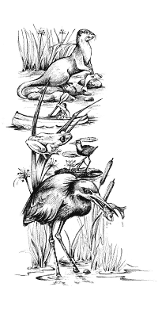Enviro Fact 7: Wetlands

Wetlands are difficult to define because of their great variation in size and location. The most important features of wetlands are: Waterlogged soils or soils covered with a shallow layer of water (permanently or seasonally), unique types of soil, and distinctive plants adapted to water-saturated soils. Marshes, bogs, swamps, vleis and sponges are examples of wetlands.

**Why are wetlands important?**

Wetlands associated with streams and rivers slow floodwaters by acting as giant, shallow bowls. Water flowing into these bowls loses speed and spreads out. Wetland plants, particularly reeds and sedges, play an important role in holding back the water. The wetland acts as a sponge as much of the flood water is then stored in the wetland and is slowly released to downstream areas, instead of it all rushing to the sea within a few days. This greatly reduces flood damage, particularly erosion, and ensures a more steady supply of water throughout the year.

**Filters:** Wetlands improve water quality as they are very good natural filters, trapping sediments, nutrients (e.g. nitrogen and phosphorus), and even pathogenic (disease-causing) bacteria. In addition, pollutants such as heavy metals (e.g. mercury, lead) and pesticides, may be trapped by chemical and biological processes. In other words, the water leaving the wetland is cleaner than the water entering it.

**Wetlands and wildlife:** Wetlands are filters where sediments and nutrients accumulate, so many plants, such as bulrushes, grasses, reeds, waterlilies, sedges and certain trees grow there. The plants, in turn, provide food and a place for attachment and shelter for many creatures. There is more life, hectare for hectare, in a healthy wetland than in almost any other type of habitat. These productive places support huge numbers of insects, fish, birds and other animals. Some animals are completely dependent on wetlands, whilst others use wetlands only for part of their lives. The wattled crane, for example, is dependant on wetlands for breeding. The rich diversity of waterbirds in southern Africa (totalling 130 species) is possible because of the many wetlands spread across the sub-continent. The wetlands of southern Africa are of international importance as they are the southern destination for many migratory water birds.

**People and wetlands:** Wetlands have been used for centuries as grazing for domestic stock, and as a source of reeds used for thatching, hut construction and basket weaving. They provide fishing and hunting, and the opportunity to observe wildlife, especially birds. Wetlands are appreciated for their beauty as open spaces and also for their educational value.

Wetlands in trouble: To many people the thought of a marsh, swamp, bog or vlei is associated with dampness, disease, difficulty and danger. Because of this wetlands are often seen as wastelands that should be converted to cropland, dams, commercial timber plantations of alien trees, waste disposal sites and pastures. Many wetlands have been "reclaimed" for industry and the construction of airports, harbours and sewage treatment plants. Historically wetlands have been drained in attempts to control malaria.

All wetlands in southern Africa are threatened. Botswana's magnificent Okavango Delta is threatened by the possible canalisation of the Boro River to supply South Africa with water for both domestic and industrial use. Throughout the region, smaller seasonal wetlands in urban areas have virtually disappeared, while riverine wetlands are constantly under threat of being turned into agricultural land.

What you can do?

* *Get to know the wetlands in your area and list the plants and animals living there. Draw a map of the wetland's position, size and use. Take photographs of the wetlands from fixed vantage points, and at different seasons of the year, to compare the changes between seasons and from year to year.*
* *Report the abuse of wetlands to your local nature conservation officer, agricultural extension officer or Department of Environmental Affairs and Tourism. Always make your report in writing to ensure that the officer concerned has to investigate.*

**Enviro Fact 8: Protected Areas**  
South Africa has a remarkable diversity of animals, plants, vegetation communities, landscapes, geological features, and numerous sites of archaeological, historical and cultural significance. Arguably one of the most effective ways to preserve and conserve this diversity is through the establishment of protected areas  
.  
**Classification of protected areas.** At present there are over 700 state owned protected areas, including more than 100 marine protected areas, covering about 75 000 km2 (6.1 % of S.A.). In addition there are over 200 privately owned protected areas, covering about 9 000 km2 (0.8 % of S.A.), thus bringing the total to about 7 %. This proportion is small by international standards, being below the ideal of not less than 10 % set by the Convention on Biodiversity  
.  
An enormous variety of protected areas occur in South Africa ranging from large national parks to comparatively tiny, little known reserves. A range of authorities is involved in the management of these protected areas, including state departments, parastatal organisations, local authorities, non-governmental organisations, communities and private individuals. The situation is further complicated by legislation, as more than ten Acts of Parliament, numerous Provincial ordinances, and various local by-laws govern the administration of protected areas, and it is commonplace for two or more pieces of legislation to be relevant for one protected area.  
  
To simplify the situation a classification system has been adopted for protected areas in South Africa. It follows the international guidelines devised by the IUCN (International Union for the Conservation of Nature). Six broad categories of protected areas are recognised and these are defined by the primary management aims of the protected area under consideration.

* Scientific reserves and wilderness areas are the most pristine of all protected areas where human intervention is non-existent or minimal. Scientific reserves are for the purpose of preserving areas of outstanding scientific importance for research. The only scientific reserve belonging to South Africa is the Prince Edward Island group (Marion Island and Prince Edward Island). Wilderness areas, e.g. Cedarberg Wilderness Area in the Western Cape, and Ntendeka Wilderness Area in KwaZulu-Natal, are large undeveloped and uninhabited areas where access is strictly controlled and only non-mechanised tourism is permitted.
* National parks and equivalent reserves are relatively large outstanding natural areas of land or sea, or both, which are not materially altered by human occupation or exploitation. They are managed mainly for ecosystem conservation and recreation. National Parks, e.g. Tsitsikamma National Park, are scattered throughout South Africa and are managed by the South African National Parks. Equivalent reserves refers to the large provincial reserves, e.g. De Hoop Nature Reserve, that have many similarities to national parks, the major difference being that they are managed by the relevant provincial authorities according to different legislation. A process is underway to ensure that all protected areas which qualify should be designated as national parks, and that an appropriate management authority operating within national policy and guidelines is appointed.
* National monuments and areas of cultural significance are areas containing at least one unique or outstanding natural feature recognised for its rarity, beauty or cultural significance. Natural monuments are established for the primary purposes of protecting and conserving the feature/s at the site, and making them available for education and tourism. Examples include botanical gardens, e.g. Kirstenbosch, and Paarl Mountain.
* Habitat and wildlife management areas are areas of land or sea where the protection and conservation of habitat is essential for the survival of important fauna and flora. Conservation of the habitats or species in these areas may require active intervention and even habitat manipulation. Most of the provincial reserves, e.g. Willem Pretorius Game Reserve, and many local reserves, belong in this category. Private nature reserves, e.g. Timbavati Game Reserve, proclaimed in terms of provincial ordinances, are distinct from conservancies, e.g. Bitterputs Conservancy, where landowners agree to combine resources to improve the conservation of a larger area, but which lack legal conservation status
* Protected landscapes or seascapes are scenic areas where traditional customs, lifestyles, and practices such as traditional fishing methods, exist in harmony with nature. They are managed to ensure that the integrity of the site is maintained, whilst allowing tourism, e.g. Kosi Bay
* Sustainable use areas are areas of land or sea, or both, which are predominantly natural and where harvesting of natural resources is permitted. These areas are established for the primary purpose of maintaining biological diversity whilst benefiting local communities by allowing them to harvest natural resources in a sustainable way.

**Citizens' role.** Protected areas are not only the responsibility of the state, and many have been established and managed by communities and private landowners. These can be designated formally in terms of the relevant legislation to provide greater protection. A developing trend is for partnerships to be forged among the state, communities and private sector interests to develop and manage protected areas and ensure that communities, especially in disadvantaged rural areas, benefit from the many opportunities which protected areas can generate. In some cases, e.g. in KwaZulu-Natal, statutory Local Boards for protected areas have been established, giving communities a direct say in the planning and management of these areas, e.g. the Hluhluwe-Umfolozi Park.

**International recognition.** Inter-governmental treaties or conventions to which South Africa is a signatory afford opportunities to register outstanding natural sites of international significance. The sites identified could belong to any of the categories of protected area described above. The special recognition accorded these sites through registration raises their conservation status and improves international support. Examples include Ramsar sites, e.g. Ndumo Game Reserve; Biosphere reserves, e.g. Kogelberg Biosphere Reserve; and World Heritage Sites, e.g. Robben Island, the Greater St Lucia Wetland Park, and the uKhahlamba-Drakensberg Park. The latter park is one of only 23 areas worldwide which has been listed as a World Heritage Site on both natural and cultural grounds.

**Peace parks.** Transfrontier parks (transboundary protected areas or peace parks) involve the collaboration of protected areas across an international border to form a single large protected area. The first transfrontier park in South Africa was created by linking the Kalahari Gemsbok National Park in South Africa with the Gemsbok National Park in Botswana to form one area now called Kgalagadi Transfrontier Park. There are initiatives to develop more transfrontier parks to enhance regional cooperation and biodiversity conservation, e.g. the Gaza-Kruger-Gonarezhou Transfrontier Park.

#### Did you know? The area under the jurisdiction of South African National Parks covers 50 % of the total protected area network. Protected areas cover less than 7 % of South Africa - significantly less than Botswana (18 %), Namibia (14 %), Zimbabwe (13 %) and Mozambique (9 %), and only 25th among countries in Africa. To rectify this a number of national parks (Karoo, West Coast, Addo, Mountain Zebra) have been enlarged recently, and new protected areas are being planned and developed.

**Enviro Facts 9: Hazardous Waste**  
The widely used term hazardous waste is difficult to define. In this fact sheet it includes substances harmful to life and the environment, i.e. wastes with any of the following characteristics: infectious, poisonous (toxic), radioactive, flammable, explosive, corrosive, carcinogenic (cancer causing), mutagenic (damages chromosomes), teratogenic (causes defects in the unborn), or bio-accumulative (accumulating in the bodies of plants and animals and thus in food chains).

Hazardous wastes are produced during industrial, medical, chemical and biological processes. Even household, office and commercial wastes contain small quantities of hazardous wastes (e.g. batteries, pesticides, bleach, paint thinners and their containers).

**Examples of hazardous waste**

* **PCBs (polychlorinated biphenyls):** Non-flammable, insulating materials used by big electrical networks such as Eskom. South Africa lacks the technology to safely treat and dispose of waste PCBs.
* **Dioxins:** A by-product of industrial processes, e.g. incineration and refining of oil. Used to bleach paper in the paper and pulp industry.
* **Heavy metals:** Widespread industrial use, such as in cadmium and nickel plating. Found in batteries (e.g. mercury, cadmium, lead), fluorescent tubes, mercury thermometers, and leaded petrol.
* **Radioactive waste:** By-product of nuclear power generation; and used in medicine (e.g. cancer therapy).
* **Medical waste:** Waste generated by health-care institutions may contain infectious material, which can transmit diseases such as tuberculosis, hepatitis, and HIV/AIDS.

**Options for treatment and disposal**There is no completely safe way of disposing of hazardous waste and the best option is the prevention and reduction of hazardous waste production, and the reuse of waste. Recently introduced minimum standards for the disposal of hazardous waste have decreased the risk of pollution, however no guarantees can be given. Some of the safer methods of dealing with hazardous waste are:

* ***Land-disposal:*** Waste is co-disposed (buried with domestic waste) and/or pre-treated in landfills that are designed with various layers of clay and plastic liners.
* ***Encapsulation:***Waste, which cannot be pre-treated or does not biodegrade, is encapsulated in concrete.
* ***Incineration (burning):*** Incineration of hazardous waste is dangerous and should not be considered as an option for treating or 'disposing' of hazardous waste. Such incineration produces dioxins and furans, and releases heavy metals into the atmosphere. Most medical waste produced in South Africa is incinerated by private contractors or hospitals.
* ***Chemical or biological treatment:*** This treatment includes adding chemicals to waste to make it less hazardous, or adding bacteria to break it down into a less toxic residue. A good example of this is the use of algae to break down liquid hazardous waste from landfills and tanneries.
* ***Plasma arc conversion:*** This treatment subjects waste to temperatures of approximately 4 000 OC, thereby reducing it to its molecular form. This new and expensive technology produces virtually no hazardous by-products. Possible drawbacks of this process are yet to be investigated in South Africa.

**International trade in hazardous waste**In the late 1980s, a tightening of environmental regulations in industrialised countries led to a dramatic rise in the cost of hazardous waste disposal. Searching for cheaper ways to get rid of the wastes, 'toxic traders' began shipping hazardous waste to developing countries and to eastern Europe. When this activity was revealed, international outrage led to the drafting and adoption of the Basel Convention. During its first decade (1989-1999), the Convention was principally devoted to setting up a framework for controlling the transboundary movements of hazardous wastes, that is, the movement of hazardous wastes across international frontiers. It also developed the criteria for environmentally sound management. A control system, based on prior written notification, was also put into place.

The Bamako Convention is an OAU (Organisation of African Unity) convention - this means that it applies only within Africa. It bans the importation of hazardous waste into Africa.   
  
South Africa is a signatory to the Basel Convention, but not the Bamako Convention.  
  
Shipping waste to other countries is no solution; it merely moves the problem. Each country should take responsibility for its own hazardous waste.  
  
**Hazardous waste and the law**Realising that pollution legislation (as well as other environmental legislation) was inadequate, the South African government embarked on a major reform of all environmental laws in 1994. Aspects of this reform process that are relevant to hazardous wastes include first, the establishment of the Integrated Pollution and Waste Management Committee (IP&WMC). This committee has been set up to streamline and co-ordinate pollution control and waste management legislation, and to develop a new National Pollution Control Act to co-ordinate pollution control.  
  
Second, NEMA (National Environmental Management Act) increases the ambit of people who can be held responsible for pollution damage from not only any person, company or government department causing pollution, to any person, company or department owning, using or controlling the land on which the problem exists - even if the pollution causing activity was authorised by law.  
  
**What can industry do about hazardous waste?**The ultimate solution is the reduction of hazardous waste production. This can be achieved in a number of ways:

* substitution of non-polluting alternatives, e.g. the use of chlorine to bleach wood and paper results in the formation of dioxins - chlorine could be replaced with oxygen;
* efficient production processes and good maintenance of machinery can reduce waste production. This can be achieved through adopting one of a number of Environmental Management Systems, such as ISO14001, Life-Cycle analysis; cradle-to-grave, and the reduction of illegal dumping;
* recycling waste reduces pollution and can result in cost-savings, e.g. expensive, toxic heavy metals could be re-used.

**Criteria to assess learners during this language lesson**

|  |  |  |  |  |
| --- | --- | --- | --- | --- |
| Criteria | Exceeded requirements of the Learning Outcome | Satisfied requirements of the Learning Outcome | Partially satisfied requirements of the Learning Outcome | Not satisfied requirements of the Learning Outcome |
| The learner participated and contributed to the group discussions, prior to the debate |  |  |  |  |
| The learner participated in the debate, putting forward his/her views and opinions |  |  |  |  |
| The learner spoke confidently and expressively during the group discussions and the class debate/discussion |  |  |  |  |
| The learner was able to acknowledge other people’s opinions during the debate and agree or disagree politely |  |  |  |  |
| The learner was able to give and receive criticism, during the debate of the ‘Water Conflict Game’ |  |  |  |  |

|  |
| --- |
| **ACTIVITY FIVE: JUST FOR FUN! MAKING A**  **JET-PROPELLED SPEEDBOAT** |

This TECHNOLOGY and NATURAL SCIENCES activity can be used to highlight different phases of water as well as the outcomes of what occurs when water changes phase. This activity can be done in the classroom or learners could try it out at home on their own.

You will need:

* A metal tube or small tin with a tight-fitting lid
* Wood (very light wood is best)
* Stiff wire (a coat-hanger works well)
* Candles and matches
* 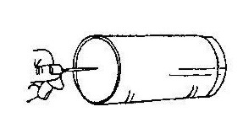A nail

1. Make a hole in one end of the metal tube / tin

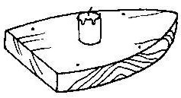

1. Saw a piece of wood to create the outline of a boat and make a shallow hole near each corner.

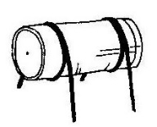

1. Using the wire, make a “cradle” for the tube – see drawing – and wind wire around the tube.
2. Place the feet into the holes in the wood.

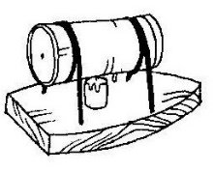

1. Half fill the tube with water and replace lid.
2. 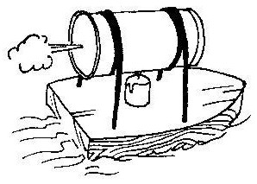Place the candle underneath the tube and light it.
3. Place the boat onto water.