Water use at home, school and

in our community
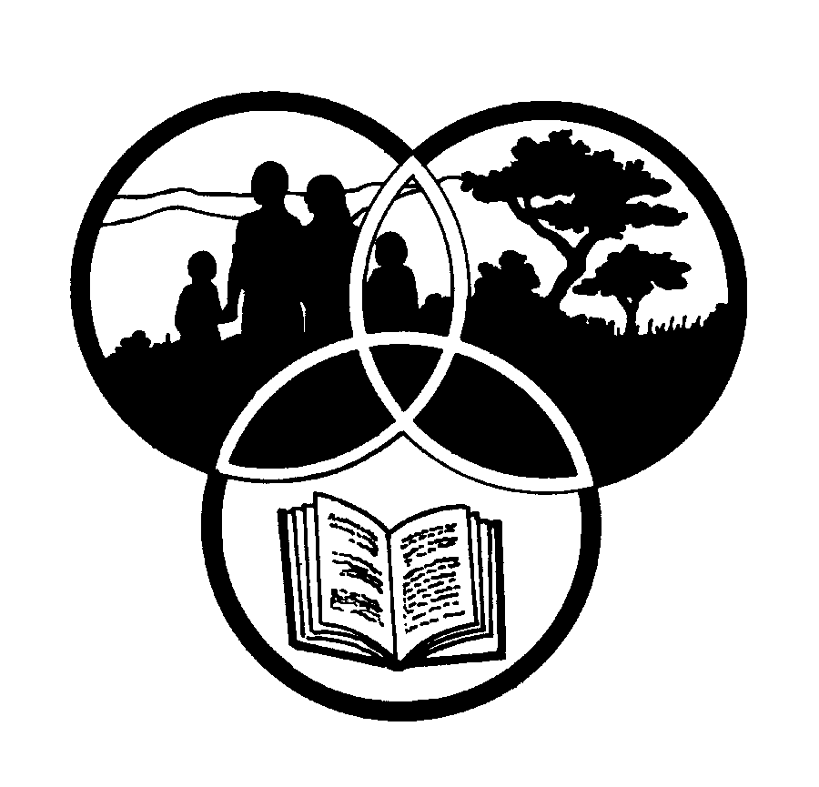
Share-Net

Share-Net is an informal partnership project committed to developing and disseminating materials in support of environmentally focused teaching and learning. Share-Net materials are copyright-free for educational purposes. We encourage you to adapt and use the materials in new, exciting ways but request that you acknowledge Share-Net as an original source. Sensible use of these curriculum activities is entirely the responsibility of the educator. Find similar curriculum materials by visiting www.envirolearn.org.za or contact Share-Net directly at PO Box 394, Howick, 3290, KwaZulu-Natal,
tel: (033) 330 3931, e-mail: sharenet@wessa.co.za
This pack supports an introduction for learners to an Eco-School’s focus on resource management

Grade 8

This pack contains:
Activity One: This SOCIAL SCIENCES : HISTORY reading and questioning activity looks at early Nguni people of southern Africa and their commonsense ways of collecting and storing “sweet” water.

Activity Two: In this ARTS AND CULTURE activity, learners conduct interviews in their local community and then share their findings with the rest of the class in small group role-plays.

Activity Three: This NATURAL SCIENCES activity allows learners to prepare for a water audit, collect data in and around their home, school and community and then develop a school water-wise management plan.

Activity Four: This LANGUAGES lesson encourages learners to investigate an environmental situation and debate, discuss and communicate their ideas.

Activity Five: This TECHNOLOGY and NATURAL SCIENCES activity can be used to highlight different phases of water as well as the outcomes of what occurs when water changes phase. This activity can be done in the classroom or learners could try it out at home.

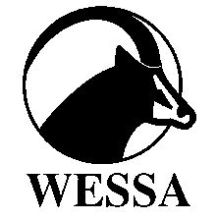
This pack of lesson plans is part of a series of lesson plans from Grade R to Grade 10 which focus on water and water-related issues. This resource development project has been funded by the Water Research Commission, Private Bag X 03, Gezina, Pretoria, 0031 (Website: www.wrc.org.za).
This pack is available electronically on www.envirolearn.org.za
Activity | Learning Area covered in this activity | Learning Outcomes covered in this activity | Assessment Standards covered in this activity
1.This reading and questioning activity looks at early Nguni people of southern Africa and their commonsense ways of collecting and storing “sweet” water. | Social Sciences: History | Learning Outcome 1: Historical Enquiry: The learner will be able to use enquiry skills to investigate the past and present.  Learning Outcome 2: Historical knowledge and understanding. The learner will be able to demonstrate historical knowledge and understanding. | - Evaluates the source used (e.g. ‘Who created the source?’, ‘Is it reliable?’, ’How useful is the information?’ [works with sources].  - Explains changes in a wider historical and environmental context [change and continuity].
2. Learners conduct interviews in their local community and then share their findings with the rest of the class in small group role-plays. | Arts and Culture | Learning Outcome 2: Reflecting: The learner will be able to reflect critically and creatively on artistic and cultural processes, products and styles in past and present contexts. | - Uses the Arts to demonstrate an awareness of environmental concerns.  Drama:  - Researches human rights and environmental issues and interprets these in small group role-plays.
3. Learners prepare for a water audit, collect data in and around their home, school and community and then develop a school water-wise management plan. | Natural Sciences | Learning Outcome 3: Science, Society and the Environment: The learner will be able to demonstrate an understanding of the interrelationships between science and technology, society and the environment. | - Understands sustainable use of the earth’s resources: Identifies information required to make a judgement about resource use. (e.g. Plans and carries out an audit of all uses of water around the school premises and develops an implementation plan to improve water management at school.
4. This lesson encourages learners to investigate an environmental situation and debate, discuss and communicate their ideas. | Languages | Learning Outcome 2: Speaking: The learner will be able to communicate confidently and effectively in spoken language in a wide range of situations. | - Communicates ideas, facts and opinions on challenging topics clearly and accurately and with a greater degree of coherence, using a range of factual oral text types (e.g. discussions, debates).  - Demonstrates a range of interaction skills by participating actively in group discussions, coverstaions, debates and group surveys and while doing so: tackles important issues; acknowledges others’ opinions and disagrees politely when necessary; motivates own point of view; gives and receives criticism.  - Persuades others.
5. This activity highlights different phases of water as well as the outcomes of what occurs when water changes phase. It can be done in the classroom or learners could try it out at home. | Technology and Natural Sciences | - | -

