Water power!
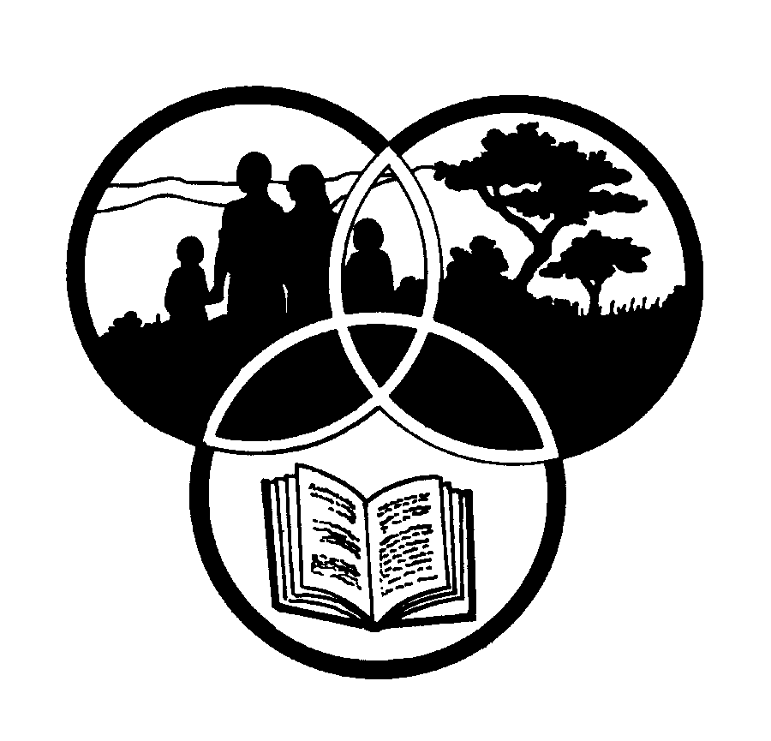
Share-Net

Share-Net is an informal partnership project committed to developing and disseminating materials in support of environmentally focused teaching and learning. Share-Net materials are copyright-free for educational purposes. We encourage you to adapt and use the materials in new, exciting ways but request that you acknowledge Share-Net as an original source. Sensible use of these curriculum activities is entirely the responsibility of the educator. Find similar curriculum materials by visiting www.envirolearn.org.za or contact Share-Net directly at PO Box 394, Howick, 3290, KwaZulu-Natal,
tel: (033) 330 3931, e-mail: sharenet@wessa.co.za
This pack supports an introduction for learners to an Eco-School’s focus on resource management

Grade 9

This pack contains:
Activity One: Learners find out more about energy and energy options in South Africa during this LANGUAGES lesson and then debate whether water as an energy option is the way forward for our country.

Activity Two: During this TECHNOLOGY exercise, learners investigate, design, make and evaluate their own design based on water or steam power.

Activity Three: This ARTS AND CULTURE lesson looks at marketing and advertising our water or steam power designs that were made in Activity Two.

Activity Four: During this NATURAL SCIENCES activity, learners develop a school environmental policy to improve water management.

Activity Five: Just for fun – learners make a jet-propelled steam boat and a water-powered wheel.

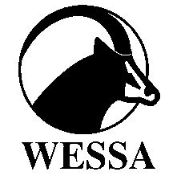
This pack of lesson plans is part of a series of lesson plans from Grade R to Grade 10 which focus on water and water-related issues. This resource development project has been funded by the Water Research Commission, Private Bag X 03, Gezina, Pretoria, 0031 (Website: www.wrc.org.za).
This pack is available electronically on www.envirolearn.org.za
Activity | Learning Area covered in this activity | Learning Outcomes covered in this activity | Assessment Standards covered in this activity
1. Learners find out more about energy and energy options in South Africa and then debate whether water as an energy option is the way forward for our country. | Languages | Learning Outcome 2: Speaking: The learner will be able to communicate effectively in spoken language in a wide variety of situations.  Learning Outcome 5: Thinking and reasoning: The learner will be able to use language to think and reason, as well as to access, process and use information for learning. | - Demonstrates a range of complex interaction skills by participating actively in group discussions, conversations, debates, group interviews and surveys.  - Extends sources and methods for locating relevant information (e.g. electronic and other media such as newspaper archives, documentary films, specialist libraries).
2. Learners investigate, design, make and evaluate their own design which makes use of water or steam power. | Technology | Learning Outcome 1: Technological processes and skills: The learner will be able to apply technological processes and skills ethically and responsibly using appropriate information and communication technology. | Investigates:  - Identifies and explains a problem, need or opportunity from a given real-life context, and investigates the context, the nature of the need, the environmental situation, and the people involved.  - Uses a variety of available technologies and methods to locate (e.g. use library referencing system, database searches, indexes).  Designs:  - Writes or communicates a short and clear statement or a design brief for the development of a product.  - Lists product and design specifications and constraints.  Makes:  - Develops plans for making that include resource lists, formal drawings and manufacturing sequence.  - Chooses and uses appropriate tools and materials to make designed products with precision and control by measuring, marking, cutting or separating, shaping or forming, joining or combining and finishing a range of materials accurately and effectively.  - Demonstrates knowledge and understanding of safe working practices and efficient use of materials and tools.  Evaluates:  - Evaluates the product or system and suggests sensible improvement or modifications that would clearly result in a more effective or higher-quality end product.
3. This lesson looks at marketing and advertising our water or steam power designs that were made in Activity Two. | Arts and Culture | Learning Outcome 4: Expressing and communicating: The learner will be able to analyse and use multiple forms of communication and expression in Arts and Culture. | Applies skills of media production, while considering target group, purpose and design elements (e.g. create an advertisement, class newsletter, poster, T-shirt, logo or jingle).
4. During this activity, learners develop an environmental policy to improve water management at their school. | Natural Sciences | Learning Outcome 3: Science, society and the environment: The learner will be able to demonstrate an understanding of the interrelationships between science and technology, society and the environment. | Understands sustainable use of the earth’s resources: responds appropriately to knowledge about the use of resources and environmental impacts:  - Contributes to formulating a school environmental policy, including constructive ways to deal with waste material and to improve water management.
5. Just for fun – learners make a jet-propelled steam boat and a water-powered wheel. | Technology and Natural Sciences | - | -

