ACTIVITY ONE: LISTENING, ANSWERING QUESTIONS

AND COLOURING IN

This listening, answering questions and colouring-in LANGUAGES activity
introduces young learners to water, by way of a very special
creature, the otter. It encourages them to discuss and share ways
that water is used in their lives.

READ THE FOLLOWING STORY TO YOUR CLASS:

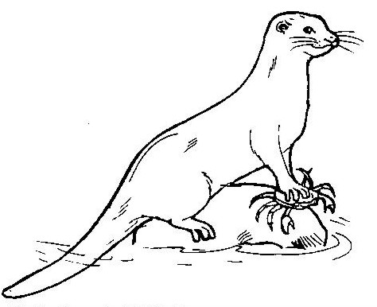
Otters live in and around mountain rivers and quiet freshwater pools. If you are very lucky, you will see them! Most people don’t see otters because they are very shy animals. They spend most of their time in or near water, where they play with one another, catch fish and clean their thick fur. They use their paws and nose to catch and eat crabs, fish, frogs, snails and even water-birds. To dry their fur after swimming, they sun themselves on rocks and sandbanks. They can swim under water for a long time by closing their ears and nostrils and they use their paws like flippers. They also use their tails to swim and it makes them sway from side to side in the water.
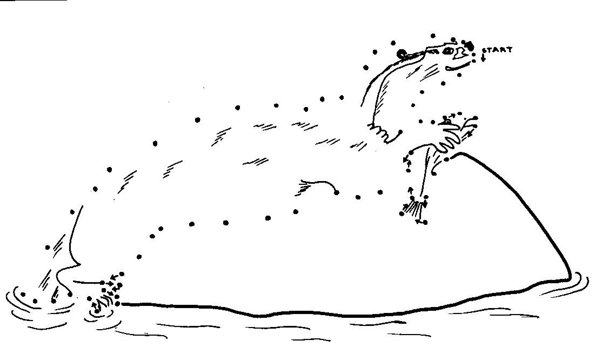

Otter

________________

Questions:

1. What was this story about?

2. Where do otters spend most of their time?

3. Have any of you seen an otter?

4. What was the otter doing?

If no-one has seen an otter, find out what other creatures the children have seen in and around water (crabs, fish, insects, water-birds) and what the animals were doing.

5. What is the otter in the picture doing? (use the enlarged A4 picture on page 2).

6. What other animals can you think of that spend most or all of their time in water? (Fish, water birds, insects, crabs)

7. Who is like an otter in this class and likes swimming? (Get responses from the whole class).

8. Who, like the otter, can swim under water?

You won’t ever see an otter where there is no water – otters have to have water in their lives. And so do we!!

Ask everyone to think of two ways they use water each day (examples include washing clothes, showering, bathing and drinking). Going round the class, you can write a list up on the board.

Can anyone think of a day when they didn’t make use of any water (remind the children that fruit juices and cooldrinks also contain water, their midday and evening meals will probably also make use of water [boiling potatoes, cooking rice], mothers wash their clothes which also makes use of water).

All learners can colour in the “Cape Clawless Otter” brown except for a white throat and chest. For a more challenging exercise and for the more adventurous learners, there is a join-the-dots exercise as well. Learners can also copy the text “Otter” onto the line drawn.

Criteria to assess learners during this languages lesson

Criteria | Exceeded requirements of the Learning Outcome | Satisfied requirements of the Learning Outcome | Partially satisfied requirements of the Learning Outcome | Not satisfied requirements of the Learning Outcome
The learner listened attentively to the story without interrupting the teacher
The learner participated confidently and fluently in a group when questions about the otter were asked
The learner recounted own personal experiences of water
The learner copied the word “Otter”
The learner used crayons and pencils with confidence and appropriately

ACTIVITY TWO: MAKING WATER BELLS

The following NATURAL SCIENCES activity introduces learners to two

of the three phases of water – liquids and solids. By following your simple verbal
instructions, each child can make their own set of musical water bells,
perhaps even compose a tune or two! They can then pop one of their water bell containers into the freezer to see water changing from one
form (a liquid) to another (a solid).

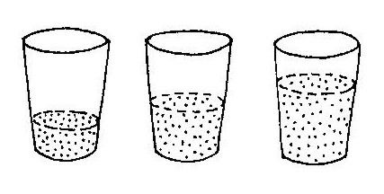
Water bells are easy to make and fun to use. They are good for playing tunes and for making up your own songs! They also give learners the opportunity of pouring and playing with water in its liquid form.

What you will need for each learner:
- Three glass containers (drinking glasses or bottles)
- Large plastic jug of water (add food colouring for interest)
- Wooden pencil

1. Let the learners pour water into each container. They must pour different amounts of water into each container (see picture above). This will change the sound they get when they hit the glass or container with the pencil.
2. Allow learners to experiment with pouring and hitting the containers until they have three different sounds. Can they make up a “water tune” of their own?

Either during this activity or as a class, ask the children what they are doing? Let them show you how different amounts of water in each glass container make a different sound when they hit the glass.

After this activity, you may like to put some of the glasses into a freezer to show the learners that water can occur in a number of forms by changing its form when frozen or heated. If you have a freezer in the staff room, place some half filled containers in it the day before this activity. Show the children the ice (if possible, give each child an ice cube to play with). They will see that it quickly melts in hot hands!! Some may even chose to suck on the ice cube and see how quickly it melts in their mouths.

Criteria to assess learners during this natural sciences lesson

Criteria | Exceeded requirements of the Learning Outcome | Satisfied requirements of the Learning Outcome | Partially satisfied requirements of the Learning Outcome | Not satisfied requirements of the Learning Outcome
The learner was able to follow simple instructions
The learner was able to explain what he/she was doing

ACTIVITY THREE: DANCING, MOVING, SHAKING

Following on from Activity One and Activity Two, learners dance, move and shake in this ARTS AND CULTURE lesson! They will need to draw on the earlier discussions and activities around water, their own personal experiences and their imaginations!

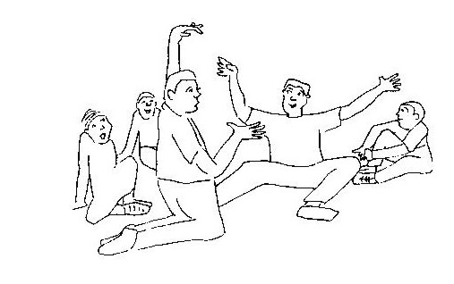
Create a physical space that encourages participation. If you are in a classroom, clear the desks and chairs to the side to create an open space. Make sure there is place for everyone to move or sit in a circle.

Warming Up
It is a good idea to take the class through some warm-up activities. Warming up in drama is more than just a physical warm-up, it also helps to build a group spirit and encourages the learners to focus (if they are too active it helps calm them down, if they seem lethargic and lazy, it will help you to energize them!!)
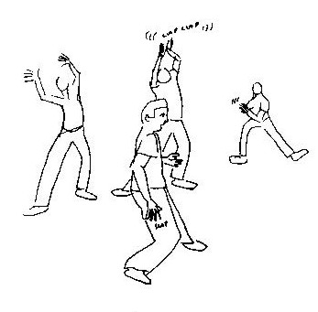

Warming Up 1: Walking around the space
- Everyone in the class should walk around the space that you have created. Each child can walk in any direction they like and change direction as often as they want to. However, they must be careful not to bump into other learners.
- Each time you clap your hands, the learners must change direction.

Warming Up 2: A physical shake-up
- The class stands in a circle, facing each other. (You may like to stand in the centre of the circle to demonstrate your instructions).
- They must imagine there is a big bowl of water right in front of them.
- Everyone in the circle should stick their fingers into their imaginary bowls.
- The learners must bring their fingers out of the water and flick and shake all the water off. Flick it up to the ceiling … and down to the ground… and to the left … and to the right.
- Next, learners put their hands into their imaginary bowl of water, up to the wrists. Again, as they bring them out, shake the water all over … now their wrists are being shaken and their fingers are being shaken.
- Then they need to put their arms into the imaginary water, up to the elbows … and bring them out … and shake … elbows, wrists and fingers.
- Keep going … adding the shoulders .. then the left leg … then the right leg … until eventually the children jump into the imaginary bowl of water, covering their whole body with water and when they jump out, they shake their whole body! An invigorating way for the children to loosen up!

Now that the children have done a couple of warm-up activities, read out the following instructions. If you need to demonstrate first, read the instruction and then demonstrate but try to encourage the children to be creative and let them know that they can make a contribution to the drama without being laughed at.

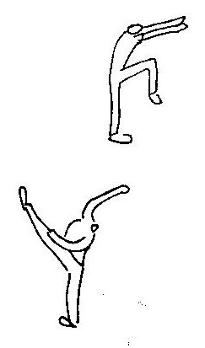
- Drink a glass of water

- Brush your teeth

- Wash your face

- Have a shower

- Wash a car or a bicycle

- Wash the dog!!

- Catch a fish in a net!

- You are walking on ice – it’s slippery and you have to make sure you don’t fall or bump into anyone else

- Put your skating boots on - remember to tie the laces tightly!

- Skate on ice

- Swim across a river

- Jump from one puddle to another puddle

- Do you remember the otter from the earlier lesson? Ask the children to swim like an otter would – from side to side - playing in the water, catching a crab or a fish.

Now, with everyone sitting in a circle, ask the learners what they enjoyed the most (you may need to remind them by going through the list above). Let them describe one or two actions that they enjoyed.

Criteria to assess learners during this arts and culture lesson

Criteria | Exceeded requirements of the Learning Outcome | Satisfied requirements of the Learning Outcome | Partially satisfied requirements of the Learning Outcome | Not satisfied requirements of the Learning Outcome
Responded to movement instructions
Did not bump into other learners
Crossed the mid-line during the drama activities
Talked about own dancing using action words

ACTIVITY FOUR: BOAT BUILDING AND RACING!

Making and racing small boats is great fun. This TECHNOLOGY lesson encourages learners to think about what materials they would like to chose for their boat, to listen and follow instructions and to speak about their designs.

You will need:
- Pieces of polystyrene (about 10cm by 20cm)
- Bark
- Leaves
- Polystyrene egg containers
- Wooden kebab sticks
- Pieces of white card for ‘sails’ (about 10cm by 10cm)
- Crayons for the learners to colour in their ‘sails’

The children can decide what materials they will need and chose what kind of boat they want to make, be it a natural ‘leaf and bark’ boat or a polystyrene egg carton cargo carrier.

For fun, you could buy a packet of jelly babies and the children could have ‘passengers’ in their hand-made boats.

Once all boats have been completed, ask the children how they feel about their boats. What made them chose what they did, do they think they have built a strong boat, why do they like their particular boat?

After this boat building exercise, you could organise a fun ‘boat race day’ if the school is near a small stream or river.

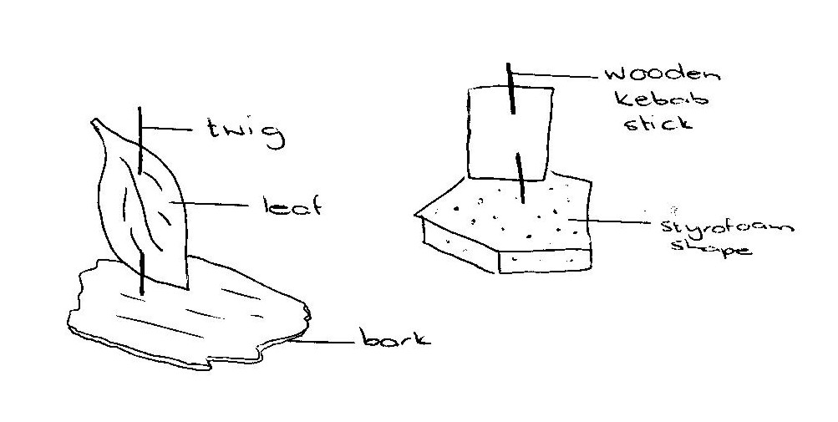
Please remember that if your class is going to sail their boats where they are unable to retrieve them, then make them from natural materials so as not to harm the environment.

Happy boat building!!

Reproduced from EnviroKids with permission

Criteria to assess learners during this technology lesson

Criteria | Exceeded requirements of the Learning Outcome | Satisfied requirements of the Learning Outcome | Partially satisfied requirements of the Learning Outcome | Not satisfied requirements of the Learning Outcome
Learner was able to chose materials to make his/her boat
Learner followed instructions of teacher and made simple boat
Learner spoke about his/her boat

ACTIVITY FIVE: JUST FOR FUN – SOME WET, DAMP,

RAINY POEMS AND RHYMES

Puddles

When the rain is coming down
In the puddles I splash around
The water's wet, but I am dry
I have my boots on, that is why!

Rain
Two ducks went waddling down the lane
Said one to the other, "What beautiful rain!"
Two children came to the door with a frown
Said they "What a pity, it's pouring down!"
And old Mr Weather scratched his head
"You can't please everyone!" he said.

Five Little Speckled Frogs
Five little speckled frogs
Sat on a speckled log
Catching the most delicious bugs – yum, yum
One jumped into the pool
Where it was nice and cool
Then, there were four little speckled frogs,
Quark, quark

Four little speckled frogs … Repeat until … there are no little speckled frogs!

1-2-3-4-5 Once I Caught a Fish Alive
1-2-3-4-5 Once I caught a fish alive
6-7-8-9-10 Then I let him go again.
Why did you let him go?
Because he bit my finger so!
Which finger did he bite?
This little finger on my right.

I Hear Thunder
I hear thunder, I hear thunder
Hark don’t you? Hark don’t you?
Pitter patter raindrops
Pitter patter raindrops
I’m wet though, I’m wet through!

