Water, water, water!!
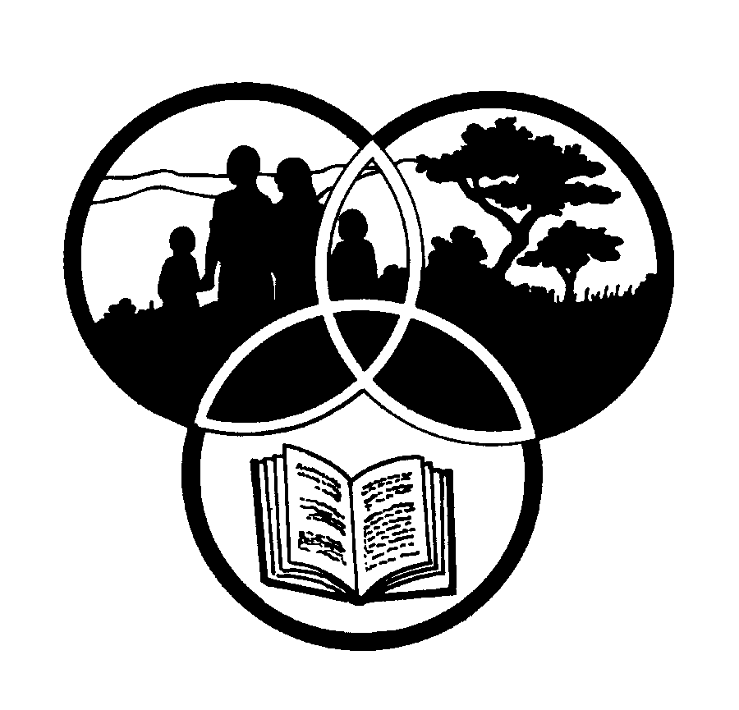
Share-Net

Share-Net is an informal partnership project committed to developing and disseminating materials in support of environmentally focused teaching and learning. Share-Net materials are copyright-free for educational purposes. We encourage you to adapt and use the materials in new, exciting ways but request that you acknowledge Share-Net as an original source. Sensible use of these curriculum activities is entirely the responsibility of the educator. Find similar curriculum materials by visiting www.envirolearn.org.za or contact Share-Net directly at PO Box 394, Howick, 3290, KwaZulu-Natal,
tel: (033) 330 3931, e-mail: sharenet@wessa.co.za
This pack supports an introduction for young learners to an Eco-School’s focus on resource management

Grade R

This pack contains:
Activity One: This listening, answering questions and colouring-in LANGUAGES activity introduces young learners to water, by way of a very special creature, the otter. It encourages them to discuss and share ways that water is used in their lives.

Activity Two: A NATURAL SCIENCES activity that introduces learners to two

of the three phases of water – liquids and solids. By following your simple verbal
instructions, each child can make their own set of musical water bells, perhaps even compose a tune or two! They can then pop one of their water bell containers into the freezer to see water changing from one form (a liquid) to another (a solid).

Activity Three: Following on from Activity One and Activity Two, learners dance, move and shake in this ARTS AND CULTURE lesson! They will need to draw on the earlier discussions and activities around water, their own personal experiences and their imaginations!

Activity Four: Making and racing small boats is great fun. This TECHNOLOGY lesson encourages learners to think about what materials they would like to chose for their boat, to listen and follow instructions and to speak about their designs.

Activity Five: Just for fun – some wet, damp and rainy poems and rhymes.

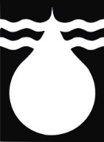
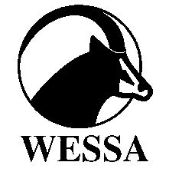
This pack of lesson plans is part of a series of lesson plans from Grade R to Grade 10 which focus on water and water-related issues. This resource development project has been funded by the Water Research Commission, Private Bag X 03, Gezina, Pretoria, 0031. (Website: www.wrc.org.za).
This pack is available electronically on www.envirolearn.org.za
Activity | Learning Area covered in this activity | Learning Outcomes covered in this activity | Assessment Standards covered in this activity
1. Listening, answering questions and colouring in. | Languages | Learning Outcome 1: Listening: The learner will be able to listen for information and enjoyment, and respond appropriately and critically in a wide range of situations.  Learning Outcome 2: Speaking: The learner will be able to communicate confidently and effectively in spoken language in a wide range of situations.  Learning Outcome 4: Writing: The learner will be able to write different kinds of factual and imaginative texts for a wide range of purposes. | - Demonstrates appropriate listening behaviour by listening without interrupting, showing respect for the speaker, and taking turns to speak.  - Participates confidently and fluently in a group.  - Recounts own personal experiences.  - Experiments with writing: manipulates writing tools like crayons and pencils.  - Copies print from the environment.
2. Introduction to two of the three phases of water (liquid and solid). | Natural Sciences | Learning Outcome 1: Scientific Investigation: The learner will be able to act confidently on curiosity about natural phenomena, and to investigate relationships and solve problems in scientific, technological and environmental contexts. | Does: Participates in planned activity:  - Follows simple instructions with assistance.  - Explains what is being done.  Reviews: Thinks and talks about what has been done.  - Uses simple words, pictures or other items with assistance to explain what has been done.
3. Drama exercise, drawing on previous two activities, personal experience and imagination. | Arts and Culture | Learning Outcome 1: Creating, Interpreting and Presenting: The learner will be able to create, interpret and present work in each of the art forms.  Learning Outcome 2: Reflecting: The learner is able to reflect critically and creatively on artistic and cultural processes, products and styles in past and present contexts.  Learning Outcome 3: Participating and collaborating: The learner will be able to demonstrate personal and interpersonal skills through individual and group participation in Arts and Culture activities. | Dance:  - Through play, co-ordinates simple gross and fine motor movements, including crossing the mid-line.  Dance:  - Talks about own dancing using action words.  Drama:  - Thinks about and shows how people and animals move.  Dance:  - Responds to movement instructions that cover space without bumping or hurting others when moving backwards and forwards.
4. Designing and building simple boats by following instructions and choosing between a range of materials. | Technology | Learning Outcome 1: The learner will be able to apply technological processes and skills ethically and responsibly using appropriate information and communication technologies. | Designs:  - Chooses from a given range, materials or substances that can be used to make simple products.  Makes:  - Makes simple products from a range of materials provided.  Evaluates:  - Expresses own feeling about the products made.
5. Just for fun - water and water-related poems and rhymes. | - | - | -

