# LEARNING AND TEACHING ABOUT WATER IN OUR CLASSROOMS

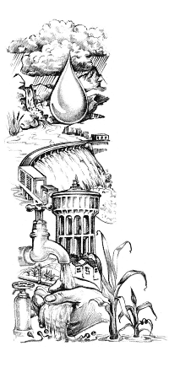

South Africa is extraordinarily rich in natural resources - except for water. Water is a vital but scarce resource, distributed unevenly in time (frequent droughts alternate with periods of good rainfall) and space (the eastern half of the country is markedly wetter than the western half). Increasing demand for water, and decreasing water quality, make careful water management a priority in our country. It has been estimated that by the year 2025 South Africa’s human population will have doubled, and there will be insufficient water for domestic use, agriculture and industry.

Our average rainfall is less than 500mm a year, with the driest part of the country receiving less than 200mm/year and the wettest receiving more than 2 500mm/year! Rain does not always fall where it is most needed, and some areas of high demand, such as Gauteng, receive less water than they need. Most rain falls in a narrow belt along the eastern and southern coasts. The rest of the country receives only 27% of South Africa's total rainfall. In addition, hot dry conditions result in a high evaporation rate.

Water is thus a very scarce resource in South Africa.

In support of learning and teaching about water and water-related issues, the Water Research Commission of South Africa and Share-Net (a project of the Wildlife and Environment Society of South Africa) have developed a series of lesson plans on water. These lesson plan packs, from Grade R to Grade 10, are linked to the South African National Curriculum.

Each pack contains five lessons, with each lesson focusing on a different learning area – these can either be used as they are, or adapted to suit the local context. Each lesson is concluded with a rubric of criteria to assess the learners. Learning Outcomes and Assessments Standards covered during each lesson are given in the summary at the beginning of the pack.

Did you know?

* the Northern Cape receives very little rain and many of the people living there rely on groundwater;
* the Western Cape, south western Cape and KwaZulu-Natal are areas with many RAMSAR wetland sites;
* the Free State is home to one of the most important river catchment areas in the country.

Use the map on the following page to, wherever possible, contextualise your lesson plans – in other words, if you live in the Northern Cape, bring groundwater and evaporation issues into your lessons, if you teach in KwaZulu-Natal or the Western Cape, wetlands could form the focus areas of your teaching lessons.

All these lesson plan packs are available on [www.envirolearn.org.za](http://www.envirolearn.org.za) Other useful websites are the Water Research Commission’s website [www.wrc.org.za](http://www.wrc.org.za) and the Wildlife and Environment Society of South Africa’s website [www.wessa.org.za](http://www.wessa.org.za)

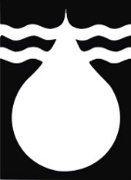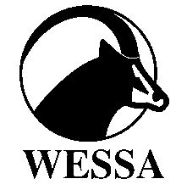

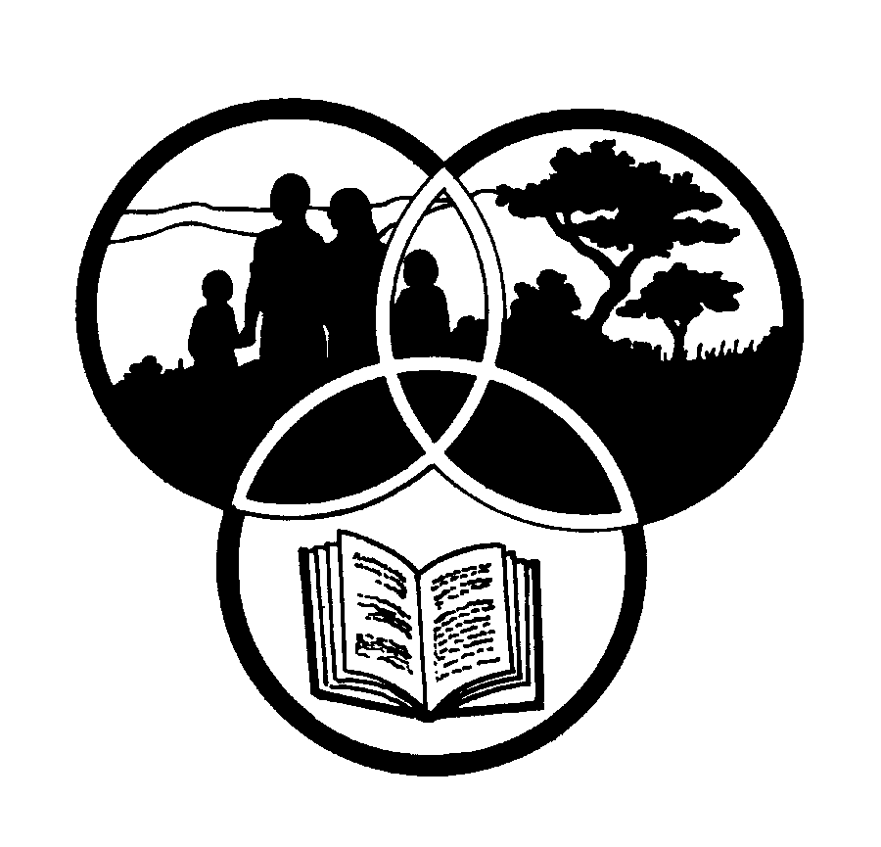

**Share-Net**