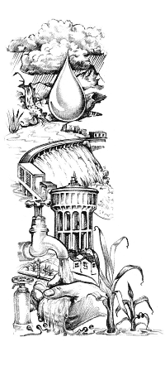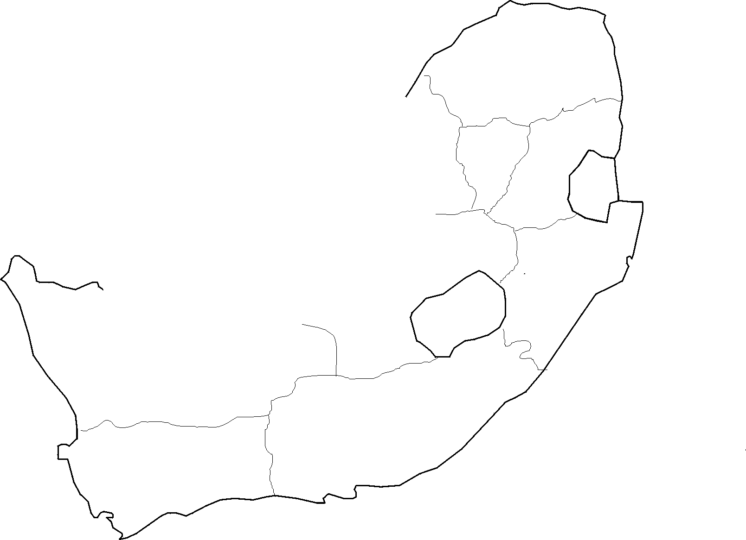

**LIMPOPO**

Limpopo is in the savanna biome, an area of mixed grassland and trees generally known as bushveld. A summer-rainfall region, the northern and eastern areas are subtropical with hot and humid summers and mist in the mountains. The bushveld is cattle country, where extensive ranching operations are often supplemented by controlled hunting. Sunflowers, cotton, maize and peanuts are cultivated in the Bela-Bela and Modimolle areas. Tropical fruit, such as bananas, litchis, pineapples, mangoes and pawpaws, as well as a variety of nuts, are grown in the Tzaneen and Makhado areas. Tzaneen is also at the centre of extensive tea and coffee plantations.

LIMPOPO

# WATER IN SOUTH AFRICA

WESTERN CAPE

FREE STATE

Cape Town 600mm/year

## EVAPORATION

Why is the west coast so dry? Water that evaporates from the Atlantic Ocean condenses to form thick mists over the cold sea. But when these mists move in over the hot land, the water evaporates again instead of falling as rain.

## EASTERN CAPE

The province's diverse climates and landscapes range from the dry and desolate Great Karoo to the lush forests of the Wild Coast and the Keiskamma Valley, the fertile Langkloof, renowned for its rich apple harvests, and the mountainous southern Drakensberg region around the town of Elliot.

Port Nolloth receives only 58 mm of rain per year!

**MPUMALANGA**

The province is a summer-rainfall area. An abundance of citrus and many other subtropical fruit as well as nuts and a variety of vegetables are produced in Mpumalanga. Nelspruit is the second-largest citrus-producing area in South Africa and is responsible for one third of the country's export in oranges. The Institute for Tropical and Subtropical Crops is located in the city.

KWAZULU-NATAL

The eastern part of country receives more rain than the rest of the country. It also has many RAMSAR wetland sites in the northern part of the province. Health and sanitation related to water-borne diseases, such as cholera, are serious issues for this region.

GAUTENG

#### Indian Ocean

*Atlantic Ocean*

NORTHERN CAPE

WESTERN CAPE

The Western Cape, unlike the rest of the country, receives its rain during the winter months. There are many important RAMSAR wetland sites in this part of the country.

FREE STATE

Bloemfontein is the Afrikaans word for ‘fountain of flowers’. It originated as a resting point for oxen next to a spring where water could always be found.

The Free State is home to one of the most important river catchment areas in South Africa, with more than 50% of the water supply for the country coming from the upper catchment area of the Little Caledon River.

Johannesburg 800mm/year

GAUTENG

Rain does not always fall where it is most needed, and areas of high demand, such as Gauteng, receive less water than they need. Using several small rivers along the way, water moves from the Katse Dam in Lesotho to the Ash River that flows into the Vaal to supply industry and people in Gauteng.

Durban 1100mm/year

KWAZULU-NATAL

NORTHERN CAPE

Huge areas of our country have few people living there because it is so dry. People must depend on water from boreholes that suck up water trapped by underground rock formations beneath the soil surface. We have about 30 000 billion litres of water underground. In some areas, groundwater is replenished by rainfall, but in many places the water is left from ages past when the climate was wetter. This water is called fossil water and once used, cannot be replaced.

East London

1400mm/year

NORTH WEST

EASTERN CAPE